Tenses

simple past simple present future
In July I was in GB. I live in Plauen. I will help you
→ 2. Verbform present progressive I am going to
→ keine Auswirkung auf Präsens I am living in.. this year. I have a party on..
(abgeschlossene Handlung) (geplantes Ereignis)

PASTNOWFUTURE
(past progessive: It was raining last week)

present perfect:
Since last year I have learned in Plauen. (Keywords: since/for/this week/ever/never/so far)

(Handlungen, die in der Vergangenheit begonnen und über die Gegenwart hinaus andauern.)

Modal Verbs
- can /could ( → be able to)
ability, permission, possibility, request
- must ( → have to )
necessity obligation
must not = nicht dürfen
prohibition
- need ( → have to)
bei Verneinung von „must“ = nicht brauchen, müssen
- may / might ( → be able to )
persmission
- should / ought to
advice, duty, recommandation
- will
request, offer, prediction
won't = will not
- would
request, offer

Passive
The man showed us (D) the computer (A)
We (D) were shown the computer (A)
The computer (A) was shown to us (D)

A=Akkusativ
D=Dativ

Im Englisch kann man das Passiv mit dem Dativobjekt (D) und dem Akkusativobjekt (A) bilden.

Aufgaben

- Mr Cooper showed the visitor (D) the room (A).
The visitor where showen the room.
- She had written him (D) a letter (A).
He had been written a letter.
- The waiter brought us (D) a huge bottle (A).
We where brought a huge bottle.

(Übung) TEST ( IT – Fachstufe 1 ) - Unit 5

Part A – text „Connecting your UPS“

1.
must do:
  - plug sockets in computer and monitor
  - connect supply to main using earthed cable
must not do:
  - do not block air vents
  - do not connect UPS via unearthed cable
need not do:
  - do not to turn it on
  - do not worry about losing data

2.
unearthed cable – earthed cable
input cable – output cable
red light – green light
close down – far up
suitable – unsuitable

3.
Schließen Sie die Kabel wie in der Abbildung an.
- Schließen Sie die zwei Kabel an den Computer und Monitor an
- Schließen Sie die USV an die Steckdose mit einem geerdeten Kabel an – schließen Sie diese niemals mit einem ungeerdeten Kabel an
- sobald das Gerät angeschlossen ist, lädt die Batterie und das Rote Licht geht an; Sie müssen die USV nicht anschalten
- Wenn Sie den Computer anschalten wollen, schalten Sie auf „Power C“
- Installieren Sie das USV Solution Pack, damit der PC runterfährt, wenn ein Stromausfall auftritt und die Batterien zur Neige gehen.
Part B – Translate the following sentences into English

a) You have to make sure that the assembly is correct.
b) Never interrupt the installation of a new drive.
c) Avoid damp and dusty places.
d) Remove the computer case.
e) This computer is equipped with two interfaces.
f) These customer requirements are necessary.
g) I did not turn off the computer.

Part C – Find out what is wrong. Match the problem 1-10 with their possible solutions

1 F
2 E
3 G
4 D
5 C
6 I
7 A
8 B
9 K
10 H

Part D – Passive

1.
a) When; invented
b) used
c) will be cleaned
d) are stolen
e) is developing

2.
f) The house is build by him in 1935
g) 200 people are company employs
h) Each car is stopped by the police every day
i) The whole building is controled by the computer
k) The meal is cooked by my mother

S. 53/2

1 Step 9
2 Step 6

3 1 4
2 2, 3
3 7
4 10
5 5
6 6
7 9

4
1 carry out
2 recommend
3 appear
4 contain
5 confirm
6 continue
7 enter
8 agree
9 select
10 keep

Adjectives and Adverbs
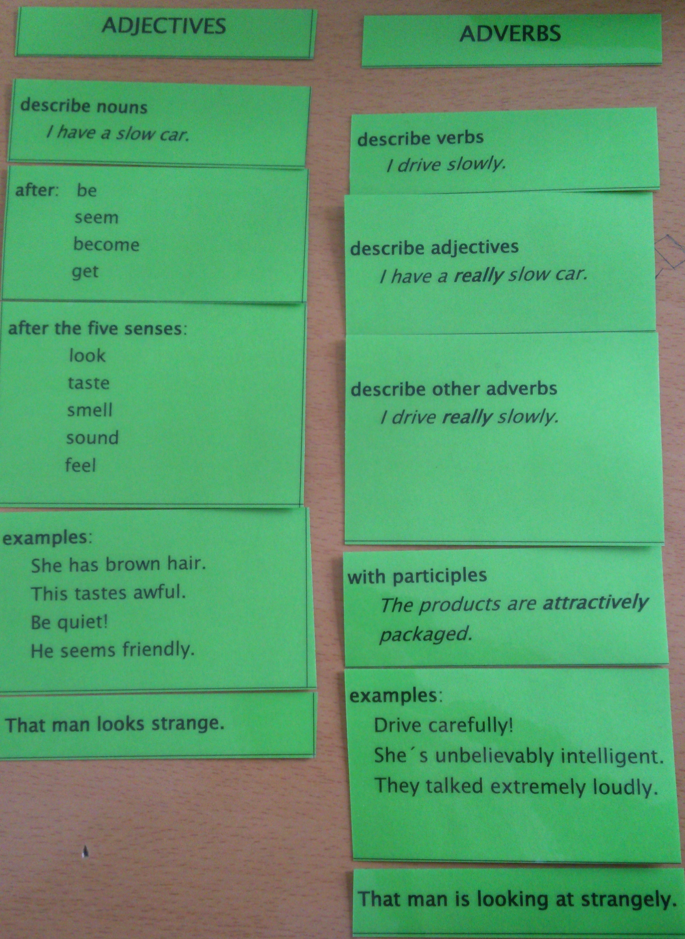

exceptions
Adjective | Adverbs
hard | hard / hardly
high | high / highly
deep | deep / deeply
fair | fair / fairly
first | first / firstly
late | late / lately
most | most / mostly
near | near / nearly
last | last / lastly
short | short / shortly
wide | wide / widely
good | well

forming
a) ending „-ly“ (slow → slowly)
b) adjectives with ending „ly“:
she is friendly (adj.)
she speaks in a friendly way. (manner)

Übung S. 62/4

1 accidentaly
2 usual
3 directly
4 correct
5 actually
6 real
7 directly
8 direct
9 alternativ
10 actually

Tafel

- My ount drives very badly, in the last year she have had 3 accidents.
- I want to talk publicly about this topic.
- The maschine shuts down automatically.
- It's raining heavely
- He is highly talented, he speaks 3 languages fluently.
- You are speaking so loudly, I cant concentrate to my work.

Legal English

- Following are the terms of a..
- The period of this contract is defined as.. trough ..
- (Sam) agrees to a purchase of .. service hours..
- Service provided under this contract is on-site and depot LABOR only.
- Computer equipment included under this contract includes..

