**The Future of Solar Energy is Clear**

Colin Adams

HSA10 – The Economics of Oil and Energy

April 28th, 2016

***INTRODUCTION***

The world’s energy almost exclusively comes from non-renewable sources. Specifically, it comes from burning fossil fuels like coal, oil, and natural gas. Because these fossil fuels are non-renewable, and since the demand for energy continues to increase annually[1], fossil fuels are running out. However, the disappearance of fossil fuels isn’t the primary concern when it comes to fossil fuels. The primary concern is the damage that fossil fuels invoke on the environment. They are the main cause of climate change, pollution, and cause billions of dollars health costs annually.[2] Because of this, the world has started to turn its attention to renewable energy in order to avoid these detrimental effects of energy.

The most sought after form of renewable energy, and the most heavily invested in, is solar energy.[3] It appears to have the most potential currently. However, there are some problems with collecting and using solar energy. One of which is the aesthetic appeal of solar panels and solar farms. In general, solar panels are considered to be ugly and unappealing. Yet, recent research has developed new technology that will likely be a solution to this problem—solar windows. Solar windows have the ability to be just as efficient as traditional photovoltaics, without the aesthetic problems, allowing clean and renewable energy to be a part of our daily lives, yet invisible to us.

***SOLAR ENERGY TODAY***

*CURRENT TECHNOLOGY*

There are two main types of solar energy today. There is solar thermal, and there is photovoltaic solar. Solar thermal works similar to a traditional power plant, by heating some fluid until it boils in order to turn a turbine, generating electricity. Photovoltaics work by converting sunlight directly into electricity. This paper will not be concerned with solar thermal due to the fact that it only accounts for 2% of electricity generated by solar worldwide. However, it is important to note that it is becoming more prominent worldwide, and has been increasing over recent years although not nearly on the same scale as photovoltaics solar.

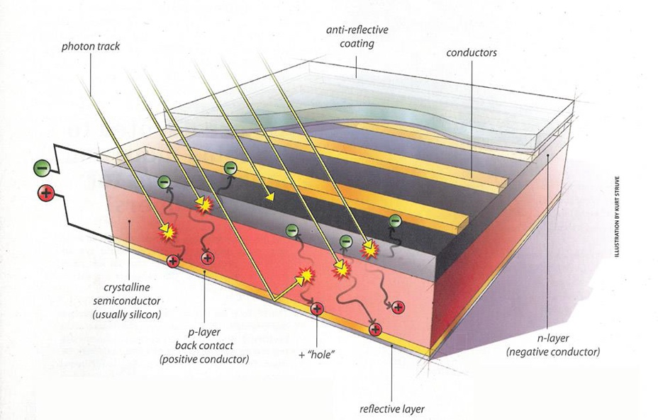Photovoltaic solar panels convert the sun’s light, and directly convert it into electricity which can be used to power homes, electronics, and some automobiles. There are three types of photovoltaic devices: crystalline silicone, thin-film, and concentrating solar panels. Yet, they all work in the same basic way. Essentially, light of sufficiently large energy falls onto the surface of the solar panel, exciting an electron within the semiconductor, usually silicon, to jump to a higher quantum mechanical energy level. With this jump, there is an energy potential, in this case of voltage within the device, which causes the electrons to flow.[4] A more visual example of what is going on can be seen in Figure 1 to the right.

Figure : Diagram of how a photovoltaic cell works

Currently, these solar panels are relatively inefficient. Most solar panels today are anywhere from 11 – 15% efficient, in the sense that if 100 Watts of sunlight fall onto the surface of the solar panel, only 11 to 15 Watts of electricity will be generated.[5] However, this efficiency has been increasing as time progresses and researchers in the laboratory have been able to make solar panels with efficiencies exceeding 45%. This increasing efficiency is making solar energy more promising today, and is partly responsible for its continued investment and increased use around the United States and the rest of the world today.

*USE OF SOLAR TODAY*

Solar energy has been increasing in use drastically over the past few years as it becomes cheaper and more widespread, not only in the United States, but around the world. In only two decades, solar energy capacity has increased by more than three orders of magnitude, growing exponentially. At the same time, the consumption of solar energy has mirrored that, as Figure 1 shows below.

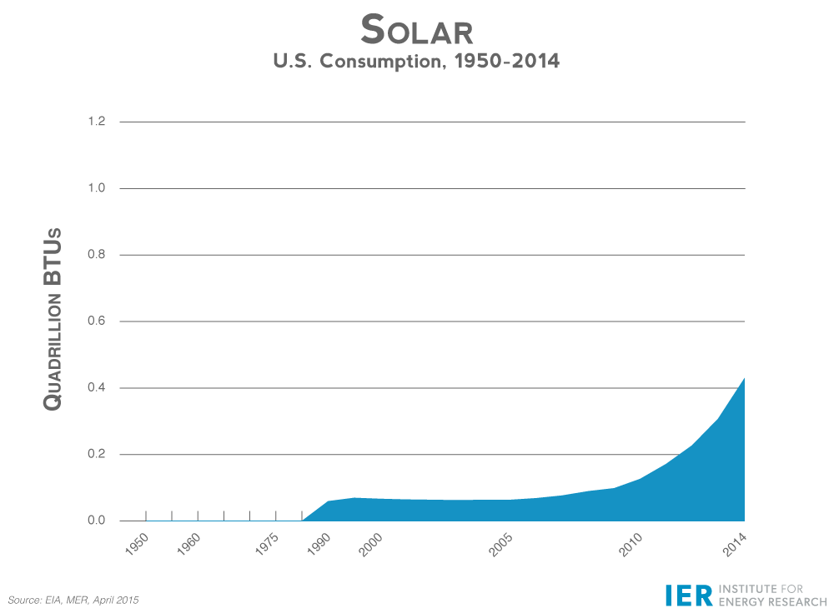 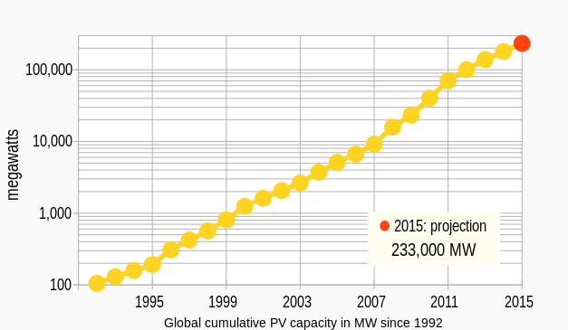

Figure 2: Solar Energy’s consumption compared to its capacity

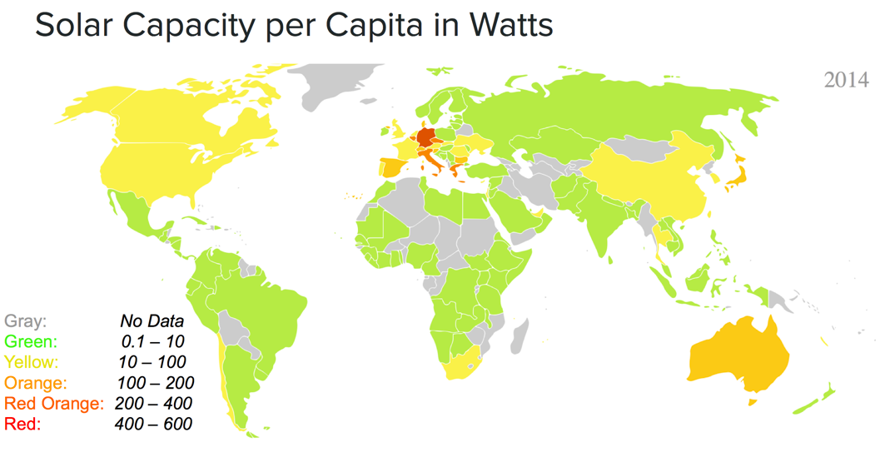As of today, solar energy is responsible for producing a mere 0.6% of the total electricity generation in the United States in 2015.[6] However, this is a drastic increase from only a few years ago. In 2013, solar energy accounted for 0.4% of electrical production in the United States.[7] This is a drastic increase in a very short amount of time, and it appears that the trend is likely going to continue, due to the fact that the cost of solar energy has been decreasing rapidly over the past few decades. Also, other parts of the world are drastically increasing the amount of solar that they use, notably Germany and other parts of central Europe as can be seen in Figure 3. In fact, in Germany, over a brief period of time, over 50% of electricity demand was answered with electricity produced from solar power in June 6, 2014.[8] On average, Germany produces more than 20% of its total electrical needs from solar power, showing that it is possible for solar to be used on a large scale.

Figure 3: Solar Energy Capacity per Capita in 2014

This is evidencing the fact that countries are continuing to make more and more investments in cleaner technology today. The reason countries are investing so heavily in solar energy is because of the drastic cuts in costs coupled with rising efficiencies of solar cells.

*COST OF SOLAR*

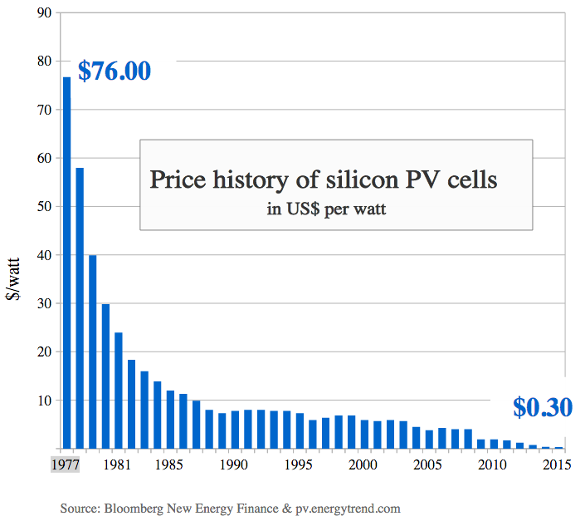The rapid rise in production and popularity of solar energy wouldn’t be possible if it weren’t for the drastic cuts in the cost of this energy. Over the course of four decades, the cost of solar energy per watt has decreased by a couple orders of magnitude, going from over $76 per watt to $0.30 per watt in a little less than 40 years[9] as Figure 4 show. This drastic reduction in the price of solar has come about for a couple of reasons.

The primary reason for this drastic reduction comes from the fact that the technology itself became cheaper and cheaper. This was the case until 2012. After this, the cost of photovoltaic cells continued to decrease due to drops in so-called “soft costs.” These soft costs include installation costs, cheaper and more efficient DC to AC electrical converters, and cheaper physical mounts to mount the the panels themselves. These reductions in soft costs evidence the increasing demand for the photovoltaic technology and its growing popularity.

Figure 4: Price history of PV cells over time

It is also important to note that these prices are the initial cost to produce the solar panel, not the average pricing of the electricity it produces over its lifetime. One of the biggest statistics of any energy technology would be the price per kilowatt hour of energy it produces. For photovoltaic solar panels, over the course of their lifetime, the price of solar panels dropped to an all-time low at $0.05 per kWh of electricity over their expected lifetimes.[10] For comparison, coal costs about $0.06 per kWh.[11]

Thus, it is evident that solar technology is getting to the point to be able to compete with conventional fossil fuels. However, there are drastic problems with solar photovoltaic technology which makes it simply a supplement to conventional energy.

*PROBLEMS WITH SOLAR*

Electricity produced from solar photovoltaics are not currently able to replace fossil fuels from the current energy situation for a couple of reasons, mostly technical but some bureaucratic.

First, the obvious reason is the sun does not always shine. Photovoltaics cannot produce electricity during the nighttime. The amount of electricity produced will very as the length of the day varies over the course of the year. This creates problems because the solar energy will significantly fluctuate over the course of the year, while the demand for energy may not.

Secondly, and currently the main problem is that energy produced from solar energy cannot be stored. The previous problems would be either eliminated or significantly reduced if excess solar energy could be stored for later use. But as it stands currently, it can’t, at least not efficiently or practically.

Third, utility scale solar farms require huge amounts of surface areas in order to capture the necessary amount of sunlight to convert to large amounts of electricity to be fed into the electrical grid. The rule of thumb is that you need about 100 square feet for every 1 kW of solar panels that are installed.[12] Doing a trivial calculation we get that to produce 1 MW of electricity for a solar farm we would

which is roughly equal to the surface area of two American football fields. Obviously, the use of solar farms is much less energy dense than any form of traditional electricity that is produced from fossil fuels.

Fourth, energy is lost during the transmission of electricity. In fact, the Energy Information Agency estimates that six percent of all electricity that is generated is lost during transmission due to the inherent resistance that the wire’s material has.[13] However, the longer the distance between the source and the destination during transmission, the higher the energy loss since resistance is directly proportional to the length of transmission.[14] Since solar farms tend to be isolated due to the large surface area of land that is required, this loss of electricity will be higher.

Lastly, photovoltaic solar panels are ugly. People avoid putting small scale units on their home’s roofs because of this, and large scale solar farms tend to have controversy over this. For example, in 2011 near my hometown, the United States Air Force Academy decided to add a six megawatt solar farm to its property that cost over $18 million. It was then criticized as being “a tremendous waste of taxpayer money and ugly…”[15] by many residents of Colorado Springs. Although this solar farm saves the Air Force Academy over a $1 million per year, it’s ugly aesthetic made it controversial.

In all, solar photovoltaics can’t replace fossil fuels because the sun doesn’t always shine, its excess energy can’t be stored to make up for the sun not always shining, it requires huge amounts of surface area for large scale solar, energy is lost in long transmission lines, and it is ugly.

However, recent research has developed new photovoltaic windows which could solve some of these problems, allowing renewable energy to be much more highly used and widespread. Especially in cities and other urban areas.

***SOLAR WINDOWS***

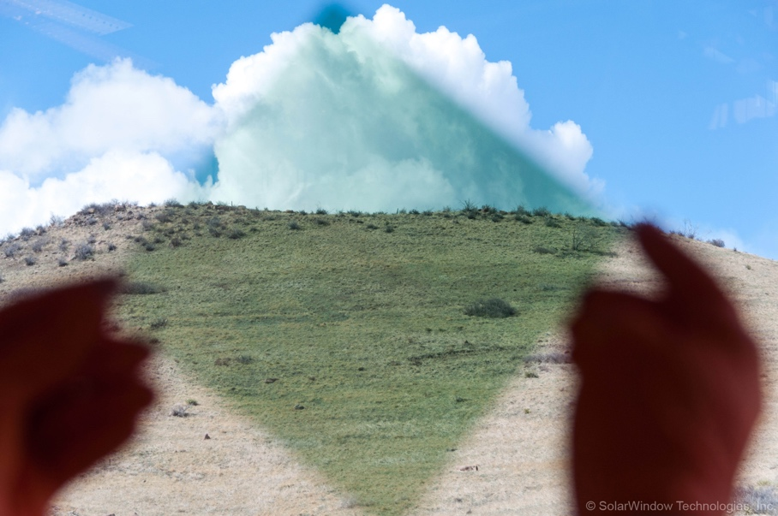In essence, a solar window is a window that produces electricity in the same way that current photovoltaic technology produces electricity. At the very core, solar windows are transparent photovoltaic-solar panels that can be implemented in structures as windows in buildings which are directly connected to the building’s electrical infrastructure to which they area apart.

However, solar windows will not be able to solve all of the problems that solar power currently has, although it will be able to help solve many of them. Solar powered windows will reduce many of these. Primarily, solar windows will be able to help solve the surface area, transmission, and aesthetic problems that traditional photovoltaic panels have today.

Figure 5: Early Stages of Solar Windows

The surface area problem is solved inherently, because windows take up large amounts of surface area as they currently stand. Additionally, solar windows will be connected to the building that they are installed in. Because of this, there will be short distances to transfer the electricity from its source to its final destination, thereby minimizing the amount of energy lost during the transfer. Lastly, solar windows would be almost indistinguishable between a regular window and a non-photovoltaic window. Consequently, solar windows would eliminate the “ugly” problem that photovoltaics currently face today.

Figure 6: Transparency of Current Solar Windows

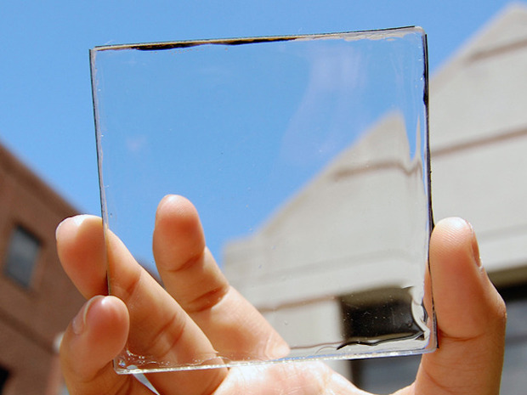Solar windows have not been around for a long time. In fact, some of the very first solar windows were developed in Oxford in late 2013.[16] However, initially, these solar powered windows were not colorless, nor were they efficient. They had a slight blue tint to the material, as shown in Figure 5 on the previous page, and were inefficient—only able to convert about 1% of the light energy into usable electricity, which is about one-fifth of the current industry standard.[17] However, recent advances in this research has made the material transparent as seen in Figure 6 to the right.

*HOW THEY WORK*

The technology of solar windows is really quite interesting because traditional solar panels today try to capture as much sunlight as possible, reflecting back as little as possible, and allowing no light to permeate through the material. This is why normal photovoltaic solar panels are black, because any light that is not absorbed is wasted. Obviously, solar windows can’t take this approach. There are two main methods for capturing the light energy. The first is to use small and specially tuned organic molecules to absorb specific wavelengths of light. The other method is to use quantum dots that fluoresce longer wavelengths that can be used by the photovoltaics.

In order for solar windows to be transparent, they must allow the visible wavelengths of light to pass through the material and absorb the remaining light that isn’t visible to the human eye that interacts with the material. In order to absorb energy to produce electricity, the solar windows must absorb light in the part of the electromagnetic spectrum that isn’t visible, namely, infrared (IR) and ultraviolet light (UV).[18] The key component to the solar windows is the material of which they are made out of.The material that the solar windows are made out of in Figure 6 use small organic molecules that are designed to absorb very specific forms of IR and UV light, while leaving the visible light untouched.[19]

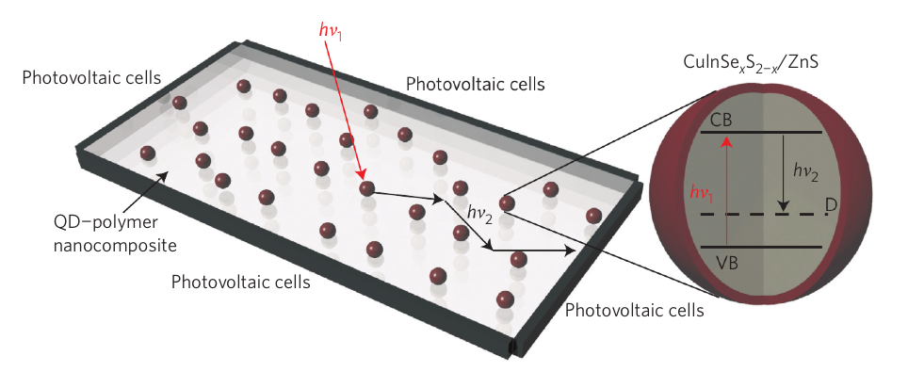The IR and UV light gets guided from the center of the glass to the edges, where solar cells are mounted, which then produces the electricity. However, there is a serious drawback to not using the visible spectrum of light, and that is efficiency. Currently, the technology that is being produced is only able to absorb about 5% of the light energy that is provided. The best efficiency that was achieved was 7% which is anywhere from one half to a third of the current industry standard.

Figure7: Diagram of how quantum dot windows work

However, there are newer designs that are coming out of the Los Alamos National Laboratory using nanoparticles called quantum dots. These quantum dots are a complex composition of copper, indium, selenium, and sulfur, all of which are non-toxic.[20] These quantum dots are imbedded within the glass and provide a small tint to the glass without distorting color. The quantum dots work by absorbing light and essentially fluorescing the infrared light to the photovoltaic strips at the edges of the glass.[21] The efficiencies of these nanoparticle solar windows are around 3.2%. Although the efficiency is lower than the industry standard, these solar windows are becoming more efficient.

*COST ESTIMATE OF SOLAR WINDOWS AND VIABILITY*

The big question surrounding these solar windows is the cost. If these solar windows are too expensive or too specialized, then they won’t be a viable replacement for traditional photovoltaic solar. However, there are already a few companies that are trying to mass produce these solar windows and sell on the market. One of these companies is called Solaria, and they claim that for each window, the cost will be about 40% more than a standard window that could be bought at a store today.[22]

However, one of the big advantages to using windows to produce solar energy is that it is relatively easy to convert a normal window, into an electricity-producing solar panel according to an associate professor of materials science at Michigan State University.[23] This means that current windows could just be retrofitted as is, without all of the hassle of installing these specialized and expensive windows entirely. Because of this, this could be a huge game changer in terms of what the energy of city will look like if this was implemented on a larger scale.

*CASE STUDY OF LOS ANGELES*

In order to show the viability of solar windows making a large impact in terms of energy, we will look at what would happen if solar windows were relatively common in Los Angeles. First, we need to consider the size of Los Angeles and the amount of window surface area that it has.

In 2013, the New York Times estimated that New York City had 47,000 buildings within the city limits. From this, they made some assumptions about relative window frequency from office buildings and residential buildings, and concluded that there are about 10.7 million windows in the city.[24] As it turns out, Los Angeles is bigger than New York City in terms of size[25], so the likely estimate for the number of windows would actually be bigger than the 10.7 million that was cited in the New York Times article. However, to have a conservative figure, we will stick with the 10.7 million windows that the NY Times estimated. Let’s make our own assumption that the typical window is 5 square meters. This gives us a total of

Now let’s make some assumptions. Let’s assume that only 10% of Los Angeles windows that are retrofitted with solar windows, and let’s assume that each of these solar windows have an efficiency of 5%.

The density of solar radiation that reaches earth is about 1200 watts per square meter[26], and the average amount of sunlight that LA gets annually is 3348 hours[27], for a daily average of 9.2 hours. Thus, we get about 11.04 kWh of energy per every square meter in LA every day.

From all of this we can calculate the amount of energy that would be produced from the solar windows.

2,950,000

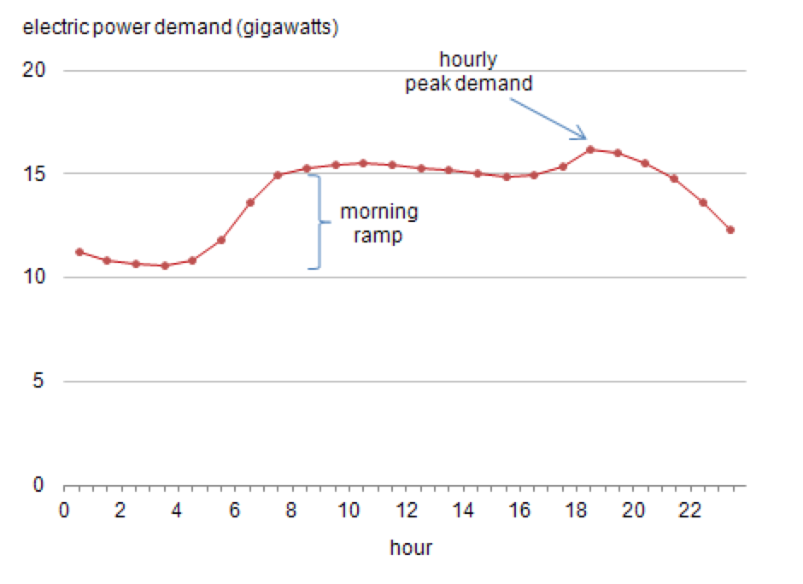Now that we know that we can produce about 2,950 MWh of energy per day, or 1,669,000 MWh annually. 2,950 MWh of electricity every day is a lot. When burned, coal produces about two pounds of carbon dioxide for every kWh that is produced.[28] Solar windows would be able to eliminate close to 6 million pounds of carbon dioxide from being released into the atmosphere, every single day in the LA region. This will reduce pollution in the city, improve air quality, and improve the lives of the residents in the area.

Figure 8: Demand for Electricity over the Course of an Average Day in the entire New England Area

Now, we need to look at the energy consumption of the city of LA, and see how much money the city would save. It is important to note that the demand for electricity is not constant throughout the day. As Figure 8 shows, the demand for increases rapidly over the morning hours and flattens out until about 10pm peak demand for the entire New England region in the United States.[29] This is actually a good approximation for the LA area in terms of population size, with 14 million people in the New England states and about 12 million people in the Los Angeles county.[30] Since solar power only works during hours when the sun is shining, we can see it would create power during the morning ramp and throughout fifteen gigawatt plateau, reducing the amount of energy that .This plateau has a demand of about 120 GWh of electricity each day when integrating under the Figure 8 curve from 8am to 6pm, which is when the solar windows would be in active. This means that the total energy that the solar windows provides 2.5% of the electrical capacity of Los Angeles every day.

The average price of electricity in LA was $0.213 per kilowatt hour in March of 2016.[31] This means that the residents who are using the solar windows would save $229.4 million per year on electricity for their homes and businesses. But how long does it take to for one window to pay itself back?

The cost of an average window is $500,[32] and as we mentioned before the price of solar windows is estimated to be 40% greater than that, which gives us a total of $700 per every solar window. If it costs $0.213 per kWh of electricity, that means that you need the window to produce about 3300 kWh of electricity before the investment will be worth it. If we have a 5 square meter solar window at 5% efficiency and there is 11.04 kWh per square meter per day, that it will take

This is the same as 3.3 years. So these windows will pay themselves off in a little more than three years after installation, and that is assuming that the price of these windows don’t decrease, and the efficiency of the window stays constant.

***CONCLUSION***

In all, solar windows have the potential to solve some of the problems that are holding traditional photovoltaic energy back. It has the ability to overcome the large amounts of surface area, the energy loss from transmittance, and would be hidden in plain sight. When more widely on the market, solar windows will be able to produce energy for cities without changing its look, allowing the beautiful city of Los Angeles, to look just the same.

Figure 9: Los Angeles at Sunset.

[WORD COUNT: 3559]

1. “Residential Electricity Prices Are Rising.” *EIA.gov*. 2014. https://www.eia.gov/todayinenergy/detail.cfm?id=17791#.
2. “The Health Effects and Costs of Air Pollution.” *Journalist’s Resource*. 2015. https://www.eia.gov/todayinenergy/detail.cfm?id=17791#http://journalistsresource.org/studies/environment/pollution-environment/health-effects-costs-air-pollution-research-roundup.
3. “Clean Energy Defies Fossil Fuel Price Crash to Attract Record $329bn Global Investment in 2015.” *Bloomberg*. 2015. about.bnef.com/press-releases/clean-energy-defies-fossil-fuel-price-crash-to-attract-record-329bn-global-investment-in-2015/.
4. Hummel, Rolf E . “Semiconductors.” In *Understanding Materials Science*, 203–4. New York: Springer2004.
5. “Solar Panel Efficiency.” *Pure Energies*. 2015. http://pureenergies.com/us/how-solar-works/solar-panel-efficiency/.
6. “What Is U.S. Electricity Generation by Energy Source?” *Eig.gov*. 2015. https://www.eia.gov/tools/faqs/faq.cfm?id=427&t=3.
7. “Solar.” *Institute of Energy Research*. 2015. http://instituteforenergyresearch.org/topics/encyclopedia/solar/.
8. “Germany Gets 50 Percent of Its Electricity from Solar for the First Time.” *The Week*. 2014. http://theweek.com/speedreads/451299/germany-gets-50-percent-electricity-from-solar-first-time.
9. “13 Cost of Solar Panels & Cost of Solar Power Charts &Graphs.” *Clean Technica*. 2015. http://cleantechnica.com/2014/09/04/solar-panel-cost-trends-10-charts/.
10. “Average Utility-Scale Solar Price In US Falls To 5¢/kWh.” *Clean Technica*. 2015. http://cleantechnica.com/2015/09/30/average-utility-scale-solar-price-in-u-s-falls-to-5%C2%A2kwh/.
11. “Levelized Cost and Levelized Avoided Cost of New Generation Resources in the Annual Energy Outlook 2015.” *Eig.g*. 2015. http://www.eia.gov/forecasts/aeo/electricity_generation.cfm.
12. “Area Required for Solar PV Power Plants.” *Solar Mango*. 2014. http://www.solarmango.com/scp/area-required-for-solar-pv-power-plants/.
13. “How Much Electricity Is Lost in Transmission and Distribution in the United States?” *EIA.gov*. 2015. https://www.eia.gov/tools/faqs/faq.cfm?id=105&t=3.
14. Hummel, Rolf E . “Electrical Properties of Materials.” In *Understanding Materials Science*, 185. New York: Springer2004.
15. Zubeck, Pam. “Working with the Sun .” *Colorado Springs Independent*. 2011. http://www.csindy.com/IndyBlog/archives/2011/06/13/working-with-the-sun.
16. Hanley, Stephen. “Solar Power Windows Ready for Production.” *Planet Save*. 2015. http://planetsave.com/2015/09/05/solar-power-windows-ready-for-production/.
17. Meirian, Lucas. “Solar Windows Poised to Change the Way We Power Buildings.” *Computer World*. 2015. http://www.computerworld.com/article/2980236/sustainable-it/solar-windows-poised-to-change-the-way-we-power-buildings.html.
18. “The Future Is Clear.” *Michigan State University*. 2015. http://msutoday.msu.edu/feature/2015/the-future-is-clear/#.
19. “Solar Energy That Doesn’t Block the View.” *Michigan State University*. 2015. http://msutoday.msu.edu/news/2014/solar-energy-that-doesnt-block-the-view/.
20. “Capture Sunlight with Windows.” *Los Alamos National Laboratory*. 2015. http://www.lanl.gov/discover/news-release-archive/2015/August/08.24-capture-sunlight-with-window.php.
21. Meinardi, Francesco, Hunter McDaniel, Francesco Carulli, Annalisa Colombo, Kirill  A. Velizhanin, Nikolay  S. Makarov, Roberto Simonutti, Victor  I. Klimov, and Sergio Brovelli. “Highly Efﬁcient Large-Area Colourless Luminescent Solar Concentrators Using Heavy-Metal-Free Colloidal Quantum Dots.” *Nature Nanotechnology* 10 (178)2015.
22. Meirian, Lucas. “Solar Windows Poised to Change the Way We Power Buildings.” *Computer World*. 2015. http://www.computerworld.com/article/2980236/sustainable-it/solar-windows-poised-to-change-the-way-we-power-buildings.html.
23. “The Future Is Clear.” *Michigan State University*. 2015. http://msutoday.msu.edu/feature/2015/the-future-is-clear/#.
24. Pallack, Michael. “Calculating the Number of Windows on Buildings in Manhattan.” *New York Times*. 2013. http://www.nytimes.com/2013/12/22/nyregion/calculating-the-number-of-windows-on-buildings-in-manhattan.html?_r=1.
25. Romero, Dennis. “LA Is Actually Bigger than NYC.” *LA Weekly*. 2013. http://www.laweekly.com/news/news-flash-la-is-actually-bigger-than-new-york-5122287.
26. “Sun’s Energy.” *University of Tennessee*. 2010. https://ag.tennessee.edu/solar/Pages/What%20Is%20Solar%20Energy/Sun’s%20Energy.aspx.
27. “Sunlight Data.” *Climata Temps*. 2012. http://www.los-angeles.climatemps.com/sunlight.php.
28. “How Much Carbon Dioxide Is Produced per Kilowatthour When Generating Electricity with Fossil Fuels?” *Energy Information Agency*. 2016. https://www.eia.gov/tools/faqs/faq.cfm?id=74&t=11.
29. “Demand for Electricity Changes through the Day.” *Energy Information Agency*. 2014. https://www.eia.gov/todayinenergy/detail.cfm?id=830.

   
30. “New England Population vs LA Population.” *Wolfram Alpha*. 2016. http://www.wolframalpha.com/input/?i=new+england+population+vs+la+population.
31. “Average Energy Prices, Los Angeles-Riverside-Orange County, March 2016.” *Bureau of Labor Statistics*. 2016. http://www.bls.gov/regions/west/news-release/averageenergyprices_losangeles.htm.
32. “How Much Does It Cost for Windows?” *Angie’s List*. 2015. https://www.angieslist.com/articles/how-much-does-it-cost-replace-windows.htm.