**The Environment is Killing Coal**

Colin Adams

HSA10 – The Economics of Oil and Energy

March 3rd, 2016

# ***Introduction***

Coal has been a major part of the world’s energy for hundreds of years. Ancient Romans used it in England during the second and third centuries, while the Hopi Indians in America used coal in the 1300’s. The Industrial Revolution, during the 1700’s played a huge role in expanding the use of coal, due to the new demand to power steamships, trains, etc., across the globe. [1] Soon, coal was being used to generate electricity in cities, and due to its low price and is one of the main electricity generating sources today, both in the United States and abroad.[2] However, due to coal’s high external costs, including the costs associated with the environment and healthcare, coal is becoming unfavorable and uneconomical. This has led to coal’s recent decline and will be the basis of the disuse of coal as a main electricity source around the world.

## ***Where Does Coal Come From?***

**Formation**

Coal is formed from large plants that died in swamps around 300 million years ago, then sank to the bottom, and somehow got buried.[3] Over these 300 million years the plants got buried deeper and deeper increasing the heat and pressure on the plant corpses. This combination of pressure and heat caused the plant’s organic matter to be transformed and compressed into a black, shiny rock which happens to burn significantly better than most other rocks. The location of these swamps that existed millions of years ago led to huge deposits of this black, shiny rock, and it is in these locations from which coal is mined from today.

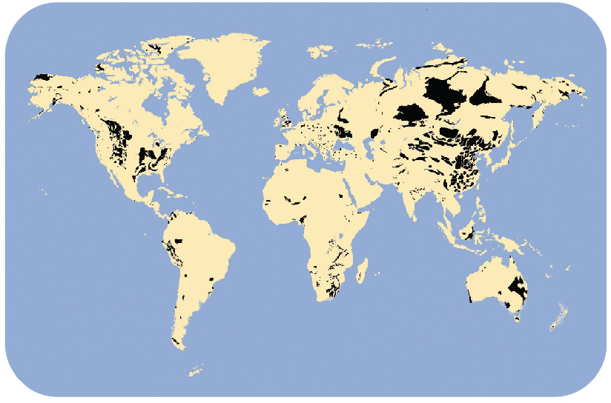 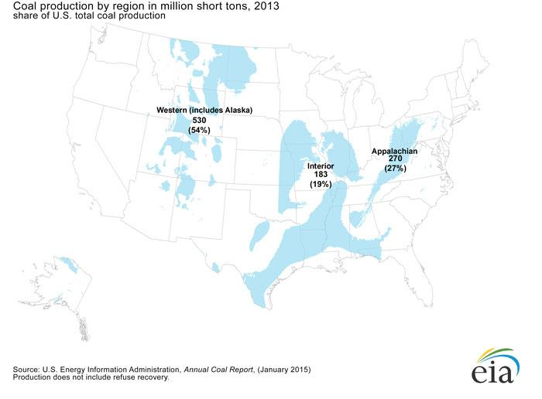

Figure 2: (Left) Coal Deposits Worldwide.[4]

(Right) Coal Deposits in US[5]

**Coal Mining and Its Environmental Impact**

Coal is mined traditionally mined using two techniques.[6] The first technique is underground mining. This is the traditional form of mining in which underground shafts are created and is carted out. Underground mining is quite damaging to the environment. Methane that is trapped inside the coal deposits and is released when it is mined. It is important to note that methane is about 30 times as potent greenhouse gas that carbon dioxide[7]. It is estimated that underground mining is responsible for 10% of methane emissions in the US each year.[8] Additionally, many of these mines leak acidic water that pollutes nearby lakes and streams as well as contaminating the groundwater. All of this is harmful to the ecosystem as well as costly to clean up.

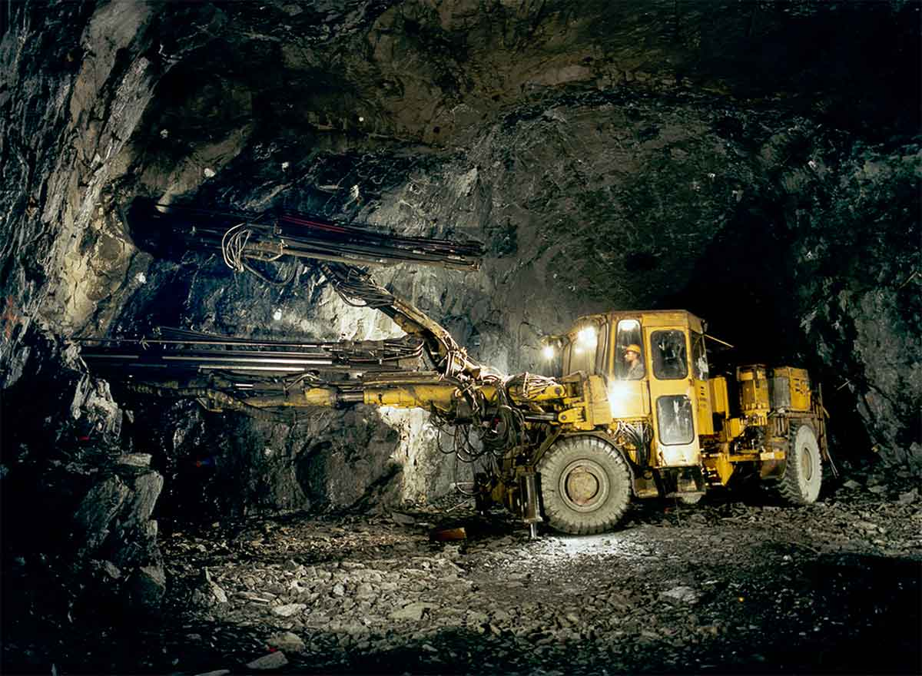

Figure 2: Example of Underground Mining[9]

The second technique for extracting coal is called surface mining. Surface mining includes a broad category of mining techniques where the miners don’t actually have to go underground to retrieve the coal, including strip mining and mountain top removal. When mining via mountain top removal, miners use explosives and other powerful machinery to remove the top of a mountain in order to reach the coal underneath. The coal then gets removed from underneath, and then the top of the mountain gets put back on top. This method of mining is much more efficient economically, due to less workers required and more yield of coal. As one could imagine, this is very harmful to the environment.

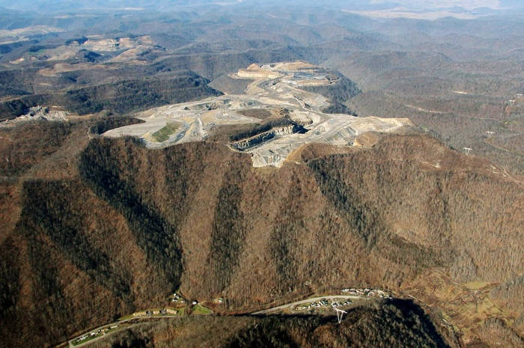 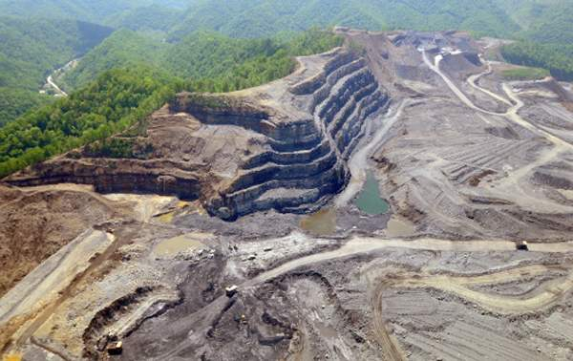

Figure 3: (Left) An Example of Mountain Top Removal Mining[10]

(Right) An example of strip mining[11]

Streams and rivers get diverted and polluted while ecosystems get destroyed when these huge amounts of rock get displaced. Frequently, coal companies go out of business and don’t pay to restore the natural environment, as they are required by law to do in the United States.[12] This forces the government, and consequently the tax payers, to pay for the restoration. For example, in just Wyoming alone, there are over $2 Billion in reclamation costs that coal companies are expected to pay[13]. However, lately, the coal industry has been struggling and many large coal companies are declaring bankruptcy within the last year.

Today, most coal is acquired by surface mining due to its efficiency and being less costly. The National Mining Association reports that in 2014, surface mines were responsible for 65.3% of coal production in the United States and produced 652,772 short tons of coal. Underground mining produced the remaining 34.7% of coal which is about 346,879 short tons. In 2013, there was a ratio of about a 5 miners working for underground mines per every 3 miners working for surface mines. Consequently, a quick calculation shows us that

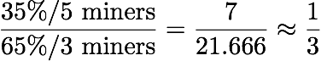

This means that underground miners are only one third as productive as surface miners are. So it makes sense for the coal industry to use surface mining as its main technique for extracting coal, because it is three times as productive as underground mining.

**Transporting Coal and Its Environmental Impact**

After coal is mined, it is transported across the country and around the world in various methods to get it to arrive at its destination. There are three main methods for transporting coal: via railroad, via waterway, and via pipeline. All three of these are relatively expensive and relatively inefficient. The most commonly used method of transporting coal is via the railroad due to the infrastructure that is already available. Nearly 70% of all coal is transported by train.[14]

The environmental impact of transporting the coal comes from burning fossil fuels to transport large quantities of fossil fuels. Coal is shipped out by the trainload which means huge amounts of fuel is necessary to transport coal. This increases the amount of carbon dioxide that coal is responsible for releasing into the atmosphere before it ever gets burned.

## ***What is Coal Used For?***

**Electricity Generation and Its Environmental Impacts**

About 93% of all coal is used for generating electricity in the United States, which is responsible for about 39% of all US electricity production.[15] Worldwide, coal is responsible for producing 41% of electricity.[16] Essentially, coal is ground up into a fine powder to help it burn better. Then, the coal is burned, boiling water which then turns a turbine in a generator, which produces the electricity and is then distributed through power lines. The particles that remain after being burned is called fly ash, and in the United States, must not be released into the environment. However, many countries aren’t as strict.

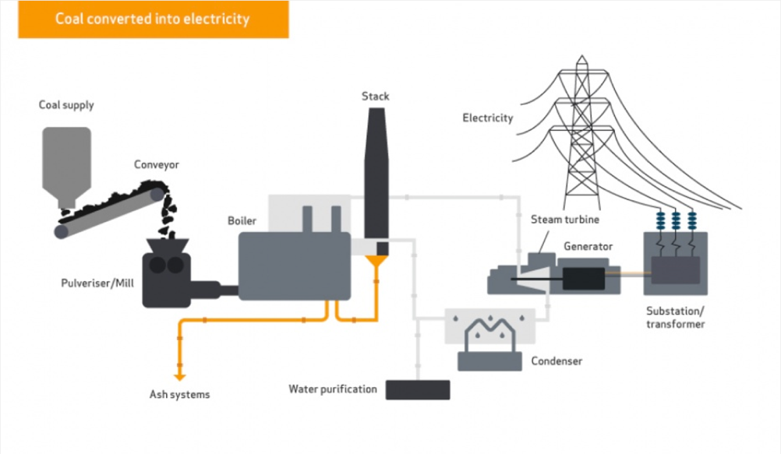

Figure 4: How Coal Produces Electricity22

Most of coal’s environmental impact comes from its emissions when burned. Primarily, a huge amount of carbon dioxide gas is released per power plant. Carbon dioxide is a harmful greenhouse gas which is the main cause of global warming. However, the emissions of burned coal are more numerous than just carbon dioxide. When burned, coal releases significant quantities of sulfur dioxide, nitrous oxides, particulates, and toxic heavy metals. Sulfur dioxide contributes to acid rain, nitrous oxides and particulates contribute to smog and harms lungs, and toxic heavy metals, like mercury, are known to cause neurological damage[17].

In addition, the fly ash that is left over from burning the coal, must be stored. This ash is usually stored near the power plant or put in a landfill; occasionally, the storage container breaks, or the coal ash leaks into the groundwater, which is very costly to clean up. Notably, this happened in Kentucky in October of 2000. An estimated 306,000,000 gallons of coal slurry—which is a mixture of fly ash and water—was released into a nearby river, killing all aquatic life. The coal company spent a total of $49 million dollars in fines and clean up costs, and was at the time, one of the largest environmental disasters, and was 30 times the size of the Exxon Valdez oil spill.[18] However, just eight years later another coal slurry released 1.1 billion gallons of coal slurry in Tennessee costing an estimated $900 million to clean up. [19] [20]

## ***The Rise, Decline, and Coming Death of Coal***

**Rise**

Coal has been used for over a hundred years to heat homes, to power engines, and to power factories. Ever since the industrial revolution, coal became the backbone of our society. Coal has become a staple of our electric society in today’s world because of two reasons: it’s numerous and cheap. In just the US alone, there are 256 billion short tons that are recoverable. The amount that is recoverable in US mines that are already operating is 19 billion short tons. The total consumption of United States in 2014 was 916 million short tons.[21] Consequently, if the US consumes coal at its rate in 2014, the US recoverable supply would last another 279.5 years. If the US coal demand grows by a whopping 10% per year, the coal supply would last for another 60 years.

Today, the cost of producing one kilowatt hour of electricity by burning coal is $0.095 for the consumer.[22] Because it is so cheap, and so plentiful, and historically always has been, coal is ingrained in our modern society. Modern society became and still is dependent on coal, but all this is changing because of the true cost of coal. Although the price of coal is staying relatively constant, and is staying low, the the true cost of coal is being realized and is increasing. This is beginning of the decline of coal.

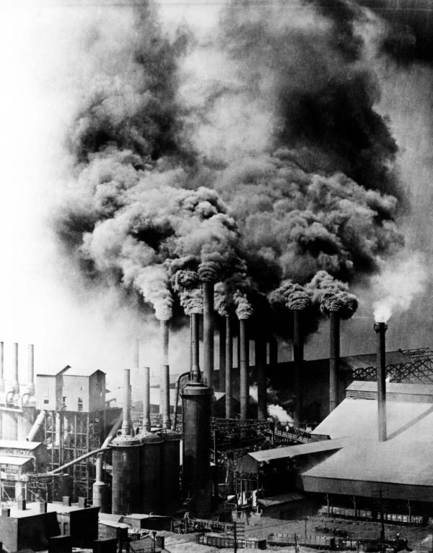 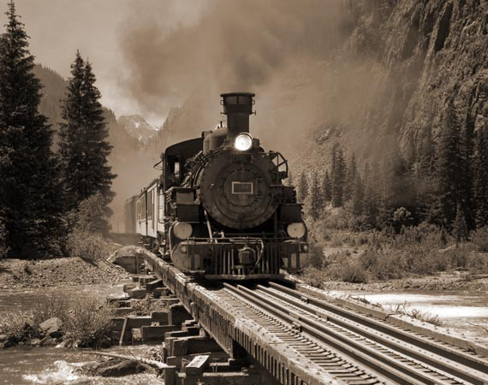

Figure 5: (Left) Factory in Pennsylvania in 1906 and (Right) 20th Century Coal-Powered Train[23]

**Decline**

The decline of coal in some sense began with the the start of the environmental movement in the mid 20th century. In fact, since 1970, the United States passed over 15 major legislative pieces in order to protect the environment; five of which directly affected the coal industry, including the Clean Air Act and the Surface Mining Control and Reclamation Act.

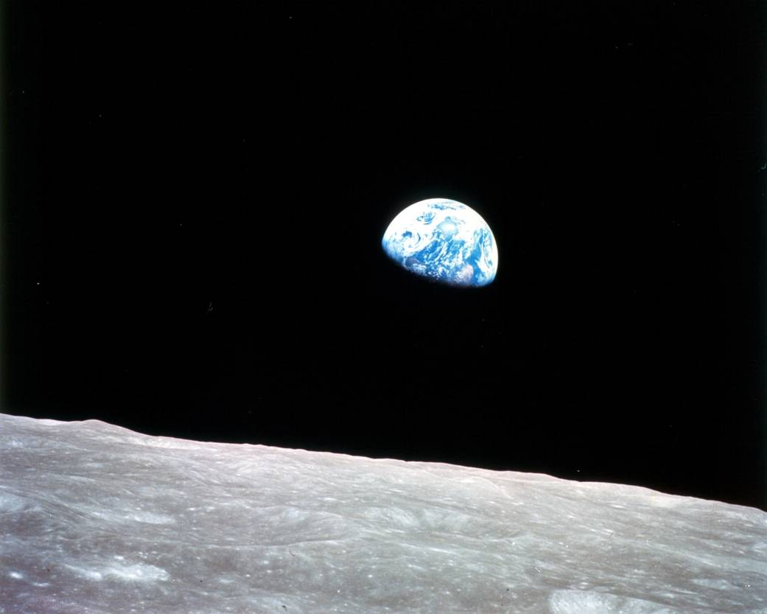

Figure 6: Earthrise Photo taken during Apollo 8 Mission[24]

Due to rising fears of climate change in the 1990’s, four major international agreements were formed trying to curb the amount emissions of greenhouse gases. These agreements include both the Montreal and Kyoto Protocols along with a United Nations Framework Convention on Climate Change. These international agreements put political pressure on the heaviest polluters in the world; namely, the US, China, and India to change. This, coupled with the fast growth of alternative and renewable energy sources, has made coal increasingly uneconomical.

This is evidenced by the fact that six major coal companies have declared bankruptcy in the United States within the last year. For example, the largest coal company in the United States, Peabody Energy, declared bankruptcy. In 2011, the Peabody Energy stock was worth over $1000 per share. Now, it is less than $3. The percentage of electricity that natural gas is producing is growing, while the amount that coal is producing is decreasing­–both domestically[25] and abroad.[26] The Energy Information Administration is reporting that coal production began declining in 2008 and that trend has continued up through 2015.[27] In 2014, the world coal market declined for the first time in 21 years, and it appears that 2015 did the same.[28] Not only this, but as we showed earlier, it makes economic sense for the coal companies to be damaging to the environment. In fact, when using the more environmentally-harmful method of surface mining, coal mining companies are about 3 times more efficient than using the traditional method of underground mining.

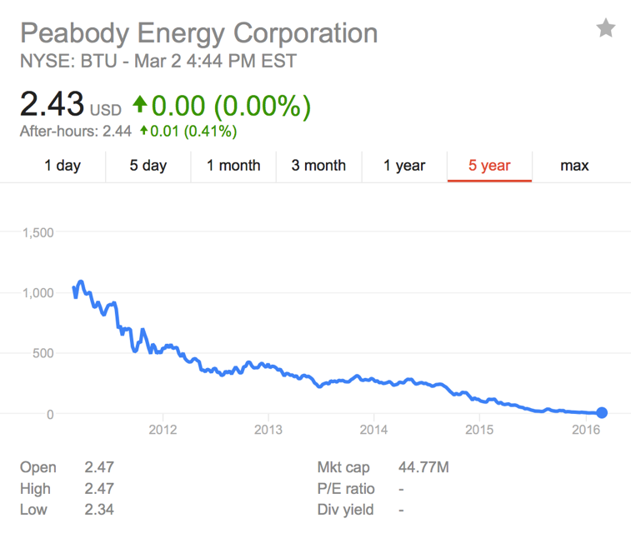

Figure 7: Stock of Peabody Energy–the Largest Private Coal Company in the US over the last 5 years

Why has coal begun to decline so rapidly? It’s because of the rise of cheaper and cleaner energy sources and because the $0.095 per kilowatt-hour that consumers are paying for, isn’t the true price of coal.

First, cleaner energy is getting cheaper and more prominent. In just five years, the price of natural gas declined by 10%. Nuclear by 20%. Onshore wind by 51%. Photovoltaic solar by 68%. During those same five years, coal’s price decreased by a mere 5%.[29]

The true cost of coal, once external costs are accounted for, show that the world’s cheap electricity isn’t so cheap after all. As mentioned before, coal must be mined; when mined, the environment is damaged—sometimes terribly. Coal must then be transported, usually by rail—causing more pollution. Lastly, the coal is burned. The emissions from this coal must be cleaned up and purified before released. These regulations are getting stricter. Despite this, harmful pollutants are released into the atmosphere, damaging the environment and creating health hazards for communities and families living nearby. This is damaging to communities with relatively strict environmental regulations such as in the US. Imagine the health cost that Beijing faced in December 2015, when the air quality was seven times the safe limit for over three consecutive days.[30]

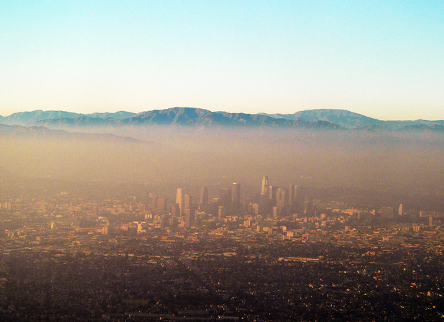 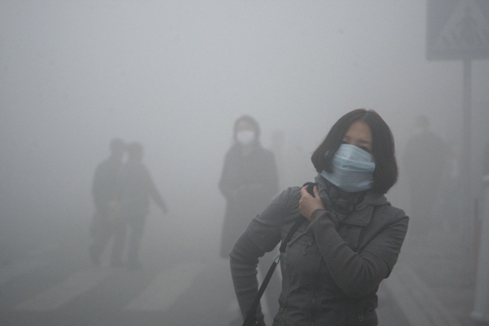

Figure 8: (Left) Smog in Los Angeles[31] and air pollution in Beijing[32]. (Right)

In fact, a Harvard Study estimated the true cost of coal, taking into account these factors. The study gave estimated that the true price of coal when considering these factors and others add anywhere from an additional $0.09 per KWh to $0.269 per KWh to the current price of $0.09 per KWh. Their best estimate of the price of coal was an additional $0.178 per KWh for a total cost of $0.273 per KWh.[33] When compared to other sources of energy, coal becomes one of the most expensive sources of energy per KWh.

Coal just isn’t worth the investment anymore.

**Coming Death**

The world is shifting away from coal and it’s because the environment is struggling. A survey of 750 economists at the 2016 World Economic Forum ranked Climate Change as the number one risk to the global economy.[34] The majority of countries are starting to choose an investment in the protecting the environment over the promise of cheap energy. This is seen by the fact that 195 countries—virtually the entire world—agreed to the Paris Agreement in December of 2015, to reduce emissions.[35] In 2015, only one one-hundredth of one percent was of the new electricity generated in the US was from coal.

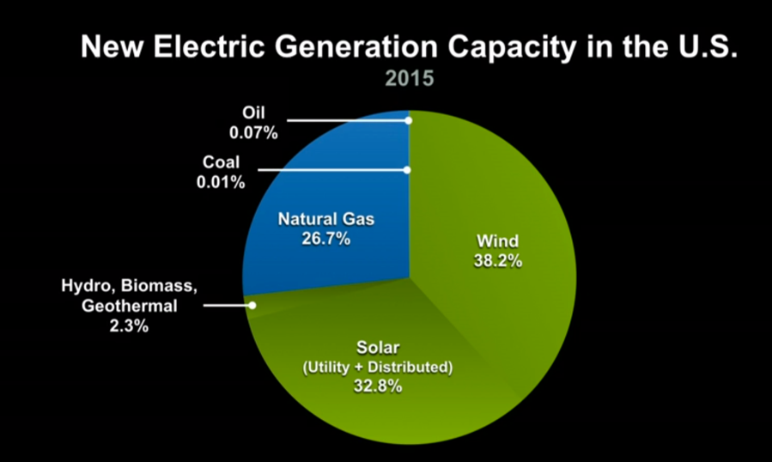

Figure 9: Investments of Energy in 2015 35

## ***Summary***

From being mined to being burned, coal damages the environment in a variety of ways while also harming human health. This damage and hazard increases the seemingly low price of coal, making it one of the most expensive forms of energy on the market when taken into account. All of this, coupled with the explosion of investment in cleaner energy—like natural gas, wind, and solar—is making coal uneconomical. This has led to the current world decline of coal. Soon, due to international pressures, the rapidly decreasing price of alternative energy sources, coal will die. The environment is fighting back against coal, and coal is losing.

[WORD COUNT: 2482]

1. http://www.fossil.energy.gov/education/energylessons/coal/coal_history.html
2. https://www.eia.gov/tools/faqs/faq.cfm?id=427.
3. http://www.coaleducation.org/q&a/how_coal_formed.html
4. http://pierie.nl/energy/future/conventional-coal-reserves/
5. http://www.eia.gov/energyexplained/index.cfm?page=coal_where
6. https://www.worldcoal.org/coal/coal-mining
7. http://www3.epa.gov/climatechange/ghgemissions/gwps.html
8. http://www3.epa.gov/climatechange/ghgemissions/gases/ch4.html
9. http://miningsolutionsint.com/underground-mining.html
10. http://earthjustice.org/slideshow/images-of-mountaintop-removal-mining
11. http://www.wvgazettemail.com/article/20100403/ARTICLE/304039984/
12. http://www.latimes.com/nation/la-na-sej-coal-reclamation-20160224-story.html
13. http://www.npr.org/2016/02/29/468577856/when-coal-companies-fail-who-pays-for-the-cleanup
14. http://www.eia.gov/KIDS/energy.cfm?page=coal_home-basics
15. http://www.eia.gov/KIDS/energy.cfm?page=coal_home-basics
16. https://www.worldcoal.org/coal/uses-coal/coal-electricity
17. http://www.eia.gov/KIDS/energy.cfm?page=coal_home-basics
18. http://abcnews.go.com/US/story?id=95285&page=1&singlePage=true
19. http://www.timesfreepress.com/news/news/story/2009/jun/06/tva-ship-spilled-coal-ash/222350/
20. http://www.cnn.com/2008/US/12/23/tennessee.sludge.spill/?iref=mpstoryview
21. http://www.nma.org/pdf/c_most_requested.pdf
22. http://www.eia.gov/forecasts/aeo/electricity_generation.cfm
23. http://explorepahistory.com/displayimage.php?imgId=1-2-444&storyId=1-9-E
24. http://www.nasa.gov/multimedia/imagegallery/image_feature_1249.html
25. http://www.eia.gov/todayinenergy/detail.cfm?id=23252#
26. http://www.eia.gov/todayinenergy/detail.cfm?id=22972
27. http://www.eia.gov/todayinenergy/detail.cfm?id=24472
28. http://www.eia.gov/todayinenergy/detail.cfm?id=23852
29. http://en.openei.org/apps/TCDB/
30. http://www.theguardian.com/world/2015/dec/21/beijings-smog-red-alert-enters-third-day-as-toxic-haze-shrouds-city
31. https://livinginatoxicworld.wordpress.com/2011/04/19/l-a-smog/
32. http://www.vosizneias.com/144171/2013/10/21/beijing-china-smog-emergency-shuts-city-of-11-million-people/
33. http://onlinelibrary.wiley.com/doi/10.1111/j.1749-6632.2010.05890.x/full
34. http://www.ted.com/talks/al_gore_the_case_for_optimism_on_climate_change/transcript?language=en
35. http://www.npr.org/sections/thetwo-way/2015/12/12/459464621/final-draft-of-world-climate-agreement-goes-to-a-vote-in-paris-saturday