**The Economic Feasibility of Artificial Photosynthesis for Commercial Production of Hydrogen Fuel**

Natalie Kadonaga

HSA 10-5 The Economics of Oil and Energy

April 28, 2016

**Introduction**

In 2015, the Obama Administration announced $75 million in funding to JCAP, the Energy Department’s Joint Center for Artificial Photosynthesis, an organization which aims to develop solar fuels such as hydrogen that can be used for fuel cell electric vehicles (FCEVs)[1]. JCAP and many other research organizations have recently focusing heavily on more efficient and low-cost methods of hydrogen fuel production, particularly artificial photosynthesis. Artificial photosynthesis has been gaining interest because it uses water, sunlight, and in some cases carbon dioxide to generate zero-emission hydrogen fuel, with a higher energy generation rate than natural photosynthesis. Is this the further development of this renewable technology a productive use of government funding? In this paper, we will discuss the economic feasibility of using artificial photosynthesis to generate hydrogen fuel and the potential of the technology for commercial production and use.

**I. The Current Situation of Solar Energy**

In order to understand why production of hydrogen fuel is important, an understanding of the current solar energy situation in the United States is required. In the Annual Energy Outlook 2015 from the U.S. Energy Information Administration, energy consumption is expected to increase from 97.1 quadrillion Btu in 2013 to 105.7 quadrillion Btu in 2040, as shown in Figure 1[2]. Most of this growth comes from natural gas and renewable energy, but it is important to note that fossil fuels are still prevalent, demonstrating that energy-related research must prioritize ways to decrease greenhouse gas emissions through expansion of renewable energy generation.

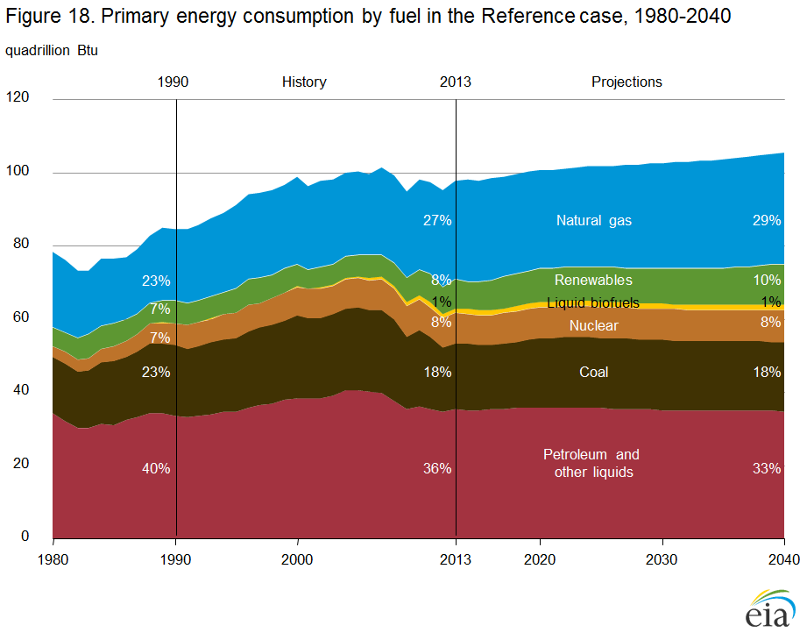

Figure : Estimated growth for energy consumption from the Annual Energy Outlook 2015 from the U.S. Energy Information Administration.

The potential for renewable energy sources is unmatched by the sun. The sun provides 100,000 TW of energy on an annual basis. At this rate, the energy from 1 hour of sunlight is equivalent to a year of human energy consumption[3]. Methods of converting sunlight to usable energy include photovoltaics and biomass. These methods can be expensive and inefficient. Electricity from photovoltaics is 5-10 times more costly than electricity from fossil fuels and as a primary energy source is 25-50 times more costly[4]. Biomass produces electricity at rates comparable to fossil fuels, but have a limited production capacity. Since natural photosynthesis converts only about 1% of sunlight into fuel, it isn’t energy efficient and requires a large amount of land to be an effective means of energy production[5]. Therefore, artificial photosynthesis systems, with higher rates of conversion from sunlight to fuel, would be promising as energy sources if producible at economically competitive costs because they would outperform photovoltaics in cost and biomass in space. Also, hydrogen fuel is attractive because its byproduct, water, is completely clean.

The United States also has a demand for hydrogen fuel. With changes from the U.S. Department of Energy such as the 2009 American Recovery and Reinvestment Act (ARRA), which funded $41.9 million for deployments of nearly 1,300 fuel cells, the hydrogen fuel cell industry has expanded. According to a report from the Fuel Cell & Hydrogen Energy Association (FCHEA) titled *The Business Case for Fuel Cells 2015: Powering Corporate Sustainability*, approximately 23% of Fortune 100 companies are “using fuel cells for primary or backup power generation, or for materials handling equipment.” Additionally, businesses such as Verizon, Wal-Mart, and FedEx have purchased or installed over 13 MW worth of stationary fuel cells in 2015 as a result of partnerships with hydrogen technology companies such as Plug Power and Bloom Energy[6].

FCEVs have also contributed to demand for hydrogen fuel. A 2016 Congressional transportation-funding bill extended tax credits for hydrogen FCEVs, offering between $1,000 and $4,000. These types of bills support predictions of the sales FCEVs in the United States to exceed 228,000 by 2024[7]. We can expect this demand to continue with further legislation focused on the reduction of greenhouse gas emissions. With more FCEVs on the roads and companies using fuel cells, research related to improving the cost and efficiency hydrogen fuel production is crucial.

We also must consider the production and delivery of hydrogen fuel. With small scale on-site generation, costs associated with transportation and delivery can be eliminated. Therefore, on-site generation options are becoming more lucrative. On the other hand, centrally located plants require delivery by pipeline, trucks, or cylinders. For this evaluation of hydrogen fuel, we will assume small scale on-site generation.

Currently, most hydrogen fuel used in industrial applications is produced by steam reforming of natural gas or methane, due to the availability and low price of natural gas (shown in Figure 2). In 2010, about 25.6 million metric tons of hydrogen fuel was produced in this method. The process, known as electrolysis, involves using an electrical current to separate water into its components of oxygen and hydrogen. Hydrogen fuel is also produced by partial oxidation of petroleum or steam gasification of coal. While these methods are historically more cost-effective, it is critical that environmentally-conscious methods of production are explored[8].

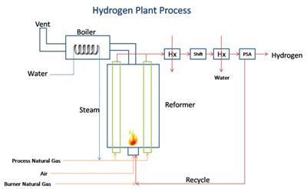

Figure : A basic schematic of the process of producing hydrogen through natural gas reformation.

**II. The History of Artificial Photosynthesis Research**

The idea of artificial photosynthesis dates as far back as 1912, when Italian chemist Giacomo Ciamician stated, “solar radiation may be used for industrial purposes… photochemistry will artificially put solar energy to practical uses. To do this is would be sufficient to be able to imitate the assimilating processes of plants [9].” However, there was no development on Ciamician’s idea until 60 years later, when chemists from Kanagawa University in Tokyo outlined a method that used sunlight to split water into oxygen and hydrogen fuel[10].

Later on, in 1998, researchers from National Renewable Energy Laboratory in Colorado created a photoelectrochemical cell that when coupled with a photovoltaic device, split water, creating hydrogen fuel. The conversion rate of solar energy to fuel was 12.4%, which was much more efficient than the conversion rate of 1% in natural photosynthesis[11]. However, the cost was 25 times too big to be competitive and the rate of performance did not last after 20 hours[12].

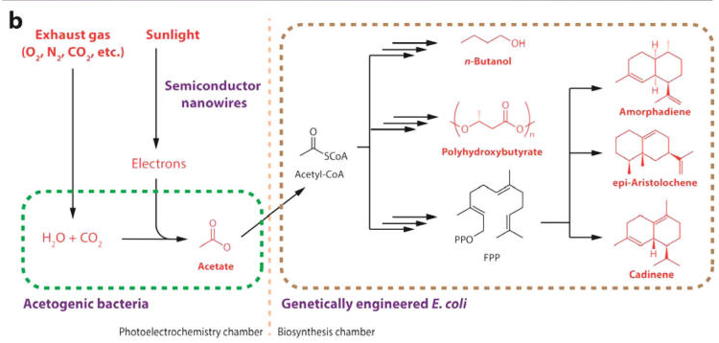

Figure : Schematic of the nanowire-bacteria method.

In March 2015, researchers from the Lawrence Berkeley National Lab and the University of California at Berkeley created a device using artificial photosynthesis with a conversion rate of solar energy to fuel of 10%. Their method was based on a nanowire-bacteria hybrid that depended on carbon dioxide fixation, shown in Figure 3. First, sunlight was harvested by a photoanode and carried in the form of electrons through semiconductor nanowires made from silicon and titanium oxide. In a photoelectrochemistry chamber, water and carbon dioxide are collected. The carbon dioxide was intended to be from the exhaust gas of using carbon-based fuels. In the chamber, the wires are studded with anaerobic bacteria called *Sporomusa ovata* that converts the carbon dioxide into acetate. Acetate is a valuable molecule as a key building block for carbon-based biofuels[13]. In a biosynthesis chamber, genetically engineered *E. coli* can convert the acetate using synthetic pathways consisting of various proteins. These different pathways show the versatility of the acetate approach since each pathway is specific enough to lead to a unique organic product. Although producing hydrogen fuel is not possible with this method, similar outputs such as butanol were created. Since the conversion from acetate to more specific molecules does not produce a 100% yield, the previously stated conversion rate of 10% must be adjusted depending on the product[14]. For example, *n*-Butanol had an acetate-to-product efficiency of 25.6%, so the overall sunlight to butanol conversion rate is 0.10 * 0.256 * 100% = 2.56%, which is not much better than natural photosynthesis which has a conversion rate of 1%. Therefore, other more efficient methods will be considered over this one.

Other methods of artificial photosynthesis, which use water splitting to create hydrogen fuel, have varied by the components used and their subsequent limitations. In the next section, the technology behind several of these current methods will be discussed.

**III. Technology and Cost of Current Methods**

The process of water-splitting is named for splitting water into hydrogen and oxygen, shown in Figure 4. In its simplest form, it is the transfer of electrons of reduction and oxidation reactions. The reduction reaction consists of water and electrons converting to hydrogen and hydroxide ions. The oxidation reaction consists of hydroxide ions converting to oxygen, water, and electrons. The input electrons of the reduction reaction are critical because they directly contribute to the amount of hydrogen produced. The management of these input electrons at the nanoparticle level is critical to maximize the amount of sunlight converted to hydrogen fuel. Many systems lose the input energy from sunlight from the wires and electrodes of the system[15]. Current methods of artificial photosynthesis vary by the ways this conversion is maximized.

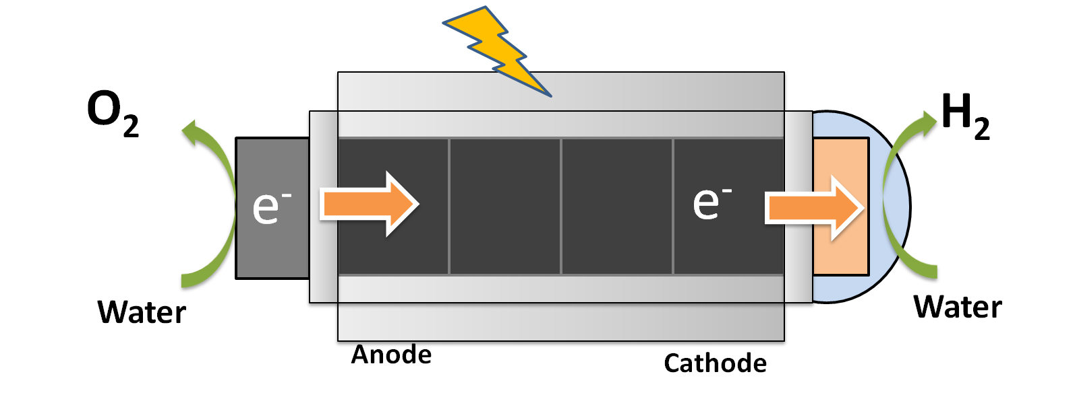One company by the name of Sun Catalytix created by Daniel Nocera at the Massachusetts Institute of Technology based their water-splitting method off of the system consisting of a conventional photovoltaic, similar to that of the National Renewable Energy Laboratory in Colorado. However, the new device used inexpensive materials, worked under simpler conditions, and was highly stable, demonstrating operation times of at least 45 hours before drops in the rate of performance. The key to making the materials less expensive was the utilization of catalysts made of nickel and cobalt. With catalysts, the water splitting chemical reaction is accelerated, increasing the conversion rate. The device was capable of energy conversion rates to hydrogen fuel of about 10%. Putting the poker card-sized device in a gallon of water in bright sunlight produced enough electricity to supply a house in a developing country with electricity for a day[16].

Figure 4: Demonstration of the water-splitting reaction.

An economic evaluation of the cost of hydrogen produced using this approach of silicon photovoltaic and electrolyzer was estimated to be around $10 per kg of hydrogen fuel[17]. In order to calculate how this translates to units of $ per kWh, we must use the specific energy of liquid hydrogen, which is 143 MJ per kg[18]. Since 1 kWh is equal to 3.6 MJ, the price per kWh for this method is therefore 10 [$/kg] * (1/143) [kg/MJ] * 3.6 [MJ/kWh] = **$0.25 per kWh**. We will use this factor of (3.6/143) = 0.025 to convert $ per kg hydrogen fuel to $ per kWh for future calculations.

HyperSolar, Inc., a Nevada corporation, used a different technique of water splitting. HyperSolar developed a method that used similar earth abundant catalysts in units of high efficiency multi-junction solar cells[19]. Their device addresses the common problems of other water-splitting devices by using a self-contained photoelectrochemical nanosystem and protective coating. The self-contained system contains less photovoltaic elements, which decreases the typical costs involved with photovoltaics and decreases the number of input electrons lost, therefore resulting in higher efficiency. The protective coating allows for the use of the device in water for longer periods and varying water conditions by preventing corrosion and short circuiting[20].

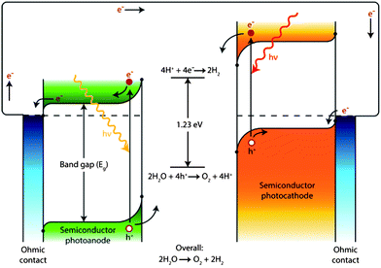As of March 2016, the HyperSolar team anticipates an energy conversion rate of 10% or higher, a stable operation exceeding 1,000 hours, and a production of hydrogen at less than $5 per kg[21]. To translate this in terms of $ per kWh, we will use the same conversion factor of 0.025 to get 5 * 0.025 = **$0.125 per kWh**.

Figure : A general representation of the direct semiconductor-water junction.

A third method uses a photoelectrochemical device with a direct semiconductor-water junction instead of photovoltaic and electrolyzer. This system works by first absorbing a solar photon in the semiconductor material to form an excited electron-hole pair. Since the semiconductor is in an aqueous electrolyte, the charges can be separated by bending the band in a positive/negative junction, as shown in Figure 5. There, the pair reaches the photoanode and photocathode surfaces. The system requires a semiconductor material with a suitable band gap of at least 1.23 eV that allows light absorption, but the gap must be small enough to absorb the greatest range of the light spectrum. These systems also have the added complexity to protect the semiconductor from the aqueous electrolyte and to have a catalyst for the reduction and oxidation reactions. These complexities make it unlikely to outperform the HyperSolar approach[22].

A recent economic analysis suggested an energy conversion rate of 10%, a lifetime of 10 years, and cost of $7 per kg, which, at 7 * 0.025 = **$0.175 per kWh** is not significantly competitive with HyperSolar[23]. However, the implementation of techniques such as “roll-to-roll solution-based processing” or direct dispersion as “micro- or submicro-particle photocatalysts” produces an estimate of $1-2 per kg, for a 1.5 * 0.025 = **$0.0375 per kWh** cost.

IV. Economic Comparison and Analysis

In order to understand the economic feasibility of the current methods, we must compare them to each other and to other sources of energy. The cost of hydrogen fuel obtained through steam reforming of methane, a fossil fuel, is recorded as $1 per kg, or 1 * 0.025 = **$0.025 per kWh[24]**.

For the costs of other energy generation resources, we will use data from the U.S. Energy Information Administration (EIA). This data includes the levelized energy costs in $ per kWh for coal, natural gas, nuclear, wind, solar PV, solar thermal, geothermal, biomass, and hydro. These costs reflect the initial capital, return on investment, continuous operation, fuel, maintenance, and time required to build the plant and its expected lifetime[25]. These costs are summarized in the table in Figure 6.

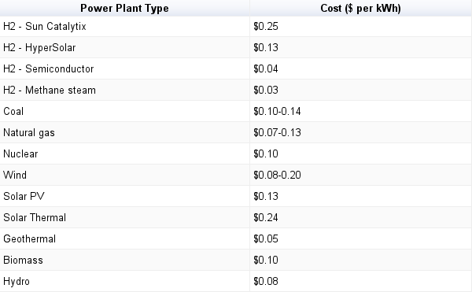Figure : Cost comparison across different energy sources.

From the table, out of the levelized energy costs from the EIA, geothermal, hydro, natural gas, and wind are the most inexpensive fuels. The costs of the hydrogen fuels from HyperSolar and the direct semiconductor methods are more inexpensive than the majority of these fuels, showing that the water-splitting methods have significant potential as a source of energy in commercial production and use, especially in the hydrogen fuel cell market. With continued research funding and larger scale projects, one can expect the use of these technologies in the coming decades. [2275]

1. Casey, Tina. “President Obama Adds $75 Million Artificial Photosynthesis Project To Rhymes-With-Bucket List.” Clean Technica. 2015. http://cleantechnica.com/2015/04/29/president-obama-adds-75-million-artificial-photosynthesis-project-rhymes-bucket-list/.
2. “Energy Consumption by Primary Fuel.” U.S. Energy Information Administration. 2015. http://www.eia.gov/forecasts/aeo/section_energyconsump.cfm.
3. Barber, James, and Phong D Tran. “From Natural to Artificial Photosynthesis.” Journal of Royal Society 102012. http://www.ncbi.nlm.nih.gov/pmc/articles/PMC3627107/pdf/rsif20120984.pdf.
4. Lewis, Nathan S. “Basic Research Needs for Solar Energy Utilization.” Report on the Basic Energy Sciences Workshop, September2005. http://science.energy.gov/~/media/bes/pdf/reports/files/seu_rpt.pdf.
5. Maverick, Tim. “Artificial Photosynthesis to Power the Future.” Wall St. Daily, February 102016. http://www.wallstreetdaily.com/2016/02/10/artificial-photosynthesis-energy/.
6. Curtin, Sandra. The Business Case for Fuel Cells 2015: Powering Corporate Sustainability. Washington, D.C. : Fuel Cell & Hydrogen Energy Association2015. http://static1.squarespace.com/static/53ab1feee4b0bef0179a1563/t/5671aab50e4c11307a7510b9/1450289845629/Business+Case+for+Fuel+Cells+2015.pdf.
7. Lorenz, Lindsay. “Annual Fuel Cell Car and Bus Sales Are Expected to Exceed 228,000 by 2024.” Navigant Researchn.d. https://www.navigantresearch.com/newsroom/annual-fuel-cell-car-and-bus-sales-are-expected-to-exceed-228000-by-2024.
8. “MARKET OPPORTUNITY.” HyperSolar, Inc.n.d. http://www.hypersolar.com/market.php.
9. Koroidov, Sergey. Water Splitting in Natural and Artificial Photosynthetic Systems . Umea, Sweden: Umea University2014. https://www.diva-portal.org/smash/get/diva2:698620/FULLTEXT01.pdf.
10. Fujishima, Akira, and Kenichi Honda. “Electrochemical Photolysis of Water at a Semiconductor Electrode.” Nature 238 (37)1972. http://www.nature.com/nature/journal/v238/n5358/abs/238037a0.html.
11. Khaselev, Oscar, and John A Turner. “A Monolithic Photovoltaic-Photoelectrochemical Device for Hydrogen Production via Water Splitting.” Science 280 (5362)1998. http://science.sciencemag.org/content/280/5362/425.full.
12. Marshall, Jessica. “Solar Energy: Springtime for the Artificial Leaf.” Nature, June 42014. http://www.nature.com/news/solar-energy-springtime-for-the-artificial-leaf-1.15341#/b2.
13. Maverick, Tim. “Artificial Photosynthesis to Power the Future.” Wall St. Daily, February 102016. http://www.wallstreetdaily.com/2016/02/10/artificial-photosynthesis-energy/.
14. Liu, Chong. “Nanowire−Bacteria Hybrids for Unassisted Solar Carbon Dioxide Fixation to Value-Added Chemicals.” Nano Letters 152015. http://pubs.acs.org/doi/pdf/10.1021/acs.nanolett.5b01254.
15. “TECHNOLOGY.” HyperSolar, Inc.n.d. http://www.hypersolar.com/technology.php.
16. EurekAlert. “Debut of the First Practical ‘Artificial Leaf,’” March 272011. http://www.eurekalert.org/pub_releases/2011-03/acs-dot031811.php.
17. Sivula, Kevin. “Toward Economically Feasible Direct Solar-to-Fuel Energy Conversion.” The Journal of Physical Chemistry Letters 62015. http://pubs.acs.org/doi/pdf/10.1021/acs.jpclett.5b00406.
18. Ameta, Suresh C, and Rakshit Ameta. Solar Energy Conversion and Storage: Photochemical Modes. Boba Raton: CRC Press2016. https://books.google.com/books?id=zCjSCgAAQBAJ&pg=PA149&lpg=PA149&dq=specific+energy+of+hydrogen+143+mj/kg&source=bl&ots=XLYB3-fa5C&sig=ImfvXh3QVAFDkdU5qQQxuc9Hh88&hl=en&sa=X&ved=0ahUKEwinlfy8rLLMAhUN1GMKHYSGAEkQ6AEIQDAF#v=onepage&q=specific%20energy%20of%20hydrogen%20143%20mj%2Fkg&f=false.
19. Fischgrund, Eric. “HyperSolar Reaches New Milestones and Reveals Next Steps for Its Renewable Hydrogen Technology.” Marketwired, March 222016. http://www.marketwired.com/press-release/hypersolar-reaches-new-milestones-reveals-next-steps-its-renewable-hydrogen-technology-otcqb-hysr-2107880.htm.
20. “TECHNOLOGY.” HyperSolar, Inc.n.d. http://www.hypersolar.com/technology.php.
21. Fischgrund, Eric. “HyperSolar Reaches New Milestones and Reveals Next Steps for Its Renewable Hydrogen Technology.” Marketwired, March 222016. http://www.marketwired.com/press-release/hypersolar-reaches-new-milestones-reveals-next-steps-its-renewable-hydrogen-technology-otcqb-hysr-2107880.htm.
22. Sivula, Kevin. “Toward Economically Feasible Direct Solar-to-Fuel Energy Conversion.” The Journal of Physical Chemistry Letters 62015. http://pubs.acs.org/doi/pdf/10.1021/acs.jpclett.5b00406.
23. Pinaud, Blaise A. “Technical and Economic Feasibility of Centralized Facilities for Solar Hydrogen Production via Photocatalysis and Photoelectrochemistry.” Energy & Environmental Science 62013. Sivula, Kevin. “Toward Economically Feasible Direct Solar-to-Fuel Energy Conversion.” The Journal of Physical Chemistry Letters 62015. http://pubs.acs.org/doi/pdf/10.1021/acs.jpclett.5b00406.
24. Sivula, Kevin. “Toward Economically Feasible Direct Solar-to-Fuel Energy Conversion.” The Journal of Physical Chemistry Letters 62015. http://pubs.acs.org/doi/pdf/10.1021/acs.jpclett.5b00406.
25. Rosenblat, Lazar. “WHY ALTERNATIVES ARE IMPORTANT .” YOUR GUIDE TO RENEWABLE ENERGY . 2015. http://www.renewable-energysources.com/.