**The Environmental Costs of Fracking**

*By: Sage Dewdney*

*HSA 10 The Economics of Oil and Energy*

*March 7, 2016*

**Background**

Crude oil is one of the most important commodities in the modern world. Over 6.97 billion barrels of petroleum products were consumed in the US in 2014 (https://www.eia.gov/tools/faqs/faq.cfm?id=33&t=6 ).[1] The vast majority of vehicles run on crude oil products, and petroleum products are also used for heating, electricity generation, asphalt production, and plastic synthesis. Petroleum products are the largest contributor to US energy consumption, despite costing over 21.56 cents per kilowatt-hour to produce.[2] Further, the stock market and the global economy are strongly tied to the price of crude oil.[3] In short, most of our daily lives are dependent upon this limited resource in some way. In more recent times, a new method of acquiring crude oil called fracking is gaining popularity. It offers several distinct advantages; prominent among them fracking allows large previously untapped deposits of oil to be mined. The increase development and implementation of fracking technology could raise the US GDP by 4%.[4]

The ability to access huge deposits of oil and natural gas via fracking offers a huge opportunity in the US to decrease 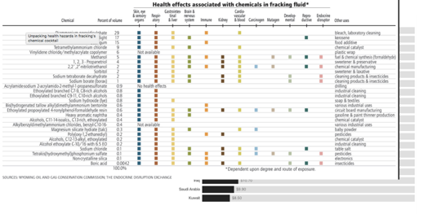energy costs by significantly increasing the availability of crude oil. While supply and demand are the main driving forces in the price of crude oil, mining the oil is also a major production cost. As seen in the figure to the right, the breakeven price for most oil fields in the US is around $36.20 per barrel. However, the production of crude oil carries other costs as well. In the US, fracking is often noted as being a relatively low cost way to obtain oil locally, but there are other costs associated with fracking that are often left unaccounted for. The environmental costs of crude oil fracking are huge including: climate change, damage to natural resources, drinking water contamination, health problems, public infrastructure damage and property devaluation.

First, consider how the process of fracking works: far underground there are rocks called shale which hold gases, water, and oil in their pores. A long vertical well is drilled, then horizontal “veins” are created and pumped full of water and chemical additives to create an area of extremely high pressure. This pressure creates cracking in the rock which releases gas, oil and water which are then forced back up to the surface where they can be processed and separated into storage tanks.[5] Compared to the traditional methods of crude oil mining where a long hole is drilled onto the earth, and a steel pipe with pressure valves is installed into the hole to pump oil out of a reservoir; fracking is an extremely powerful process capable of extracting oil from previously unreachable areas.

There are several environmental issues associated with fracking and estimating their cost to the environment can be challenging, so this paper will attempt to address major costs and risks associated with fracking while offering cost estimates where available.

**I. Climate Change**

The initial construction of a fracking site usually involves deforestation; tens of acres of land must be cleared and totally leveled just for the site itself, further additional changes to the surrounding landscape often include further deforestation to establish new roadways. Deforestation is a huge cost to the environment, it is estimated that over $133.6 million is lost annually due to deforestation in the US.[6] Deforestation leads to the loss of a habitat for millions of species and is a major contributor to climate change. Trees prevent soil degradation, absorb green house gases, and act as insulation to prevent extreme temperature swings.

Fracking also contributes to environmental damage by releasing large amounts of methane, a greenhouse gas, into the air. Methane gas makes up over 90% of shale gas and recent studies suggest that a considerable portion of this gas leaks during fracking.[7](5 Wigley, 2011 at 601 and 607; Howarth, 2011 at 679; Jackson, Robert

B. et al. “Research and Policy Recommendations for Hydraulic Fracturing

and Shale-Gas Extraction.” Duke University, Center on Global

Change. 2011 at 2)

Not everything about crude oil fracking is negatively impactful to the environment. One significant benefit of shale oil production is that it could displace around 40% of waterborne crude oil imports to the US.[8] By reducing the need to transport large quantities of oil, fracking can reduce the pollution generated by barges.

**II. Damage To The Natural Landscape**

Shale basins are often found near important natural resources and historically important sites. Such basins have already been targeted by Shell and Total near the Auca Mahuida natural protected wildlife area in Argentina, which places a major wildlife sanctuary at risk.

Indigenous communities have found issue with shale oil drilling in Russia, South Africa, Brazil and Argentina where their entire way of life has been disrupted often without consulting the indigenous people at all.[9]

**III. Water Contamination**

Many large shale oil basins have been identified under transboundary aquifers. These groundwater resources hidden below ground contain enough free water to provide safe, high quality drinking water for everyone for years from a single aquifer.[10] Many of the basins located under transboundary aquifers are found in areas where water is already scarce and companies hoping to drill through these aquifers risk contaminating or destroying water supplies used by millions of people.9

In countries like Mexico, “The majority of (…) shale basins overlap with areas that are already plagued with high levels of water stress” [11]Fracking not only endangers existing water supplies but also requires a lot of water to perform. Much of the water used during fracking is rendered undrinkable by the process. The US EPA estimates that in 2010, 140 billion gallons of water were used to mine just 30,000 active wells.[12] Considering the demands for water in areas like Mexico where water shortages have already led to violent confrontations the impact of fracking on water availability is a major consideration.

**IV. Health Problems**

Fracking also poses major health risks to those in the areas surrounding a site. Chemicals used in the liquid extraction of crude oil from shale rock have considerable detrimental effects on the health of those exposed to them. In the chart below from the Wyoming oil and gas conservation commission, you can see that many of the chemicals found in fracking fluid pose the risk of damage to sensory organs as well the respiratory, nervous, and gastrointestinal system. 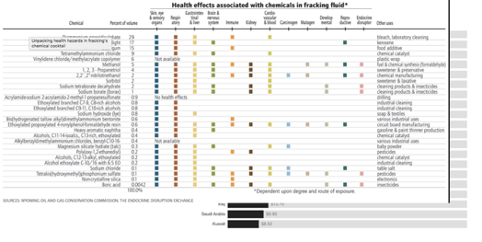

While risk of exposure to may seem low, several studies have shown dangerous levels of air pollution near fracking sites. According to the National Resources Defense council Oil and natural gas production has been connected to increased risk of birth defects and cancer.[13]

**V Infrastructure Damage**

Fracking operations can also wreak havoc on the surrounding infrastructure. Many operations are in undeveloped areas incapable of comfortably supporting the large increase in traffic associated with a fracking outfit. Transport of materials and equipment taxes local roads and railways heavily, and exporting the oil also imposes a significant demand on local infrastructure.

Another huge impact on local infrastructure is due to the increased seismic activity associated with drilling in these areas. The geology in shale basins can vary to an extreme degree making it very difficult to anticipate seismic imp act. Since fracking has recently increased in China the region has experienced several uncharacteristic earthquakes in the last couple years. The US has observed multiple earthquakes over a 5 on the Richter scale due to fracking in previously seismically inactive areas, and seismic activity has also significantly increased in Mexico including deadly earthquakes that completely destroyed the local area.[14]

**Conclusion**

While fracking could be a major boon to both the US and global economy, the environmental impacts of this technology need to be given greater attention. When considering forms of energy production, the impact on the environment needs to be considered as well. Fracking endangers culturally important areas, places a major threat to water supplies, contributes to deforestation and a loss in biodiversity, causes health problems, contributes to climate change and may be responsible for lethal earthquakes. While the companies responsible for fracking activities are not paying this potentially huge cost, local communities are and such costs need to be accounted for when considering fracking as a viable alternative to obtain energy. Many modern energy alternatives like nuclear power are being dismissed as too risky to the surrounding environment, but traditional methods of energy production need to be examined with the same level of scrutiny.

[Word Count: 1533]

1. US EIA Crude Oil and Petroleum Products Explained
2. Institute for Energy Research Energy Generating Costs
3. Stephen Gandel Stock Market Plunge Why Crude Oil Matters Fortune Magazine
4. PWC Shale Oil the Next Energy Revolution
5. Kate Kershner How Hydraulic Fracking Works
6. Lawrence Damyang Economic Cost of Deforestation in Semi-Deciduous Forests—A Case of Two Forest Districts in Ghana
7. S Wrigley Research and Policy Recommendations for Hydraulic Fracturing and Shale-Gas Extraction
8. PWC Shale Oil the Next Energy Revolution
9. Andy Gheorghiu Fracking Frenzy (2014)
10. Shammy Puri Internationally Shared Aquifer Resource Management
11. Sharon Kelly New Report Highlights Fracking’s Global Hazards
12. US EPA The Potential Impacts of Hydraulic Fracking on Water Contamination (2011)
13. National Resources Defense Council Unchecked Fracking Threatens Health, Water Supplies
14. Andy Gheorghiu Fracking Frenzy (2014)