**Economic Advantage and Environmental Disadvantage of Shale Gas**

Charleen Tan

HSA 10-5 The Economic of Oil and Energy

March 6, 2016

1. Background

Shale gas is a form of natural gas that found in shale formations. Shale formations are sedimentary rocks that can be used for petroleum and natural gas. U.S. shale gas production has increased from 5% to 56% of total U.S. dry gas production from 2004 to 2015.[1] Hydraulic fracturing is an common method that shale gas is produced. In the hydraulic fracturing, a pumper truck injects a mixture of sand, water and chemicals into the well. High pressure in the well causes the rock layers to crack and the shale gas is released. Then, the shale gas flows out of well.[2] In this paper we will examine the economic advantage and environmental cost of shale gas production.

1. Economic Advantage of Shale Gas

With increasing production in shale gas, there are many benefits in the economic aspects.

* 1. Additional Employment

Shale gas production has provided many job opportunities for U. S. economy. According to America’s Natural Gas Alliance (ANGA), shale gas industry provides 1.6 million job opportunities. As shown in Fig. 1, majority of shale gas employment is in the service firms. [3]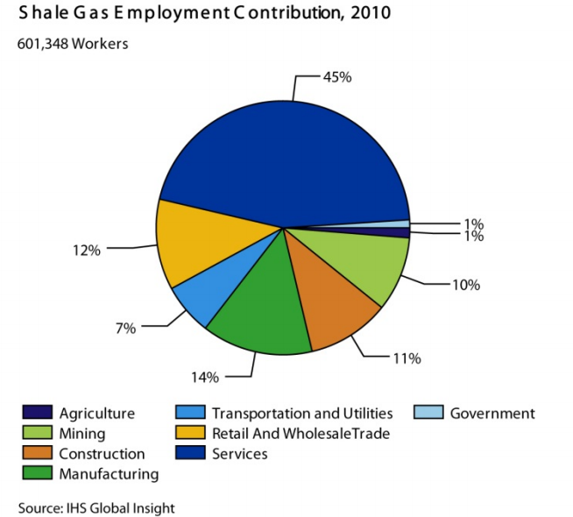 Fig. 1

Major production of shale gas is produced after 2008. In 2008, U. S entered a recession due to mortgage crisis. With the complex national economic issues, many people lost their jobs and unable to support their family. However, the government solves the low employment rate by supporting the production of shale gas where it provides many opportunities for people to work. The explosion of shale gas helped the U. S. Economy.

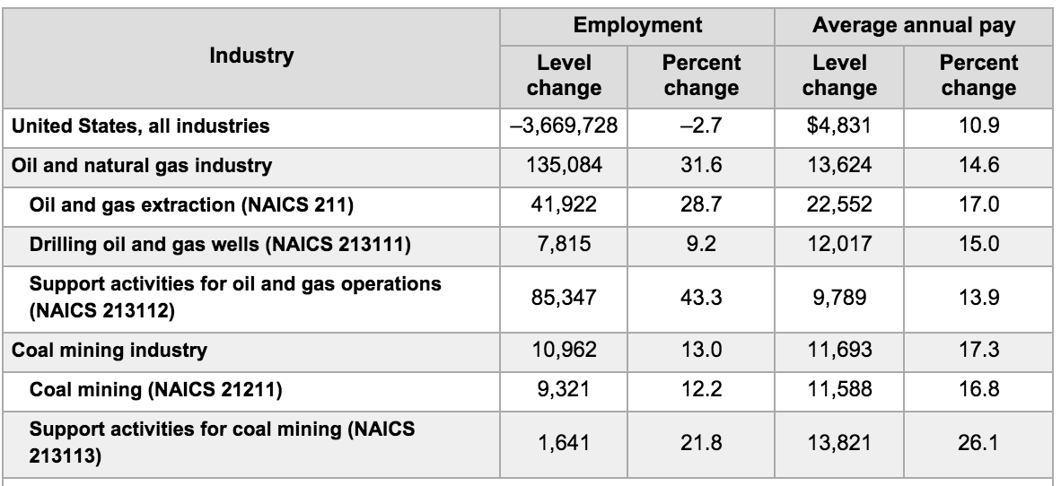

Table 1[4]

Table 1 indicates that the overall employment in all industries in U.S. decreased from 2007 to 2012. That makes sense because U.S. was under Great Depression from 2008 to 2010. However, the employment in Oil and natural gas industry increased. Not only the employment increased, but also the average annual pay increased by 22552 for Oil and gas extraction. Such change in the employment and average annual pay are contributed by the explosion of shale gas.

Because the employment and wages increase in the shale gas industry, shale gas “generate more than $930 billion in federal, state, and local tax and royalty revenues”.[5]

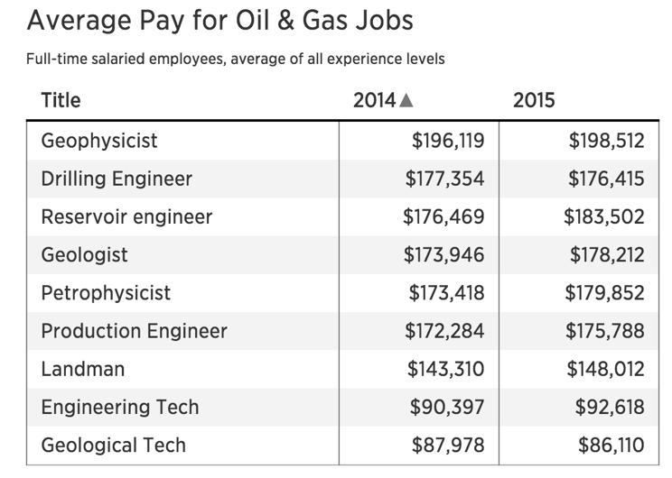Table 2[6]

As shown in Table 2, the average pay for oil and gas jobs is high comparing with the average household income in the U.S. $51939.[7] With high income, workers in the oil and gas industry pay more tax to the government. Thus, the government gets higher federal revenue as well. Therefore, the shale gas provides additional employment and helps the economy in U.S.

* 1. Lower energy prices

The production of shale gas increase and the overall reservoir of shale gas increase also.

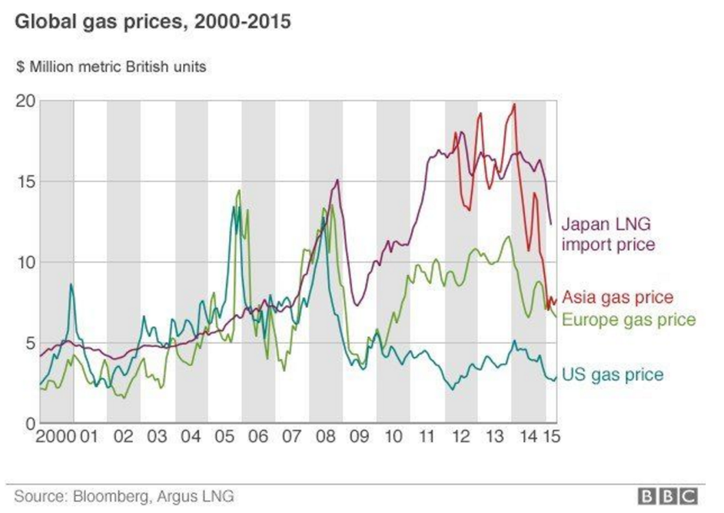Fig. 2[8]

In Fig. 2, the trend of US gas price decrease after 2008. With the explosion of shale gas, the energy prices of US are lower than that of other parts of the world. The price of gas has decreased from $13 to $4 millions metric. The lower energy prices and increase production show that the demand domestically has not increased.

Although the energy prices decrease in US, gas prices in Asian, and Europe are still higher that that of US. Because US has abundant natural gas, natural gas production and the consumption are already self- sufficient. US is able to export the natural gas to other countries. Plotting the data from U.S. Energy Information Administration (eia), we get an increase trend of natural gas exports as shown in Fig.3.

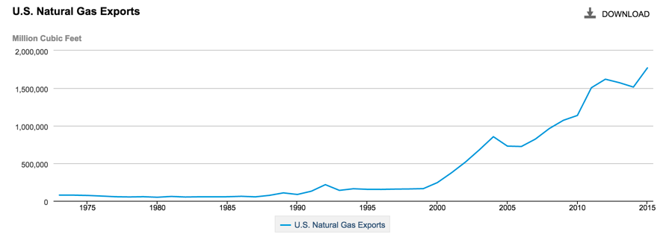Fig 3

Such increase in exports explain the reason that the gas price in other areas especially Japan liquid natural gas import price is significantly higher than U.S. natural gas prices. As shown, the production of natural gas not only helps to decrease the natural gas prices domestically, but also helps U.S. to earn money from other countries that reply on importing natural gas as their natural gas resources.

* 1. Secured Energy Supply

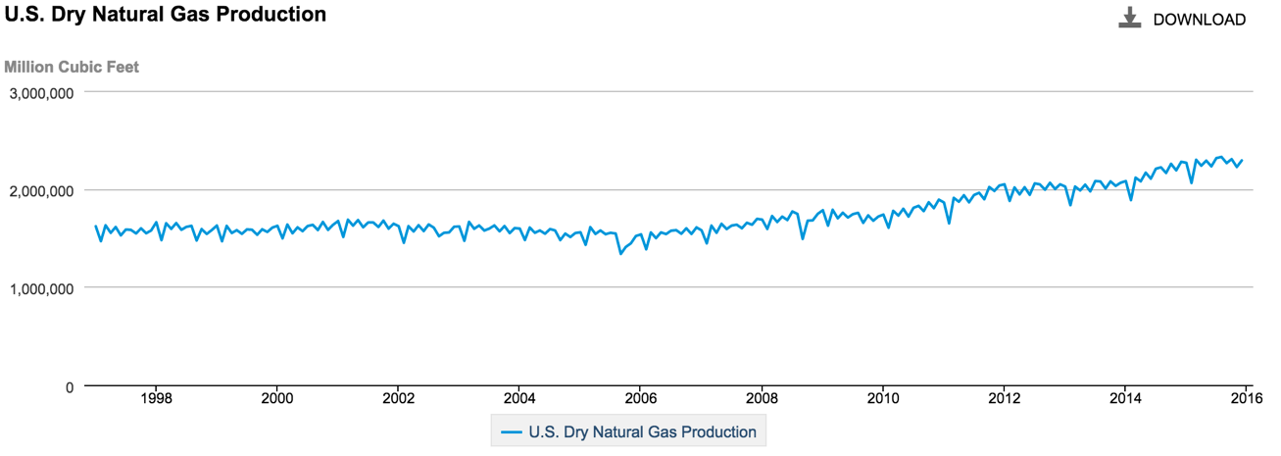Fig.4

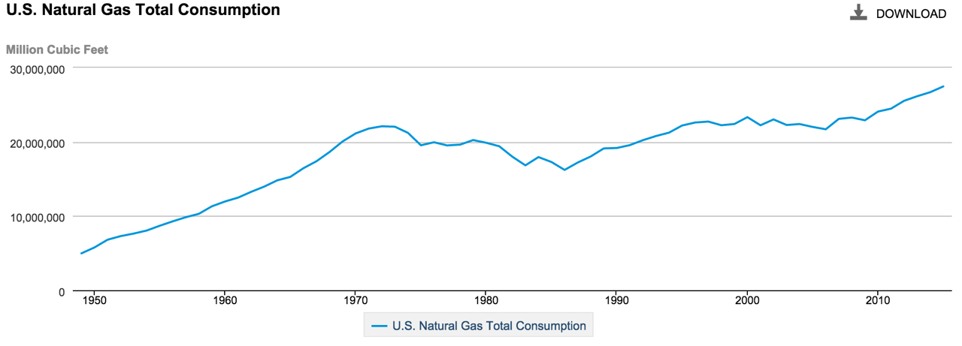

Fig.5

Fig 4 and Fig 5 are both from eia data. In these two figures, the trend has shown that the natural gas production and consumption even out, where they are both near 30,000,000 million cubic feet. As shown, U.S. is self- sufficient for the natural gas. Therefore, with abundant gas supply, U.S would not be in danger of lack of gas resource in the short term of time.

1. Environmental Disadvantage of Shale Gas
   1. Green House Emissions

As many of article states, “natural gas releases about half the carbon emissions that coal does when burnt”. [9] Although the carbon emission is decreases, the technology that the industry use, fracking, causes more serious environmental problem than using coal. Significant amount of methane is into the air at the drilling site of the shale gas production. Methane is a much more potent greenhouse gas then carbon dioxide.[10] Although the concentration of methane in the atmosphere is low, its high “global warming potential” ranks it amongst the worst of the greenhouse gases.[11]

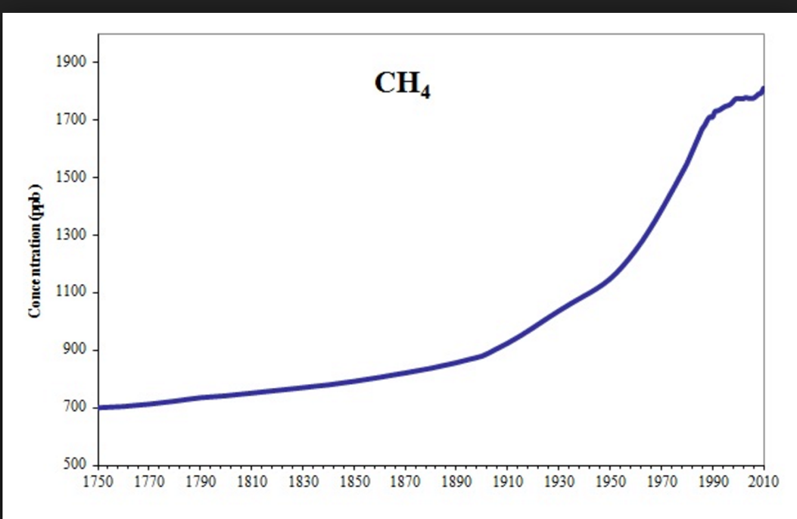

Fig 6[12]

With the increase trend of methane concentration in the atmosphere, there is a potential risk that global warming would have been more severe. Because there is no efficient way to decrease the concentration of the methane in the atmosphere, such environmental cost outweighs the economic problems much more. Decreasing the concentration of methane is difficult; the production and usage of shale gas is potentially harmful for human’s health, though the effects are not imminent.

* 1. Use of Water in Fracking

Fracking is the technology that industries used to obtain shale gas from drilling well. One of the steps in fracking is to inject sand, water, and chemicals into the well at high pressure. The pressurized mixture causes the rock layers to crack.

A single fracture requires roughly 50,000 to 100,000 gallons of water.[13] On average, American family of four uses 400 gallon of water per day.[14] With calculation, the amount of water used for a single fracking provide a water usage for a typical family for half year. With many propagandas of saving water in agriculture and household, the natural gas industries are using clean water to fracture gas. 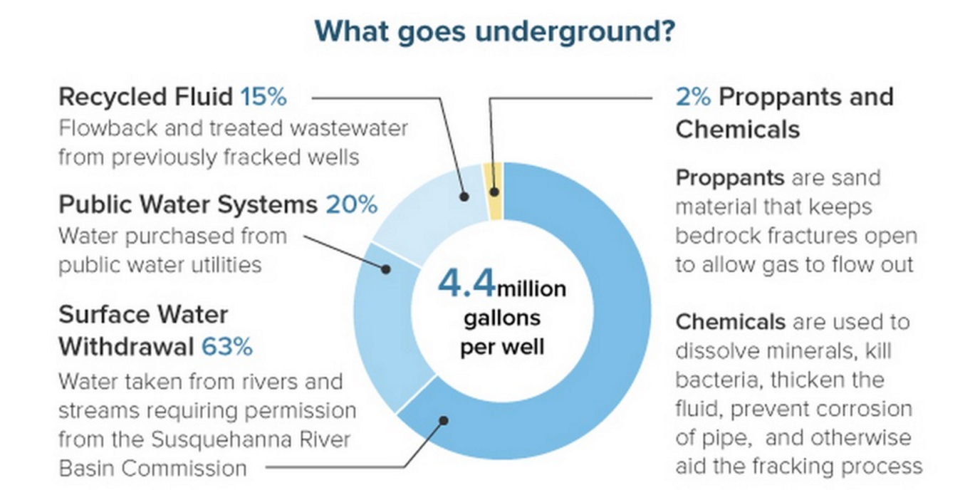

Fig. 7[15]

As shown in Fig. 7, only 15% of water that is used in the fracking is recycled fluid. Those recycled fluid is treated as wastewater with needs further sanitizing for actual household usage. As indicated in the graph, water that is used in the fracking is not seawater; it is “water taken from rivers and streams” (Fig 7). Rivers and streams water is clean water readily. However, shale gas industries use them for drilling and only a small percent of them is recycled.

* 1. Pollution in Water

The fluid that is used and produced in the fracking process consists of many volatile organic compound, such as benzene, toluene, and xylene.[16] A list of chemicals used in fracking are for different purposes.[17] These volatile organic compounds are significant danger to human health. Such chemical compounds cannot be degraded easily. The mixture of these chemical makes the scientists even harder to degrade. Since degrading the chemicals is difficult, many chemical residuals might remain in the underground water system which might be consumed in the residential area near the drilling sites.

Not only the organic and inorganic chemicals are used the fracking, many radioactive chemicals are found also. According to the researcher from American Chemical Society, “200 times greater than upstream and background sediments and above radioactive waste disposal threshold regulations, posing potential environmental risks of radium bioaccumulation in localized areas of shale gas wastewater disposal”. [18] As we know, radioactive chemicals cause higher probabilities for people to get cancer. Therefore, the underground water near drilling site is polluted as well.

1. Conclusion Remarks

As shown, shale gas production has led to economic growth in the nation. However, the environmental cost of fracking is not measurable. Because the economic growth from shale gas production is imminent and obvious, industries many benefits for the workers at the site. People tend to ignore the environmental disadvantages of shale gas production because pollutions in air and water are not obvious. As shown, many chemicals polluted the water is radioactive and radioactive chemicals decay themselves for the long time. When the radioactive pollution starts to get noticeable, stop fracking shale gas would have been too late because the results are to reversible.

There are severe disadvantages of shale gas production. Many of the scientists tend to work on renewable energies such as solar and wind which is more clean and the use of fossil fuels. The government should not allow more production in shale gas because the economic effects are imminent and believes the economic advantage outweighs the environmental disadvantage. The government should also promote the industries to try to focus more on the renewable energy instead of drilling more wells for natural gas because the amount of water is limited also.

[Word count: 1521]

1. http://www.eia.gov/conference/2015/pdf/presentations/staub.pdf
2. http://iehn.org/documents/CPFIShaleGasGuidanceNoteApril2013.pdf
3. http://anga.us/media/content/F7D1750E-9C1E-E786-674372E5D5E98A40/files/ihs%20shale%20gas%20jobs%20brochure.pdf
4. U.S. Bureau of Labor Statistics, Quarterly Census of Employment and Wages program.
5. http://anga.us/media/content/F7D1750E-9C1E-E786-674372E5D5E98A40/files/ihs%20shale%20gas%20jobs%20brochure.pdf
6. http://www.cnbc.com/2015/07/22/oil-and-gas-jobs-pay-is-still-big-but-not-booming.html
7. https://en.wikipedia.org/wiki/Household_income_in_the_United_States
8. http://www.bbc.com/news/business-32781779
9. http://www.carbonbrief.org/shale-gas-more-or-less-polluting-than-coal
10. https://www.imperial.ac.uk/media/imperial-college/grantham-institute/public/publications/briefing-papers/Shale-gas-and-climate-change---Grantham-BP-10.pdf
11. http://apps.sepa.org.uk/spripa/Pages/SubstanceInformation.aspx?pid=65
12. http://www.eea.europa.eu/data-and-maps/figures/atmospheric-concentration-of-ch4-ppb-1
13. http://iehn.org/documents/CPFIShaleGasGuidanceNoteApril2013.pdf
14. https://www3.epa.gov/watersense/pubs/indoor.html
15. https://stateimpact.npr.org/pennsylvania/2013/12/30/top-10-stories-of-2013-a-high-profile-lawsuit-plus-water-use-and-fracking/
16. http://www.gaslandthemovie.com/whats-fracking/faq/fracking-fluid
17. https://fracfocus.org/chemical-use/what-chemicals-are-used
18. http://www.acs.org/content/acs/en/pressroom/presspacs/2013/acs-presspac-october-2-2013/radioactive-materials-and-contaminants-found-at-fracking-wastewater-disposal-site.html