**Bringing Nuclear Energy Back**

By Aaron Lutzker

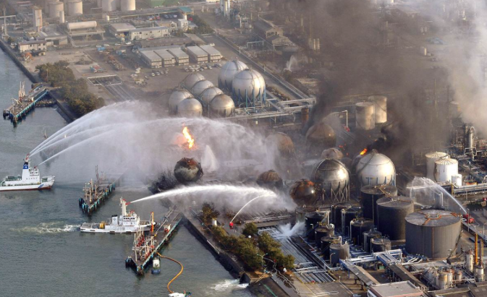 Nuclear Energy has emerged as an efficient, yet highly controversial form of power. Nuclear energy tops other forms of power in terms of environmental impact. In fact, Nuclear Energy produces almost no pollution. Yet, Nuclear Energy is plagued by a large problem, the potential for a nuclear meltdown. The threat of a meltdown detracts significantly from the positives appeal of Nuclear Power. A nuclear meltdown occurs when a plant malfunctions and the Uranium rods overheat causing an explosion, scattering radioactive debris across the surrounding area. The threat to tens of thousands of people living in proximity of the plant has caused the public to strongly oppose using Nuclear Power. Although this is a valid concern, there have only been a handful of few nuclear meltdowns in the history of nuclear energy. The nuclear power industry must convince the public that meltdowns are a thing of the past if they wish to survive as an industry.

Figure - Fukushima nuclear reactor after the 2011 meltdown http://prn.fm/tag/fukushima-daiichi-nuclear-disaster/page/2/

Politicians have refused to fund Nuclear Power, following the demands of many of their constituents. The Fukushima nuclear disaster brought forth the latest anti-Nuclear sentiment. In 2011, a large earthquake and subsequent tsunami ravaged japan. Fukushima power plant, a nuclear reactor located on the northeastern coast of japan, was in operation during the disaster. Through a series of events, the reactor lost the ability to cool its core and proceeded to meltdown, forcing tens of thousands of people in the Fukushima area to evacuate. The meltdown only fueled the present anti-nuclear sentiment.

Bending to the demands of their constituents, politicians defunded nuclear power in the wake of the Fukushima disaster. It now appears that Nuclear Power will not stay unless Nuclear Meltdowns can be guaranteed to never occur again. We should not be phasing out such a green form of power. Stewart Brand, a strong proponent of nuclear energy said, “Radiation that looks like a great evil in basically a design problem. Nuclear provides a clean base load electricity that produces waste just a size of a coke can as compared to a coal fired plant that belches out 16,000 tons/year of CO2 emission for the same power supply? (Walsh). The people have demanded that Nuclear Meltdowns be stopped, therefore we must find a way to guarantee they will never occur again. To better analyze how to make Nuclear Energy safer, 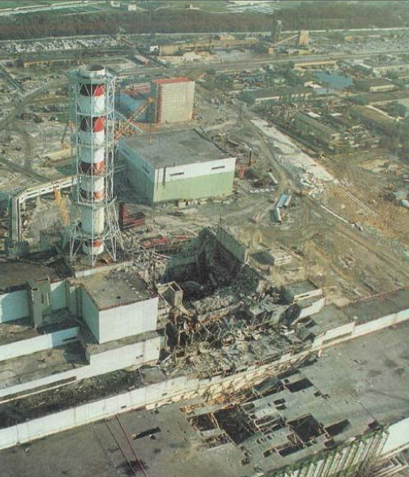we have to look at the faults of the current process.

Figure - Chernobyl reactor after the catastrophic meltdown http://zidbits.com/2011/04/how-do-nuclear-power-plants-work/

Nuclear reactors chiefly run on Uranium fuel rods. Uranium rods are an enriched product of the Uranium mined from the ground. The Uranium rods must be enriched in order to be used for nuclear reactors. Nuclear reactors do not even harness the full potential of the Uranium they run on, they use up a fraction of the Uranium before the Uranium is changed out. The modern reactors are unable to use most of the fuel rods. The Uranium rods are used in the reactor to generate extreme amounts of energy in the form of heat. Pressurized water at over 100 times atmospheric pressure flows through the core and is heated to extreme levels. Hot pressurized water from the core is then piped into a steam generator chamber where the super heated water is used to produce steam. The steam is routed to power turbines that are attached to a generator, which creates power. The pressurized cooling fluid then returns to the core and the steam returns to water.

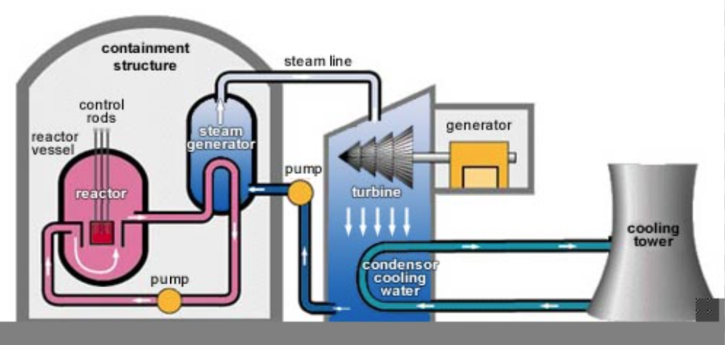 Nuclear energy is inherently unsafe because of the steam forming process. A reactor melts down when fuel rods are not able to be quenched and therefore heat up to dangerous levels. The failure to quench the fuel rods is often caused by an inability to pressurize the water in the core. If water is not pressurized, then the water will become steam in the core and not only fail to quench the rods, but expand into steam and blow up the core. The reactor building is made out of 2-meter reinforced concrete that is blown apart by the steam. The core explosion scatters radioactive fuel rod material all over the environment and into the atmosphere.

Figure - diagram of a standard nuclear reactor

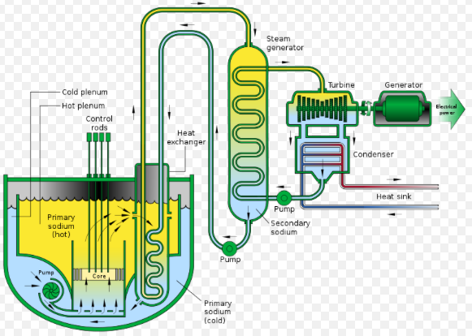 The passive nuclear reactor introduces technology that would make the nuclear meltdown impossible. The Advanced Fast Reactor (AFR) as it has been called, uses principles of nature to avoid melting down. The AFR utilizes molten salt to cool the reactor core in the place of fluid. Salt has a high boiling point and therefore does not need to be pressurized like water does to cool the core. Salt has a boiling point of 300-400 Celsius at 1 atmosphere, which is higher than the core will ever get, allowing the salt to cool the core properly at atmospheric pressure. The salt can absorb so much heat that the reactor cannot possibly meltdown (Arora). In fact, at a test reactor in Argonne, Illinois, scientist tried to make an AFR meltdown, and it would not do it. This experiment proved the safety of the AFR (Baurac).

Figure - ARF reactor design http://large.stanford.edu/courses/2013/ph241/waisberg1/

Assuming the AFR were the answer to the safety concern in modern nuclear reactors, it is necessary to explore the financial implications of such a dramatic change to the Nuclear Power industry. Converting a current water reactor to an AFR reactor would involve replacing the core of the reactor. The cost of converting current reactors to AFR reactors would also involve accounting the money not being made when the reactor is being refurbished. To simplify our calculation, we will just pay attention to the overnight costs to replace the core. Usually nuclear reactors incur large costs on loans taken out to pay for their infrastructure, we will ignore this interest cost for the purpose of a simplified calculation.

Currently, the cost to build an AFR reactor is more than a regular reactor, which costs between 6 and 9 billion U.S. dollars (Schlissel). The cheapest way to build an AFR reactor is to refurbish current reactors to an AFR setup. The NEI states it will cost roughly 500 million dollars to decommission the current core of a nuclear reactor and build a new core (Schlissel). One cannot simply replace an existing reactor core with an AFR core because of the radiation risk to workers. A new core would need to be built and the previous core slowly dismantled over many years. Because it is not possible to simply replace the current core, this will actually decrease costs.

Building another core eliminates the shutdown costs associated with replacing a core. Spreading the cost over the remaining years of service of the power plant, we can see how much power prices would be raised. Currently, nuclear power costs between 5-8 cents per Kilowatt-hour over the lifecycle of the plant (Schlissel). The average nuclear power plant in the United States has roughly twenty years left in its life cycle before either it must be decommissioned or major refurbishments made. In 20 years, a nuclear power plant will generate 3.6 *10^11 Kilowatt-hours. Taking the 500 million dollars it will cost to change the reactor and spreading it over 20 years worth of energy, we get an increase of 1/5 of a cent per kilowatt-hour. This cost is almost negligible over the rest of the lifetime of the reactor.

The only way to address and solve the publics concerns on nuclear power is to make nuclear power unable to be dangerous. The AFR reactor is not only the best method to do so, but the most cost-efficient and permanent method. The nuclear energy industry will not survive if we do not upgrade our reactors to work in a safe and reliable way. The public has to push their representatives to move forward with safe nuclear power.

[1281]

Work Cited

Walsh, Bryan. "Nuclear Energy Is Largely Safe. But Can It Be Cheap? | TIME.com." *Science Space Nuclear Energy Is Largely Safe But Can It Be Cheap Comments*. Time, 8 July 2013. Web. 03 Mar. 2016

Arora, Pankaj. "How to Make Nuclear Energy Safe." *Triple Pundit People Planet Profit*. Triple Pundit, 04 Apr. 2011. Web. 03 Mar. 2016.

Schlissel, David, and Bruce Biewald. "Plant Construction Costs." *Islands for Offshore Nuclear Power Stations* (1982): 79-80. *PSR*. Synapse, July 2008. Web. 1 Mar. 2016.

Baurac, Dave. "Argonne's Nuclear Science and Technology Legacy." *Passively Safe Reactors Rely on Nature to Keep Them Cool*. Argonne National Laboratory, Nov. 2002. Web. 03 Mar. 2016.