Advantages to Compressed air Pumped Hydropower Storage

**I. Introduction**

Today, there are two problems that exist with the forms of energy used by the United States. The first problem is there is too much carbon dioxide produced as a byproduct of the current forms of energy. Second, the majority of the sources used are non-renewable. This means that as we go about our daily lives, driving to school, cooking food, doing laundry, washing dishes, taking showers, and flying in planes, we are leaving a carbon footprint behind ruining the environment and we are using up all of the oil, coal, and natural gas, leaving none for the next generations. With all these problems, there exists a solution - the world’s largest battery, changed, to become an even bigger battery. Compressed air pumped storage hydropower, a spin off of pumped storage hydropower, provides an economically feasible solution to the electricity sector of energy use.

**II. History**

Just this week, in both my introductory chemistry course and introductory physics course, my professors talked about how we need to design a way to store energy more effectively. We need something that will not produce greenhouse gases as it stores. We need something that is cheap. We need something that is reliable. We need something that does not impact the environment. We need to find a way to convert between energy forms without losing a lot of energy. I believe there is something that can meet almost all of these requirements, that uses an innovative design change to the world’s oldest form of energy production.

Over the last century, the hydropower capacity of the United States increased to 79 gigawatts.[1] However, today hydropower accounts for only 6% of the electricity generation in the United States. Natural Gas and Coal produce the majority of the electricity, together accounting for 66% of electricity generation.

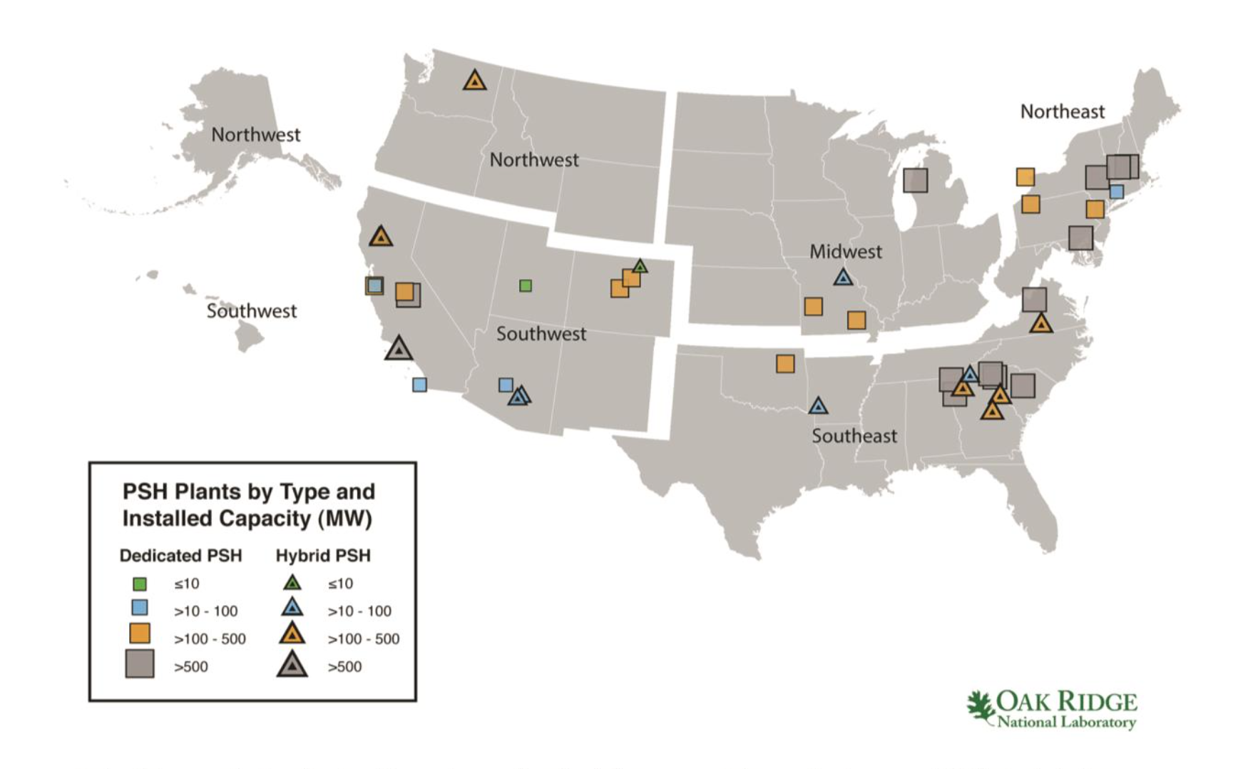 The first pumped hydropower storage station was built in the 1930’s in Connecticut. The engineers described it as a 10 mile long battery. Today there are 40 pumped hydropower stations in the United States with 22 gigawatts of storage and 60 getting licenses and permits. The 60 getting licenses have 51 gigawatts of storage.[2] Below is a picture of the current pumped storage hydropower sites in the United States. [3]In this paper I will present a different type of pumped hydropower station that should be implemented in the 60 projects getting licensing instead of the current design.

**III. Types of Hydropower**

Over the years, many types of hydropower plants have been designed. Additionally, many of the types of hydropower plants come in many different sizes. Below I describe some of the advantages and disadvantages of some of the main types of hydropower. Then we will discuss how the new air pressure pumped hydropower station is more economically feasible to add to the current infrastructure.

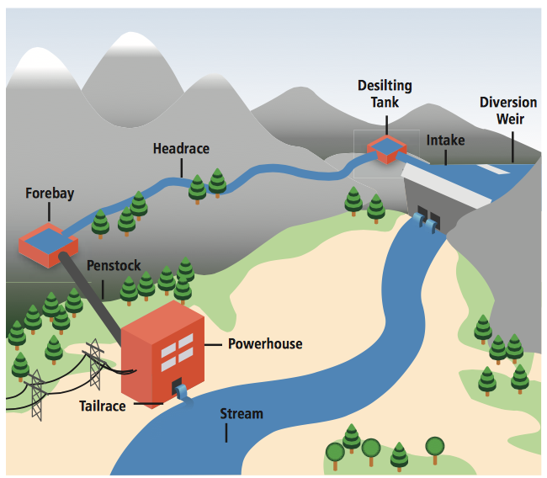**A. Run of River**

One type of hydropower plant is run of river. Run of river hydropower systems produce electricity from the natural flow and elevation drop in rivers. Figure 3 is a picture of how run of river hydropower stations work. [4]Run of river is advantageous because it does not harm the current environment in the river. Another advantage is that run of river stations can begin being used right when construction is done. There is no storage unit that needs to be filled. Many sources claim that run of river technology is much cheaper to build compared to pumped storage hydropower, this reducing the lost of energy; however, this is not true. More on cost will be discussed later.

Run of river has many disadvantages. One disadvantage is that energy output is variable between seasons. Depending on the season, more or less energy could be created. Since there is little to no storage in run of river hydropower stations, there are seasons with little electricity production. Sometimes, the demand for electricity does not match the production of electricity because of the variability in flow. Some run of river systems contain storage, but the storage only has an hourly or daily capacity.

**B. Pumped Storage**

A second type of hydropower plant is pumped storage hydropower. Pumped storage systems use off-peak electricity to pump water from a lower reservoir to a higher reservoir. This is advantageous because electricity can be generated during peak hours and stored during off peak hours. This allows demand to match supply. It also creates stability. Pumped storage 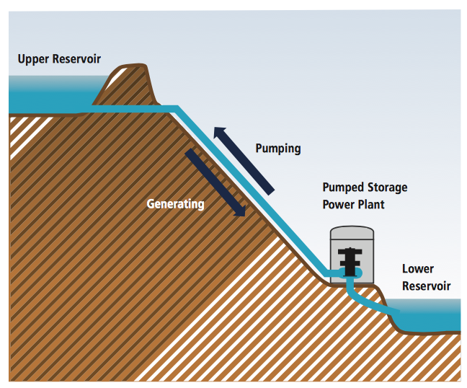systems are like batteries. Pumped storage systems are also able to decrease variability in using other renewable sources such as wind and solar because the pumped storage site can produce electricity during the variable and off times of the wind and solar. [5]

Pumped storage hydropower does have some disadvantages. One disadvantage is that when a pumped hydropower station is built, it destroys the environment and habitats that were previously there. The aquatic ecosystems and terrestrial wildlife habitats are destroyed. Because of this, it is difficult to find locations to build pumped hydropower stations. Another disadvantage is that after the pumped storage hydropower system is constructed, it cannot be used immediately. The upper reservoir must be filled up first. Also, the pumped storage system uses a large plot of land making the possible number of locations for building these stations small. Additionally, the power output of gravity is quite weak compared to other source of potential energy. To match the energy stored in a single AA battery, we would have to lift 100 kg, 10 meters. To match the energy stored in one gallon of gasoline, we would need to life 13 tons of water, one kilometer high.[6] These calculations clearly show the weakness of gravitational potential. Hydropower makes up for this loss by increasing the volume of the dams. This is a problem too because then the dam takes up more land and destroys even more habitats.

**IV. Innovative Solutions to Pumped Storage Hydropower**

Multiple new and innovative pumped storage hydropower systems have been engineered recently. I will lay out the advantages and disadvantages to variable speed pumped storage, undersea pumped storage, and compressed air pumped storage. I will briefly describe how the first two work and then describe why the compressed air pressure design is most advantageous for society’s current needs.

**A. Variable Speed Pumped Storage**

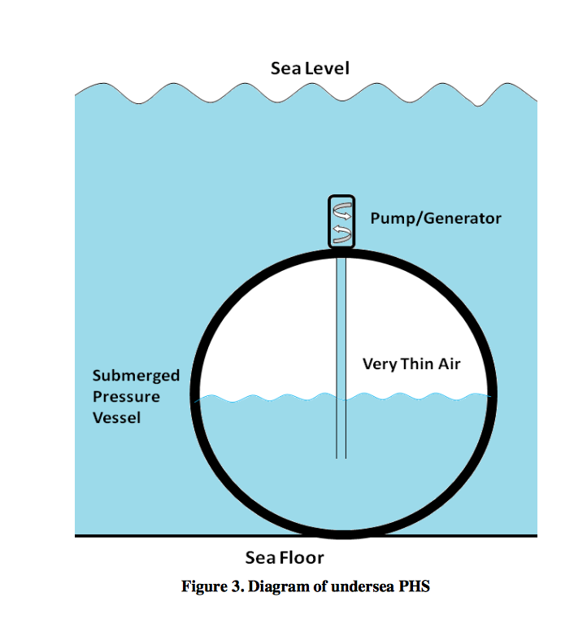 The current pumped hydropower systems have a Francis turbine. The turbine acts a pump when the water is pumped off the hill and acts as a turbine when it goes down the hill. In the current system, the speed at which the turbine works can be varied to increase efficiency, but the speed of the pump cannot. The variable speed pumped storage system fixes this problem. The new design allows the speed of the pump to be varied. This increases the power efficiency, thus reduces the cost of electricity production. This also decreases the turnaround time between pump and turbine mode. The only variable speed pumped storage system today is in Japan. [7]

**B. Undersea Pumped Storage**

Another spin off of the pumped storage hydropower is called undersea pumped storage. The undersea mechanism utilizes tanks placed on the seabed. During electricity production, valves on the tanks are opened and turbines spin, generating electricity as the tanks fill up. The more tanks, the greater the electricity capacity. Once the tanks fill up, the turbine is reversed and acts like a pump. This allows the electricity to be stored for future use. The high pressure at the seabed work the same way as gravity does in the conventional pumped storage system. The undersea pumped storage systems are jut as efficient as the conventional systems - both have 80% efficiency. [8]Another advantage is that wind and solar energies can be connected to the tanks at the seabed. During times of excess wind and solar energy production, the excess energy is sent down to the tanks to provide enough electricity during the pumping stage. [9]The undersea technology is quite innovative in its design because it allows excess wind and solar energies to be stored.

C. Compressed Air Pump Storage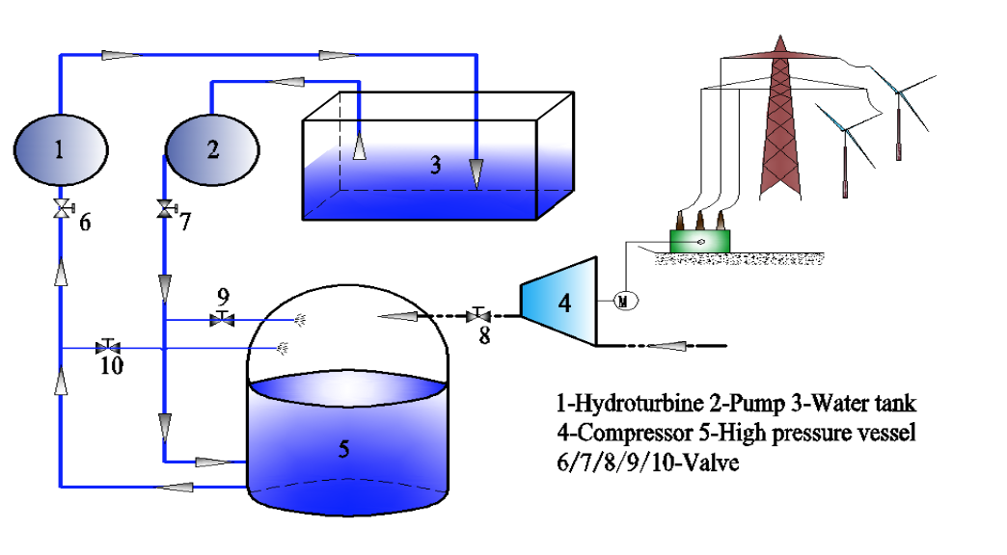

Here I present a simple and short introduction to compressed air hydropower storage. The compressed air hydropower station pumps water into a pre-pressurized vessel. As water is pumped into the compressed air vessel from valves 7 and 9, the water level rises, and the air becomes pressurized. The greater pressure in the air is equivalent to higher elevations in conventional pumped storage systems. The greater the pressure, the greater the energy output. The air temperature in the vessel increases as more water in pumped in because of PV = nRT. So to combat this, some water is sent from valve 9 into tank 5 to decrease the temperature. That’s why we opened valve 9 in the beginning. The storage process is done during low demands for electricity. Then valves 7 and 9 are closed and valves 6 and 10 are opened. The high pressure water moves the turbine and generates electricity. [10]

**V. Environmental and Economic Advantages to Compressed Air Hydropower**

The compressed air pressure pumped hydropower storage has high reliability, high economic feasibility, and low environmental impact compared to the conventional systems. I will discuss these aspects now.

A. Environmental

The compressed air pressure pumped storage facility does not need to be placed on a mountain, near a body of water, or close to a place with lots of rainfall. The only thing needed, is a tank of water, air pumps, and a vessel. Theoretically, this could be placed anywhere where there is an empty plot of land. However, I will argue that we should build these next to places with high wind and high solar energy infrastructure. This is because the compressed air system can use the energy produced from the wind and sun to run the pump that pumps the water into the vessel. We currently do not have a way to store the energy produced from wind and solar sources cheaply and this mechanism allows us to. Here I show a map of states with high wind and solar energy infrastructure already in place. [11]

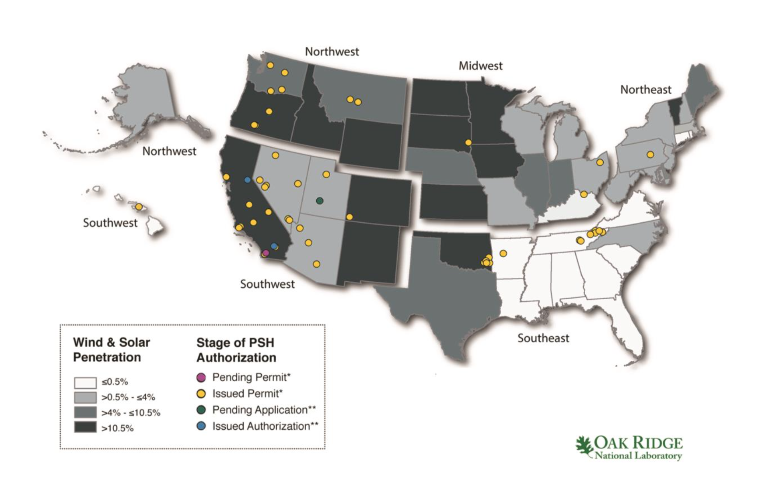

From the map we should be building these stations in California, Oregon, Idaho, Wyoming, Colorado, New Mexico, Oklahoma, Kansas, North Dakota, South Dakota, Minnesota, Iowa, and Vermont.

Let’s do some calculations to see how many compressed air energy systems we would need to install in the United States to provide enough electricity storage for the entire population. Tom Murphy argues that we need 7 days of storage so that nobody has to change their current habits. [12] To create 7 days of storage, we need 2 TW of storage or 336 billion kwh. Based on Haunran Wang’s research paper, A Novel Pumped Hydro Combined with Compressed Air Energy Storage System, the maximum power output from a compressed air pressure system is 2700 MW. [13] To obtain 2 TW of stored energy, we would need 750 compressed air storage systems. This does not seem plausible. This would be 15 stations per state. It probably is not feasible to change the entire storage infrastructure to compressed air storage stations. However, if we assume Tom Murphy’s assumption is wrong, in fact he said that many people disagreed with his assumption, we can change the number of required stations. Let’s say instead we only need one day of storage. Then we would only need about 100 compressed air storage stations. This is much more feasible. We must remember though that this would take over the entire energy storage infrastructure, which isn’t actually necessary. I think it would be a reasonable goal to turn at least 25% of the current energy storage towards renewables such as compressed air hydropower. The math presented above shows that compressed air hydropower stations are in the range of feasibility of replacing 25% to 100% of the existing energy storage infrastructure.

We can also see that there is no carbon dioxide released into the atmosphere from the electricity storage and electricity production. Global warming is a big problem that we need to find a solution to. Using compressed air hydropower stations is a step in the right direction to solve the global warming crisis.

B. Cost

|  |  |  |  |  |
| --- | --- | --- | --- | --- |
| Type | Equipment | Cost ($) | Cost Fraction | Total Cost |
| Pumped Hydropower Storage | Pump | 18.93 | 6 | 315.32 |
| Hydro Turbine | 37.85 | 12 |
| Compressed Air Hydropower Storage | Compressor | 12.21 | 50 | 260.07 |
| Pump | 18.93 | 50 |
| Hydro Turbine | 37.85 | 50 |
| High Pressure Vessel | 61.05 | 50 |

Now onto cost. The biggest question from everybody for any new technology is, how much is this going to cost me? Let’s take a look at how much the electricity is going to cost from the compressed air stations. First, I must mention that the stations can produce electricity and store electricity. The produced electricity is not delivered to the power grid, only the stored energy is delivered. This is because the produced electricity in combination with the solar and wind electricity, is used during demand valleys to store the electricity. The cost of the compressed air hydropower station is tabulated in Haunran Wang’s research paper, A Novel Pumped Hydro Combined with Compressed Air Energy Storage System. The table is below. [14] The cost is reported in Chinese Dollars. I reproduced the table with the values converted to US dollars.

We can see from the table that it costs $260 per 1 MW of energy storage. This is the capital cost of building the site. This is less than the cost per MW of conventional pumped storage hydropower. The cost of conventional pumped storage power is $315 per 1 MW of energy storage. The costs of running the machinery to store electricity are not calculated here, but the new technology uses the excess electricity produced from the wind and solar plants, making it practically $0. In the conventional pump, the electricity produced during the day from the system is used to pump the water back up the hill, so the cost here is also practically $0. One last thing to consider is that the capacity on the compressed air pump is 135% more than the conventional pump. So, to equal the capacity of the compressed air pump, we would need to build more conventional pumps, making the compressed air pump an even cheaper option.

**VI. Conclusion**

From a standpoint of cost and the environment, we can clearly see why the new compressed air pump should replace the current licenses of the 60 new conventional pumped storage hydropower stations in the United States.

Word Count: 2455

1. http://www.irena.org/documentdownloads/publications/re_technologies_cost_analysis-hydropower.pdf
2. http://www.irena.org/documentdownloads/publications/re_technologies_cost_analysis-hydropower.pdf
3. http://www.energy.gov/sites/prod/files/2015/04/f22/2014%20Hydropower%20Market%20Report_20150424.pdf
4. http://www.irena.org/documentdownloads/publications/re_technologies_cost_analysis-hydropower.pdf
5. http://www.energy.gov/sites/prod/files/2015/04/f22/2014%20Hydropower%20Market%20Report_20150424.pdf
6. http://physics.ucsd.edu/do-the-math/2011/11/pump-up-the-storage/
7. http://energystorage.org/energy-storage/technologies/variable-speed-pumped-hydroelectric-storage
8. http://www.hydro.org/wp-content/uploads/2014/01/NHA_PumpedStorage_071212b12.pdf
9. Research on Storage Capacity of Compressed Air Pumped Hydro Energy Storage Equipment by Jingtain Bi
10. A Novel Pumped Hydro Combined with Compressed Air Energy Storage System by Huanran Wang
11. http://www.energy.gov/sites/prod/files/2015/04/f22/2014%20Hydropower%20Market%20Report_20150424.pdf
12. http://physics.ucsd.edu/do-the-math/2011/11/pump-up-the-storage/
13. A Novel Pumped Hydro Combined with Compressed Air Energy Storage System by Huanran Wang
14. A Novel Pumped Hydro Combined with Compressed Air Energy Storage System by Huanran Wang