Switches - EtherChannels
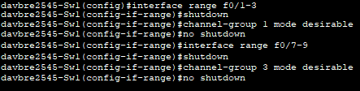
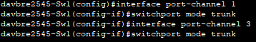
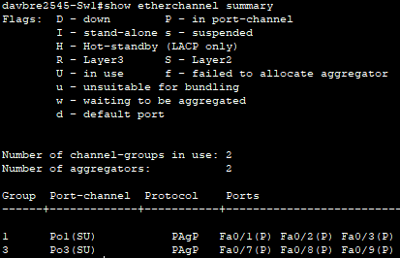

Router - IPv6 Network Configuration
