Benchmark to choose feature selection method

After filtering out features based on variance values and joining features based on correlation, we will select features based on traditional methods: RFE, tree based, sequential forward, L2 and Lasso.

In this benchmark, we compare different methods.
Number of features after applying different filters

 | Salinity |  |  |  | Temperature |  |  |  | pH |  | Oxygen
 | Gene Families | Gene Families | kmer9 | kmer9 | Gene Families | Gene Families | kmer9 | kmer9 | Gene Families | kmer9 | Gene Families | kmer9
 | Classif of extremes | Regres of full range | Classif of extremes | Regres of full range | Classif of extremes | Regres of full range | Classif of extremes | Regres of full range | Regres of full range | Regres of full range | Classif of extremes | Classif of extremes
isolates | n = 746 | n = 3,418 | n = 746 | n = 3,418 | n = 534 | n = 13,198 | n = 534 | n = 13,198 | n = 3,630 | n = 3,630 | n = 2,722 | n = 2,683
features | 20,141 | 20,141 | 131,072 | 131,072 | 20,141 | 20,141 | 131,072 | 131,072 | 20,141 | 131,072 | 20,141 | 131,072
Filter by variance | 3,725 | 10,977 | 31,151 | 26,345 | 4,305 | 5,640 | 131,072 | 82,051 | 3,638 | 40,230 | 4,823 | 24,008
Join correlated features | 3,002 | 7,700 | 2,174 | 9,384 | 3,173 | 5,581 | 9,062 | 6,793 | 3,583 | 4,096 | 4,651 | 8,867
Convert to CSV | ok | ok | ok | ok
RFE | ok | ok | ok | ok
tree-based | ok | ok | ok | ok
sequential- forward | - | - | Error | -
L2 | ok | ok | ok | ok
Lasso | - | - | Error | Error (convergence warning) |  |  |  |  | 18  (30’’, 1MB, only 18 feat had scores >0)
 |  |  |  | 30 min run time

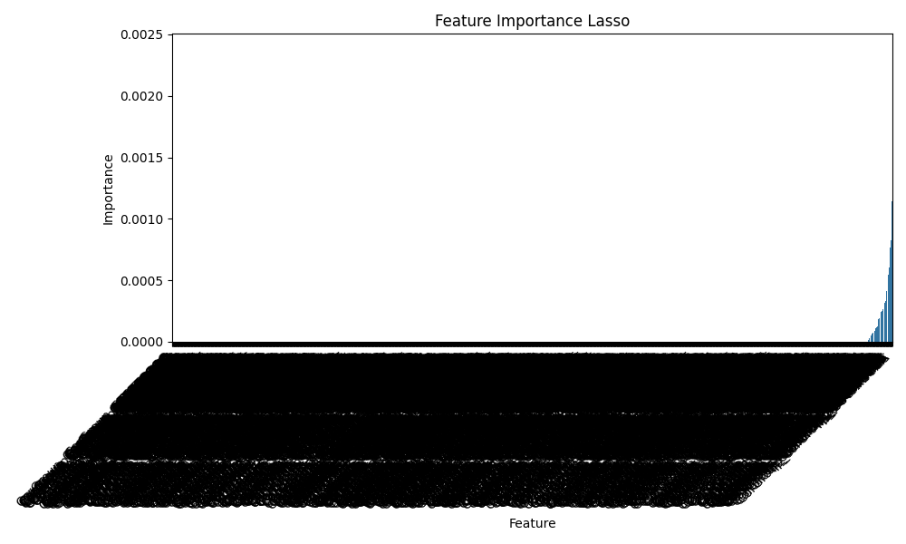
Salt, kmer9, classification

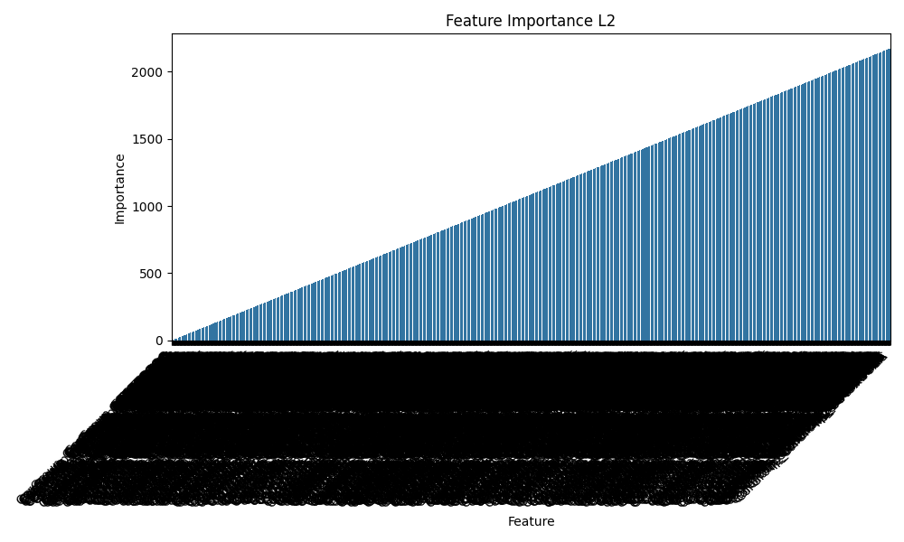
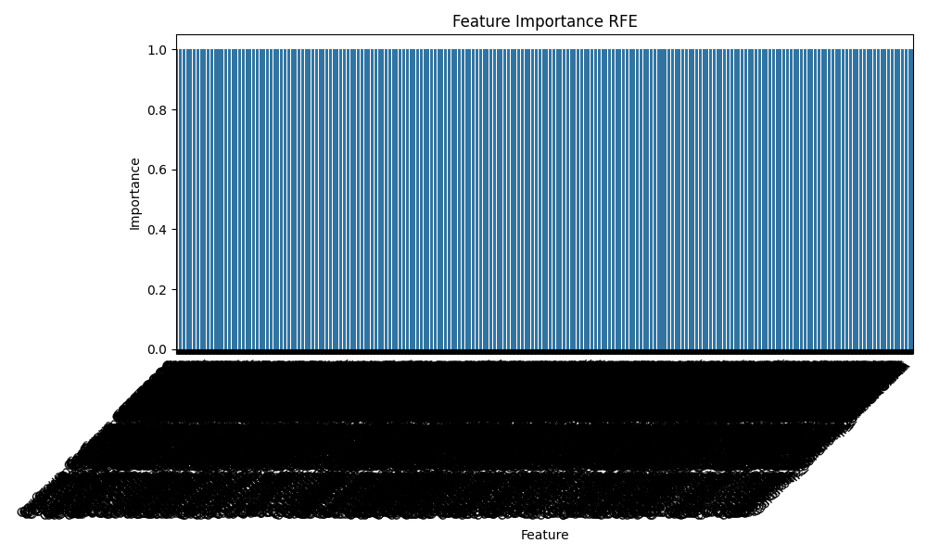
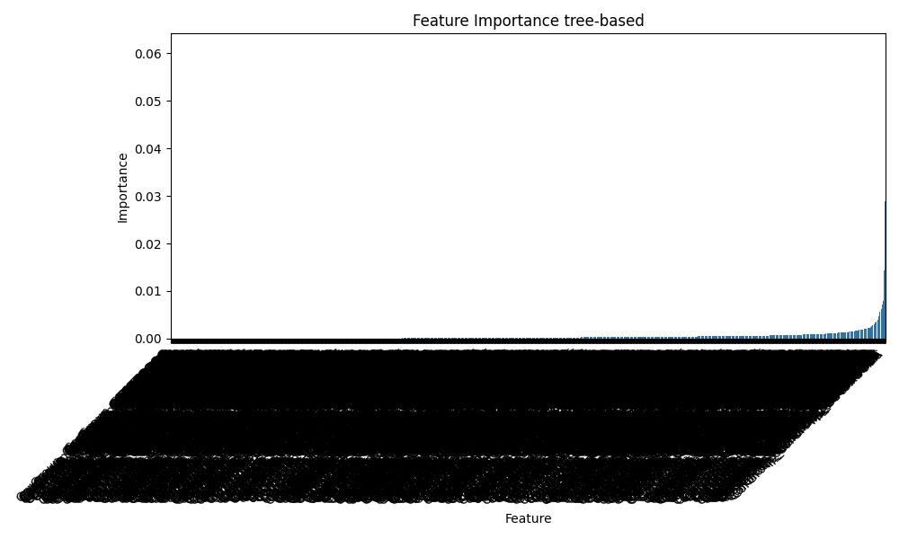

Benchmark

Classification (RF, undersampling)
Number of initial isolates for filtering: 932
Number of initial features: 2,174
Number of isolates considered in the analysis: 745

L2 tree-based
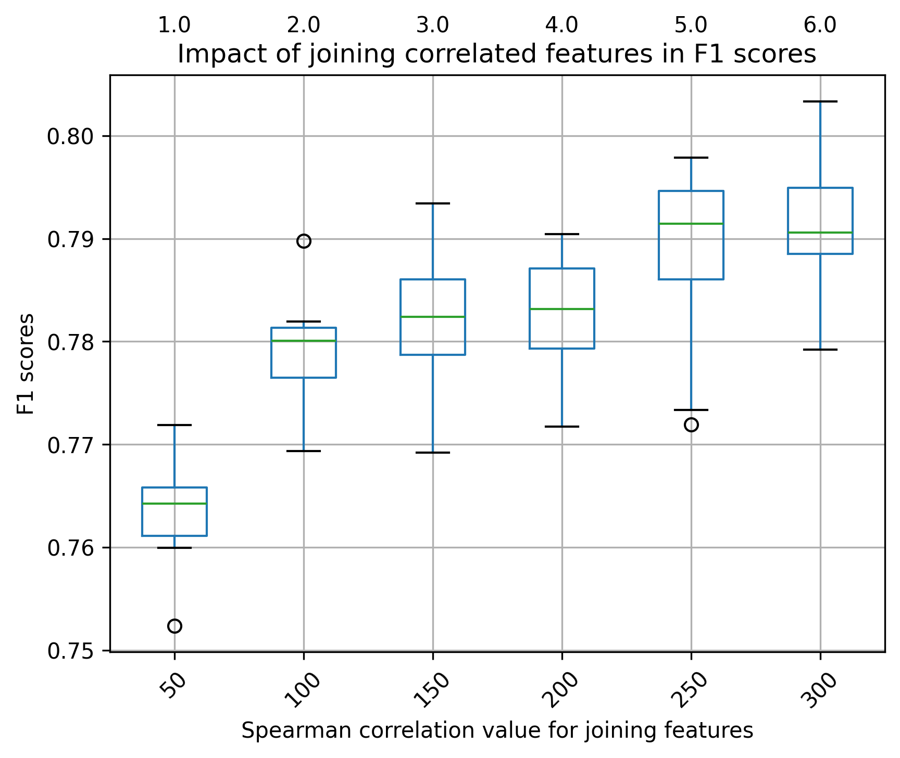
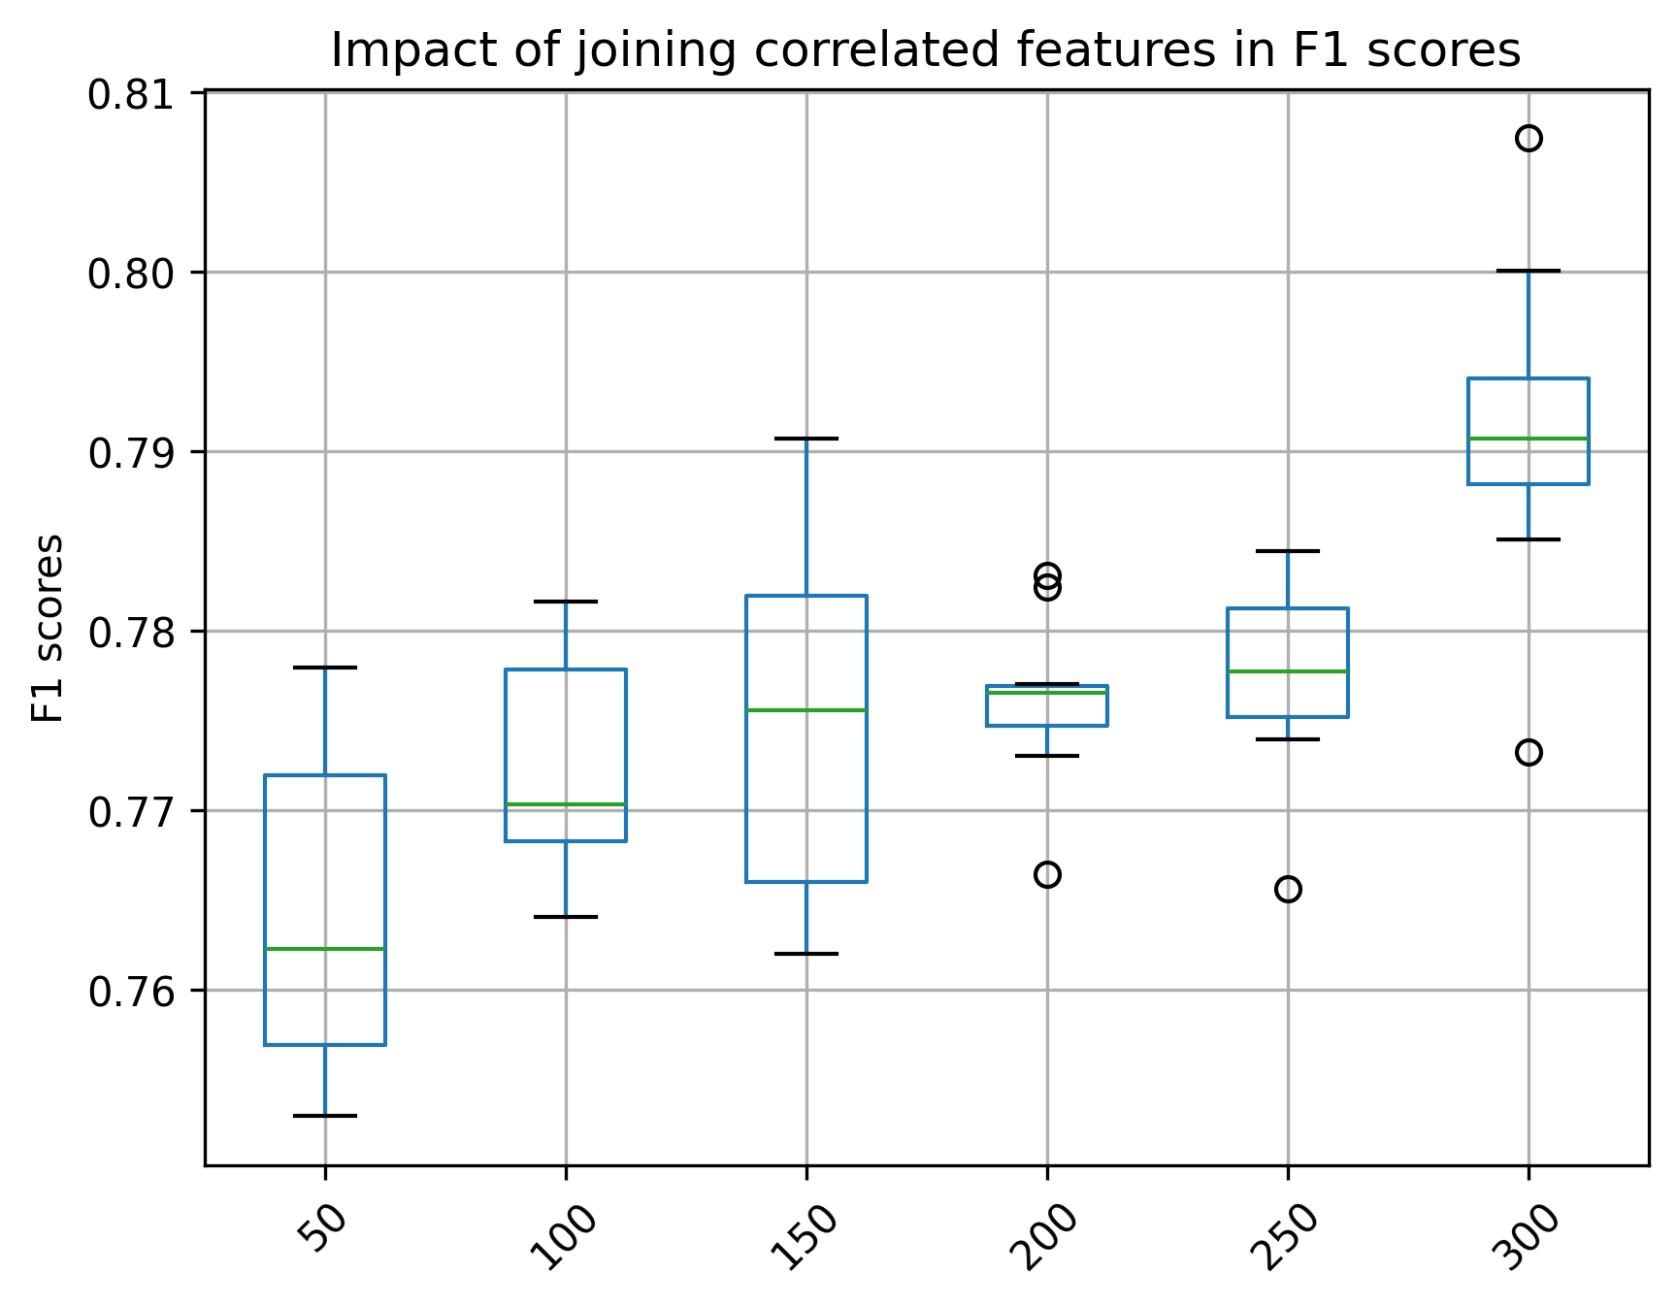

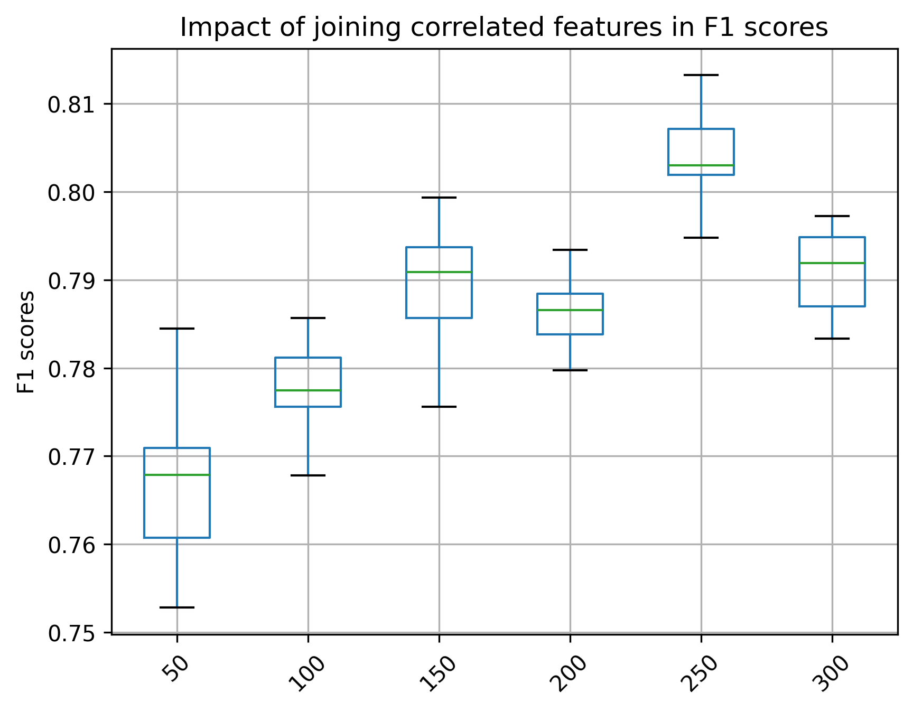
random

Salt, kmer9, regression

RFE tree-based L2
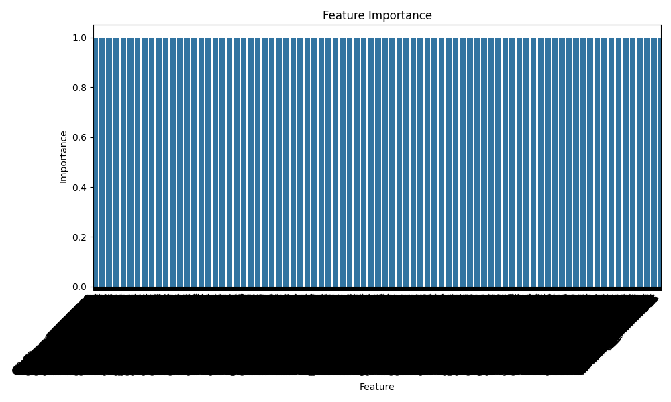
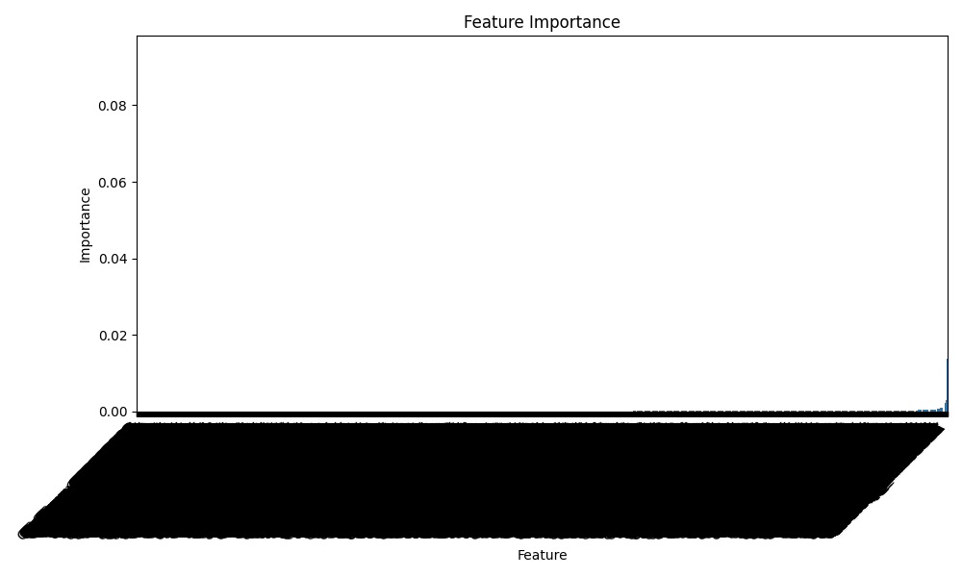
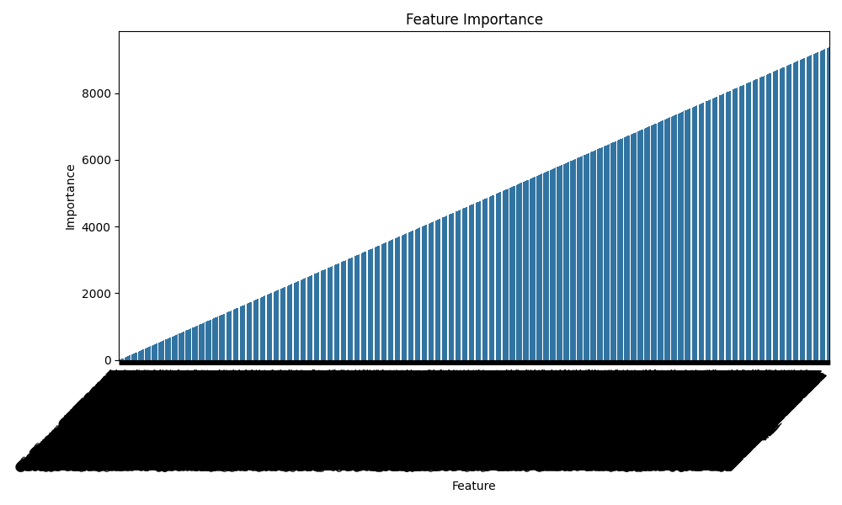

Benchmark

Regression (RF, mean NaCl)
Number of initial isolates for filtering: 3,418
Number of initial features: 9,384
Number of isolates of analysis: 2,734

L2 tree-based
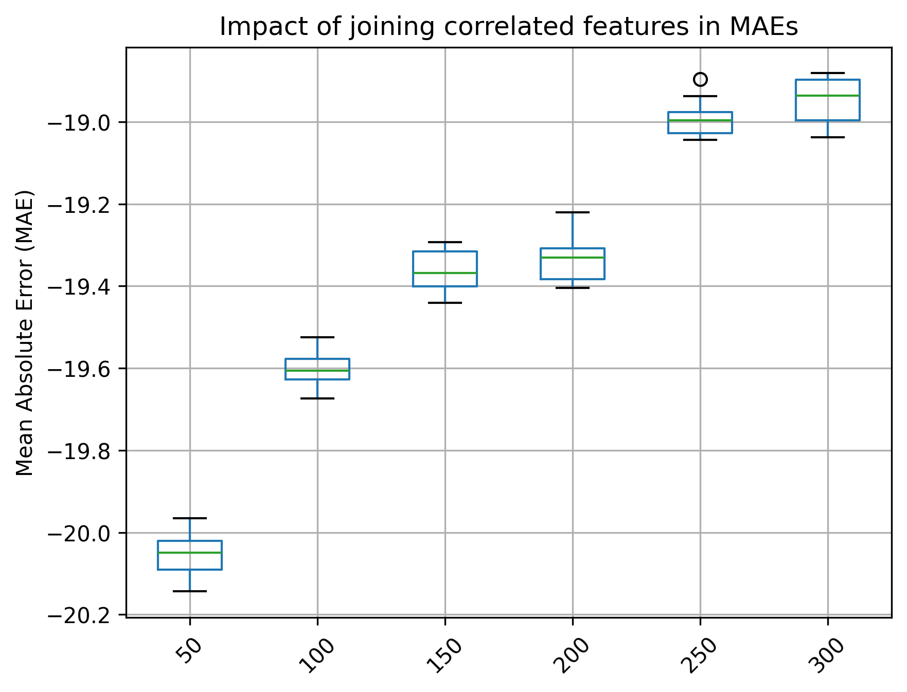
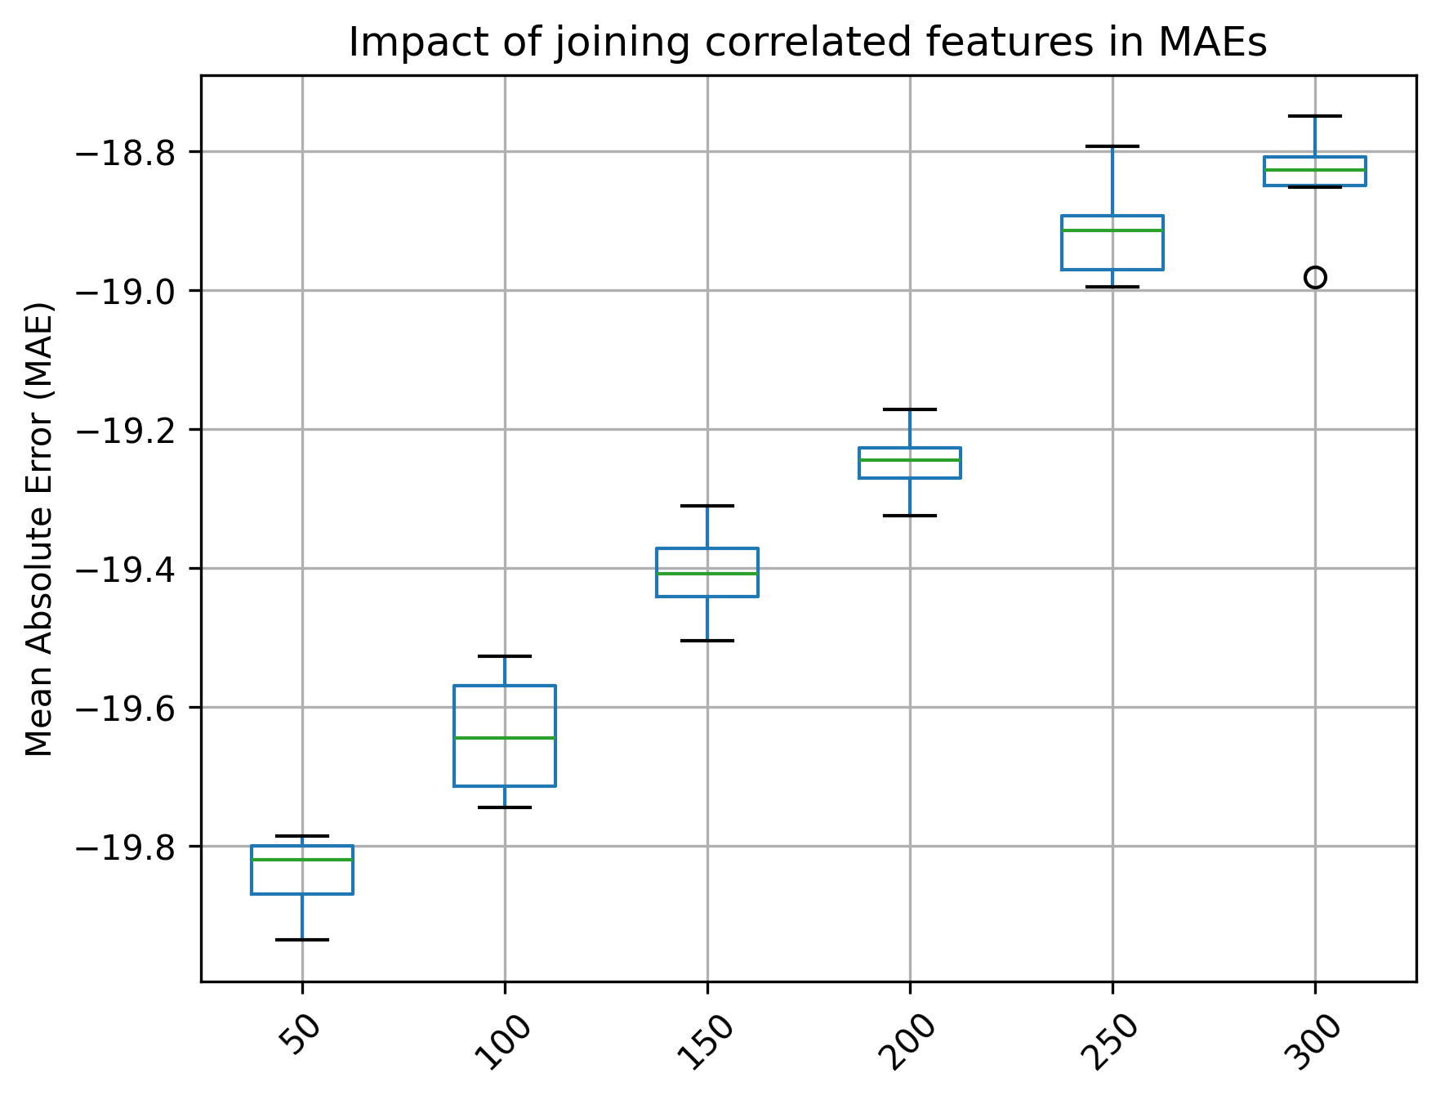

random
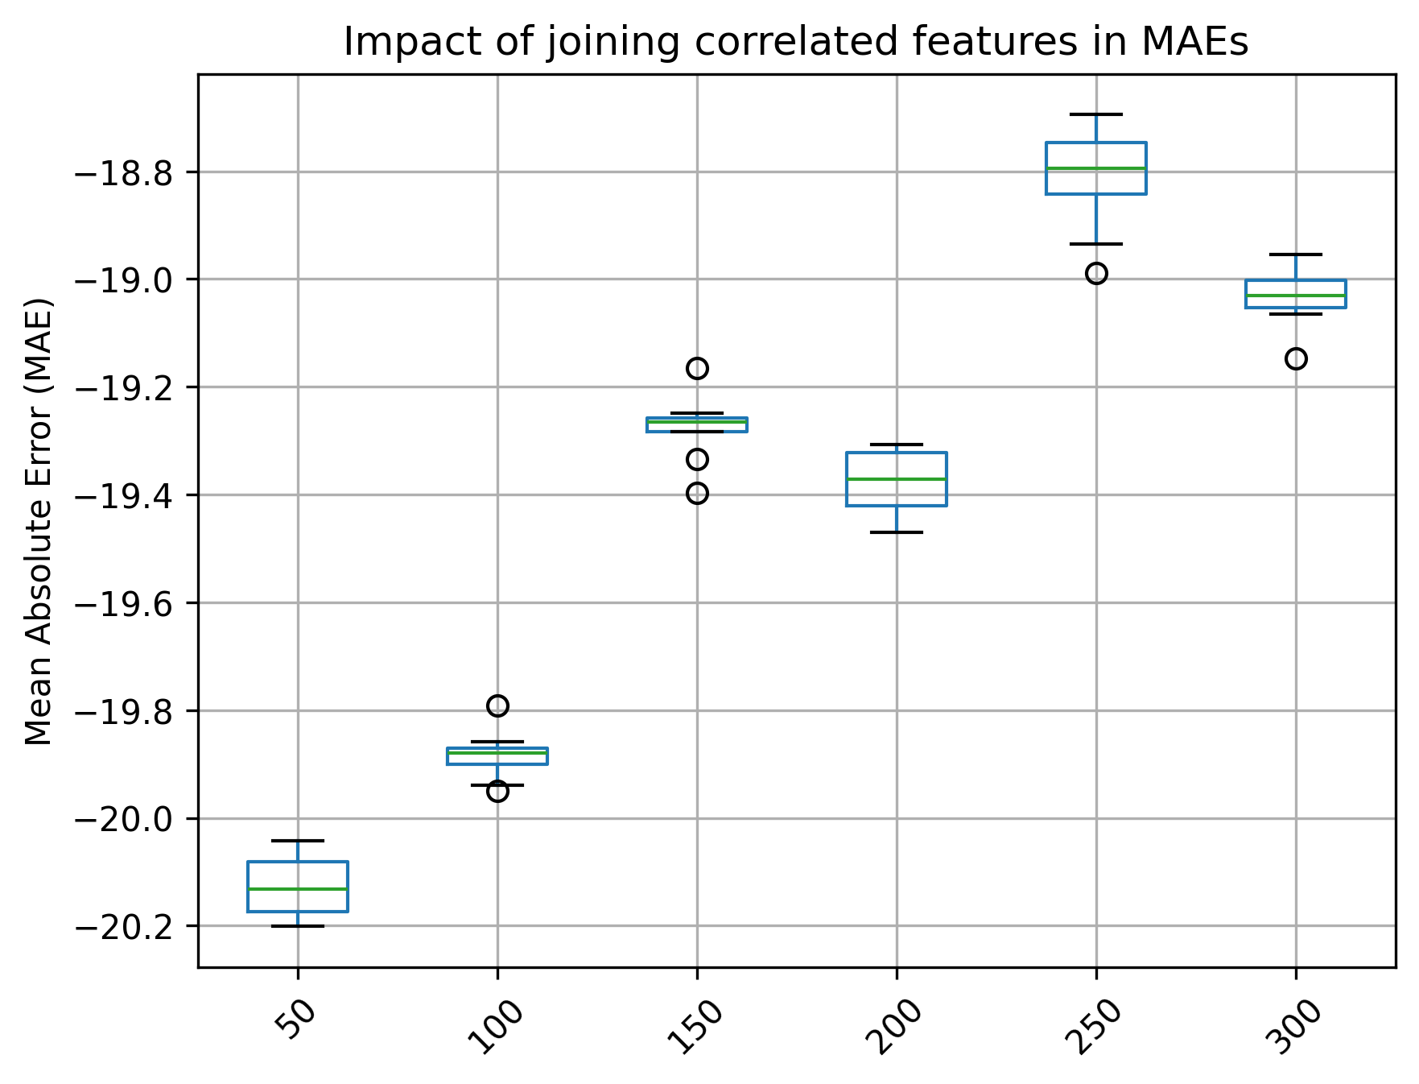
Salt, gene-families, classification

RFE tree-based L2

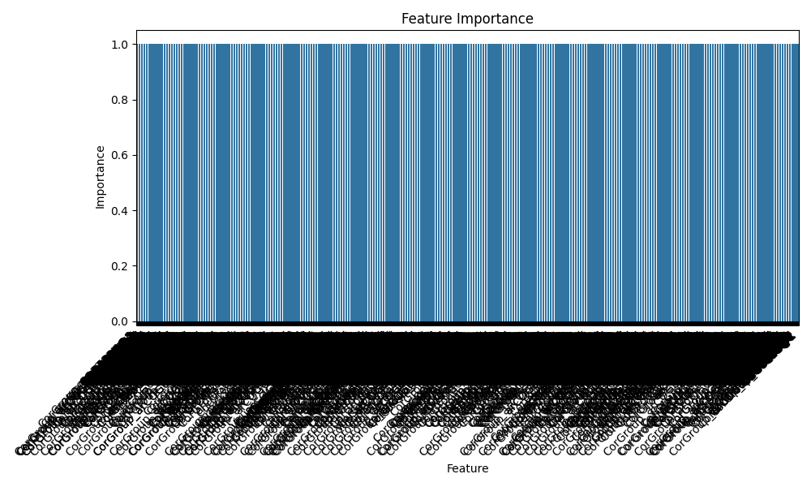
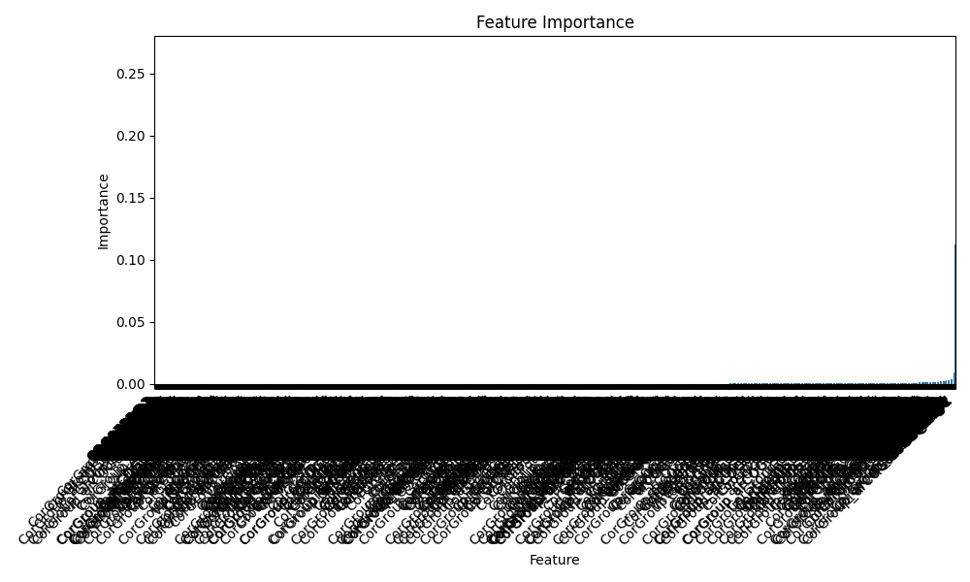
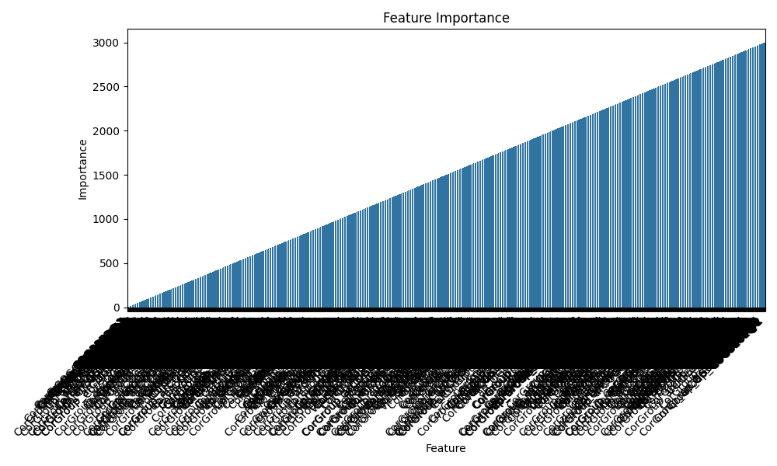

Benchmark

Classification (RF, undersampling)
Number of initial isolates for filtering: 932
Number of initial features: 3,002
Number of isolates considered in the analysis: 745

L2 tree-based
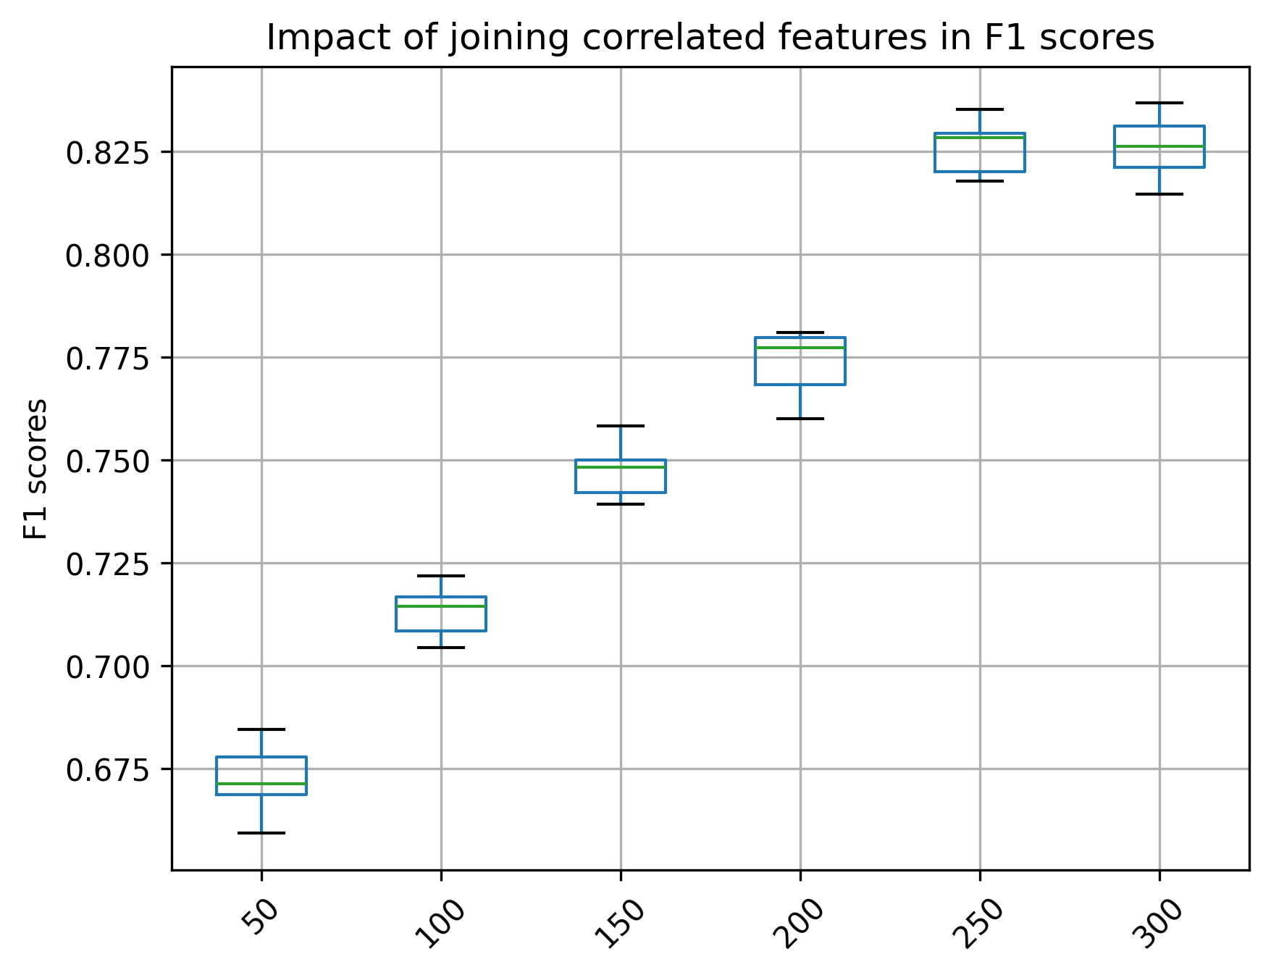
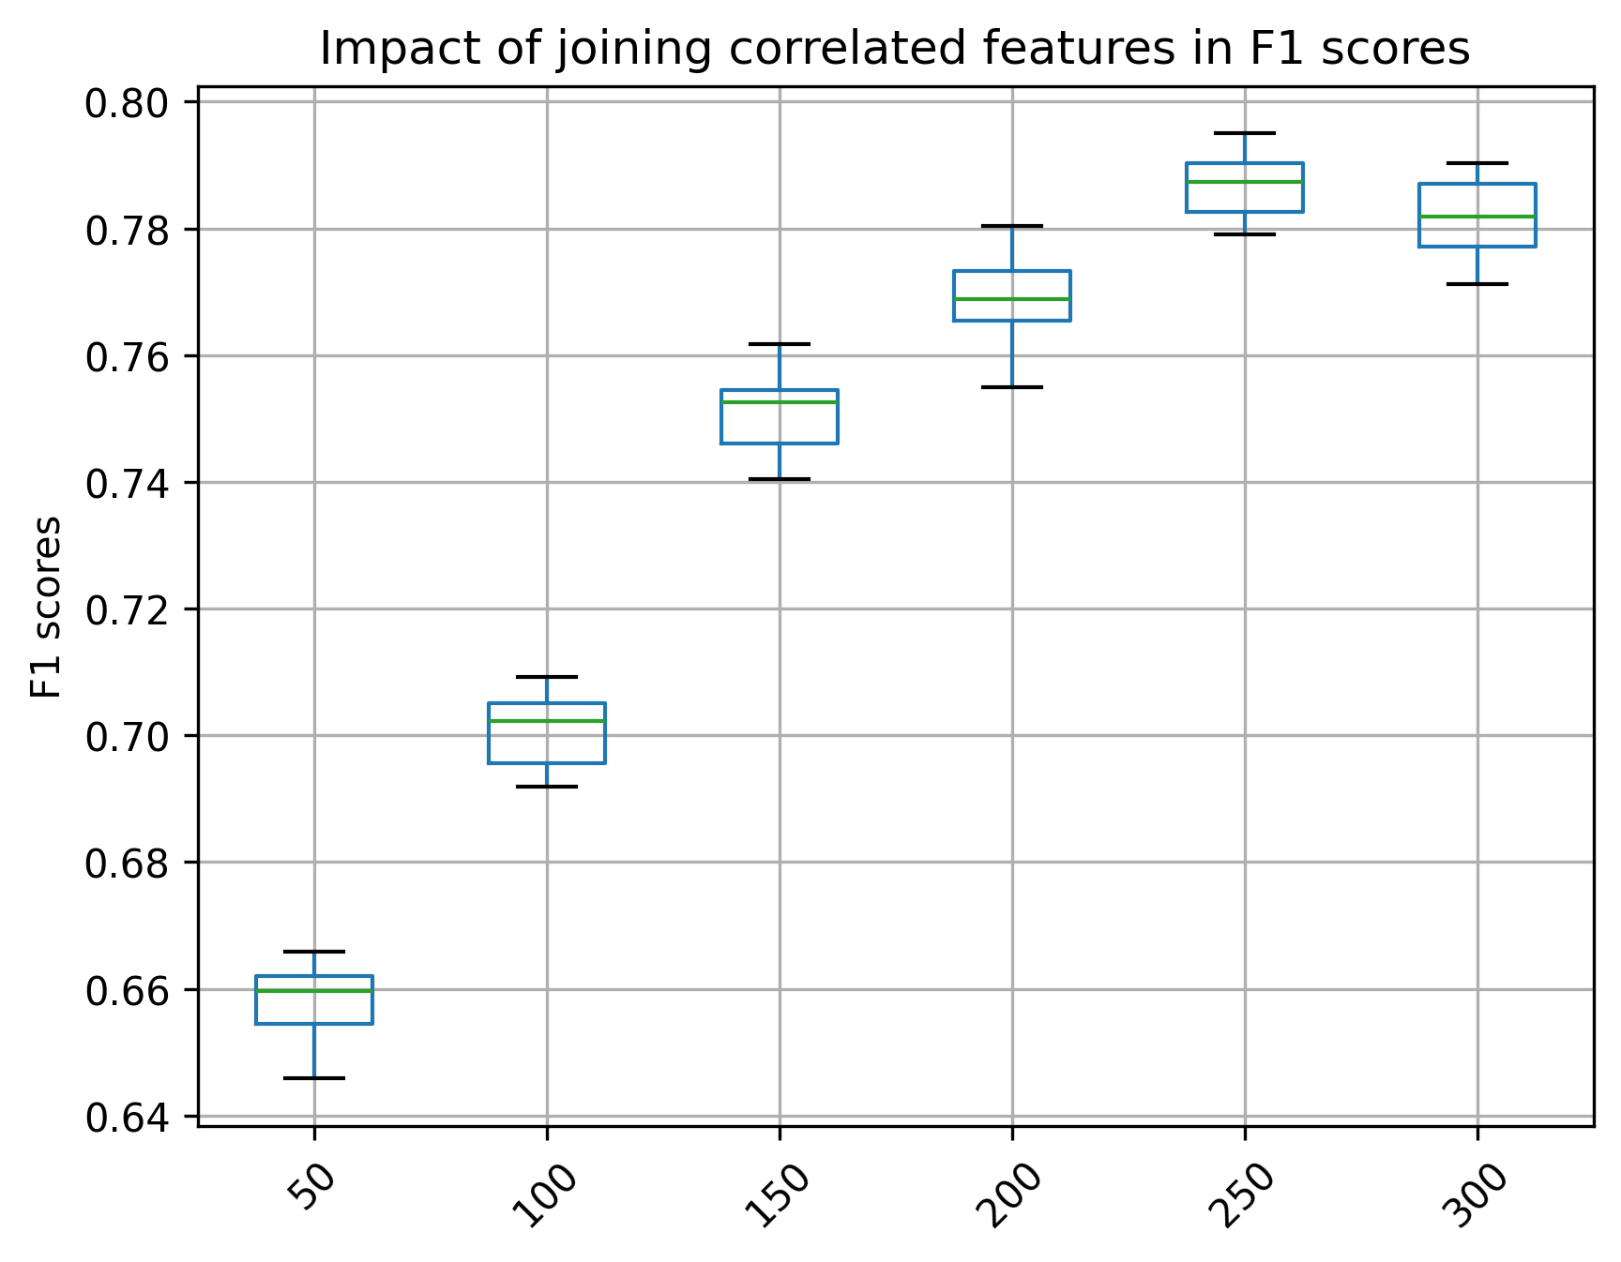

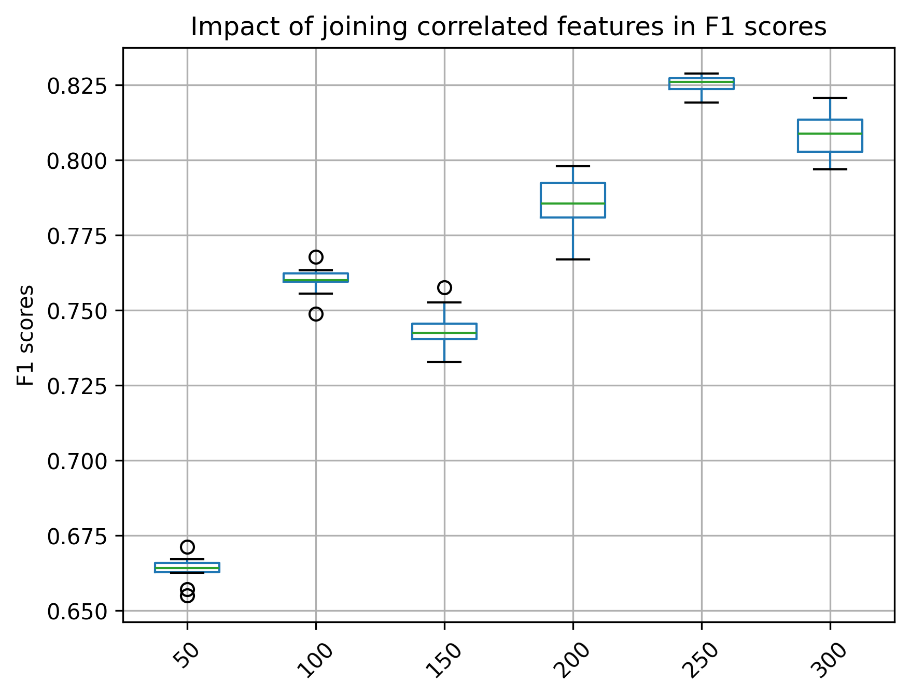
random

Salt, gene-families, regression

RFE tree-based L2
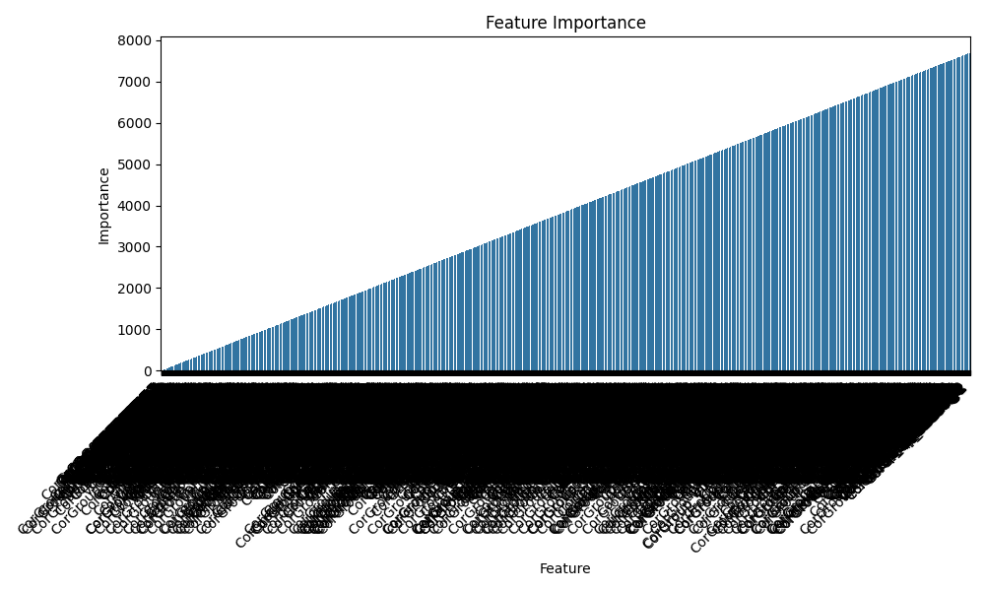
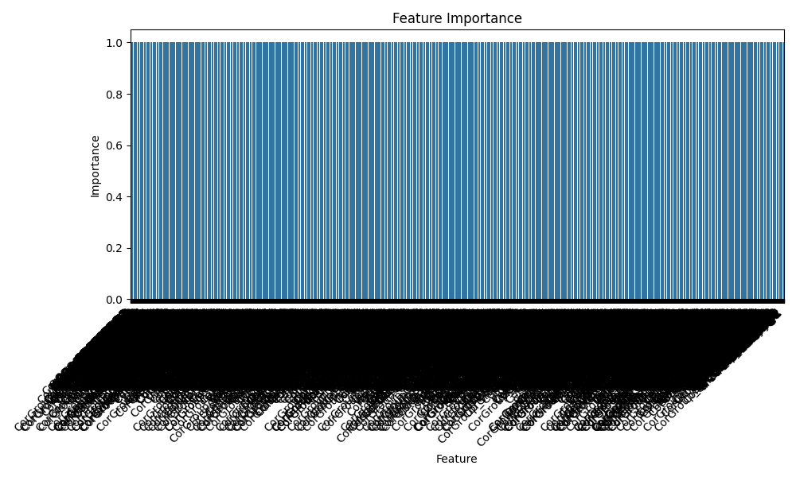
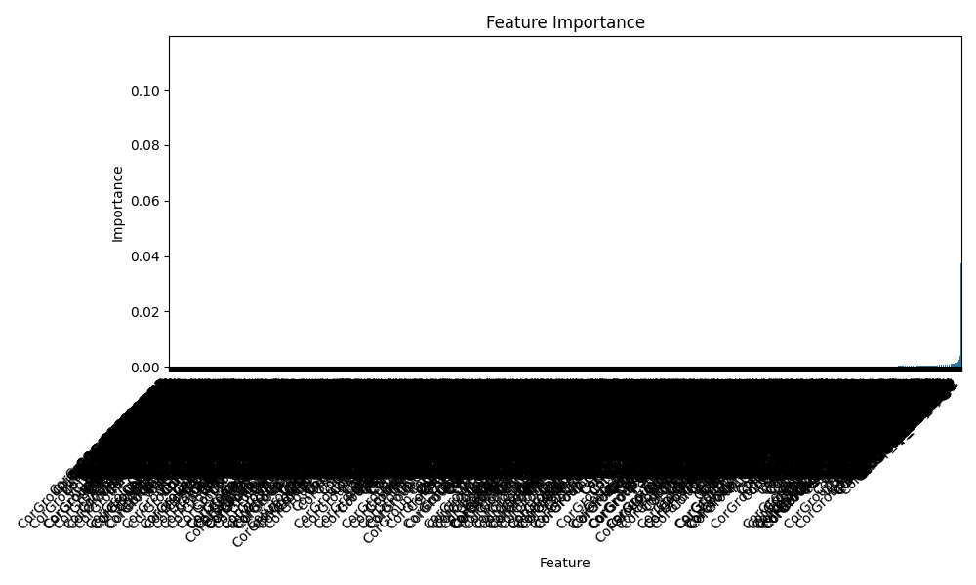

Benchmark

Regression (RF, mean NaCl)
Number of initial isolates for filtering: 3,418
Number of initial features: 7,700
Number of isolates of analysis: 2,734

L2 tree-based

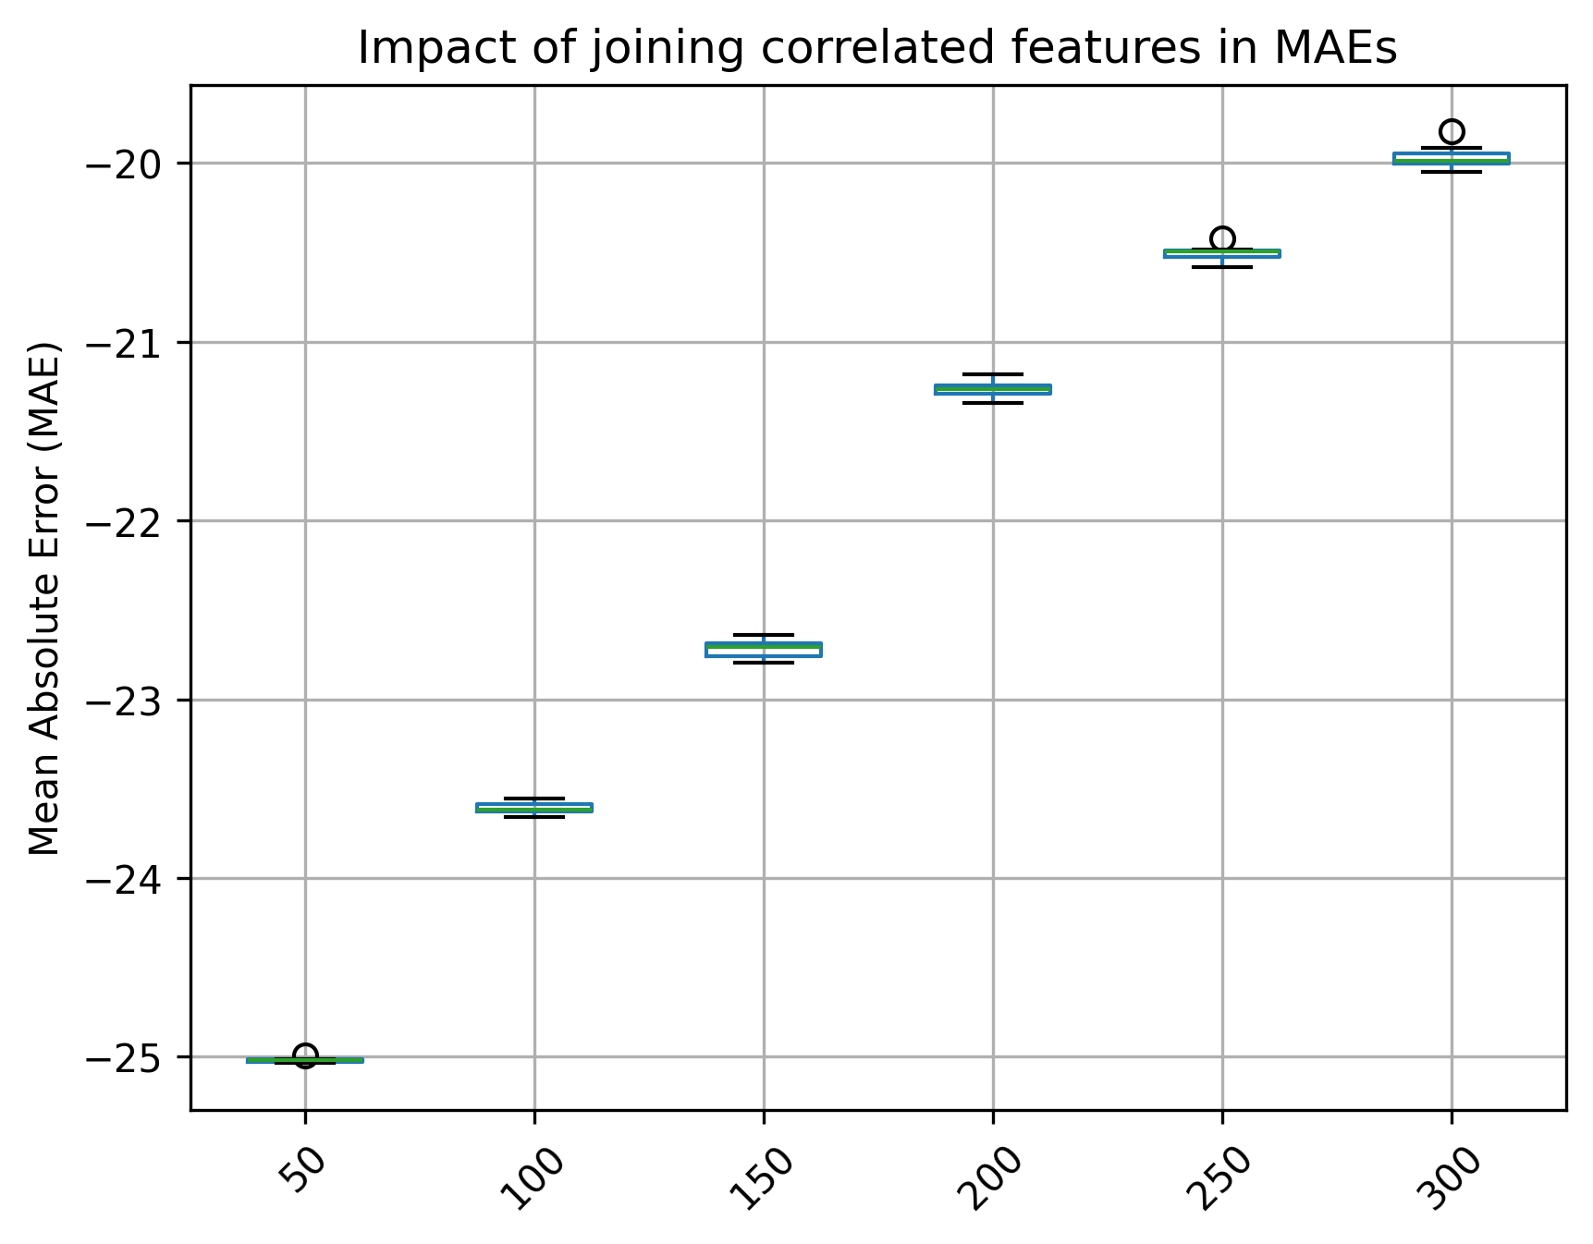
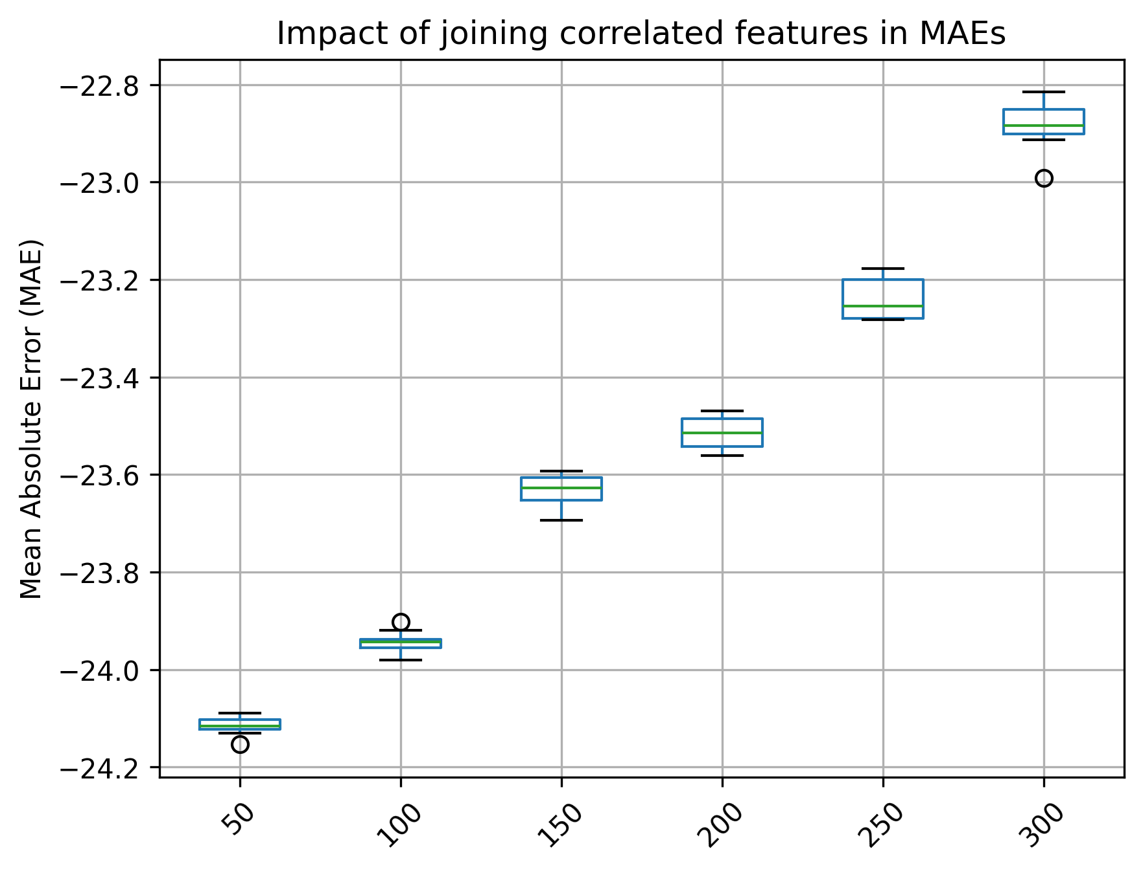

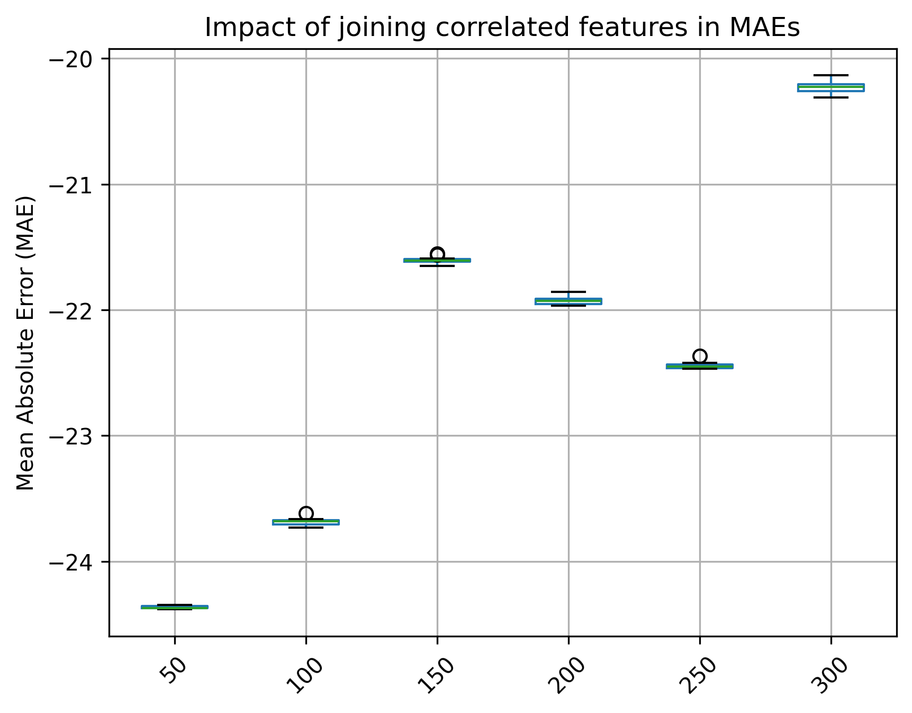
random

Temperature, gene-families, classification

Benchmark

Temperature, gene-families, regression

Benchmark

Temperature, kmer9, classification

Benchmark

Temperature, kmer9, regression

Benchmark

Oxygen, gene-families, classification

Benchmark

Oxygen, kmer9, classification

Benchmark

pH, gene-families, regression

Benchmark

pH, kmer9, regression

Benchmark

