Benchmark to choose threshold for filtering features based on variance

Low-variance features do not add much important information to the ML model to predict abiotic factors from genomic features. Therefore we will filter them out. To choose an appropriate threshold for filtering features based on their variance, we did a benchmark. This benchmark measures the model’s metrics for different thresholds. The threshold with the highest metric is chosen per abiotic factor and feature (gene families or kmers). Metrics were: F1 score and MAE (maximum absolute error) for classification and regression respectively.

First, variance was measured for each feature (gene families and kmers), using numpy function var: https://numpy.org/doc/stable/reference/generated/numpy.var.html. This function measures the spread of a distribution following the formula (sum of a minus the mean squared divided by the number of elements):

N = len(a)
d2 = abs(a - mean)**2
var = d2.sum() / (N - ddof)
Afterwards, variances were normalized to a range [0; 1] to make different features comparable following:

( variances – variances.min() ) / ( variances.max() – variances.min() )

A plot was made to understand the variances of different features. Based on the plot, we chose appropriate ranges of study for different features. The idea was to cover most of the data.

The benchmark was done with 80% of the data (training set). 20% of the data (test set) was set aside for final evaluation after feature selection and hyperparameter tuning (source: https://scikit-learn.org/stable/modules/cross_validation.html). The training and test sets were created with a reproducible command (sklearn, model_selection, train_test_split, random_state = 99).

Discussion of results

- Gene families have higher variance compared to kmers;

- For classification, salinity has a clear lower F1-score, 0.85, than temperature and oxygen, >0.96. This is not due to the lower number of samples used in the analysis, since salinity, n = 746, has more samples than temperature, n = 534 (oxygen has n = 2,722);

- For classification, the metrics do not change very much with different variance thresholds;

Normalized variances of gene families and kmer9
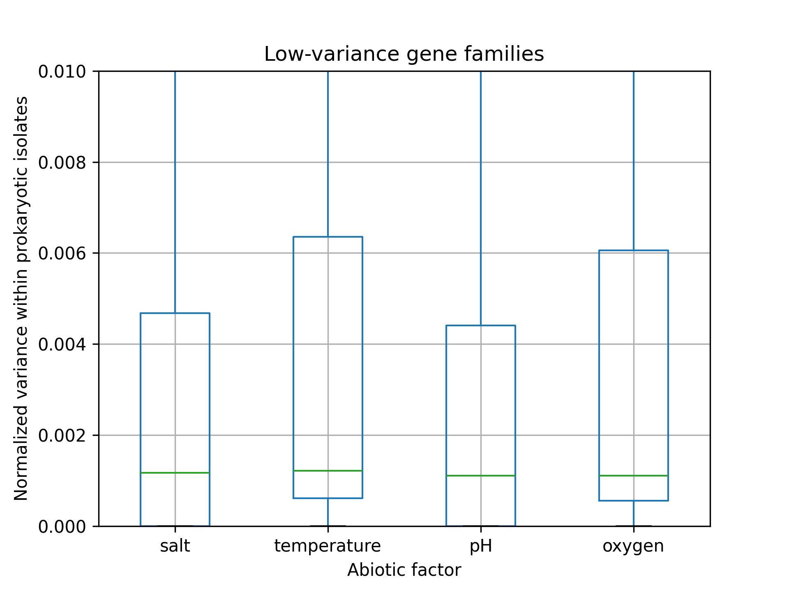
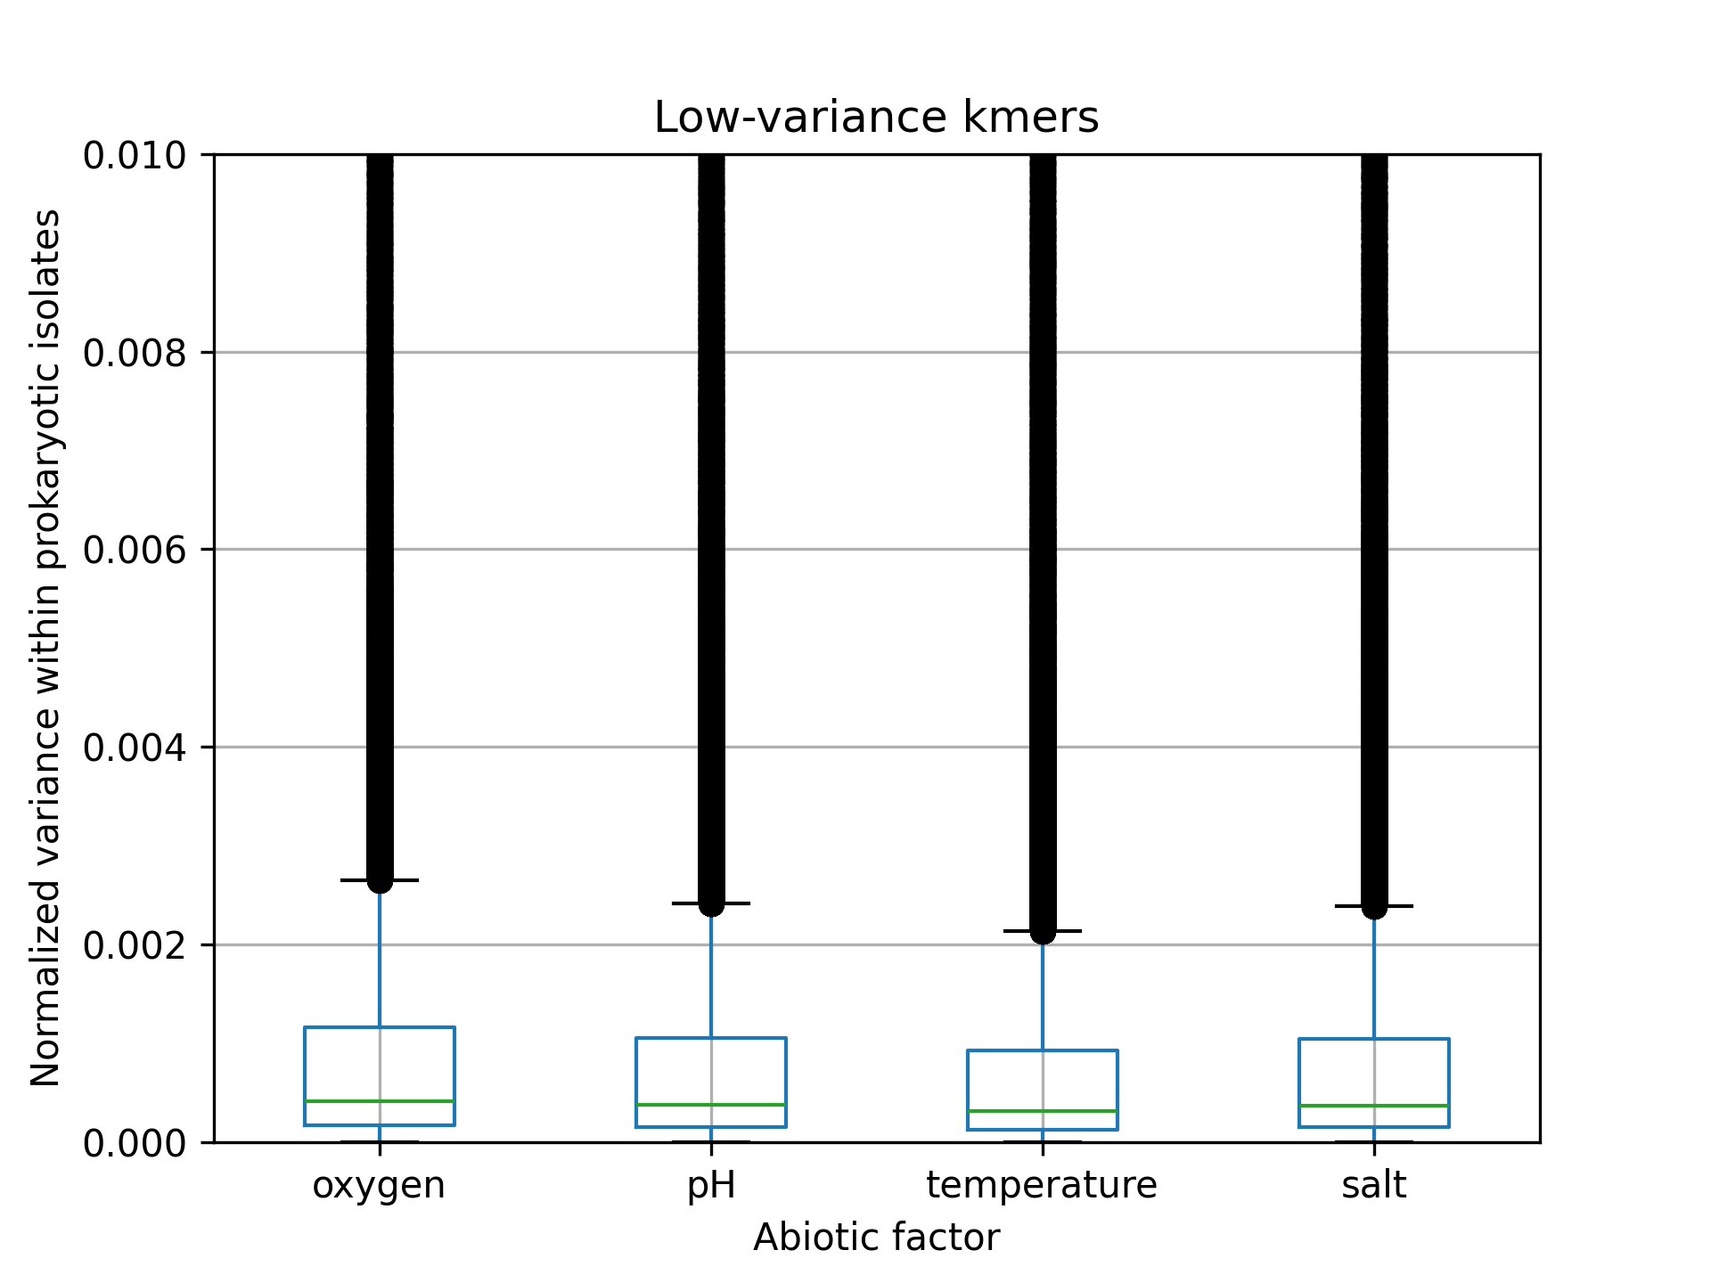
Conclusions:
- gene families have higher variance compared to kmers;
- for gene families, I we did the benchmark iteration between 0 and 0.01 normalized variance;
- for kmers, I we did the benchmark between 0 and 0.002 normalized variance.

Understanding normalized variances of gene families

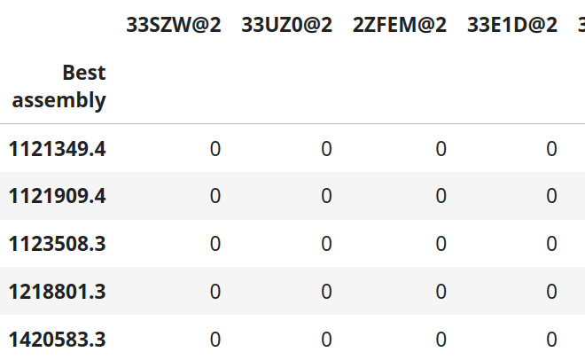
COGs with norm_var = 0 are absent from all species in the dataframe:

How about COGs with low, non-zero variances? They are present in very few species in the dataframes ( < 0.25% os isolates).

The tables below show counts of 1s (presence) in the abiotic factor’s dataframe for the indicated filter. For normalized variances between 0.002 and 0.010, the vast majority of species do not have the COGs.

Salinity (n = 3,418):
Low-variance filter | 0.002 | 0.003 | 0.004 | 0.005 | 0.006 | 0.008 | 0.009 | 0.010
Counts of 1s | 1 | 2 | 3 | 4 | 5 | 6 | 7 | 8
Percentages | 0.029 | 0.059 | 0.088 | 0.117 | 0.146 | 0.176 | 0.205 | 0.234

Temperature (n = 13,198):
Low-variance filter | 0.002 | 0.003 | 0.004 | 0.005 | 0.006 | 0.008 | 0.009 | 0.010
Counts of 1s | 4 | 7 | 10 | 14 | 17 | 25 | 27 | 33
Percentages | 0.030 | 0.053 | 0.076 | 0.106 | 0.129 | 0.189 | 0.205 | 0.250

Oxygen (n = 7,255):
Low-variance filter | 0.002 | 0.003 | 0.004 | 0.005 | 0.006 | 0.008 | 0.009 | 0.010
Counts of 1s | 2 | 4 | 6 | 8 | 10 | 13 | 15 | 18
Percentages | 0.028 | 0.055 | 0.083 | 0.110 | 0.138 | 0.179 | 0.207 | 0.248

pH (n = 3,630):
Low-variance filter | 0.002 | 0.003 | 0.004 | 0.005 | 0.006 | 0.008 | 0.009 | 0.010
Counts of 1s | 1 | 2 | 3 | 4 | 5 | 7 | 8 | 9
Percentages | 0.028 | 0.055 | 0.083 | 0.110 | 0.138 | 0.193 | 0.220 | 0.248

How about the top 50 most important features for salinity classification? In this experiment, I built a model to classify the salinity of prokaryotic isolates based on their COG profile.

- top 50 COGs of the SVC model had normalized variance between 0.34 and 1 (possible range: [0; 1])
- top 50 COGs of the RF model had normalized variance between 0.063 and 1 (possible range: [0; 1]).

Lowest variances:
- COG1025@2 has norm var = 0.34 (lowest variance of RF) and is present in 318/3,418 isolates; it is related to post-translational modification, protein turnover, and chaperones;
- COG3544@2 has norm var = 0.06 (lowest variance of SVC) and is present in 55/3,418 isolates; it is a domain of unknown function. Most of the 55 isolates have high or low salinity:
Salinity group
high 33
medium 18
low 4

RF top 50 features: SVC top 50 features:
Feature | Norm. variance |  | Feature | Norm. Variance
COG1025@2 | 0.338 |  | COG3544@2 | 0.063
COG0787@1 | 0.363 |  | COG3410@1 | 0.136
COG3887@2 | 0.485 |  | COG5617@2 | 0.192
COG0769@1 | 0.511 |  | COG4988@1 | 0.306
COG1154@2 | 0.526 |  | COG0173@2 | 0.316
COG0826@2 | 0.567 |  | COG0318@1 | 0.345
COG0569@1 | 0.587 |  | COG0532@2 | 0.373
COG3975@2 | 0.592 |  | COG0322@2 | 0.417
COG1115@2 | 0.631 |  | COG0129@2 | 0.475
COG2509@2 | 0.659 |  | COG3887@2 | 0.485
COG3968@2 | 0.664 |  | COG1154@2 | 0.526
COG0471@2 | 0.701 |  | COG0826@2 | 0.567
COG1042@1 | 0.717 |  | COG0569@1 | 0.587
COG2176@2 | 0.732 |  | COG1012@2 | 0.654
COG0025@2 | 0.732 |  | COG2509@2 | 0.659
COG2060@2 | 0.758 |  | COG1960@2 | 0.660
COG2759@2 | 0.785 |  | COG3968@2 | 0.664
COG1274@2 | 0.807 |  | COG3533@2 | 0.671
COG3605@2 | 0.808 |  | COG3347@1 | 0.739
COG3158@2 | 0.824 |  | COG0249@2 | 0.748
COG4666@2 | 0.831 |  | COG3285@1 | 0.786
COG1884@1 | 0.852 |  | COG1074@2 | 0.797
COG5000@2 | 0.870 |  | COG1033@2 | 0.803
COG3408@2 | 0.888 |  | COG1274@2 | 0.807
COG2216@2 | 0.900 |  | COG3605@2 | 0.808
COG0745@1 | 0.905 |  | COG3158@2 | 0.824
COG0659@2 | 0.922 |  | COG4666@2 | 0.831
COG3387@2 | 0.926 |  | COG0318@2 | 0.838
COG2373@2 | 0.934 |  | COG2866@2 | 0.843
COG0477@2 | 0.939 |  | COG0442@2 | 0.860
COG0370@2 | 0.948 |  | COG0358@2 | 0.867
COG1292@2 | 0.956 |  | COG4191@1 | 0.878
COG3696@2 | 0.958 |  | COG3408@2 | 0.888
COG1009@2 | 0.960 |  | COG1271@2 | 0.896
COG1038@2 | 0.960 |  | COG2216@2 | 0.900
COG2352@2 | 0.970 |  | COG1003@1 | 0.924
COG0281@1 | 0.982 |  | COG2373@2 | 0.934
COG3808@2 | 0.982 |  | COG0477@2 | 0.939
COG0326@2 | 0.983 |  | COG1292@2 | 0.956
COG0539@2 | 0.986 |  | COG3696@2 | 0.958
COG2111@1 | 0.986 |  | COG5002@2 | 0.959
COG0531@2 | 0.987 |  | COG2303@2 | 0.960
COG1866@2 | 0.989 |  | COG1554@2 | 0.963
COG1034@2 | 0.990 |  | COG0591@2 | 0.968
COG0554@2 | 0.991 |  | COG2902@2 | 0.976
COG4147@2 | 0.996 |  | COG0281@1 | 0.982
COG0422@2 | 0.997 |  | COG2838@2 | 0.983
COG1032@2 | 0.998 |  | COG0753@2 | 0.994
COG1523@2 | 1.000 |  | COG1032@2 | 0.998
COG0277@1 | 1.000 |  | COG1523@2 | 1.000

Applying filter with best F1 score

If we filter features based on the variance yielding the best F1 scores, we will have:

 | Salinity |  |  |  | Temperature |  |  |  | pH |  | Oxygen
 | Gene Families | Gene Families | kmer9 | kmer9 | Gene Families | Gene Families | kmer9 | kmer9 | Gene Families | kmer9 | Gene Families | kmer9
 | Classif of extremes | Regres of full range | Classif of extremes | Regres of full range | Classif of extremes | Regres of full range | Classif of extremes | Regres of full range | Regres of full range | Regres of full range | Classif of extremes | Classif of extremes
isolates | n = 746 | n = 3,418 | n = 746 | n = 3,418 | n = 534 | n = 13,198 | n = 534 | n = 13,198 | n = 3,630 | n = 3,630 | n = 2,722 | n = 2,722
features | 20,141 | 20,141 | 131,072 | 131,072 | 20,141 | 20,141 | 131,072 | 131,072 | 20,141 | 131,072 | 20,141 | 131,072
Filter by variance | 3,725 | 10,977 | 31,152 | 26,345 | 4,305 | 5,640 | 131,072 | 82,051 | 20,141 | 40,239 | 4,823 | 24,008
Join correlated features
Tree based
LASSO
L2
RFE
sequential forward

Salt, gene-families

Classification (RF, undersampling) Regression (RF, mean NaCl)
Number of initial isolates for filtering: 3,418 Number of initial isolates for filtering: 3,418
Number of initial features: 20,141 Number of initial features: 20,141
Number of isolates considered in the analysis: 746 Number of isolates of analysis: 2,734
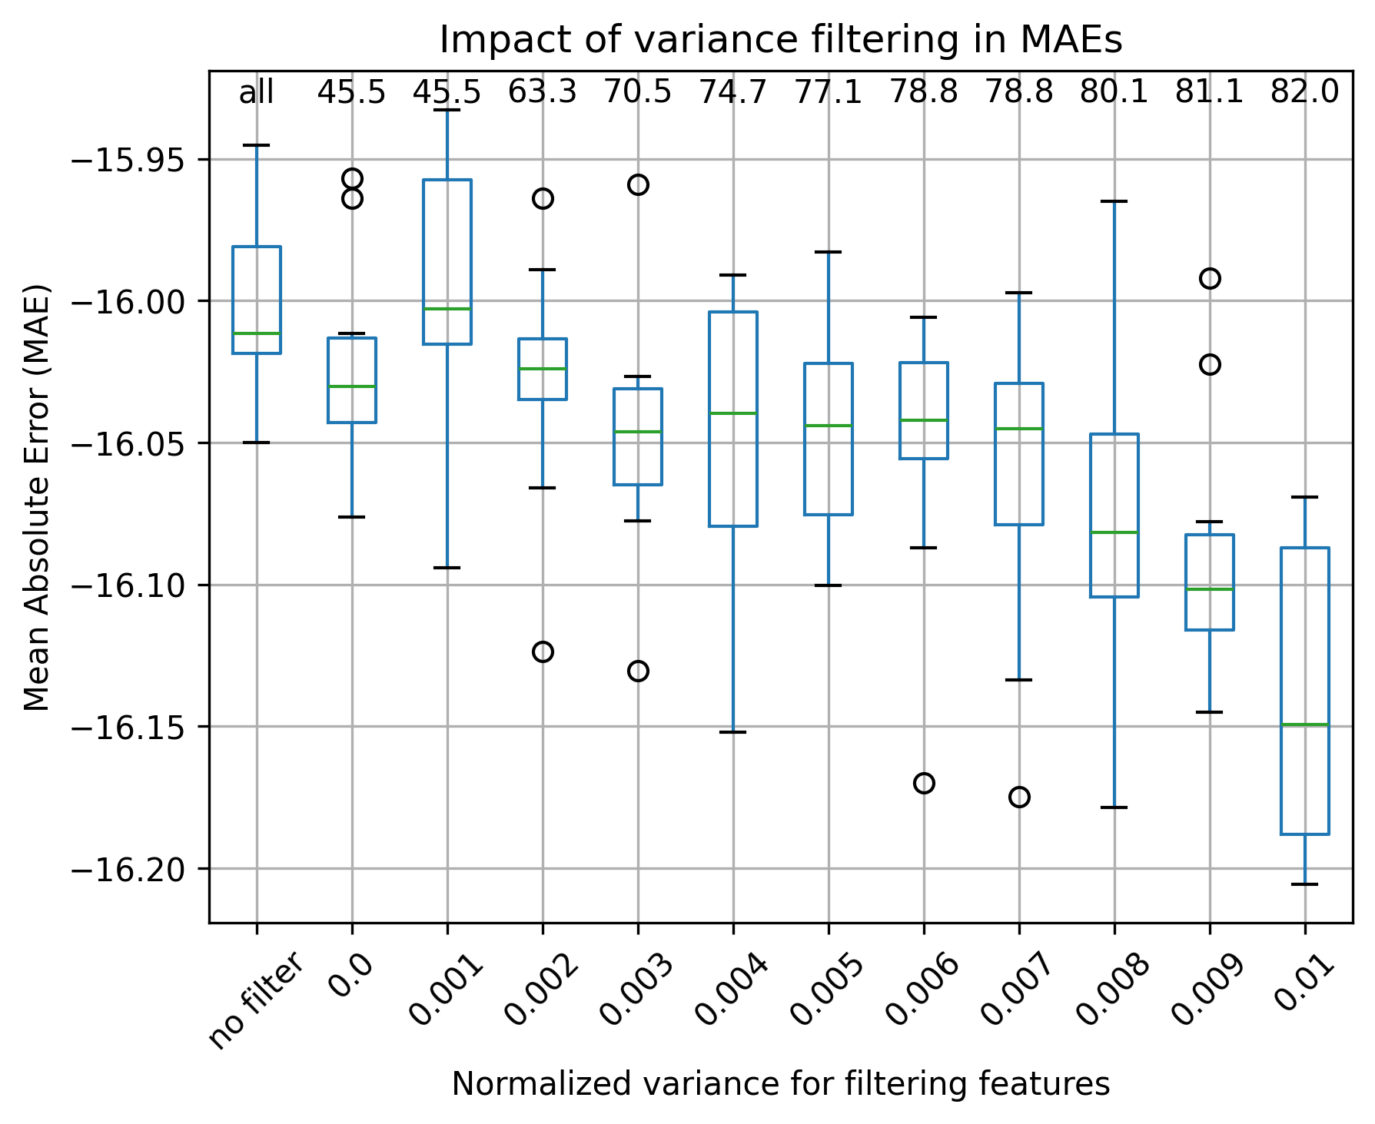
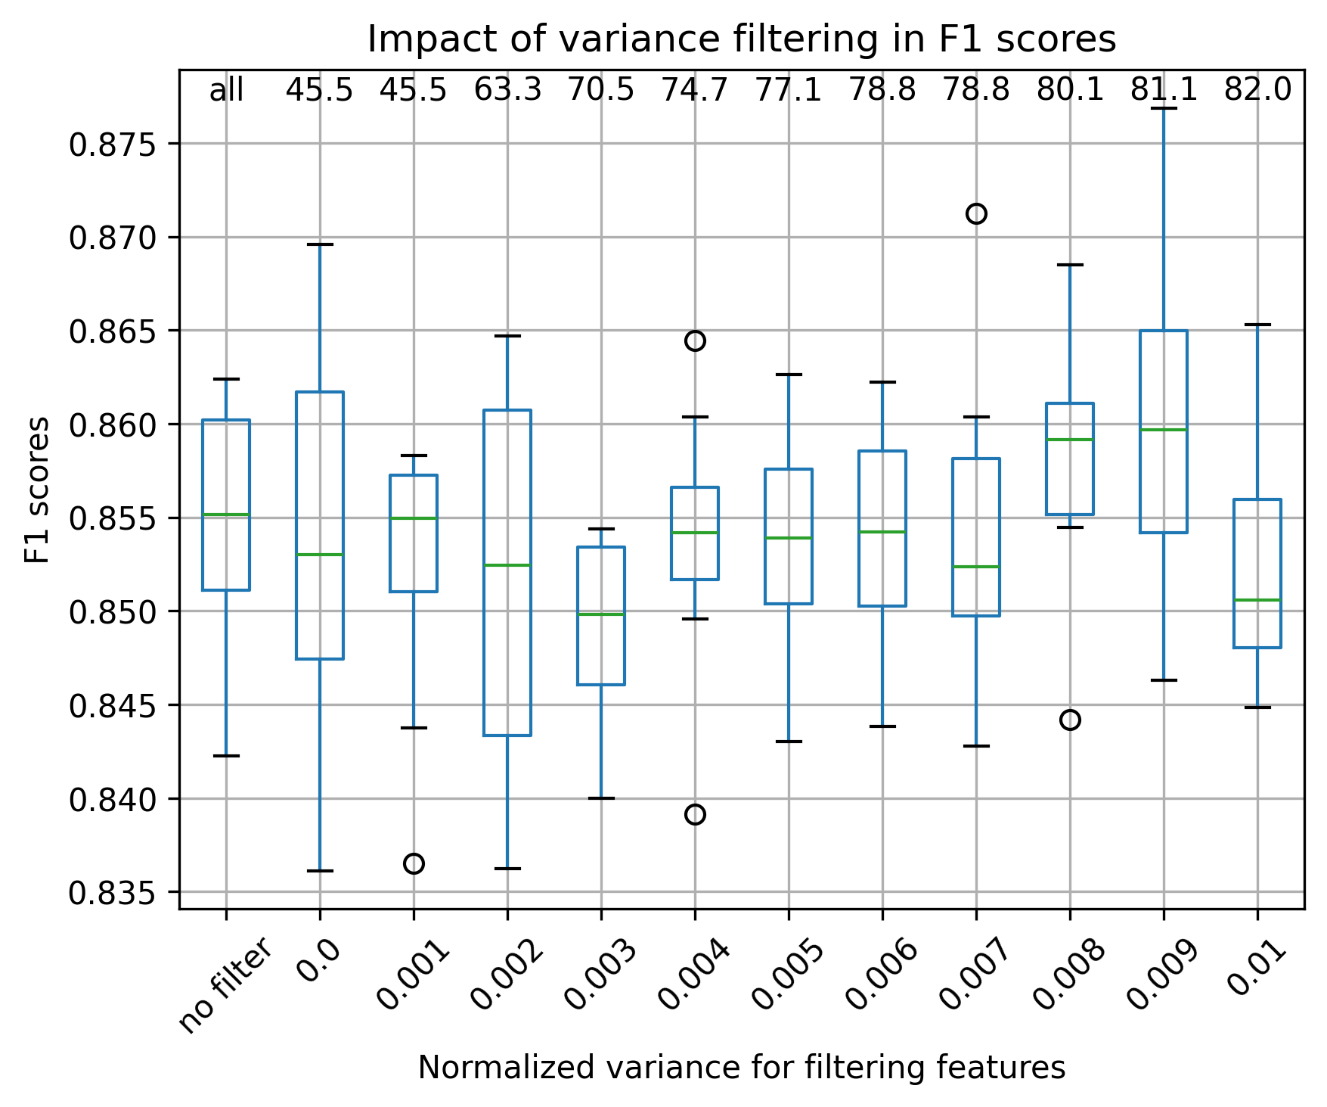

Choice of threshold: 0.009 Choice of threshold: 0.001
Obs: The numbers on top of the plot indicate the percentage of features that are filtered out when applying the filtering, “all” indicates no filter was applied.

Of the initial 20,141 Gfs, 9,155 (45.5%) had zero normalized variance. All of the 9,155 COGs had zeroes in the dataframe.

Salt, kmer9

Classification (RF, undersampling) Regression (RF, mean NaCl)
Number of initial isolates for filtering: 3,418 Number of initial isolates for filtering: 3,418
Number of initial features: 131,072 Number of initial features: 131,072
Number of isolates considered in the analysis: 746 Number of isolates of analysis: 2,734

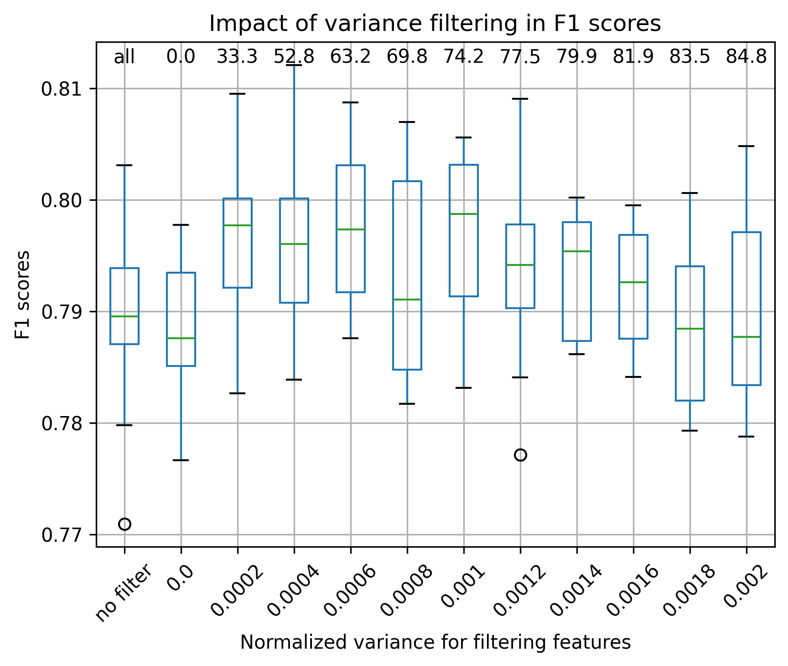
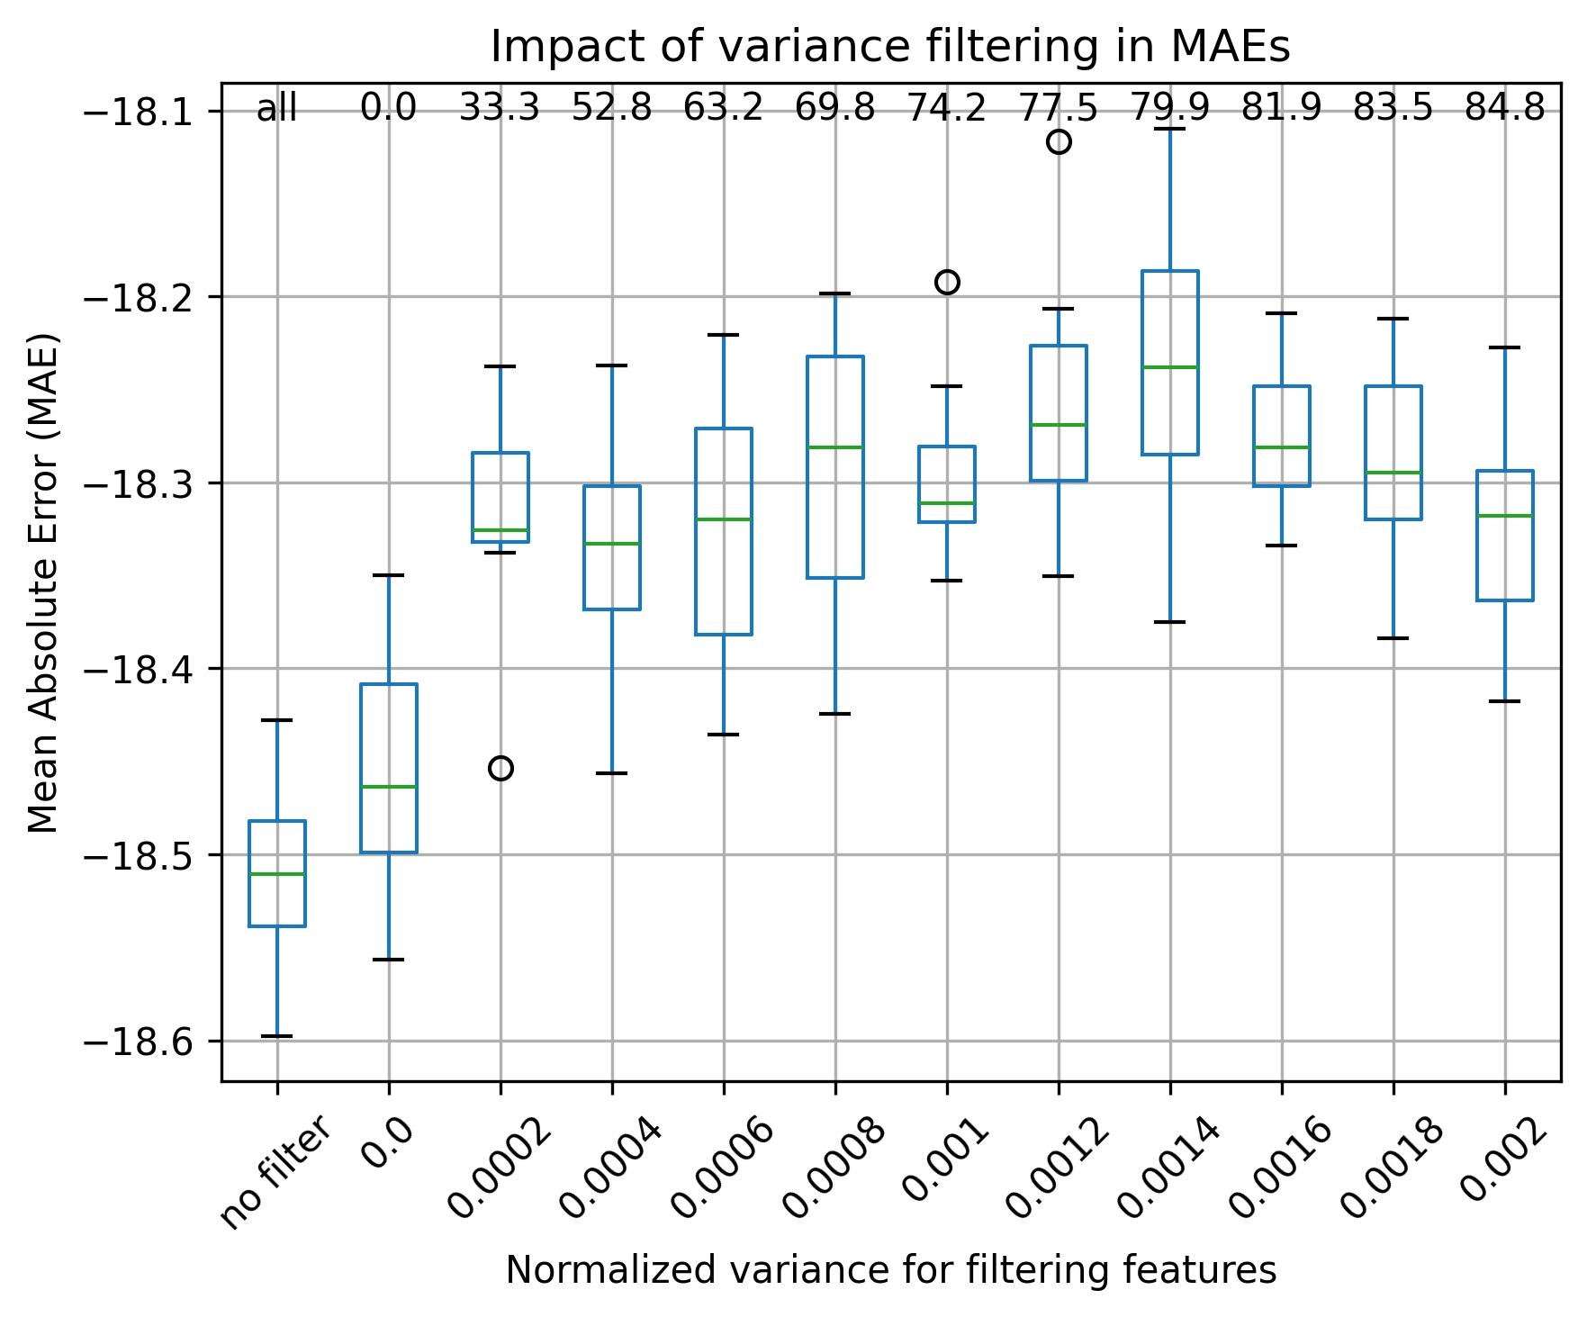

Choice of threshold: 0.001 Choice of threshold: 0.0014

Temperature, gene-families

Classification (RF, undersampling) Regression (RF, mean temperature)
Number of initial isolates for filtering: 13,198 Number of initial isolates for filtering: 13,198
Number of initial features: 20,141 Number of initial features: 20,141
Number of isolates considered in the analysis: 534 Number of isolates considered in the analysis: 10,558

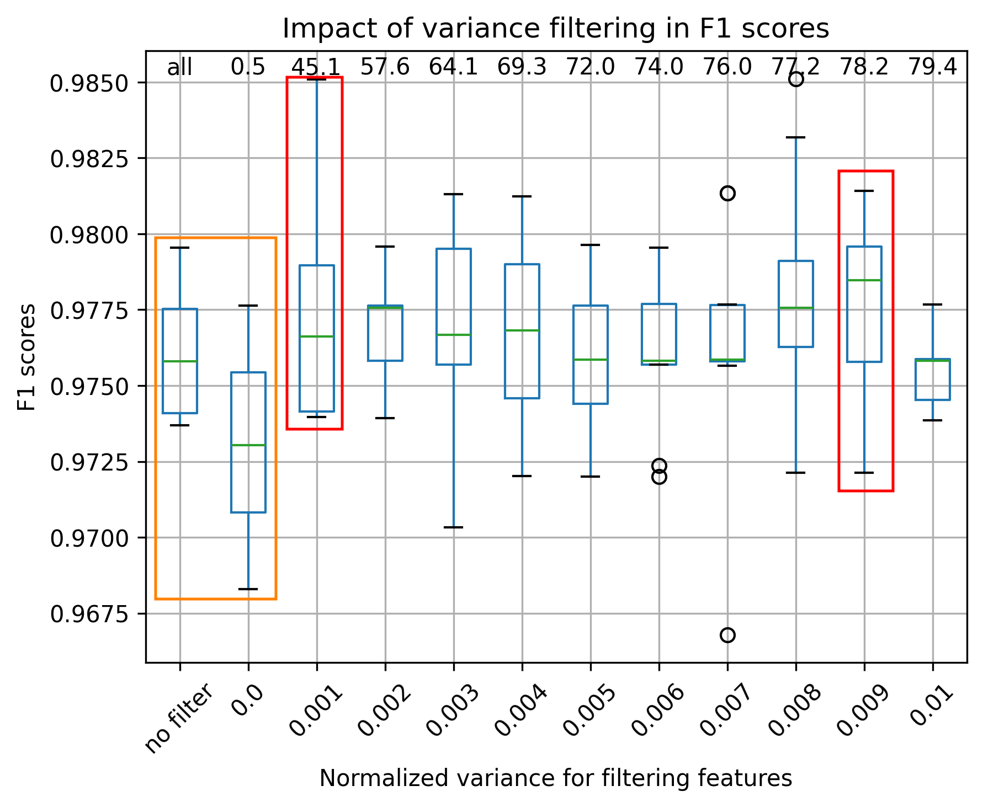
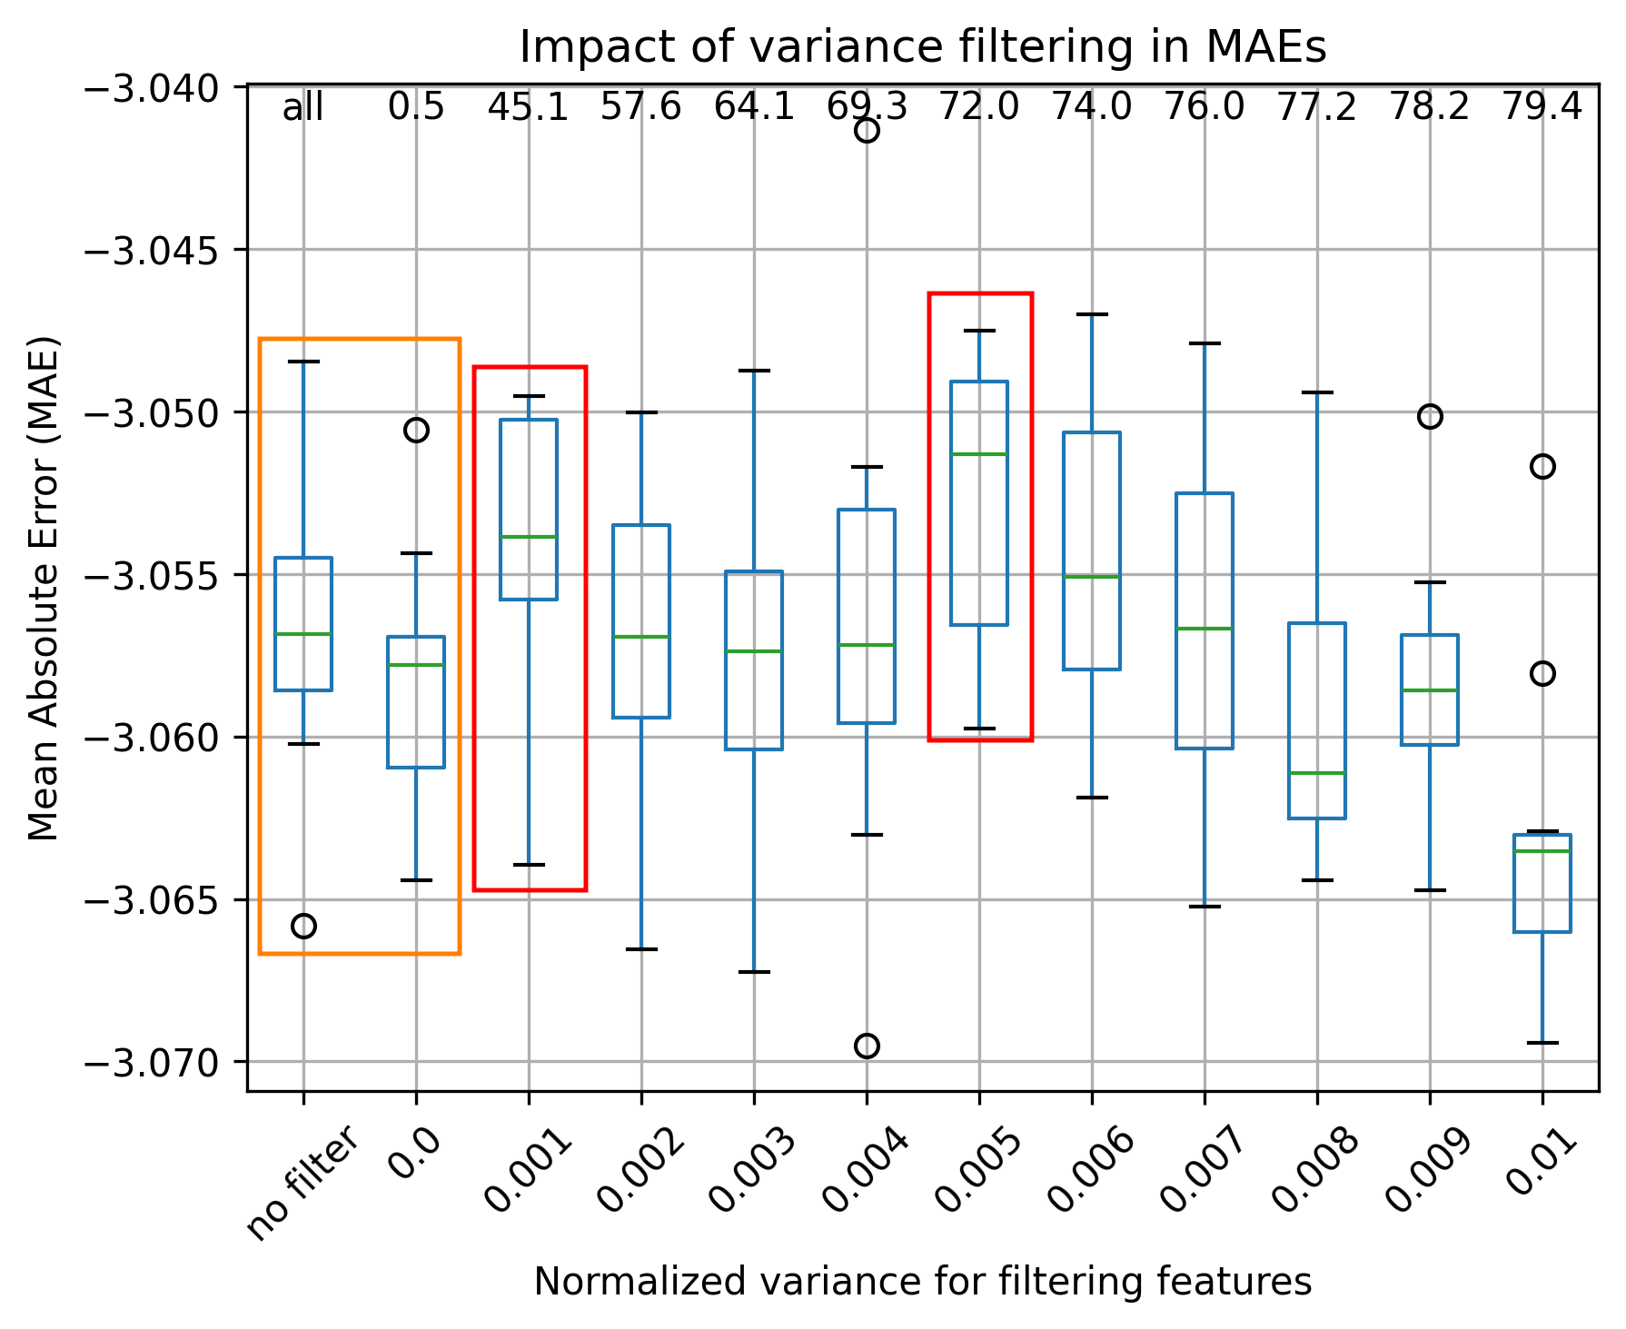

Choice of threshold: 0.009 Choice of threshold: 0.005
Obs: Mann-Whitney test p-value > 0.05 for groups marked in orange and red. This means that “no filter” and filtering features with 0.0 variance have no difference in the RF metrics. Additionally, some other groups also have no difference in the RF metrics.

Temperature, kmer9

Classification (RF, undersampling) Regression (RF, mean NaCl)
Number of initial isolates for filtering: 13,198 Number of initial isolates for filtering: 13,198
Number of initial features: 131,072 Number of initial features: 131,072
Number of isolates considered in the analysis: 534 Number of isolates considered in the analysis: 10,558

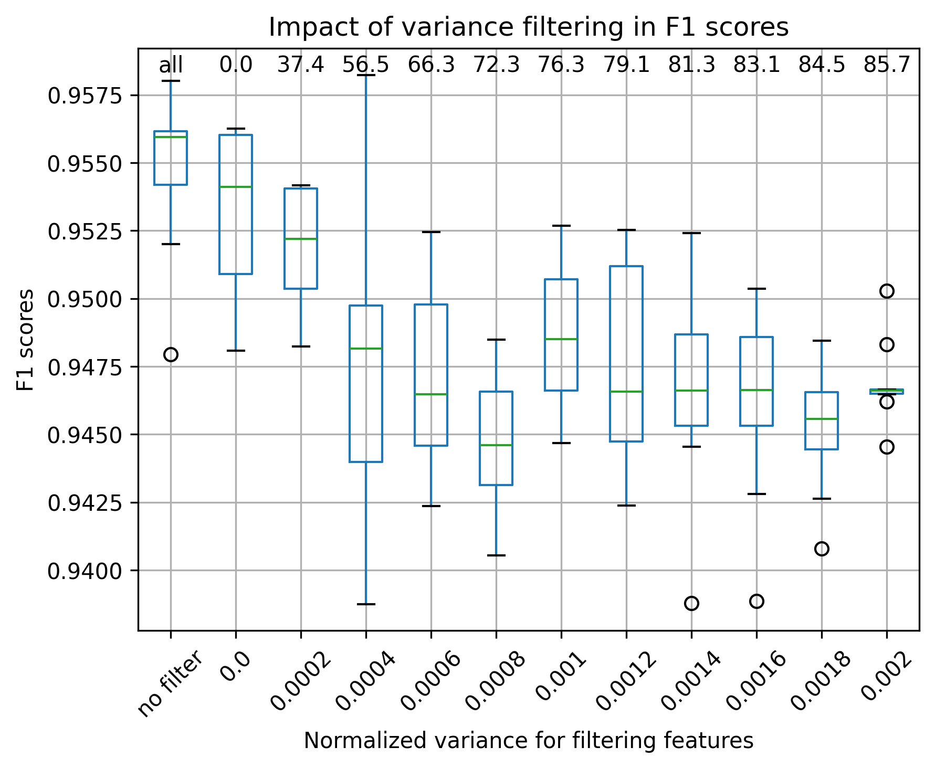
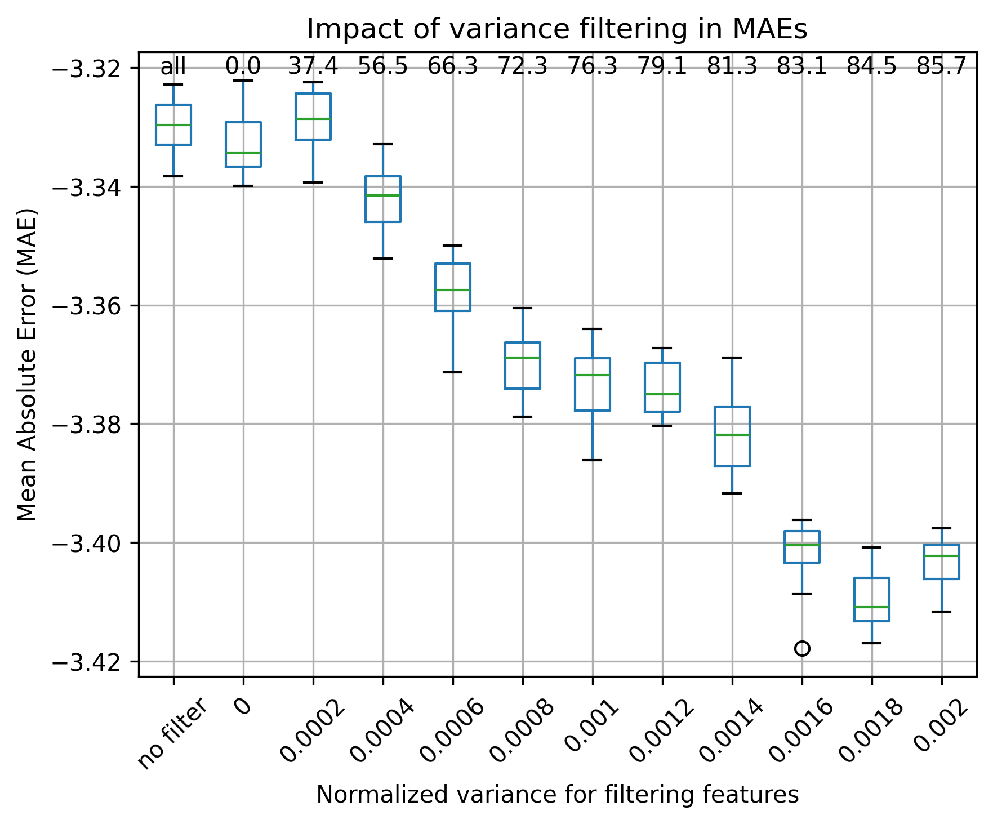

Choice of threshold: 0.0 Choice of threshold: 0.0002

Oxygen, classification

Gene families (RF, undersampling) kmer9 (RF, undersampling)
Number of initial isolates for filtering: 7,255 Number of initial isolates for filtering: 7,255
Number of initial features: 20,141 Number of initial features: 131,072
Number of isolates considered in the analysis: 2,722 Number of isolates considered in the analysis: 2,722

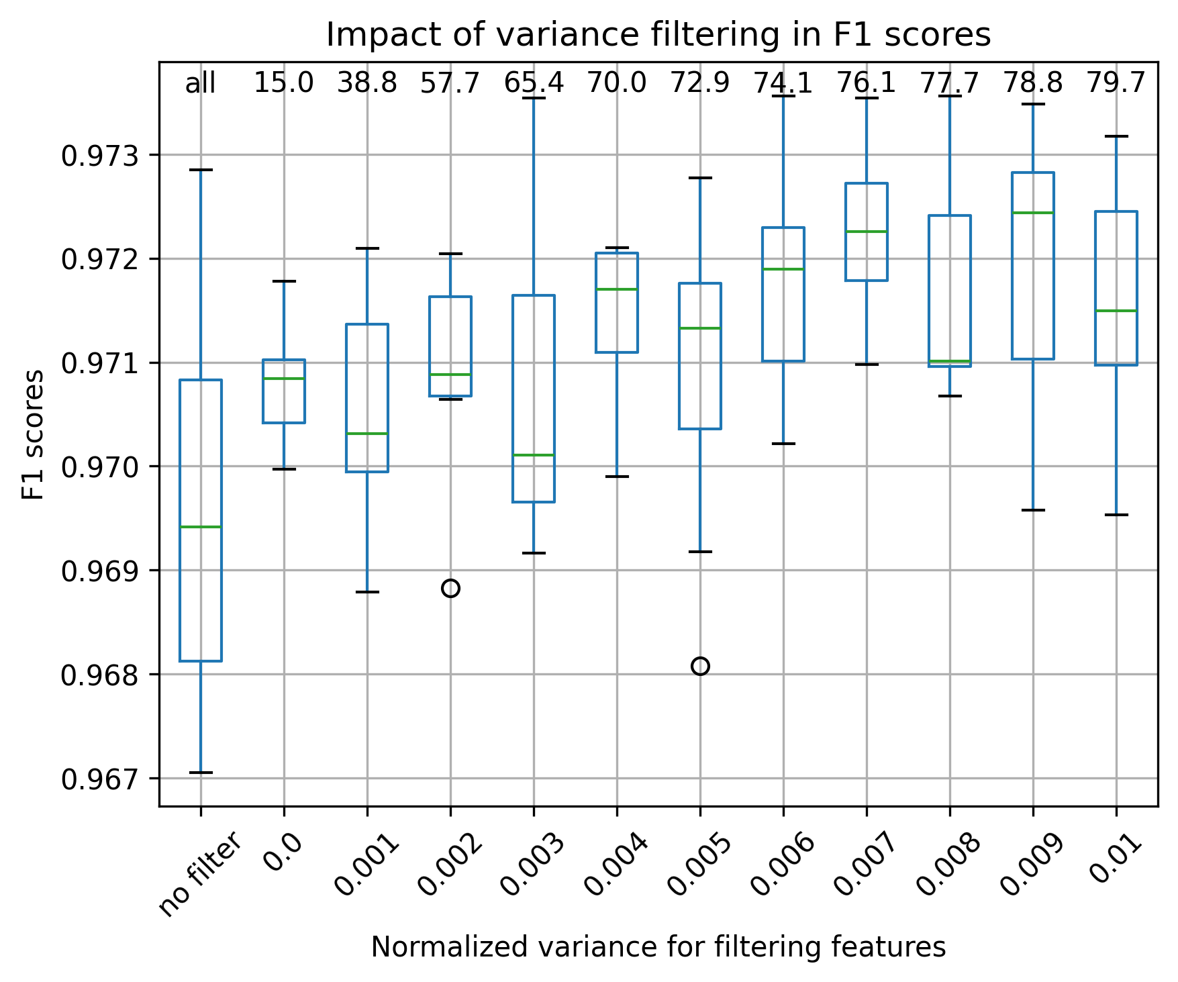
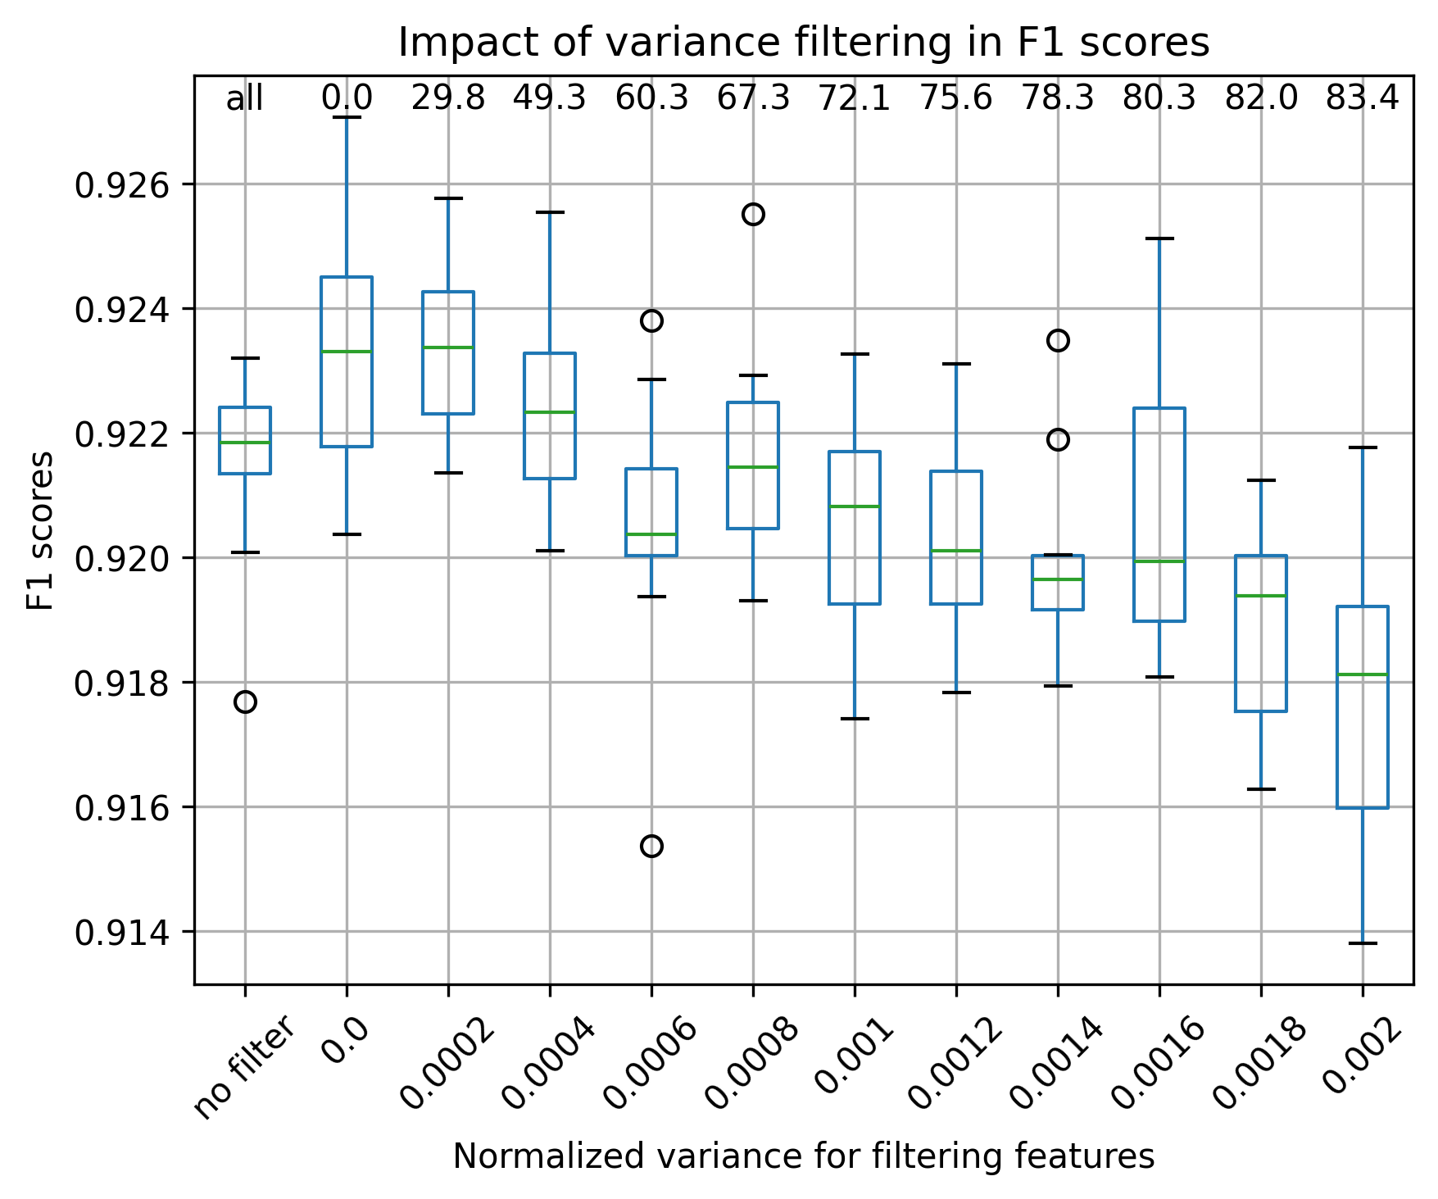

Choice of threshold: 0.009 Choice of threshold: 0.0002

pH, regression

Gene families (RF, mean pH) kmer9 (RF, mean pH)
Number of initial isolates for filtering: 3,630 Number of initial isolates for filtering: 3,630
Number of initial features: 20,141 Number of initial features: 131,072
Number of isolates considered in the analysis: 2,904 Number of isolates considered in the analysis: 2,904
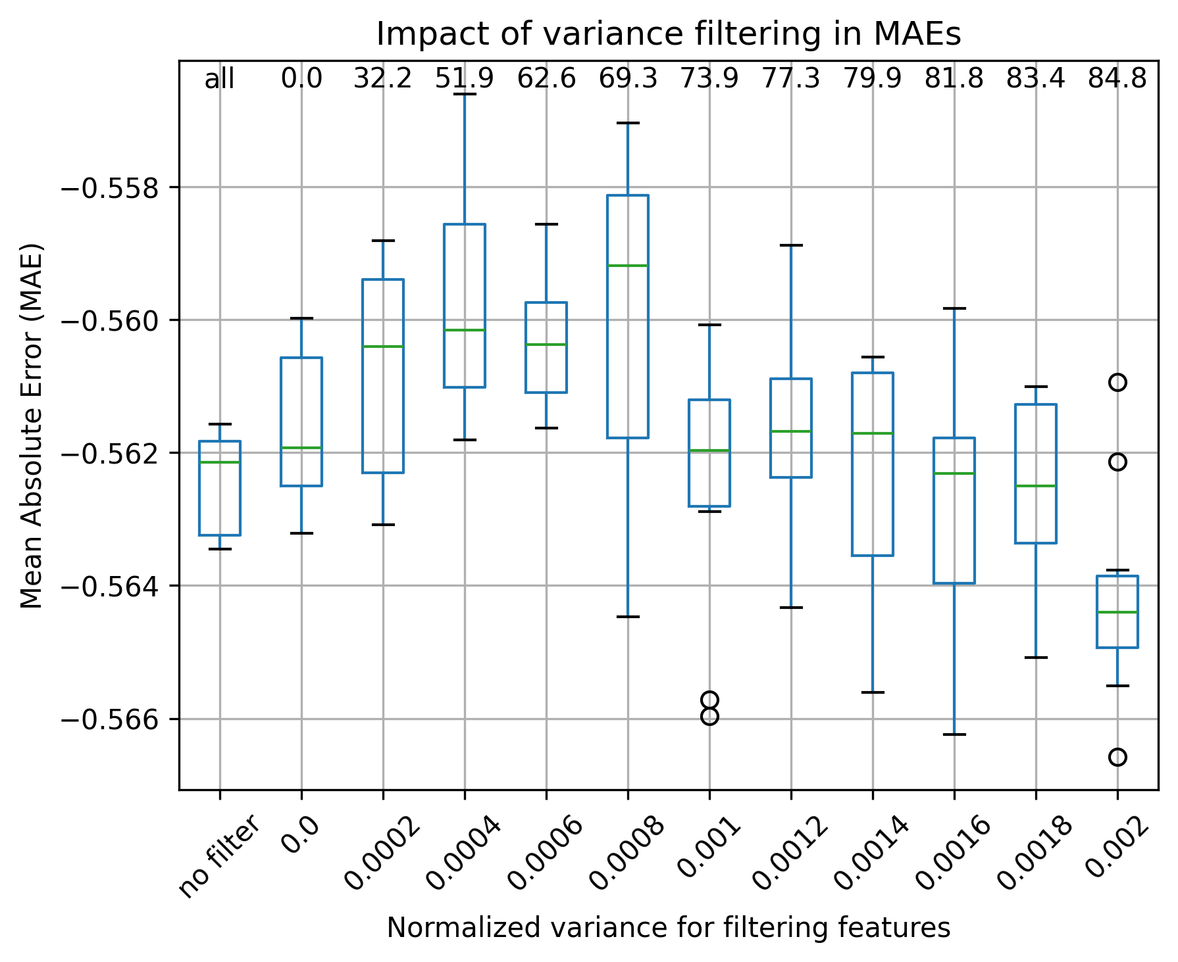
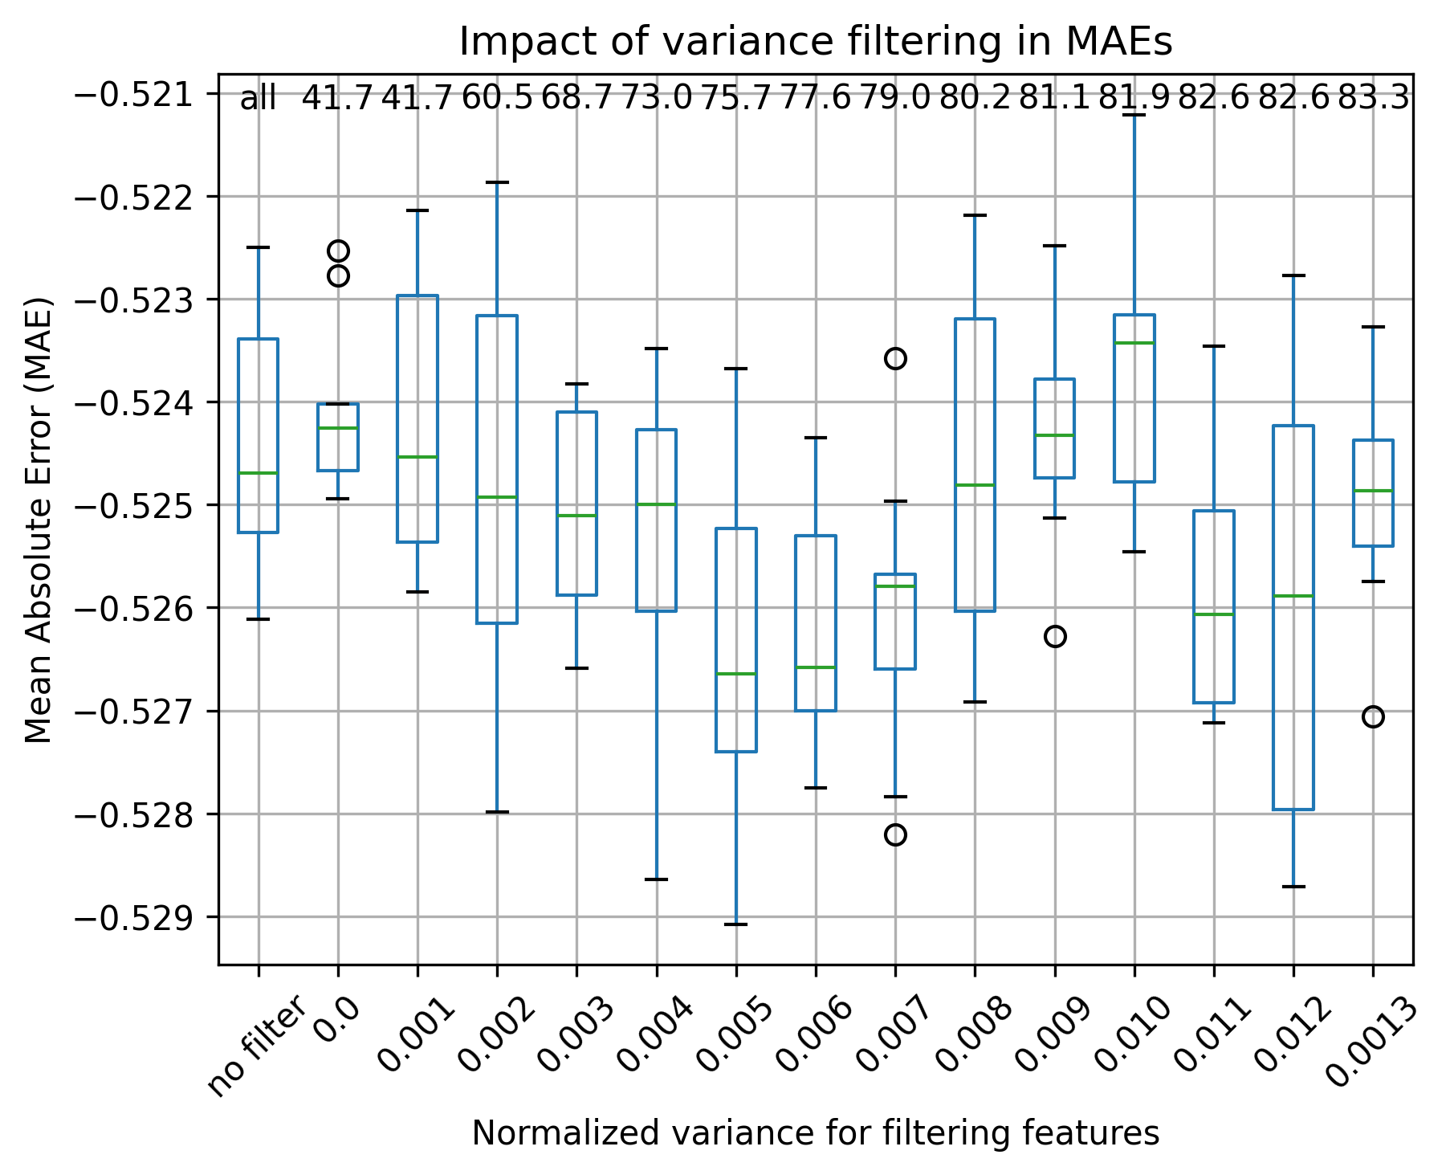

Choice of threshold: 0.010 Choice of threshold: 0.0008

