Benchmark to choose threshold for joining features based on correlation

Features that correlate highly only add complexity to the model without yielding extra information. Therefore, we decided to filter out highly correlated features. We identified correlated features and chose one feature to represent the group. The representative feature is the one with the highest correlation values to others of the group.

In this benchmark, we chose different Spearman correlation values, from 0.70 to 0.95 and measured the machine learning metrics when choosing different filters.

Number of features after applying different filters

 | Salinity |  |  |  | Temperature |  |  |  | pH |  | Oxygen
 | Gene Families | Gene Families | kmer9 | kmer9 | Gene Families | Gene Families | kmer9 | kmer9 | Gene Families | kmer9 | Gene Families | kmer9
 | Classif of extremes | Regres of full range | Classif of extremes | Regres of full range | Classif of extremes | Regres of full range | Classif of extremes | Regres of full range | Regres of full range | Regres of full range | Classif of extremes | Classif of extremes
isolates | n = 746 | n = 3,418 | n = 746 | n = 3,418 | n = 534 | n = 13,198 | n = 534 | n = 13,198 | n = 3,630 | n = 3,630 | n = 2,722 | n = 2,683
features | 20,141 | 20,141 | 131,072 | 131,072 | 20,141 | 20,141 | 131,072 | 131,072 | 20,141 | 131,072 | 20,141 | 131,072
Filter by variance | 3,725 | 10,977 | 31,151 | 26,345 | 4,305 | 5,640 | 131,072 | 82,051 | 3,638 | 40,230 | 4,823 | 24,008
Join correlated features | 3,002 | 7,700  (tara 2h) | 2,174  (2 chunks) | 9,384  (draco 31h, 8G, 1 core) | 3,173 | 5,581  (draco 9h, 11G, 5 cores) | 9,062  (5 chunks)** | 6,793  (4 chunks*, draco 9 days no filter, 18h others, 5 cores) | 3,583  (draco 2h, 5G, 5 cores) | 4,096  (2 chunks,  draco 37h, 11G, 5 cores) | 4,651 | 8,867
RFE
Tree based
Sequential forward
L2/LASSO

*: high correlations are not possible to be calculated, the matrices are too large. I ll do the benchmark only until 85%
“no filter” is running in parallel to cor filters
**: thresholds 0.70, 0.75 could be calculated, but >=0.80 could not. Even if they could, too many features would remain
shapes: 0.70: (668, 11471)
0.75: (668, 20610)
0.80: (668, 35487)
0.85: (668, 57725)
0.90: (668, 87951)
0.95: (668, 120554)

Salt, gene-families

Classification (RF, undersampling) Regression (RF, mean NaCl)
Number of initial isolates for filtering: 932 Number of initial isolates for filtering: 3,418
Number of initial features: 3,724 Number of initial features: 10,986
Number of isolates considered in the analysis: 745 Number of isolates of analysis: 2,734

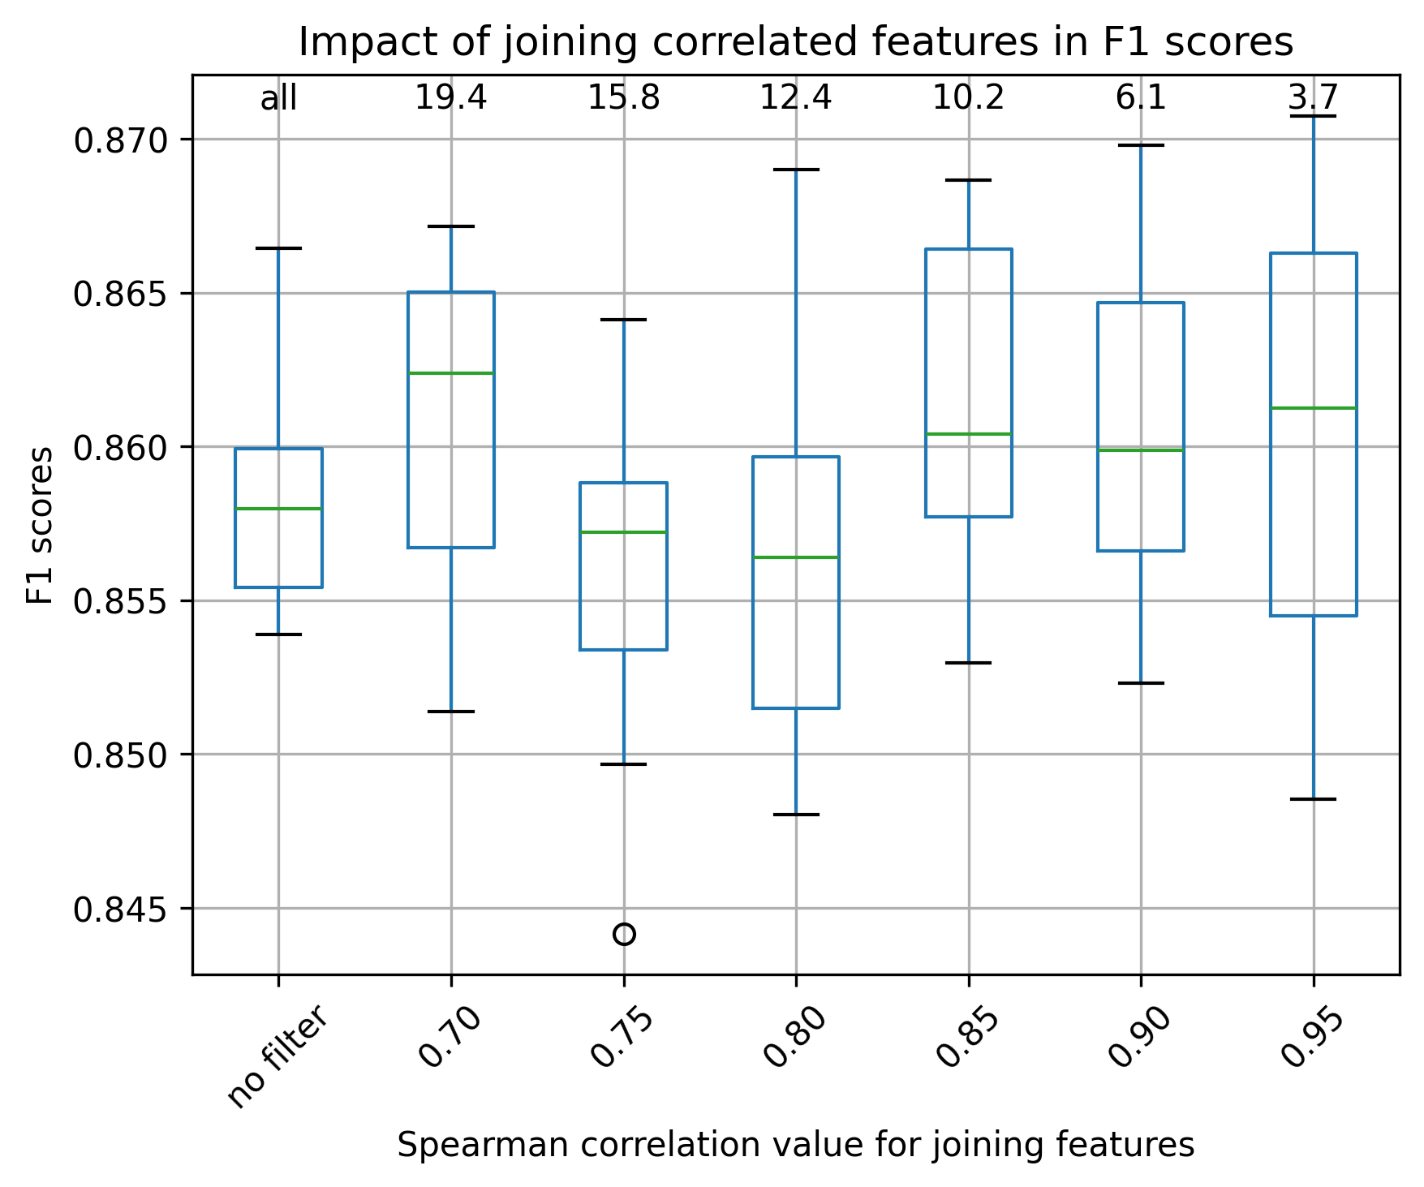
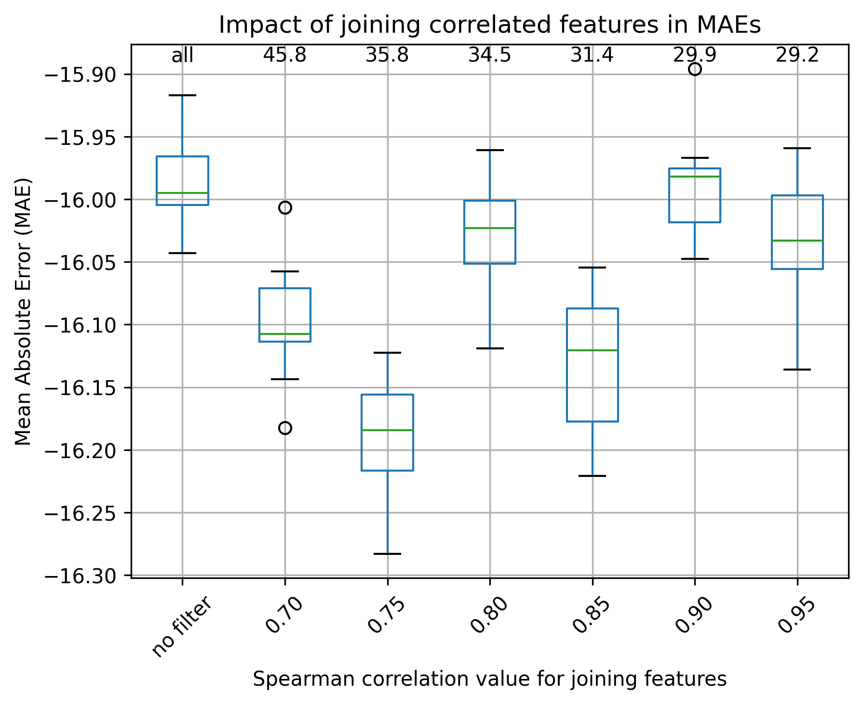

Choice of threshold: 0.70 Choice of threshold: 0.90
Obs: The numbers on top of the plot indicate the percentage of features that are filtered out when applying the filtering, “all” indicates no correlation filter was applied.

Salt, kmer9

Classification (RF, undersampling) Regression (RF, mean NaCl)
Number of initial isolates for filtering: 932 Number of initial isolates for filtering: 3,418
Number of initial features: 31,151 Number of initial features: 26,301
Number of isolates considered in the analysis: 745 Number of isolates of analysis: 2,734

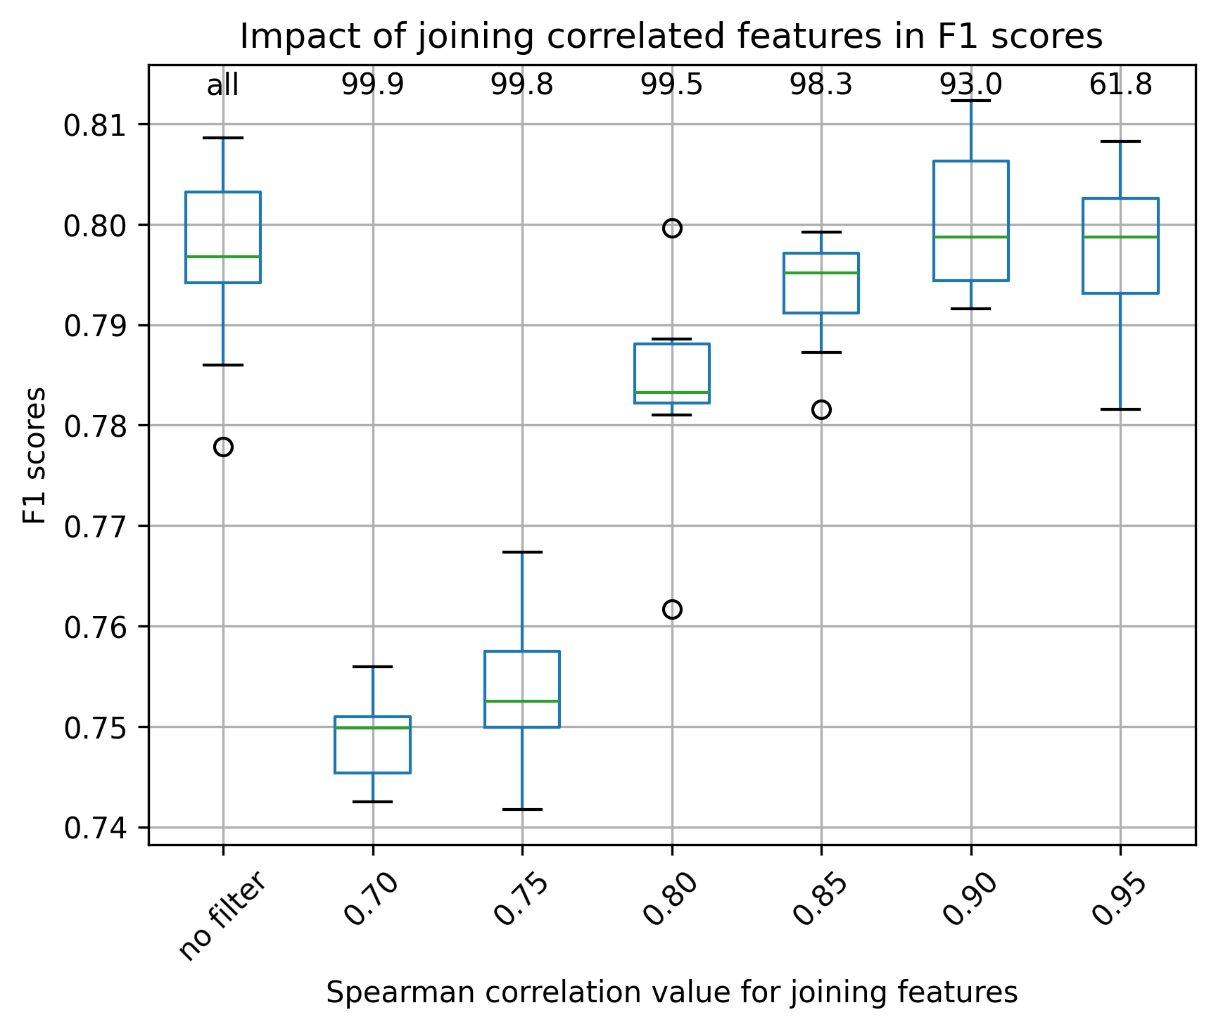
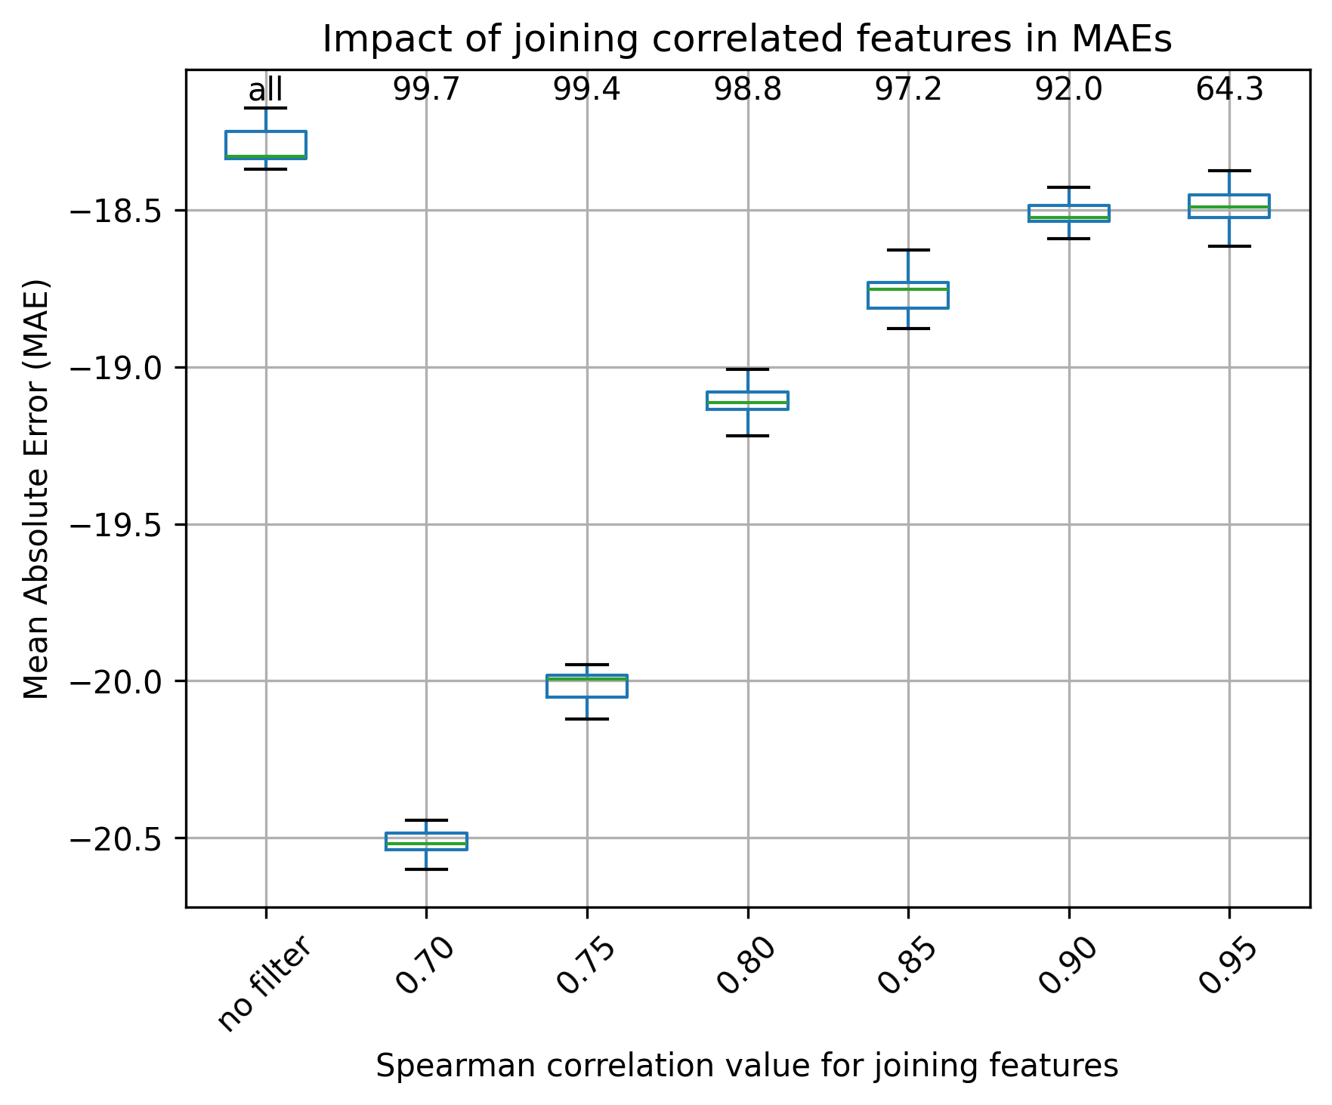

Choice of threshold: 0.90 Choice of threshold: 0.95

Temperature, gene-families

Classification (RF, undersampling) Regression (RF, mean temperature)
Number of initial isolates for filtering: 668 Number of initial isolates for filtering: 13,198
Number of initial features: 4,305 Number of initial features: 5,642
Number of isolates considered in the analysis: 534 Number of isolates considered in the analysis: 10,558
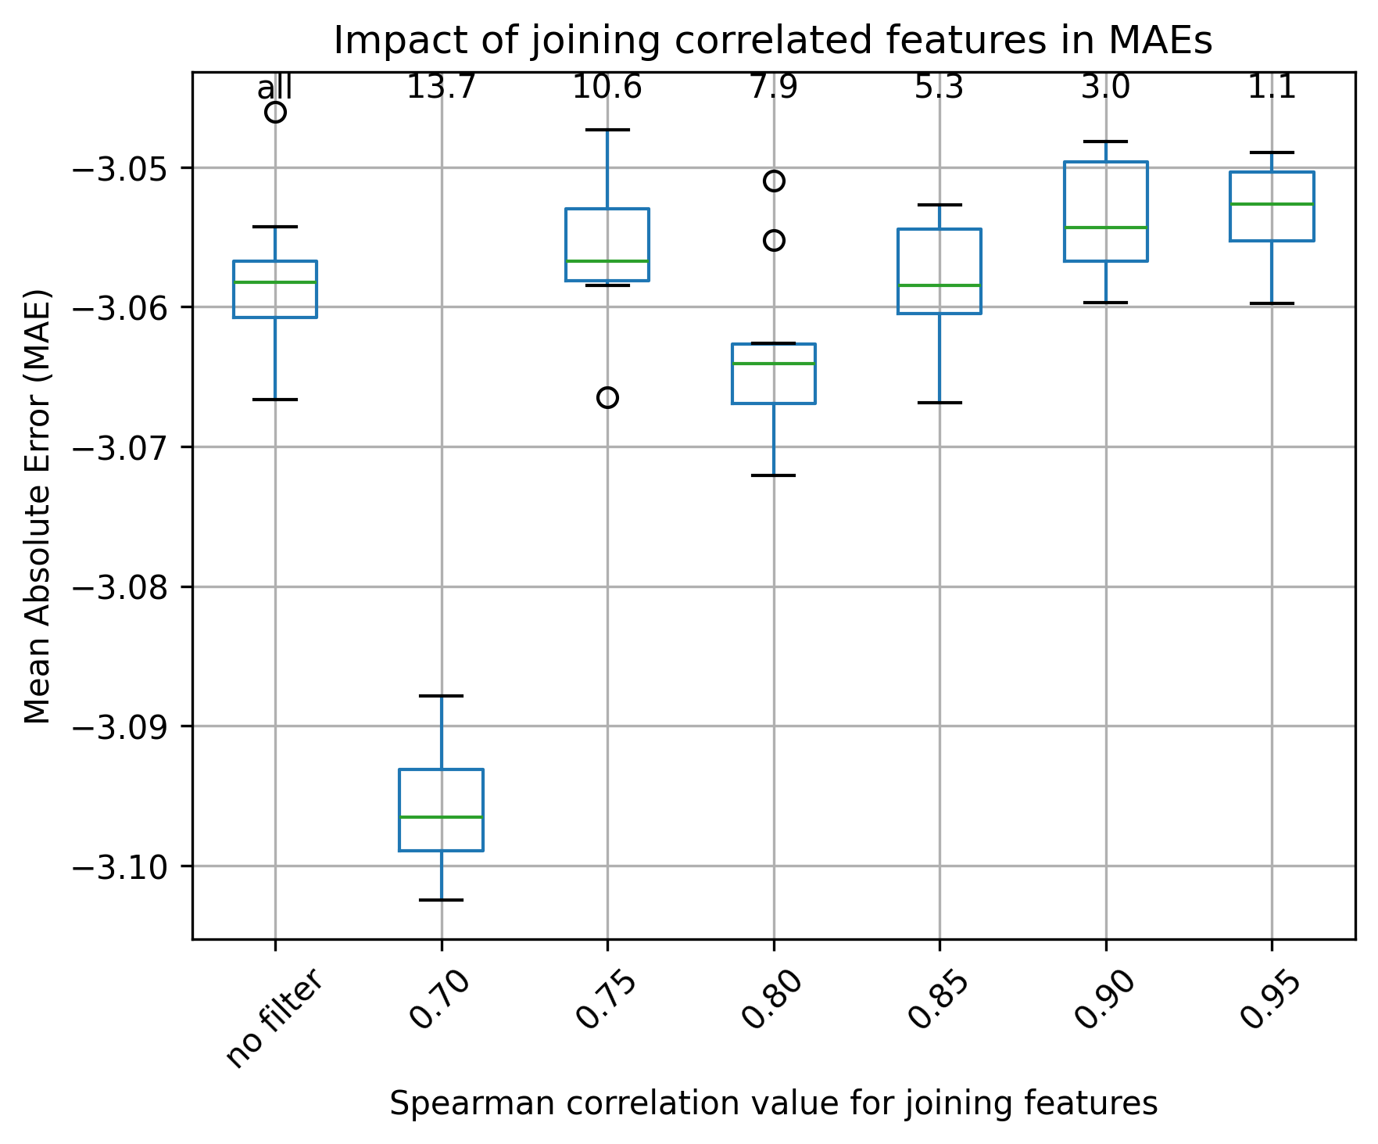
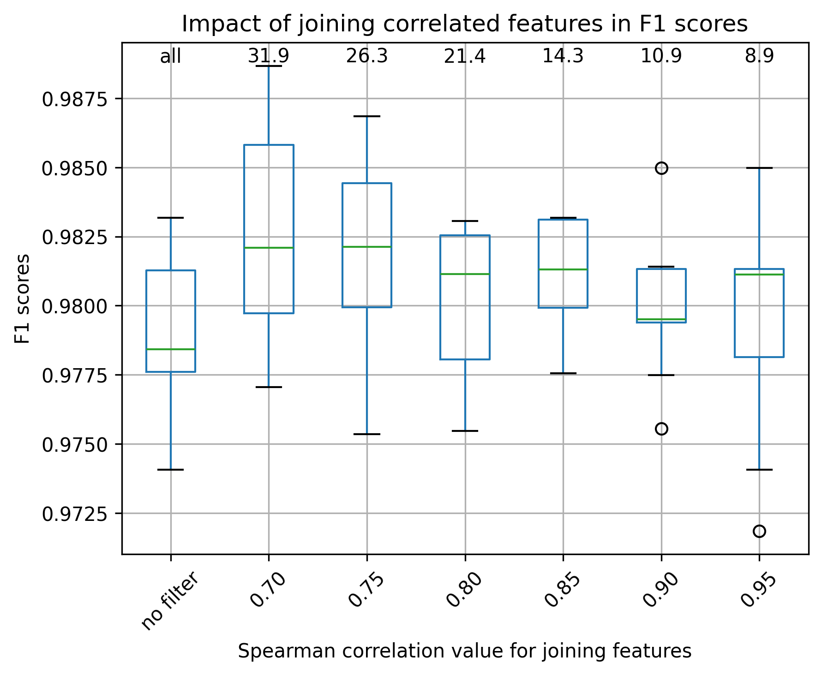

Choice of threshold: 0.75 Choice of threshold: 0.95
Obs: Mann-Whitney test p-value > 0.05 for groups marked in orange and red. This means that “no filter” and filtering features with 0.0 variance have no difference in the RF metrics. Additionally, some other groups also have no difference in the RF metrics.

Temperature, kmer9

Classification (RF, undersampling) Regression (RF, mean NaCl)
Number of initial isolates for filtering: 668 Number of initial isolates for filtering: 13,198
Number of initial features: 131,072 Number of initial features: 82,051
Number of isolates considered in the analysis: 534 Number of isolates considered in the analysis: 10,558

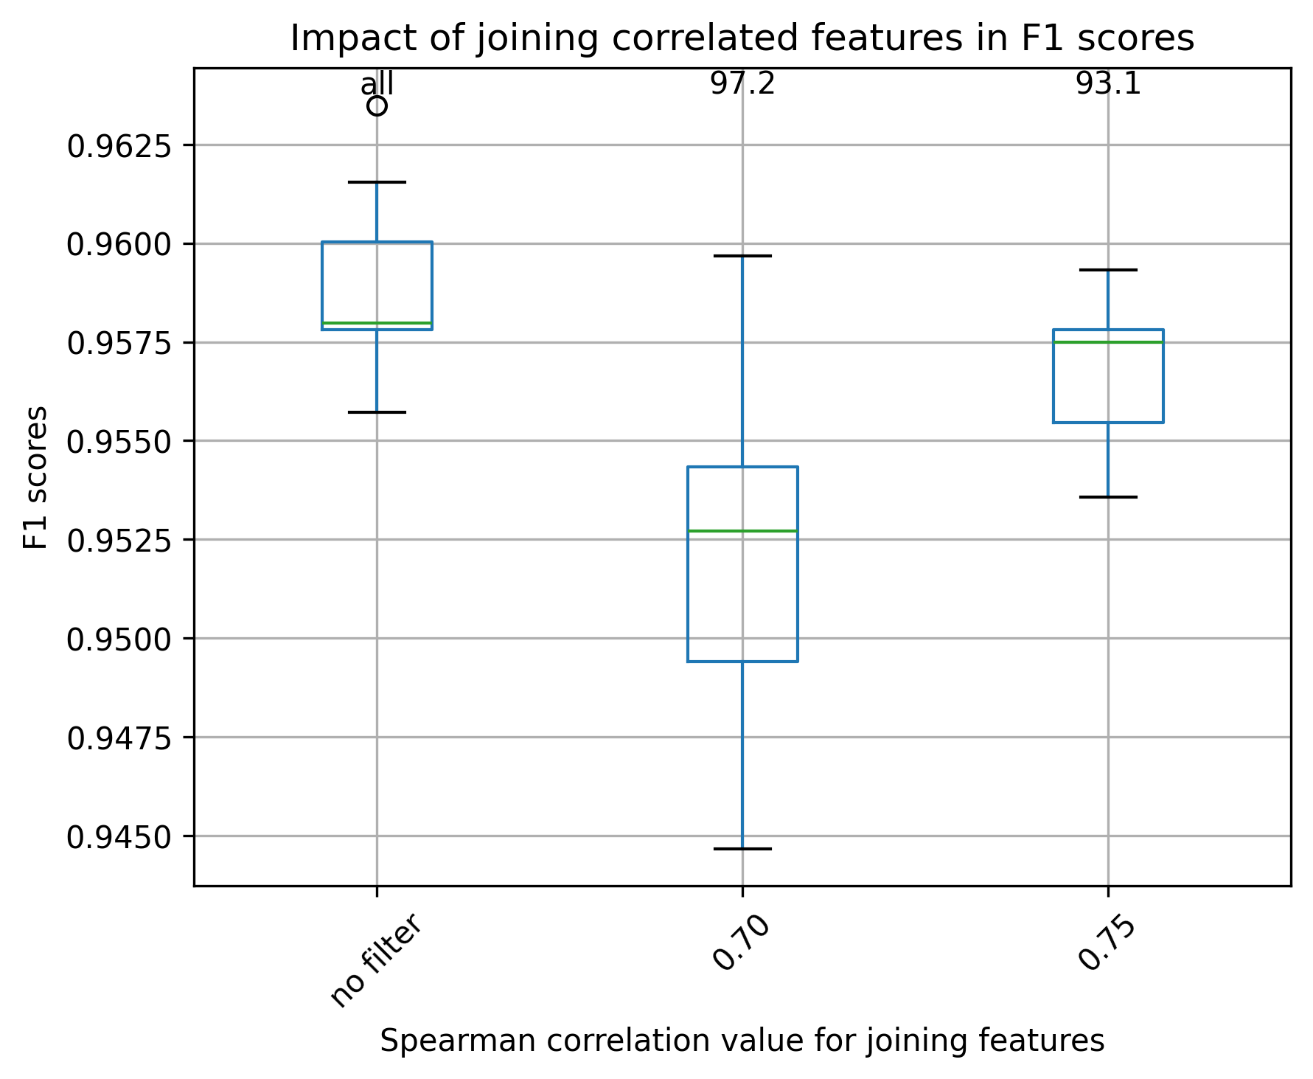
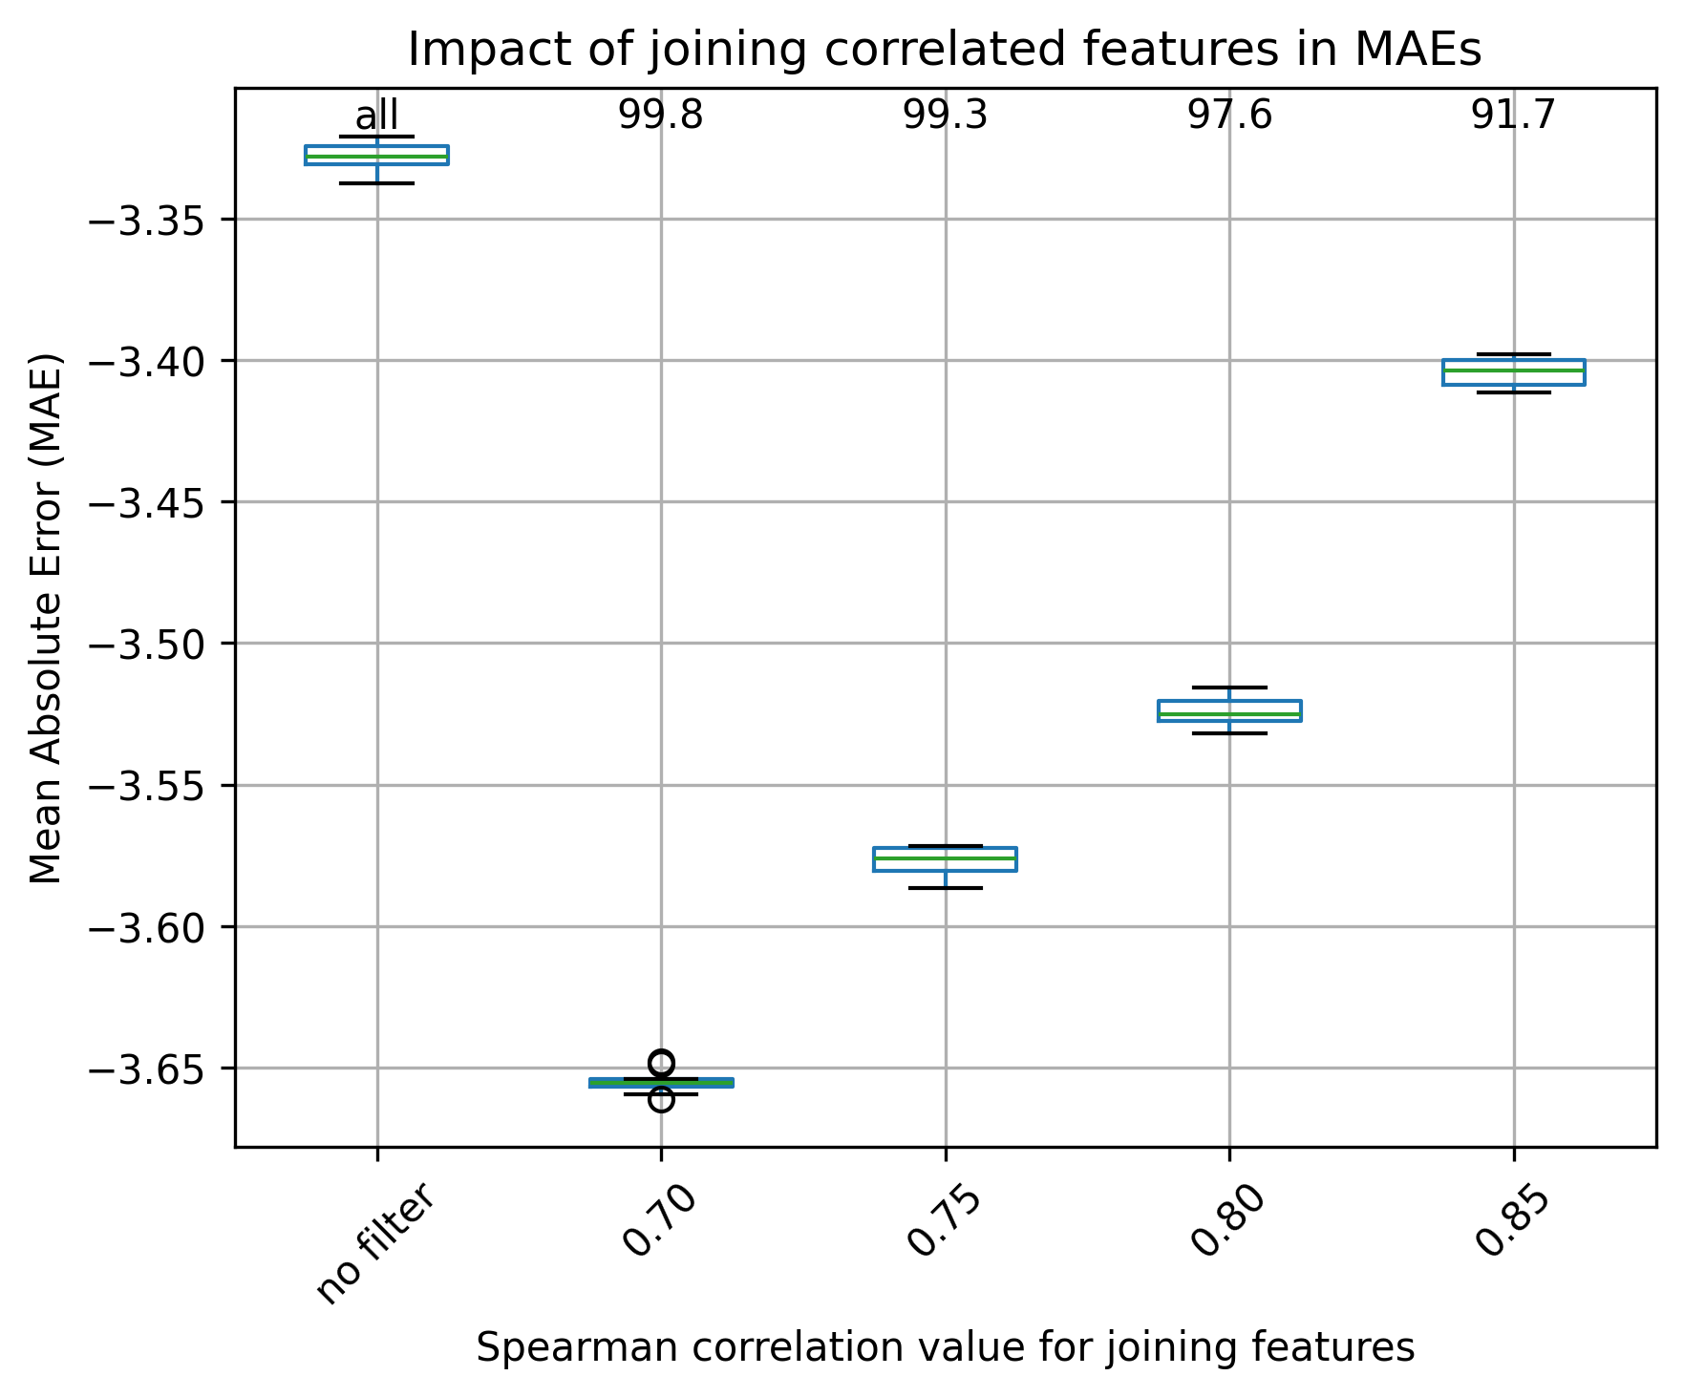

Choice of threshold: 0.75 Choice of threshold: 0.85

Oxygen, classification

Gene families (RF, undersampling) kmer9 (RF, undersampling)
Number of initial isolates for filtering: 3,402 Number of initial isolates for filtering: 3,354
Number of initial features: 4,823 Number of initial features: 24,007
Number of isolates considered in the analysis: 2,721 Number of isolates considered in the analysis: 2,683

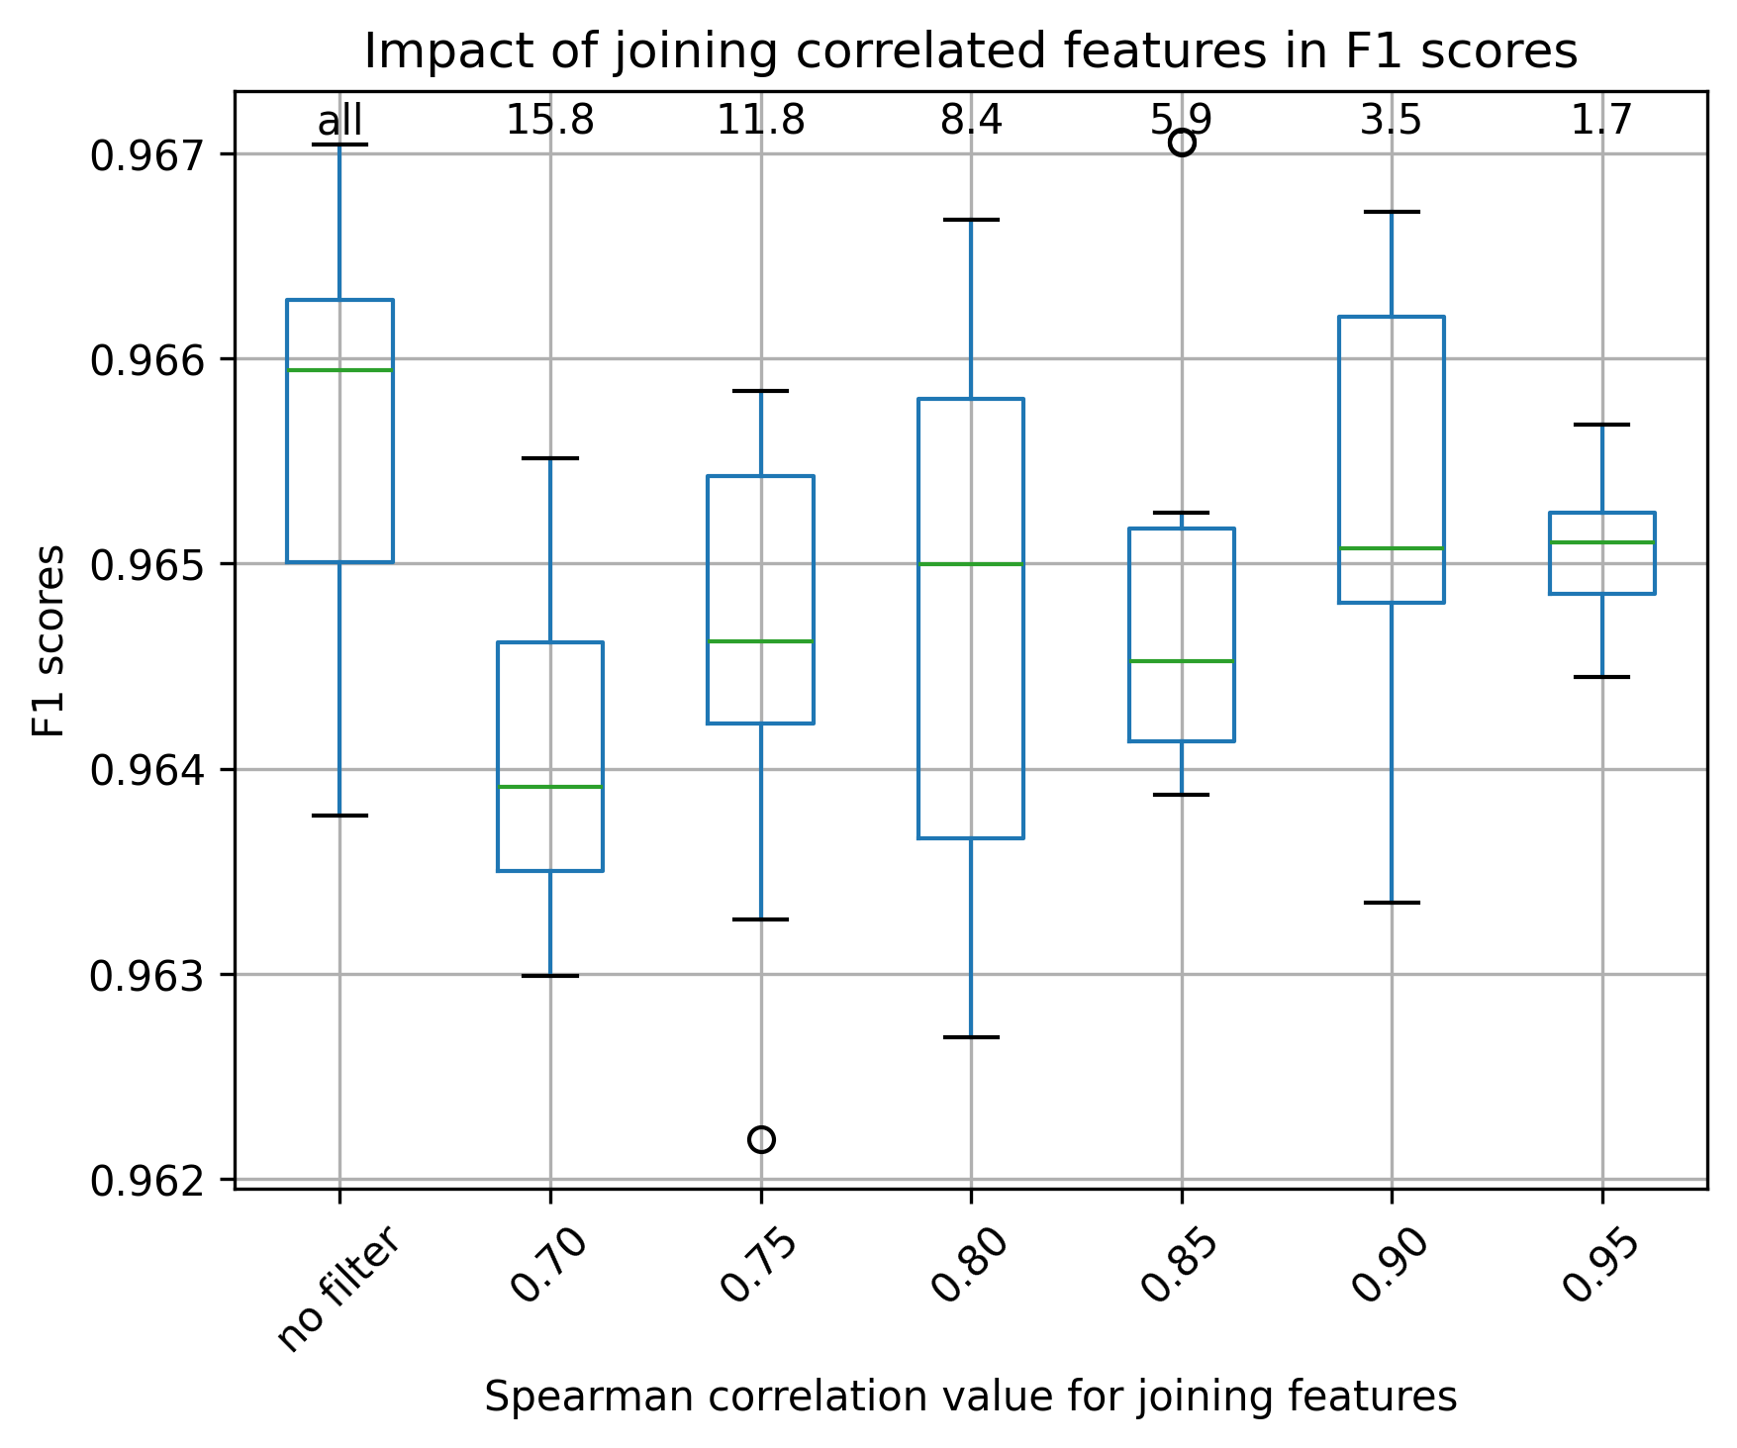
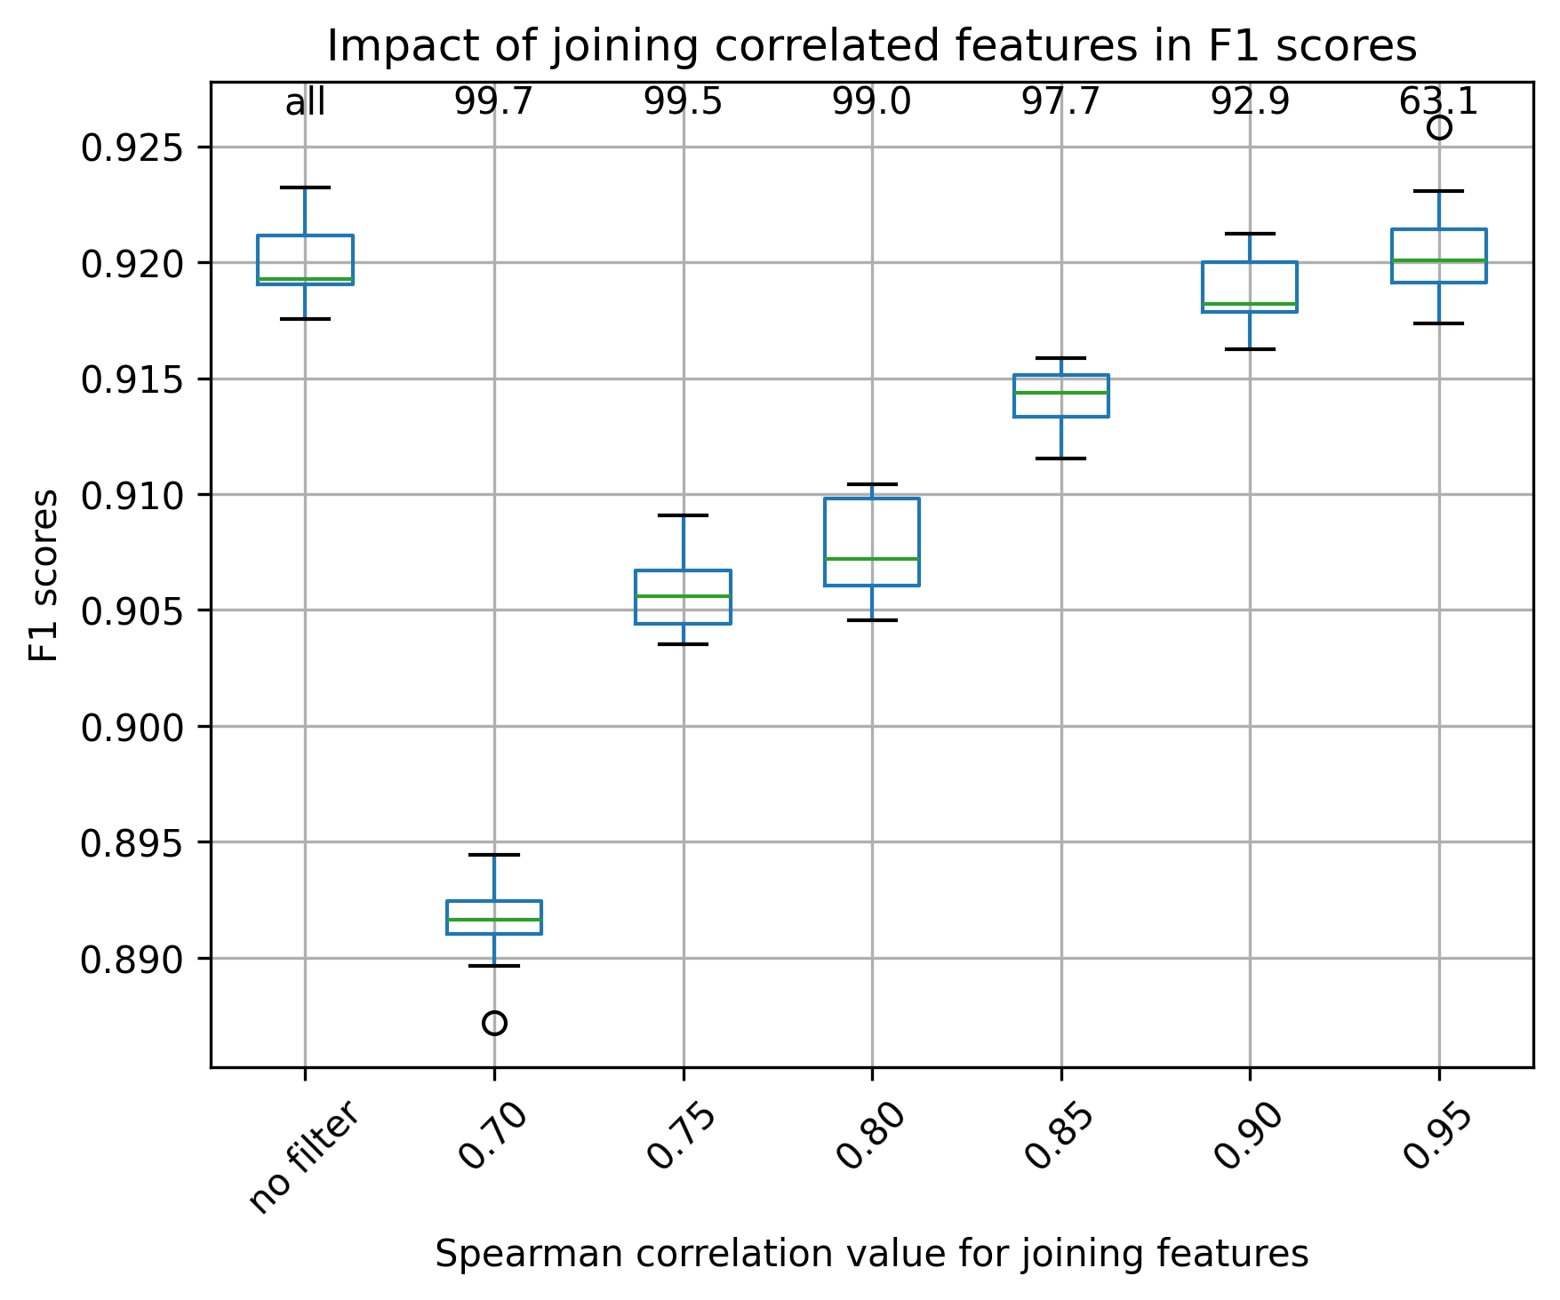

Choice of threshold: 0.90 Choice of threshold: 0.95

pH, regression

Gene families (RF, mean pH) kmer9 (RF, mean pH)
Number of initial isolates for filtering: 3,630 Number of initial isolates for filtering: 3,630
Number of initial features: 3,638 Number of initial features: 40,230
Number of isolates considered in the analysis: 2,904 Number of isolates considered in the analysis: 2,904
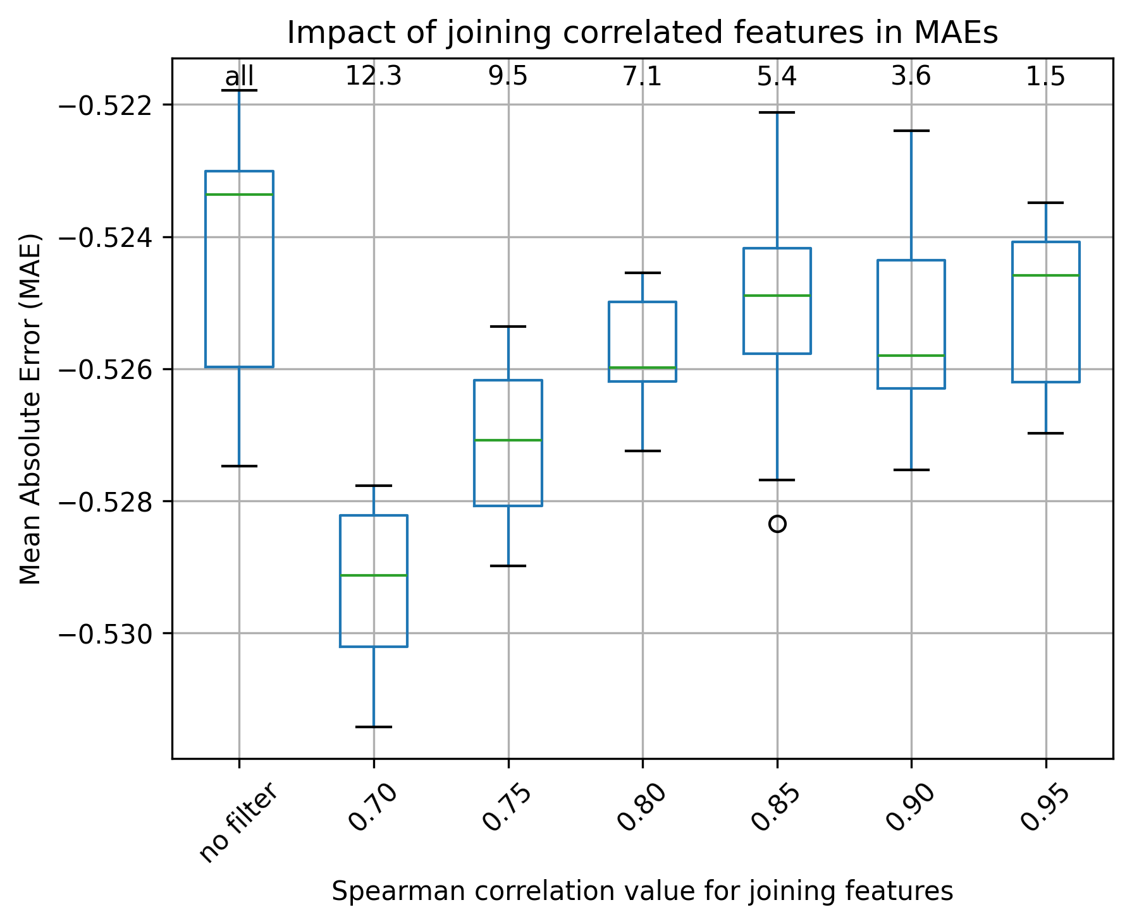
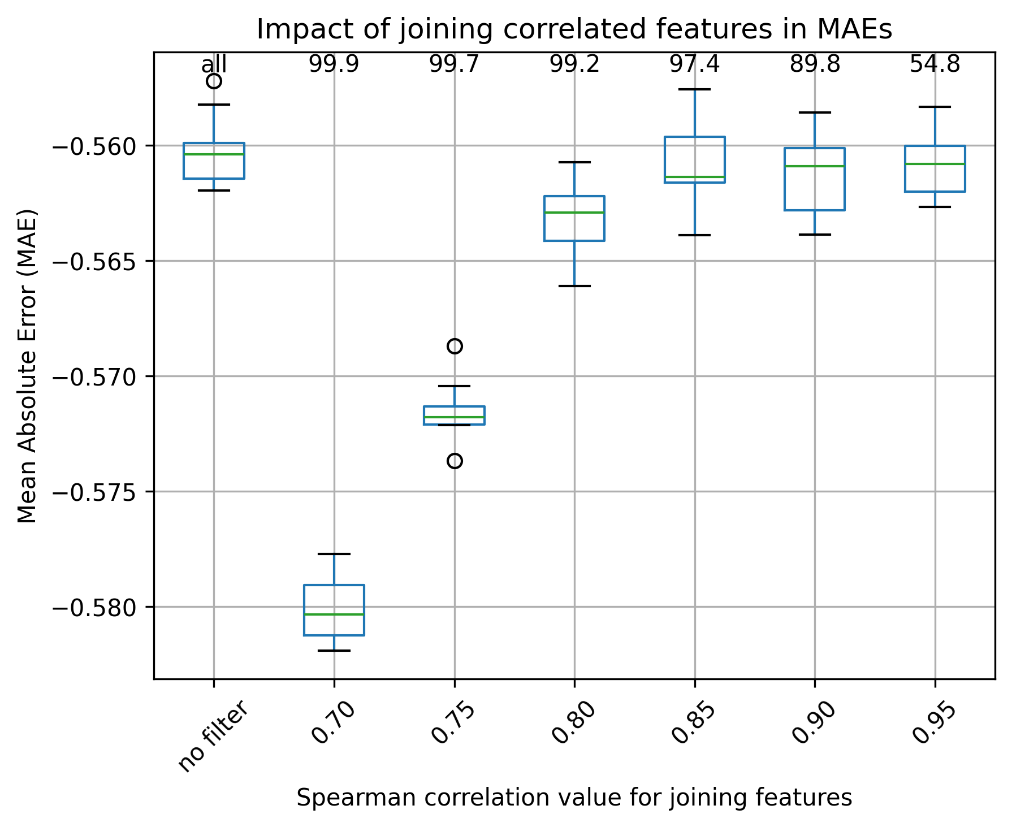

Choice of threshold: 0.95 Choice of threshold: 0.90

