Postfix is a well know mail server to configure and utilize for messaging.

sudo apt install mailutils

Using tail -f, command we can follow a file update live.

This is useful many times monitoring log while debugging or recreating a issue of a support ticket/case by customer.

tail -f /*var/log/messages*

*tail -f /var/log/mail.log*

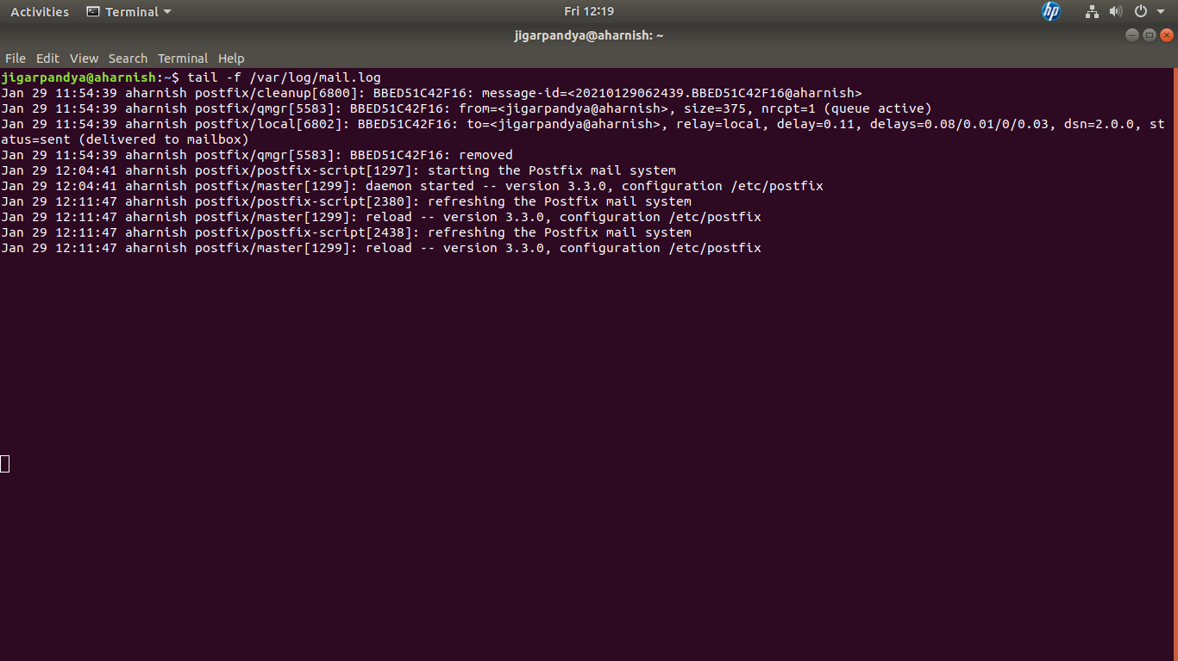

‘mail’ command enables user to command line messaging.

