Document Details

Name: Learn To Use Makefile

Prepared by, Prof. Jigar M. Pandya

Assistant Professor, Computer Engineering Department. FoT.

D.D.University. Nadiad. Gujarat. India.

[jigarpandya.ce@ddu.ac.in](mailto:jigarpandya.ce@ddu.ac.in)

14th June, 2018.

Version 1.0

Demo Make

Utility ‘make’ is the first successful and widely accepted command line build automation tool. For a project it is always the case that multiple developers will work on multiple source and header files. Building and testing even a small change is frequent requirement during development.

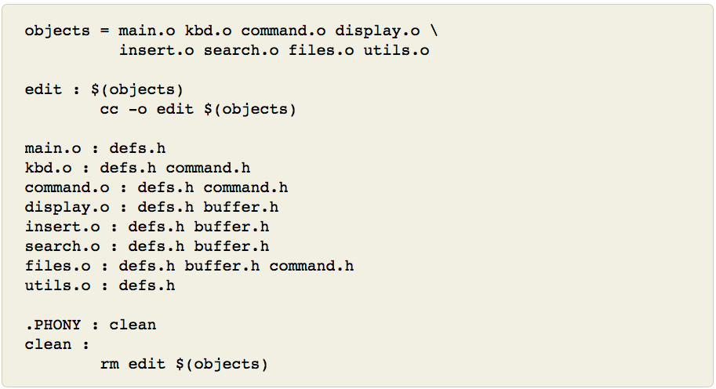

Image Source: <https://www.gnu.org/software/make/manual/html_node/make-Deduces.html#make-Deduces>

Descenders are ant, maven, etc. Now we have in the market CICD (Continuous Integration Continuous Development) and GUI tools like Jenkins.

**Make**

Terminology:

A Rule looks like below,

target … : prerequisites …

recipe

…

…

The first rule target is also known as goal.

For the folder content, use following command sequence after understanding the purpose.

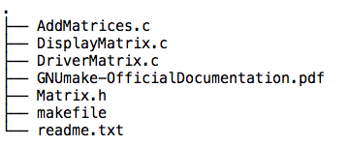

(1) Below -n option, shows the recipe to be run on target named clean. Also may use option --dry-run

>make -n clean

>ls

(2) Below actually runs the recipe of target clean directly. Note that there are no prerequisites to process for target named clean.

>make clean

>ls

(3) Default goal is all as it is the first target. make command by default runs file named makefile default target. make or 'make all' is one and the same. Note that the prerequisites are also processed if not already. Note that object files are generated and finally linked as runme executable file. You may test it. It shall show sample resulting matrix.

>make

>ls

>./runme

Optionally, may clean up using 'make clean' command now.

(4) Update any single or more source/header file(s) content or just timestamp modification using touch command. And run make to notice that it behaves smart via running only those targets which are affected.

> touch AddMatrices.c

> ls -lt

> make -n all

> make all

> ls -lt

**Directory Files Content and run log on macOS High Sierra Version 10.13.4 (17E199) using script command:**

Script started on Thu Jun 14 13:07:07 2018

bash-3.2$ pwd

/Users/DemoUser/Desktop/StepAheadWithC/LearnToUseMake

bash-3.2$ tree .

.

├── AddMatrices.c

├── DisplayMatrix.c

├── DriverMatrix.c

├── GNUmake-OfficialDocumentation.pdf

├── Matrix.h

├── makefile

├── readme.txt

└── typescript

0 directories, 8 files

bash-3.2$ cat DriverMatrix.c

/*

Driver program for using my matrix library

DriverMatrix.c

*/

#include <stdio.h>

#include "Matrix.h"

#define R 3

#define C 3

int main()

{

int m1[R][C]={{1,2,3},{4,5,6},{7,8,9}},

m2[R][C]={{11,12,13},{14,15,16},{17,18,19}},

m[R][C],

status

;

/*

int i,j;

printf("Please, enter two %dx%d matrices ",R,C);

for(i=0;i<R;i++)

{

for(j=0;j<C;j++)

{

scanf("%d",&m1[i][j]);

}

}

for(i=0;i<R;i++)

{

for(j=0;j<C;j++)

{

scanf("%d",&m2[i][j]);

}

}*/

status=addmatrices(m1,m2,m);

if(status==0)

{

printf("\n Addition of two matrices\n");

displaymatrix(m);

}

else

printf("Two matrices of different size can not be added.");

return 0;

}

bash-3.2$ cat Matrix.h

//Matrix.h

#define R 3

#define C 3

int addmatrices(int [][C], int [][C], int [][C]);

void displaymatrix(int m[][C]);

bash-3.2$ cat AddMatrices.c

#define R 3

#define C 3

int addmatrices(int m1[][C],int m2[][C],int m[][C])

{

int i,j;

for(i=0;i<R;i++)

{

for(j=0;j<C;j++)

{

m[i][j]=m1[i][j]+m2[i][j];

}

}

return 0; //success

}

bash-3.2$ cat DisplayMatrix.c

#include <stdio.h>

#define R 3

#define C 3

void

displaymatrix(int m[][C])

{

int i , j;

for (i = 0; i < R; i++) {

for (j = 0; j < C; j++) {

printf("%5d", m[i][j]);

}

printf("\n");

}

}

bash-3.2$ cat makefile

#Compiling with -c option generates independant binary object file which can be shared with others.

all: runme

runme : DriverMatrix.o AddMatrices.o DisplayMatrix.o

gcc -o runme Addmatrices.o DisplayMatrix.o DriverMatrix.o

DriverMatrix.o : DriverMatrix.c Matrix.h

gcc -Wall -c DriverMatrix.c -o DriverMatrix.o

AddMatrices.o : AddMatrices.c

gcc -c AddMatrices.c -o AddMatrices.o

DisplayMatrix.o : DisplayMatrix.c

gcc -c DisplayMatrix.c -o DisplayMatrix.o

.PHONY : clean

clean:

rm -rf *.o

rm -rf runme

bash-3.2$ make -n clean

rm -rf *.o

rm -rf runme

bash-3.2$ ls

AddMatrices.c Matrix.h

DisplayMatrix.c makefile

DriverMatrix.c readme.txt

GNUmake-OfficialDocumentation.pdf typescript

bash-3.2$ make clean

rm -rf *.o

rm -rf runme

bash-3.2$ ls

AddMatrices.c Matrix.h

DisplayMatrix.c makefile

DriverMatrix.c readme.txt

GNUmake-OfficialDocumentation.pdf typescript

bash-3.2$ make

gcc -Wall -c DriverMatrix.c -o DriverMatrix.o

gcc -c AddMatrices.c -o AddMatrices.o

gcc -c DisplayMatrix.c -o DisplayMatrix.o

gcc -o runme Addmatrices.o DisplayMatrix.o DriverMatrix.o

bash-3.2$ ls

AddMatrices.c GNUmake-OfficialDocumentation.pdf

AddMatrices.o Matrix.h

DisplayMatrix.c makefile

DisplayMatrix.o readme.txt

DriverMatrix.c runme

DriverMatrix.o typescript

bash-3.2$ ./runme

Addition of two matrices

12 14 16

18 20 22

24 26 28

bash-3.2$ touch AddMatrices.c

bash-3.2$ ls -lt

total 3184

-rw-r--r-- 1 DemoUser staff 3414 Jun 14 13:09 typescript

-rwxrwxrwx 1 DemoUser staff 194 Jun 14 13:09 AddMatrices.c

-rw-r--r-- 1 DemoUser staff 0 Jun 14 13:09 AddMatrices.

-rw-r--r-- 1 DemoUser staff 880 Jun 14 13:09 DisplayMatrix.o

-rwxr-xr-x 1 DemoUser staff 8700 Jun 14 13:09 runme

-rw-r--r-- 1 DemoUser staff 760 Jun 14 13:09 AddMatrices.o

-rw-r--r-- 1 DemoUser staff 1556 Jun 14 13:09 DriverMatrix.o

-rw-r--r--@ 1 DemoUser staff 228 Jun 14 09:56 readme.txt

-rw-r--r-- 1 DemoUser staff 516 Jun 14 09:10 makefile

-rw-r--r--@ 1 DemoUser staff 1574458 Jun 14 09:04 GNUmake-OfficialDocumentation.pdf

-rwxrwxrwx 1 DemoUser staff 678 Jun 14 08:57 DriverMatrix.c

-rwxrwxrwx 1 DemoUser staff 117 Jun 14 08:46 Matrix.h

-rw-r--r-- 1 DemoUser staff 205 Jun 14 01:16 DisplayMatrix.c

bash-3.2$ make -n all

gcc -c AddMatrices.c -o AddMatrices.o

gcc -o runme Addmatrices.o DisplayMatrix.o DriverMatrix.o

bash-3.2$ make all

gcc -c AddMatrices.c -o AddMatrices.o

gcc -o runme Addmatrices.o DisplayMatrix.o DriverMatrix.o

bash-3.2$ ls -lt

total 3184

-rw-r--r-- 1 DemoUser staff 760 Jun 14 13:09 AddMatrices.o

-rwxr-xr-x 1 DemoUser staff 8700 Jun 14 13:09 runme

-rw-r--r-- 1 DemoUser staff 3414 Jun 14 13:09 typescript

-rwxrwxrwx 1 DemoUser staff 194 Jun 14 13:09 AddMatrices.c

-rw-r--r-- 1 DemoUser staff 0 Jun 14 13:09 AddMatrices.

-rw-r--r-- 1 DemoUser staff 880 Jun 14 13:09 DisplayMatrix.o

-rw-r--r-- 1 DemoUser staff 1556 Jun 14 13:09 DriverMatrix.o

-rw-r--r--@ 1 DemoUser staff 228 Jun 14 09:56 readme.txt

-rw-r--r-- 1 DemoUser staff 516 Jun 14 09:10 makefile

-rw-r--r--@ 1 DemoUser staff 1574458 Jun 14 09:04 GNUmake-OfficialDocumentation.pdf

-rwxrwxrwx 1 DemoUser staff 678 Jun 14 08:57 DriverMatrix.c

-rwxrwxrwx 1 DemoUser staff 117 Jun 14 08:46 Matrix.h

-rw-r--r-- 1 DemoUser staff 205 Jun 14 01:16 DisplayMatrix.c

bash-3.2$ exit

Script done on Thu Jun 14 13:10:06 2018