Demonstration

**How to verify that the file downloaded from web is not corrupted?**

Most sites provide downloads of either software or source. Once the download is complete, you may cross check the download is correct and not corrupted.

Sites provide feature called checksum. Site has counted the checksum with selected encryption algorithm i.e. md5, sha26, etc and provided the checksum result separately.

Once download finishes, you can run local utilities to find the checksum of downloaded file.

Ideally the local resulting checksum as per selected algorithm shall match with provided by the site.

If so, you can confirm that the file is not corrupted.

To demonstrate the example, I have chosen to download famous IDE and validate downloads.

Know that wget is a http command line client. It does naive activity as your firefox, safari or chrome may be doing.

Download the zip file:

wget <https://download.jetbrains.com/idea/ideaIC-2020.2.3.win.zip>

Download the checksum value:

wget https://download.jetbrains.com/idea/ideaIC-2020.2.3.win.zip.sha256?_ga=2.75943445.1008361575.1606023864-469026589.1606023864

Display the checksum value:

cat ideaIC-2020.2.3.win.zip.sha256?_ga=2.75943445.1008361575.1606023864-469026589.1606023864

Generate the checksum value of downloaded zip file:

sha256sum ideaIC-2020.2.3.win.zip

Note that both checksum hex values are matching (highlighted in yellow text). Hence, we can judge that the download is correct.

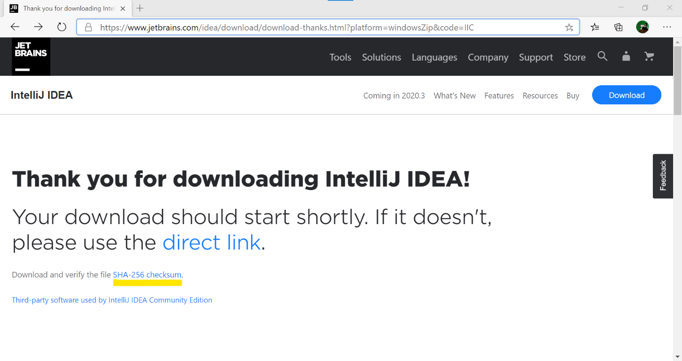

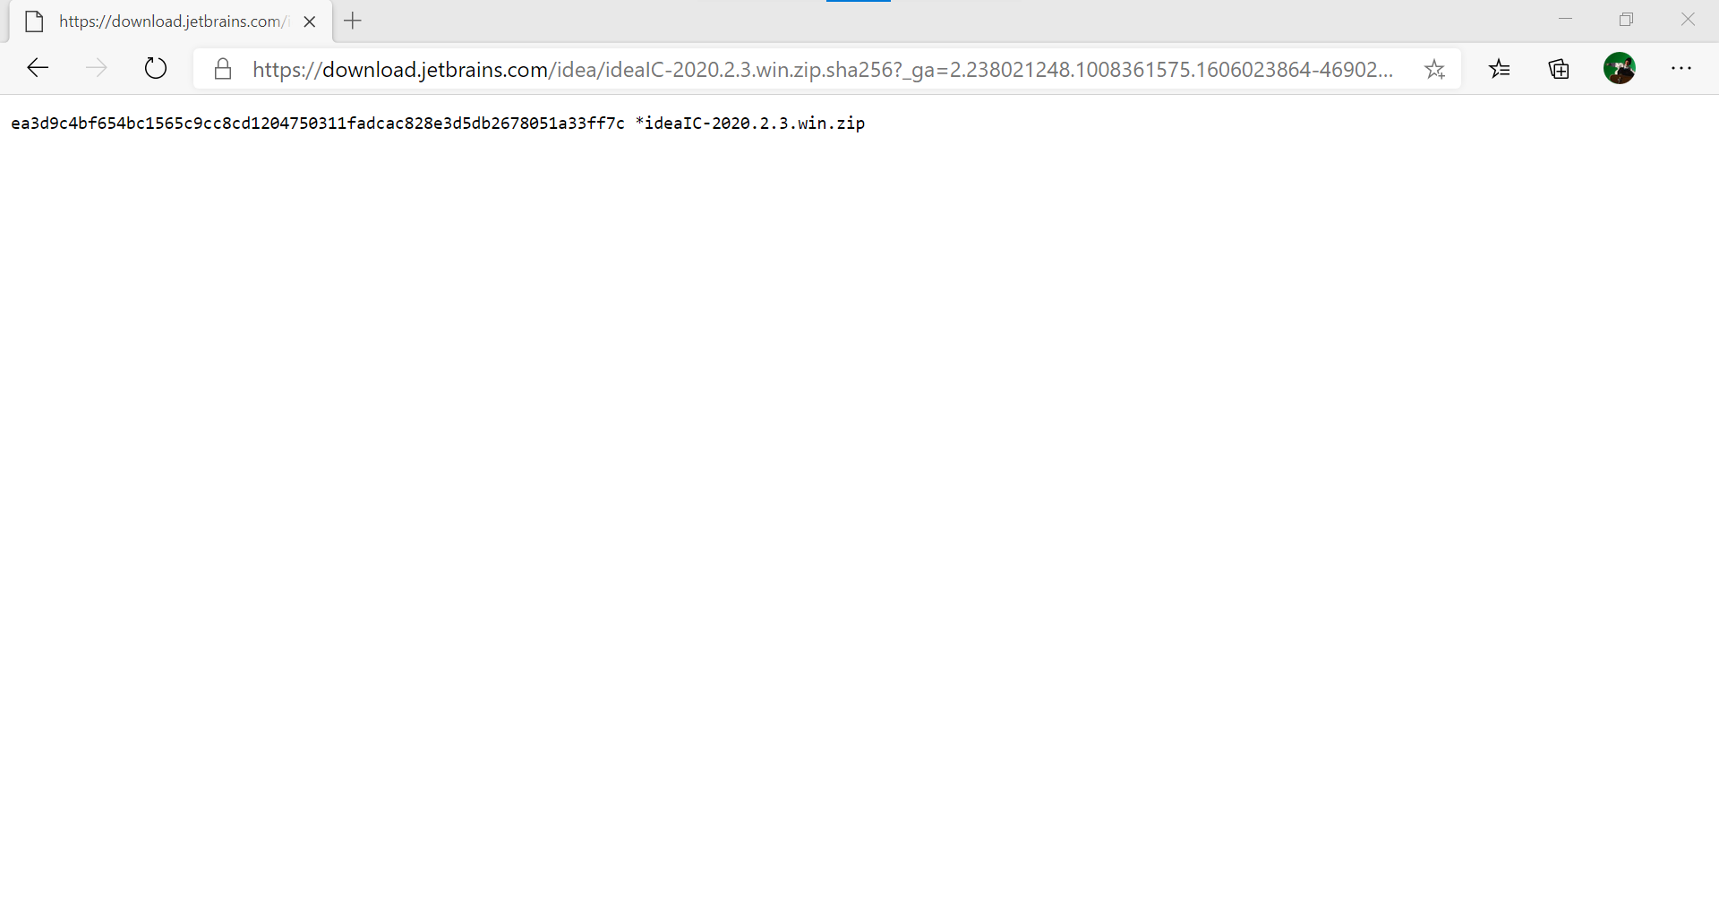

Below execution has been carried out on Ubuntu app with Windows Subsystem for Linux enabled on MS Windows 10.

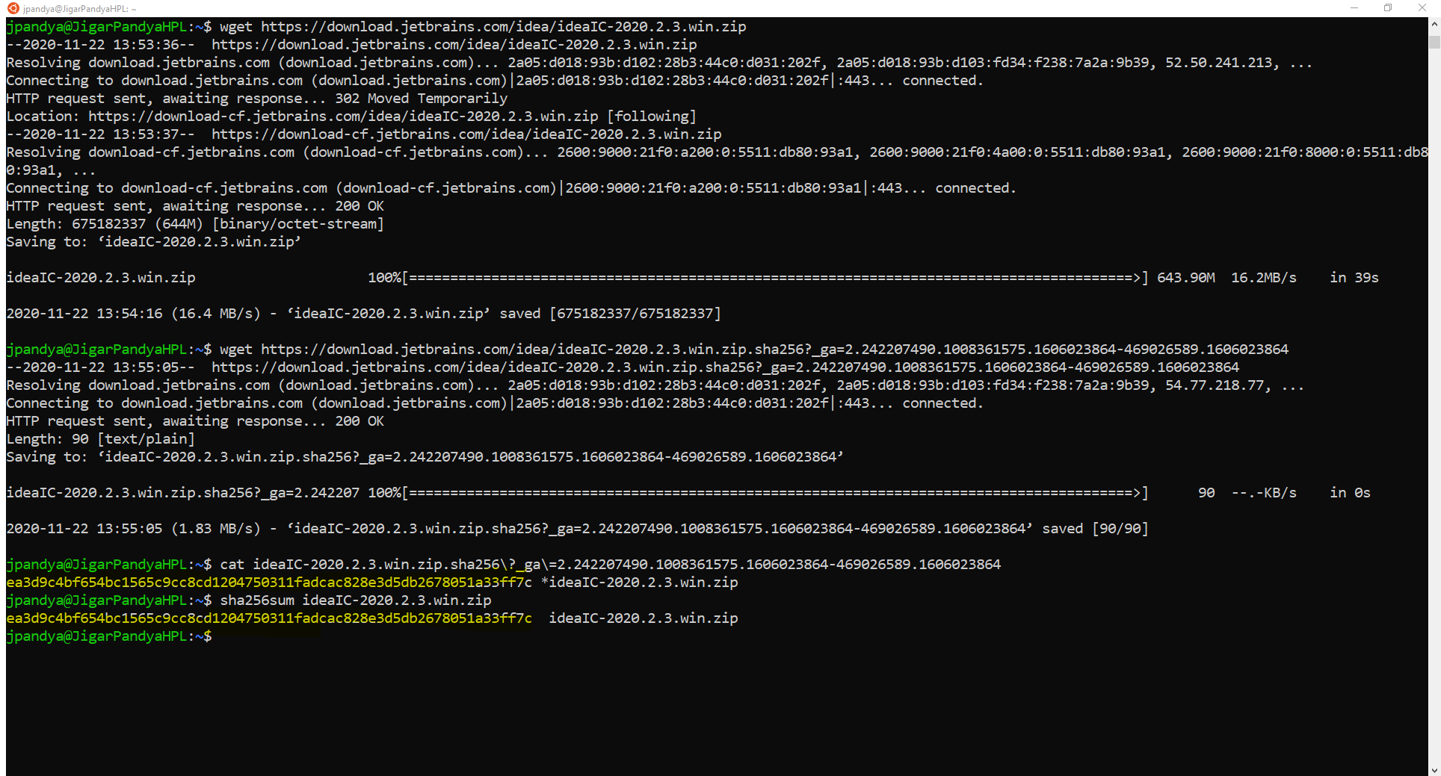

Demonstrated By:

Jigar Pandya

<https://linkedin.com/in/jigar-pandya>

Document last updated on 22nd Nov, 2020.