**Demonstration**

**File Categories in Linux**

Know that ls -l command shows long listing of files. First character has meaning as below for appropriate file category.

Notice that this file categories are architecture-based categories on the usage of files and not just extensions.

|  |  |
| --- | --- |
| - | Regular File |
| d | Directory File |
| p | Named pipe/FIFO for IPC |
| s | Socket for network communication |
| c | Character device file |
| l | Soft Link |
| b | Block file |
| … |  |

**Regular files**

These are normal files i.e. text file.

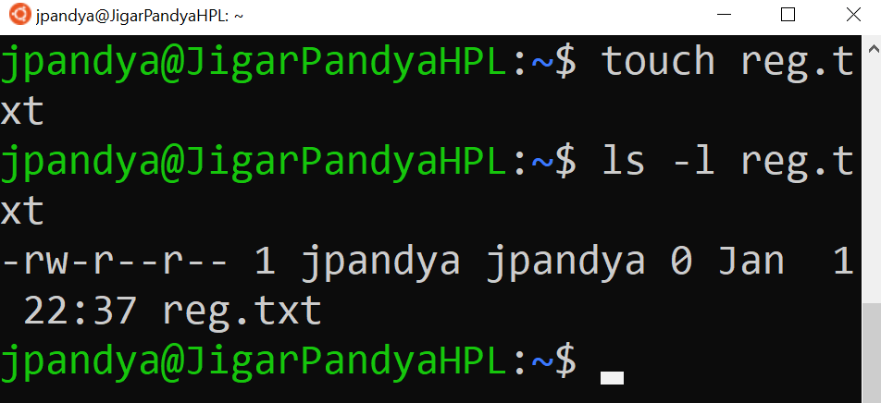

**Directory Files**

Directory is a type of file which can be operated upon with commands. When we create a subdirectory, its very much like editing its parent directory and adding one more entry. The name of files and subdirectories are actually written as content of directory housing them.

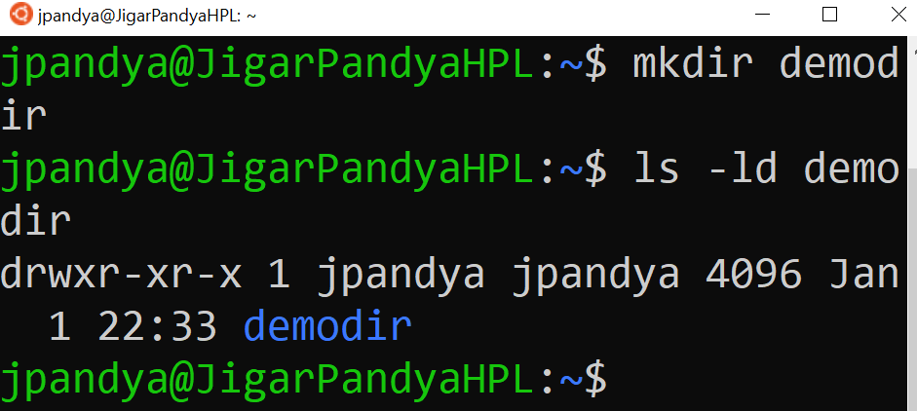

**Character device file**

Terminal is a type of file only. We can literally write to it and it will be read by hardware to display on the screen. Also is true for a printer like devices.

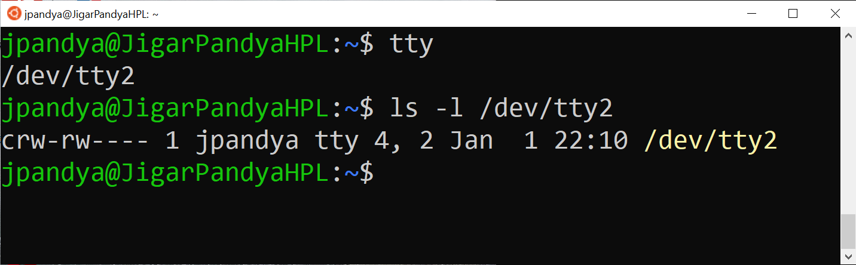

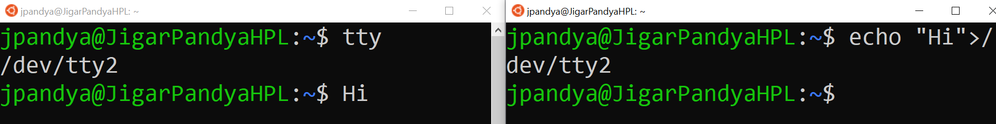

A pseudo file used to flush access logs. The file size will always be zero no matter how much you write to it. Its an example of a complete consumer.

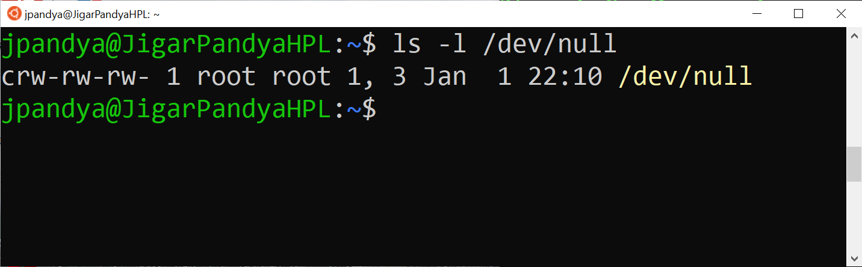

**PIPE**

A named pipe is a type of file in which process can write and another process can read from. Pipe is an example of FiFO (First In First Out). The image below shows that in left terminal a pipe is created using mkfifo command. Right hand side is actually waiting on data from the pipe. The user running command on left side to flow data which were displayed as output on right side automatically.

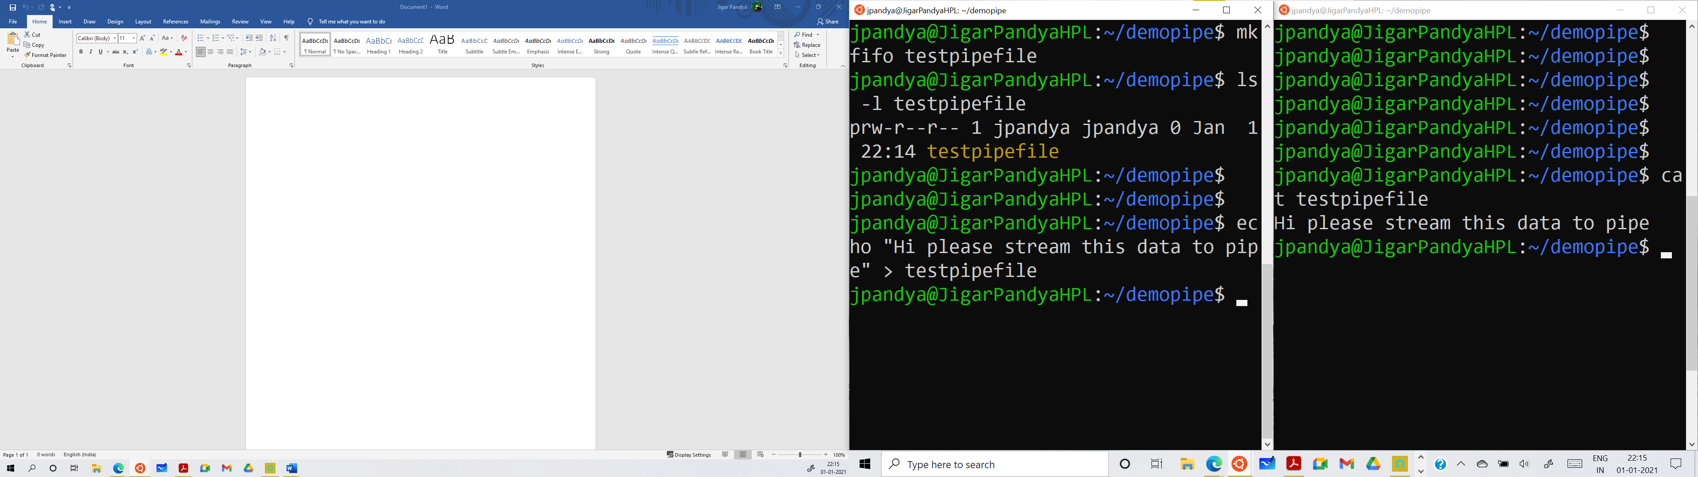

**Symbolic Link / Soft Link / Short-cut file**

Know that short cut to another file/location is itself a type of file in linux. It holds only location of destination file. We can create using ln -s source linkname and verify that the inode numbers of shortcut differs than the destination.

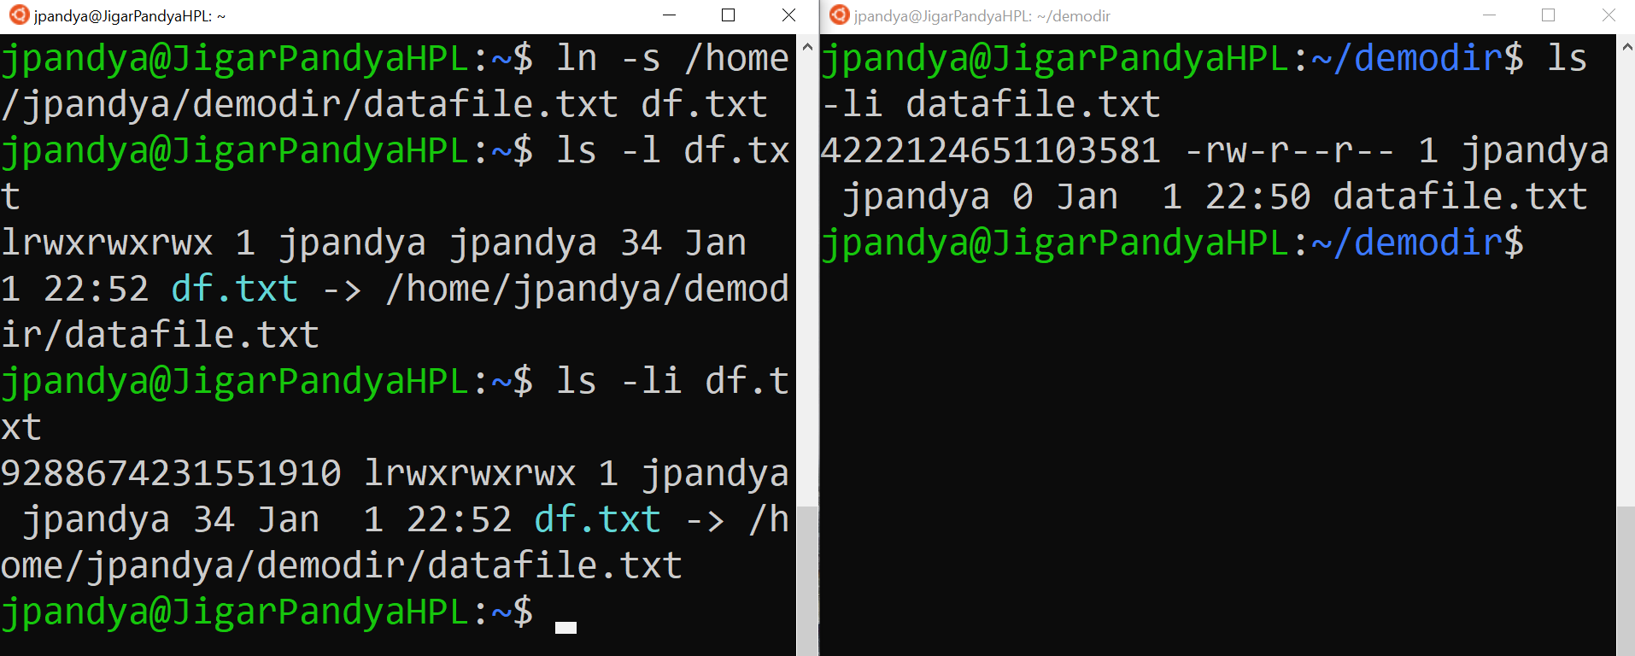

Moreover, we know digit 0, 1, 2 can be alternatively used for accessing standard input – 0 (keyboard), standard output – 1 (Screen) and standard error – 2 (Screen or log file).

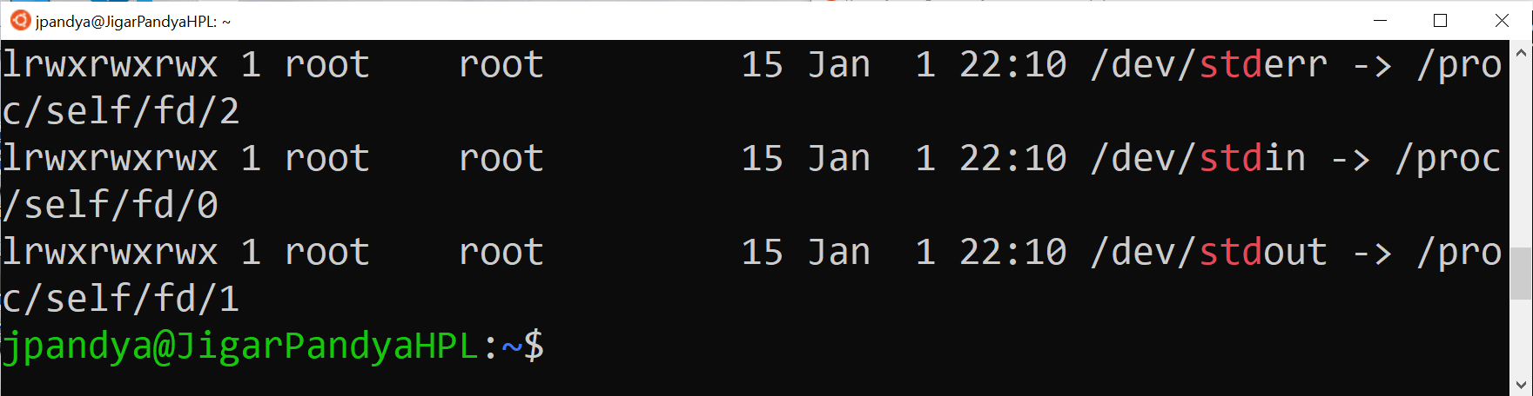

See that in below deliberately I am generating error and redirecting it to a file.

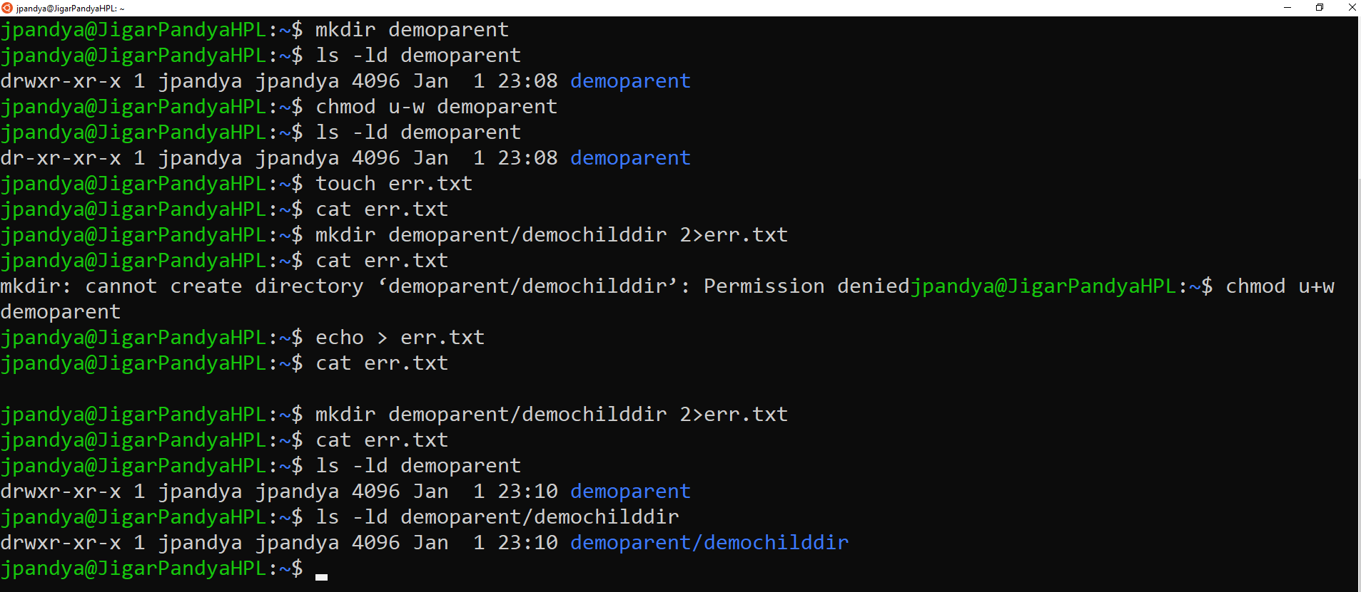

**Socket**

In the client-server architecture sockets help communicate and are endpoints. Using various socket programming library i.e. c sockets, win sockets, etc we can create and sockets. For example mysql daemon internally relies on a socket file.

**Block File**

Mostly partitions are block files. May use fdisk -l to list out partitions and ls -l <device-path>. Know that having block I/O is faster than byte by byte processing.

Demonstrated By:

Jigar Pandya

<https://linkedin.com/in/jigar-pandya>

Document last updated on 1st Jan, 2021.