**Practice Linux using a cloud compute instance**

Note that most of the infrastructure as a service with cloud platform provides Linux Compute Instances (free eligible – primary level). Students can practice basic Linux commands and also learn more about cloud platforms and other services.

The primary protocol for establishing remote connection is SSH.

1. Create a free-tier account
2. Login and create a compute instance
   1. Download ssh public and private keys.
3. Know the public ip of compute instance.
4. Connect to compute instance (on a cloud) using ssh client like putty, xshell, terminal, etc.

4.1 The file permissions of public key need to be modified as part of safety requirement.

1. Terminate the instance.

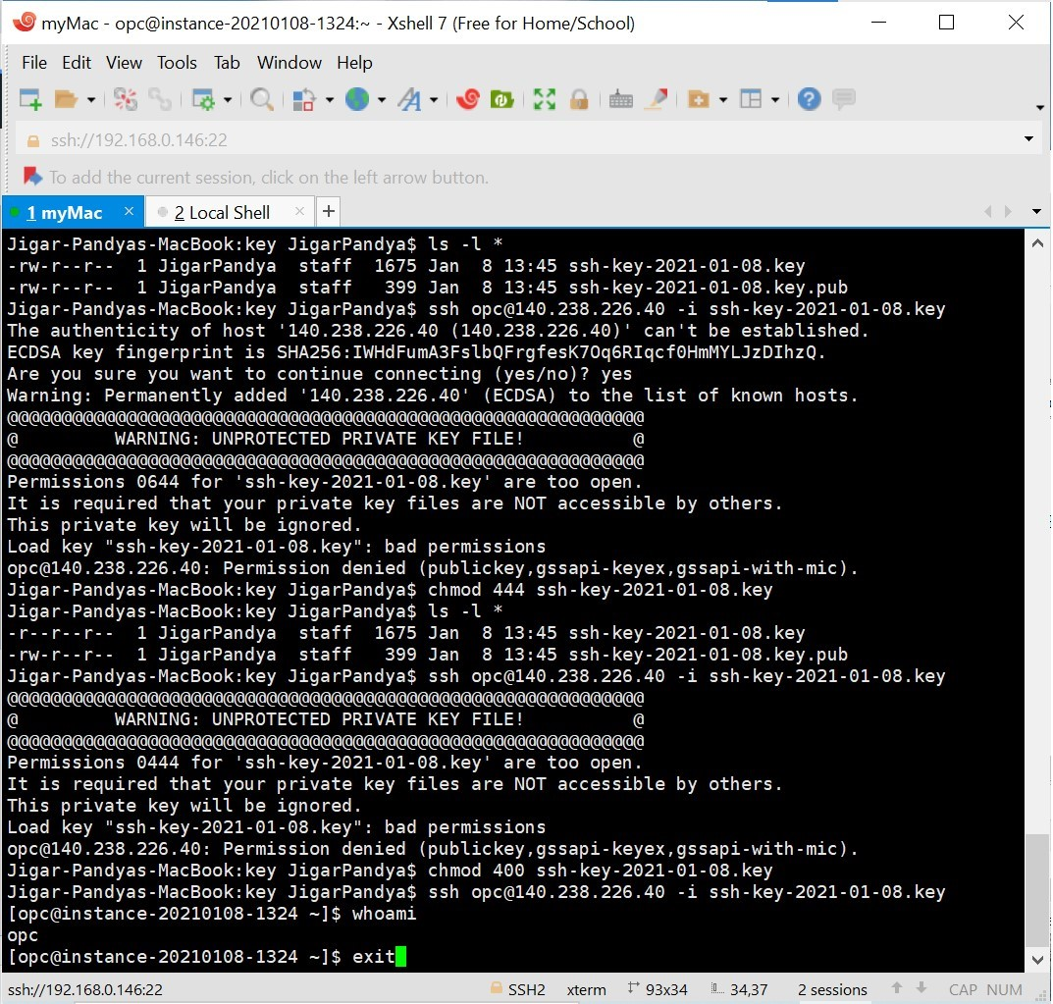

Demonstrated By:

Jigar Pandya

<https://linkedin.com/in/jigar-pandya>

Document last updated on 08th Jan, 2021.