SSH

A protocol used to connect to a computer using its IP address or host name. A user can login with password or passwordless if user equivalence is established.

Ifconfig command gives you interface details for unil-like computers. On windows the network command ipconfig helps achieve the task of knowing your interface.

Here, I am demonstrating that on my macbook I have created a folder.

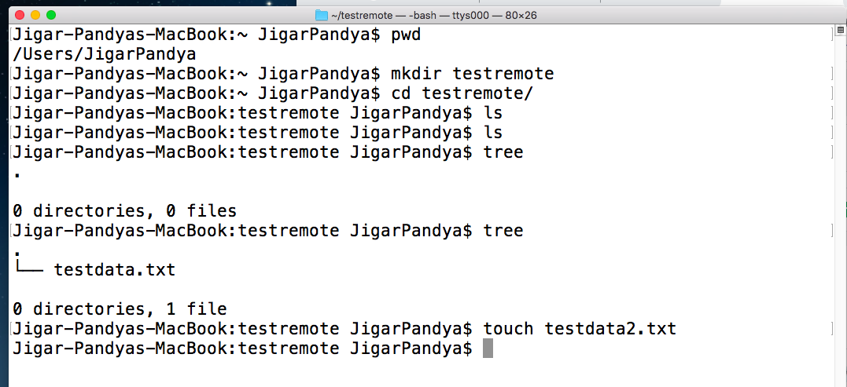

Connecting to macbook from another computer in the network.

SSH client helps me connect. I.e. putty, xshell and more.

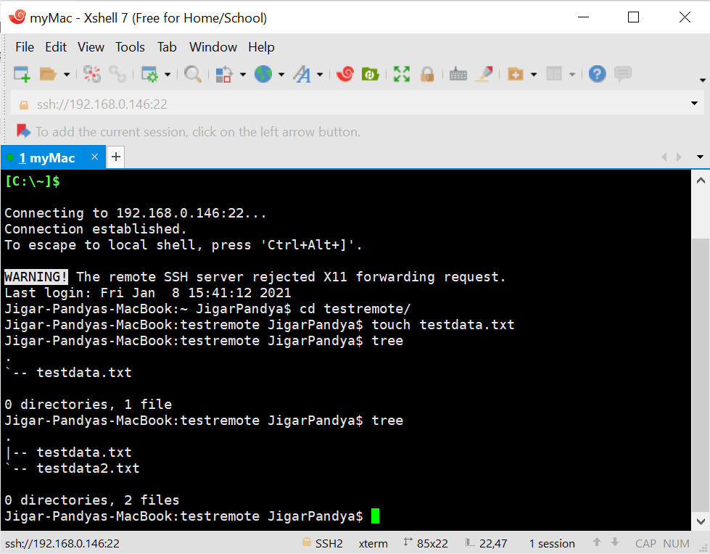

Know that both the sessions are active with the same username. Its the power of multiuser and multitasking systems. I could also connect using different user name.

Demonstrated By:

Jigar Pandya

<https://linkedin.com/in/jigar-pandya>

Document last updated on 08th Jan, 2021.