Pipe Operator

Dataset: 13 3 25 20 3 16 23 18 20 7 12 5 22 15 4 7

echo "13 3 25 20 3 16 23 18 20 7 12 5 22 15 4 7" | tr ' ' ','

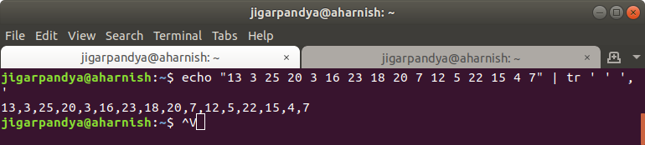
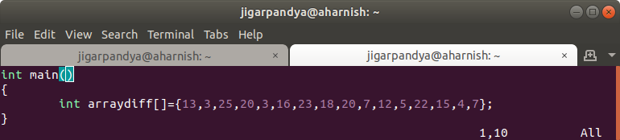

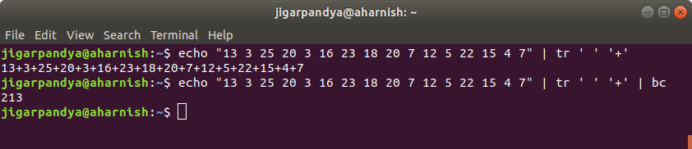
echo "13 3 25 20 3 16 23 18 20 7 12 5 22 15 4 7" | tr ' ' '+' | bc

