Project Status Report

Name: Apriori Algorithm Implementation using Hadoop

Developers: Sagar Daswani

Project Mentors: Prof. Brijesh S. Bhatt
Asst. Prof
Computer Engineering

Prof. Jigar M. Pandya
Asst. Prof
Computer Engineering

Date of Status: 12th January, 2018

About Project:
Using Hadoop Data File System finding frequent item sets using Apriori Algorithm.

Techology Used: Apache Hadoop platform , Python

Overall Project Status: On Track

Project Module Status:

Understanding Theoritical Concepts related to project: Working

Standalone Mode Installation : Completed

Hadoop Comands : Completed

Apriori program in python: Completed

Implementation of Apriori on Hadoop: Working

Apriori Algorithm Implementation On Hadoop:

In Java language I have implemented Apriroi Algorithm, using logic of power sets on Map-Reduce Framework I am able to generate desired results.

Here is the java code :

import java.io.IOException;
import java.util.StringTokenizer;
import java.util.*;
import org.apache.hadoop.conf.Configuration;
import org.apache.hadoop.fs.Path;
import org.apache.hadoop.io.*;
import org.apache.hadoop.io.Text;
import org.apache.hadoop.mapreduce.Job;
import org.apache.hadoop.mapreduce.Mapper;
import org.apache.hadoop.mapreduce.Reducer;
import org.apache.hadoop.mapreduce.lib.input.FileInputFormat;
import org.apache.hadoop.mapreduce.lib.output.FileOutputFormat;

public class Apriori_MapReduce
{

//Mapper Class
public static class TokenizerMapper extends Mapper< LongWritable, Text, Text, IntWritable>
{
private final static IntWritable one = new IntWritable(1);
private Text word = new Text();

public static String myarray="";
public void map(LongWritable key, Text value, Context context) throws IOException,
InterruptedException
{
String transaction = value.toString();
List<String> itemsets = getItemSets(transaction.split(" "));
for(String s : itemsets)
{
Text Final_result = new Text();
Final_result.set(s);
context.write(Final_result,one);

}
}

//Function for generating PowerSets.
//input: [ 1 2]
//output:[] [1] [2] [1 2]
private List<String> getItemSets(String[] items) {

List<String> itemsets = new ArrayList<String>();

int n = items.length;

int[] masks = new int[n];

for (int i = 0; i < n; i++)
masks[i] = (1 << i);

for (int i = 0; i < (1 << n); i++){

List<String> newList = new ArrayList<String>(n);

for (int j = 0; j < n; j++){

if ((masks[j] & i) != 0){
newList.add(items[j]);
}

if(j == n-1 && newList.size() > 0 && newList.size() < 100){
itemsets.add(newList.toString());
}
}
}

return itemsets;
}

}

//Reducer Class
public static class IntSumReducer extends Reducer<Text,IntWritable,Text,IntWritable>
{
private IntWritable result = new IntWritable(1);

public void reduce(Text key, Iterable<IntWritable> values,Context context) throws
IOException, InterruptedException
{
int sum = 0;
for (IntWritable val : values)
{
sum += val.get();
}
if(sum >= 2)
{
result.set(sum);
context.write(key, result);
}
}
}
public static void main(String[] args) throws Exception
{
Configuration conf = new Configuration();
Job job = Job.getInstance(conf, "Apriori ");
job.setJarByClass(Apriori_MapReduce.class);
job.setMapperClass(TokenizerMapper.class);
// job.setCombinerClass(IntSumReducer.class);
job.setReducerClass(IntSumReducer.class);
job.setOutputKeyClass(Text.class);
job.setOutputValueClass(IntWritable.class);
FileInputFormat.addInputPath(job, new Path("/user/hadoop/test/input"));
FileOutputFormat.setOutputPath(job, new path("/user/hadoop/test/output"));
System.exit(job.waitForCompletion(true) ? 0 : 1);
}
}

Command Line Statements to run Code:

Assuming..
1: Hadoop is already Installed and running.
2: Directories for input and output in this format:
/user/hadoop/test/input
hadoop fs -mkdir /user/hadoop/test/input
/user/hadoop/test/output
(this will be created during runtime and not need to create before hand)

Input File:
Input_File.txt:

1 2 3
4 2 3
1 5 6

command to move this text file from local to hdfs:
hadoop fs -put Input_File.txt /user/hadoop/test/input
To view Copied file:
hadoop fs -cat /user/hadoop/test/input/Input_File.txt

Commands To Execute Program:
1: hadoop com.sun.tools.javac.Main Apriori_MapReduce.java
2: jar cf ap_mr.jar Apriori_MapReduce*.class
3: hadoop jar ap_mr.jar Apriori_MapReduce

Command to view Output:
hadoop fs -cat /user/hadoop/test/output/part-r-00000

Command to Delete output file after every run:
hadoop fs -rm -r /user/hadoop/test/output

ScreenShot of FinalOutput :

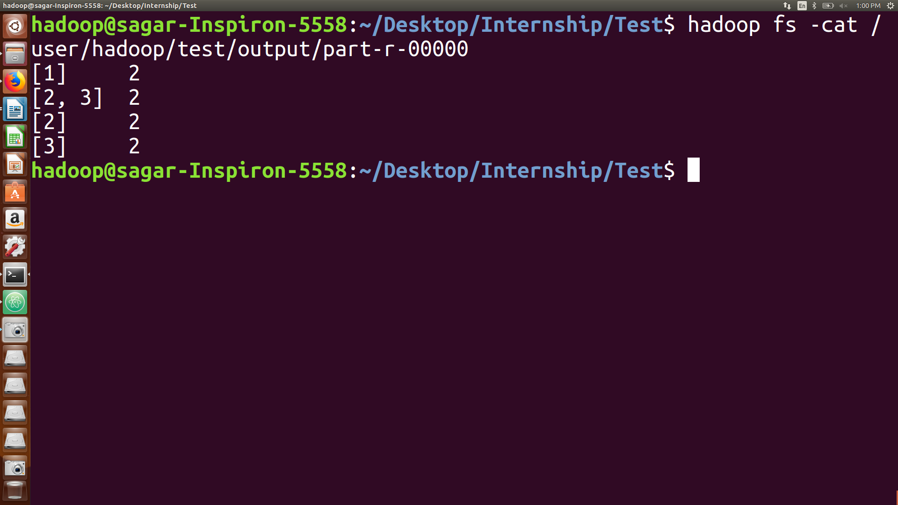
Shuffling and Reducing:
Threshold: 2
[1 , 2]
[2, 2]
[3 , 3]
[4 , 1]
[5 , 1]
[6 , 1]
Mapping:

[1 , 1] [2 , 1] [3 , 1]

[1 2 , 1 ] [1 3, 1] [2 3, 1]

[1 2 3, 1]
1 2 3

4 2 3

1 5 6
1 2 3
4 2 3
1 5 6
[4 , 1] [2 , 1] [3 , 1]

[4 2, 1] [4 3 , 1] [2 3, 1]

[4 2 3, 1]
[1 , 1] [5 , 1] [ 6 , 1]

[1 5 , 1] [1 6, 1] [5 6, 1]

[1 5 6,1]
[1 , 2]

[2 , 2]

[3 , 2]

[2 3, 2]
[1 2, 1]

[1 3, 1]

[2 3, 2]

[4 2, 1]

[4 3, 1]

[1 5, 1]

[1 6, 1]

[5 6, 1]

[1 2 3, 1]

[4 2 3, 1]

[1 5 6, 1]
Input File:
Splitting:
FinalResult:

