SAMPLE INPUT/OUTPUT
FINDING MINIMUM SPANNING TREE USING KRUSKAL’S ALGORITHM

EXAMPLE1 :
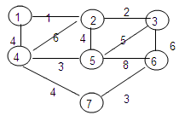
7
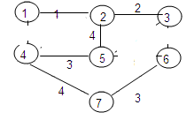

GRAPH MINIMUM SPANNING TREE

Add more node? -- press 'y' or 'Y' for yesY
Enter number of node one

Add more node? -- press 'y' or 'Y' for yesy

Enter number of node two … upto seven….

Add more node? -- press 'y' or 'Y' for yesn

Add more edge? -- press 'y' or 'Y' for yesy

Enter source and destination node number and weightone
two
1

Add more edge? -- press 'y' or 'Y' for yesy

Enter source and destination node number and weighttwo
three
2
…. For whole graph

Add more edge? -- press 'y' or 'Y' for yesn

Following graph have been entered by user
Node Name. one
Node Name. two
Node Name. three
Node Name. four
Node Name. five
Node Name. six
Node Name. seven
EdgeWeight LeftNode RightNode
1 one two
2 two three
3 seven six
3 five four
4 four seven
4 two five
4 one four
5 five three
6 four two
6 three six

8 five six
following are the edges selected for minimum spanning tree
EdgeWeight LeftNode RightNode
1 one two
2 two three
3 seven six
3 five four
4 four seven
4 two five

EXAMPLE 2:

Following graph have been entered by user
Node Name. one
Node Name. two
Node Name. three
Node Name. four
Node Name. five
EdgeWeight LeftNode RightNode
10 five one
15 two three
20 two four
25 four five
30 three four
35 one four
40 one three
50 one two
following are the edges selected for minimum spanning tree
EdgeWeight LeftNode RightNode
10 five one
15 two three
20 two four
25 four five

