Dissimilarity Matrix Calculation

Euclidean distances are root sum-of-squares of differences,
and manhattan distances are the sum of absolute differences.

Help

??distance
?cluster::daisy

library(cluster)

ll=matrix(c(22,20,1,0,42,36,10,8),ncol=4)

ll
[,1] [,2] [,3] [,4]
[1,] 22 1 42 10
[2,] 20 0 36 8

distances=daisy(ll,metric=c("euclidean"))
> distances
Dissimilarities :
1
2 6.708204

Metric : euclidean
Number of objects : 2
>

square root ( square(22-20) + square(1-0) + square (42-36) + square(10-8) )

square root (4+1+36+ 4)

square root(45)

6.70

> distances=daisy(ll,metric=c("manhattan"))
> distances
Dissimilarities :
1
2 11

Metric : manhattan
Number of objects : 2
>

| 22-20| + |1-0| + |42-36| + |0-8|

2 + 1 + 6 + 2

11

library(psych)
ellipses(x=ll)

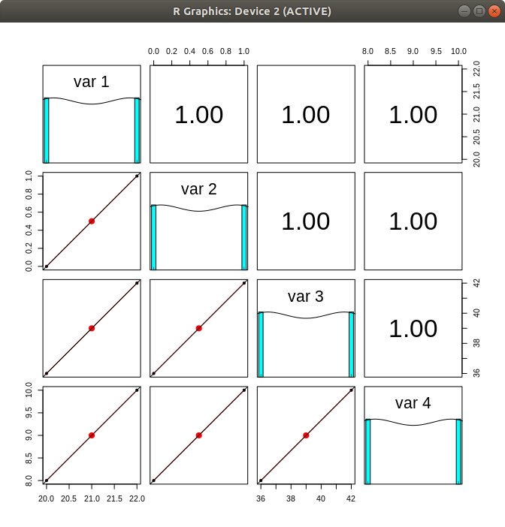
minkowski(3)

supremum distance also known as chebyshev distance.

??chebyshev

?pracma::chebApprox

> ll
[,1] [,2] [,3] [,4]
[1,] 22 1 42 10
[2,] 20 0 36 8
> ll[1,1]-ll[2,1]
[1] 2
> ll[1,2]-ll[2,2]
[1] 1
> ll[1,3]-ll[2,3]
[1] 6
> ll[1,4]-ll[2,4]
[1] 2
>

