Reports using SQLDeveloper

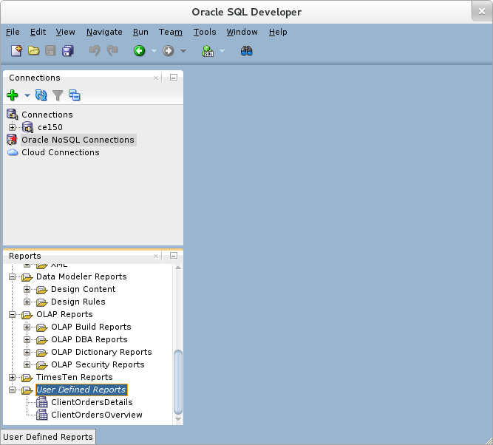

Step 1:

Master Report (Independent)

Create a new User Defined Reports -> ClientOrderOverview

Select Style: Table

select client_no, name, count(s_order_no) from client_master natural join sales_order group by client_no,name;

Save and run the report to see the results.

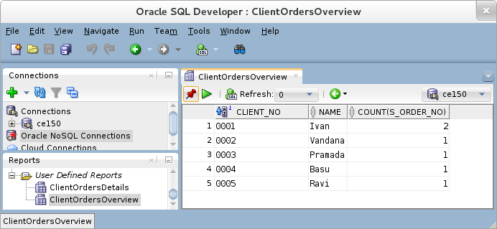

Step2:

Sub Report (with bind variable)

Create a new User Defined Reports -> ClientOrdersDetails

Select Style: Table

select * from sales_order where client_no=:CLIENT_NO

Note: Using column, we are creating a bind variable. When query will be run, input is expected from user for this :CLIENT_NO.

Verify “Binds” tab to have entry of CLIENT_NO bind variable. This is happening because of having a bind varible in the query.

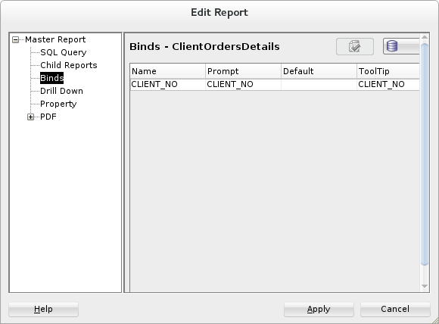

Step 3: Drill Down support in master report

““”
Drill Down means lets say you are seeing population count country wise, then when you click on a chosen country if you expect that it shall show you all state wise population for that country then this is exmple of drill down.

The chosen country id is passed as a value to bind variable of a query written for sub report.
“””

Right click and edit the ClientOrderOverview Report

Choose “DrillDown” tab, name and select the subreport here.

Click the drop down under “Report” and choose “ClientOrderDetails” from UserDefinedReports category.

Save the report.
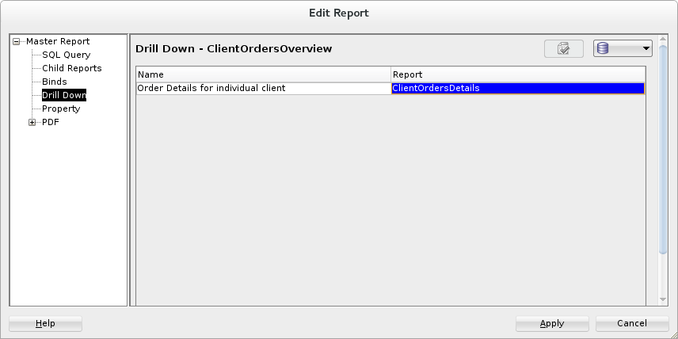

Step 4:

Execute Master Report “ClientOrderOverview” and once it shows the result.

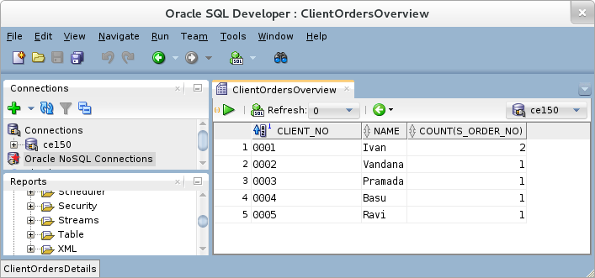
Select a row, right click and select the sub report to be executed “Order Details for Individual Client”.

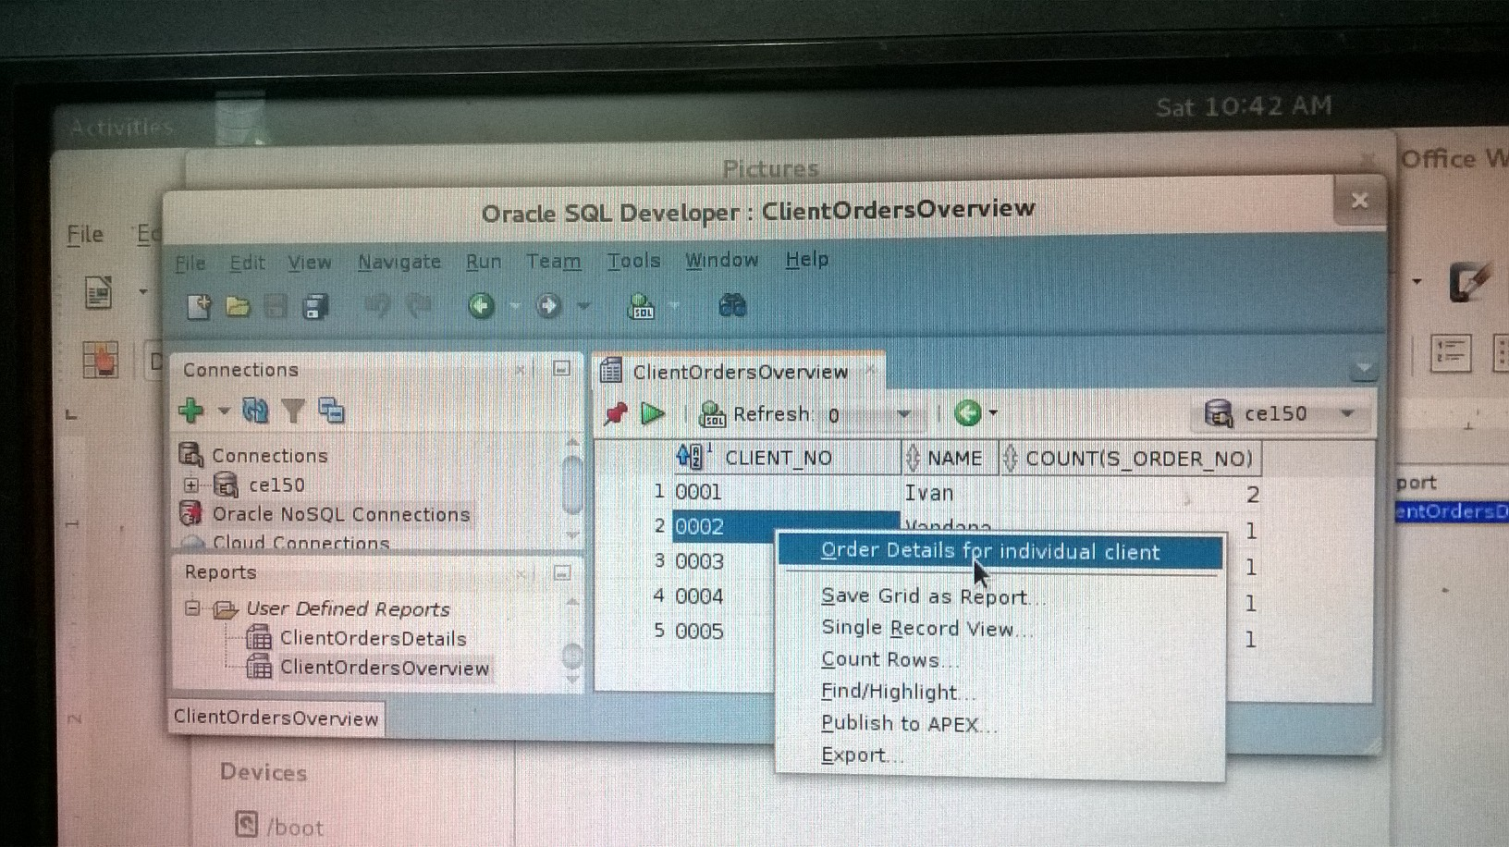
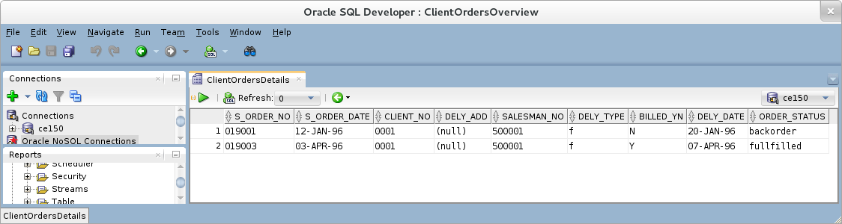

You may also use, green back arrow to go back to master report, etc.

Also, try changing the report sytle to graph, etc.

This way report generation is important for User Interface Development. The way we represent data to user decides the level of user satisfaction. If the information is represented graphically then it is many times easier to process and present.

Other reporting tools include Informatica, Crystal Reports, JasperSoft Reports, Google Charts, Motion Charts, etc.

