**DATA SCIENCE FOR ENGINEERS**

**Assignment-0- Solution Document**

**Create a data frame with given vectors below.**

**vec1** = c(1,2,3)

**vec2** = c("Apple", "Orange", "Guava”)

**vec3** = c(180,100,50)

Store the data frame in the variable named – “**fruits”**.

**Answer questions from 1 to 3 below. These are based on the data frame created above.**

1. What is the command to extract the information from **2nd** & **3rd** rows of the **3rd**column?
   1. **print(****fruits [2:3,3])**
   2. print(fruits [,2,3])
   3. print(fruits [2,3,])
   4. print(fruits [,3])

Solution:

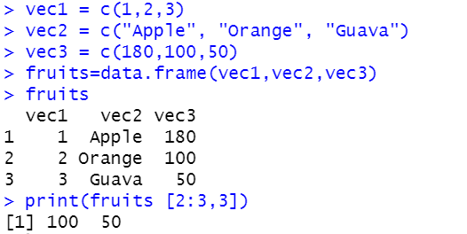

1. The command to add a new row to the data frame **“****fruits”** with the following values

vec1= 4, vec2="Grapes", vec3="120" passed to each vector is:

* 1. fruits =rbind(data.frame(vec1= 4, vec2="Grapes", vec3="120", fruits))
  2. fruits =rbind(data.frame(vec1= 4, vec2="Grapes", vec3="120"))
  3. fruits =rbind(data.frame(vec1= 4, vec2="Grapes", vec3="120"”), fruits)
  4. **fruits =rbind(fruits, data.frame(vec1= 4, vec2="Grapes", vec3="120"))**

Solution:

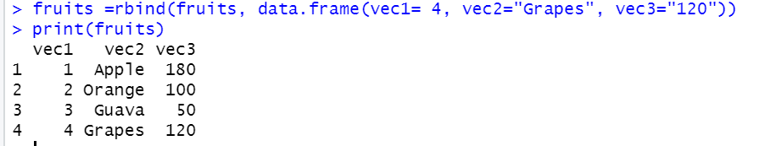

1. The command to add a new column to the data frame **“fruits”** with vector **“vec4”** taking values 10,20,30,40 is: -

**Note: Please answer the question based on data frame created in question 2**

* 1. fruits ==cbind(dataframe(vec4 = c(10,20,30,40), fruits )
  2. **fruits =cbind(fruits ,data.frame(vec4 = c(10,20,30,40)))**
  3. fruits =cbind(fruits.data.frame(vec4 = c(10,20,30,40)))
  4. fruits =cbind(data.frame(vec4 = c(00,20,30,40)), fruits)

Solution:

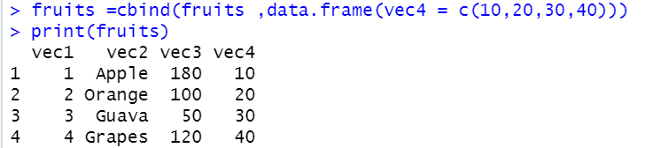

1. In R studio IDE the shortcut key **ctrl+Shift+S** executes
   1. all commands in console and displays the output.
   2. selected command alone
   3. **all commands in console without displaying them.**
   4. all commands in variable explorer

Solution:

In R studio IDE the shortcut key **ctrl+Shift+S** executes all commands in console without displaying them.

1. The line graph shows the country wise breakup of the number of cases who have recovered from COVID-19. Which country has the least number of recovered cases?

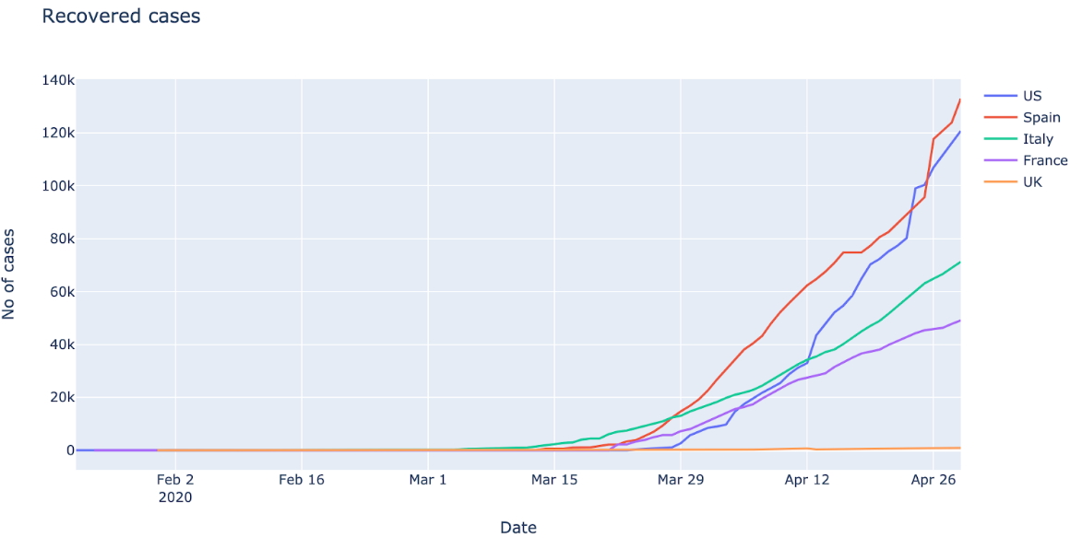

1. **France**
2. US
3. UK
4. Spain

Solution:

Compared to other countries showed in the graph France has the least number of recovered cases as of April 26th.

**Create a list using vec1, vec2 and vec3 and store the vectors in the list variable - “mylist”. Answer Q6 based on ‘mylist’.**

**vec1** = c(6,7,8)

**vec2** = c("Football","Basketball","Volleyball")

**vec3** = c("300", "400", "600")

1. Choose the correct command to replace **“Basketball”** with **“Carrom”**?
   1. mylist[[2]][3] = "Carrom"
   2. **mylist[[2]][2] = "Carrom"**
   3. mylist[2,3] = "Carrom"
   4. mylist[2]3 = "Carrom"

Solution:

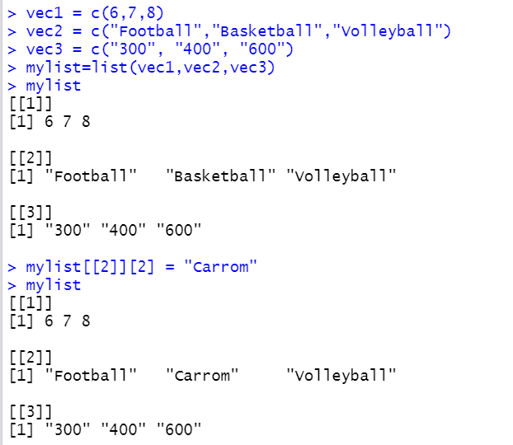

1. The library needed to do melt & cast operations in R is---
   1. Cars
   2. Caret
   3. Gdata
   4. **reshape2**

Solution:

R programming language has many methods to reshape the data using reshape2 package. melt() and cast() are the functions that efficiently reshape the data

1. The correct command to build a square matrix ‘A’ with numbers from 13 to 21, arranged column wise is:-
   1. A =matrix(c(13:21), nrow = 3, ncol = 9, byrow = T)
   2. A =matrix(c(13:22), nrow = 3, ncol = 1, byrow = F)
   3. A =matrix(c(13:22), nrow = 3, ncol = 3, byrow = T)
   4. **A = matrix(c(13:21), nrow = 3, ncol = 3, byrow = F)**

Solution:

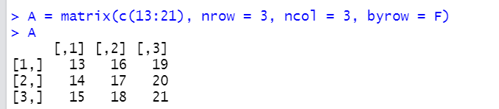

Answer all the questions from 9 to 10 using the matrix from Question 8:

1. The command to extract all the elements of third column from matrix “A” is ---
   1. A[3,]
   2. **A[,3]**
   3. A(3,)
   4. A{3}

Solution:

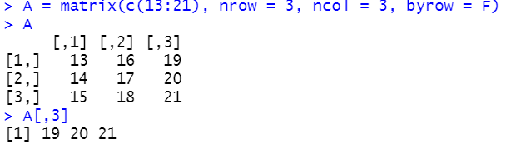

1. The command to extract the element in 1st row, 1st column from matrix “A” is-
   1. A(1,1)
   2. A[1,3]
   3. A{2,3}
   4. **A[1,1]**

Solution:

