GUI based export database pump using sqldeveloper oracle tool:

sudo sqldeveloper

Step1: To connect and verify tables with records:
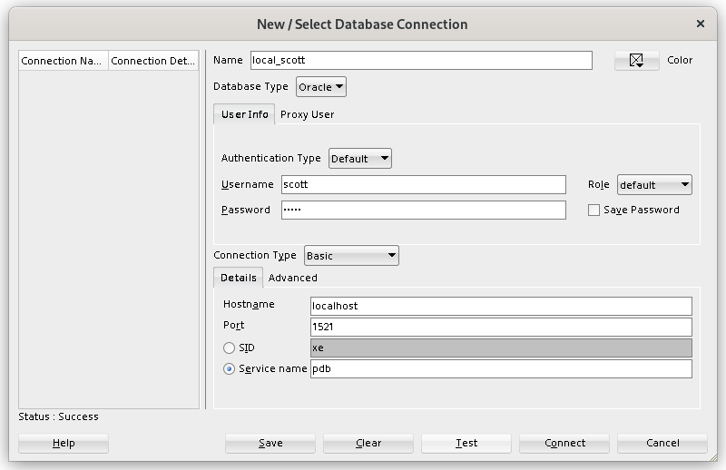

select count(*) from client_master;
select count(*) from product_master;
select count(*) from subject_master;

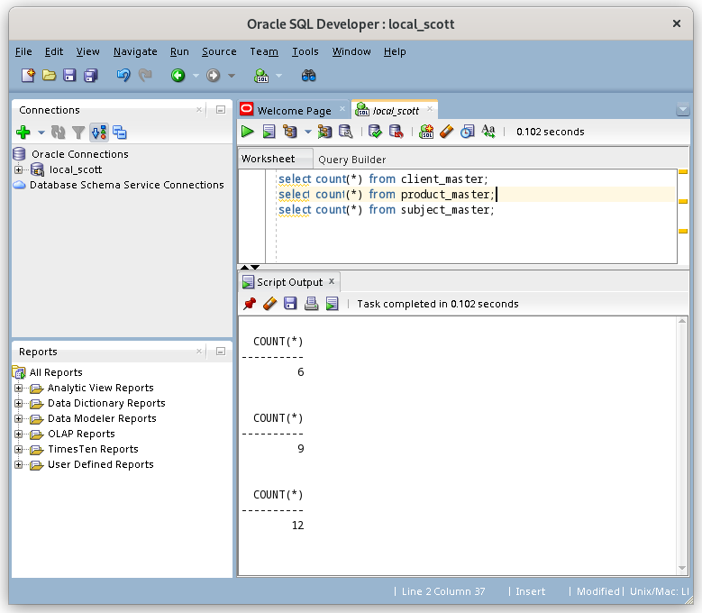

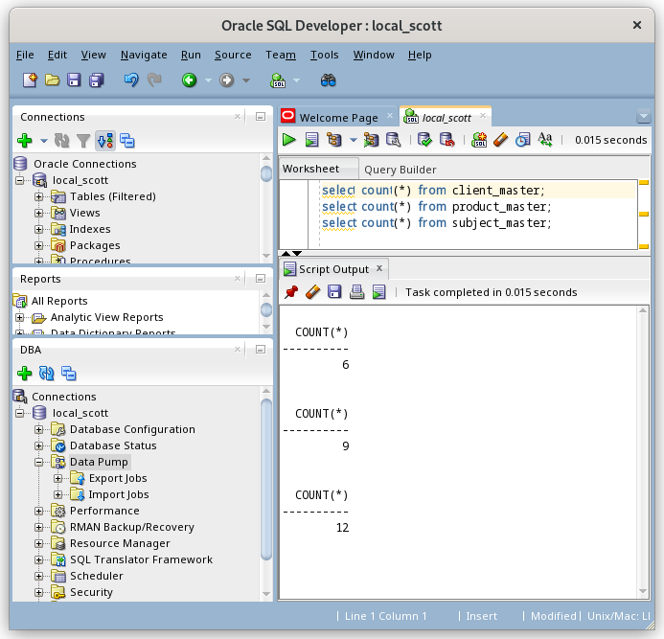
Enable DBA item from View menu:

Establish connection under DBA space

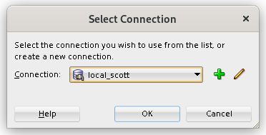

Step2: Use database dump export wizard

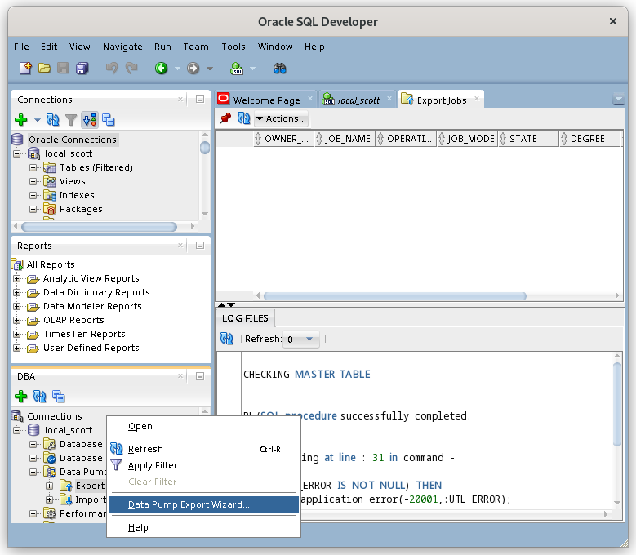

Step 3: Follow steps in the wizard as below

Wizard has 8 steps.

3.1 & 3.2 Choose types to be exported as database for example.

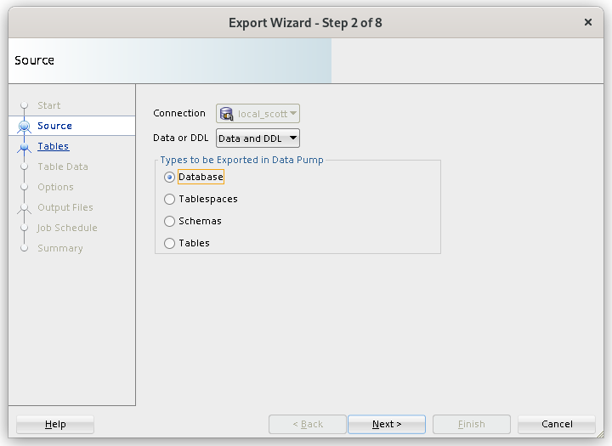

3.3

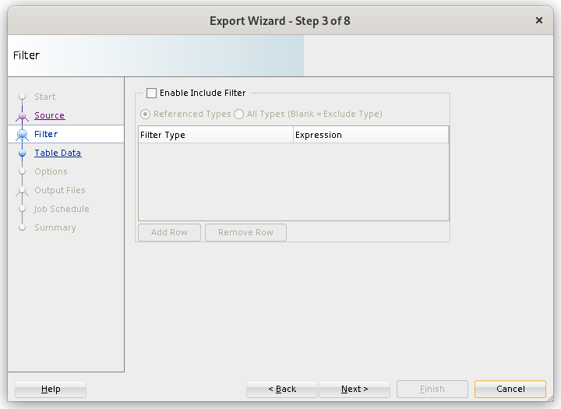

3.4
Press look up button
Click and select the table to fetch

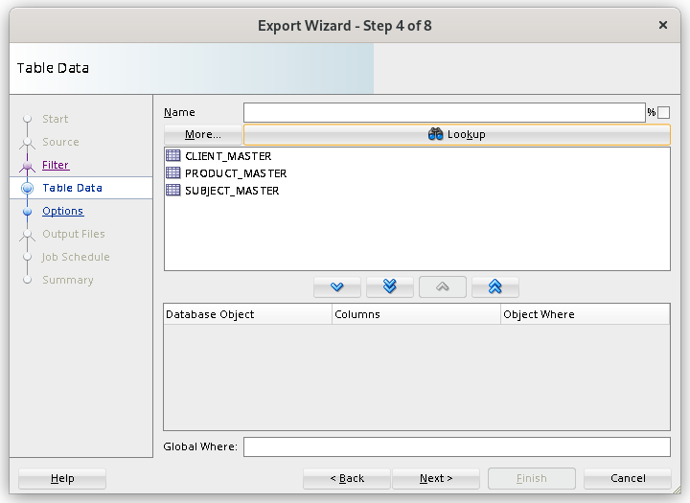
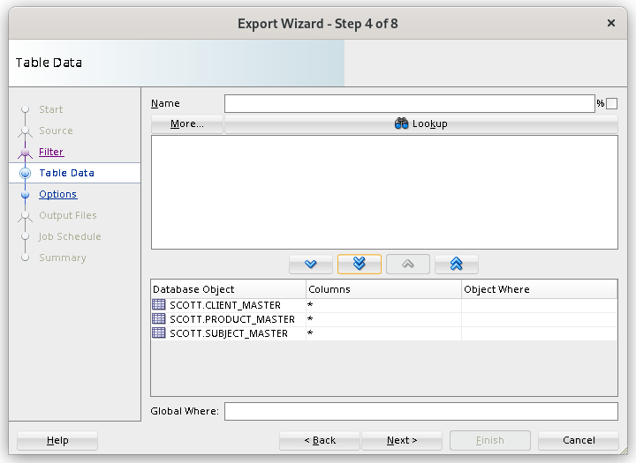

3.5

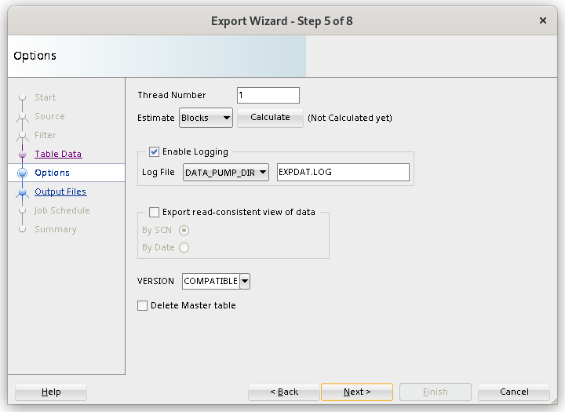

3.6

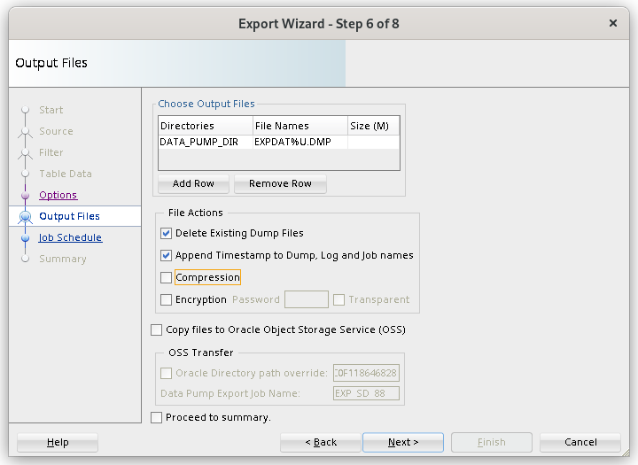

3.7

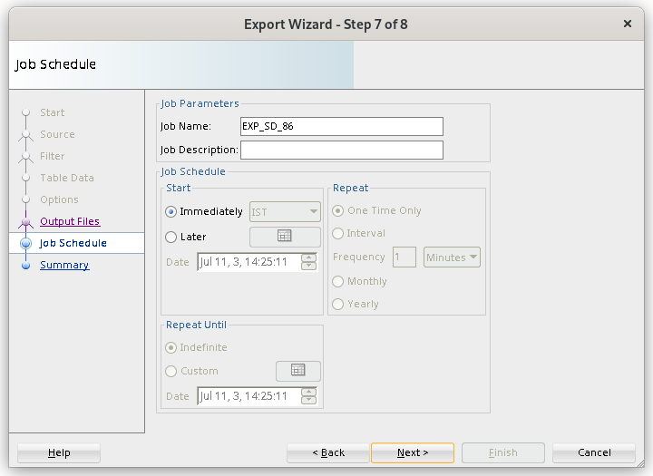

3.8

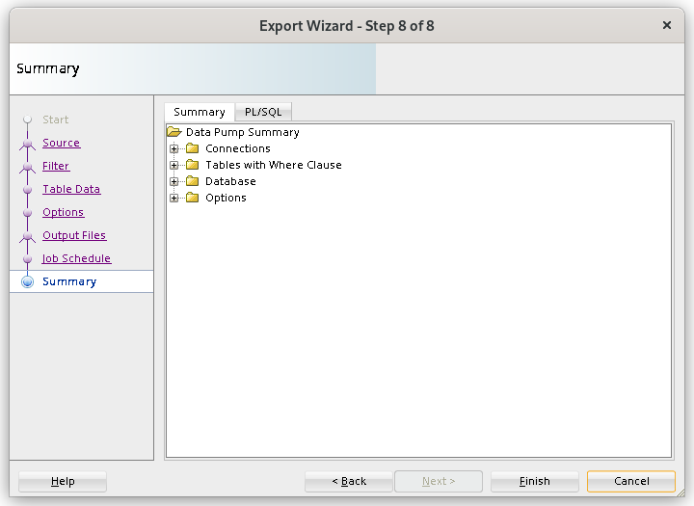

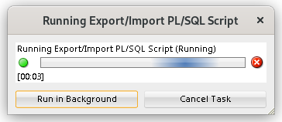

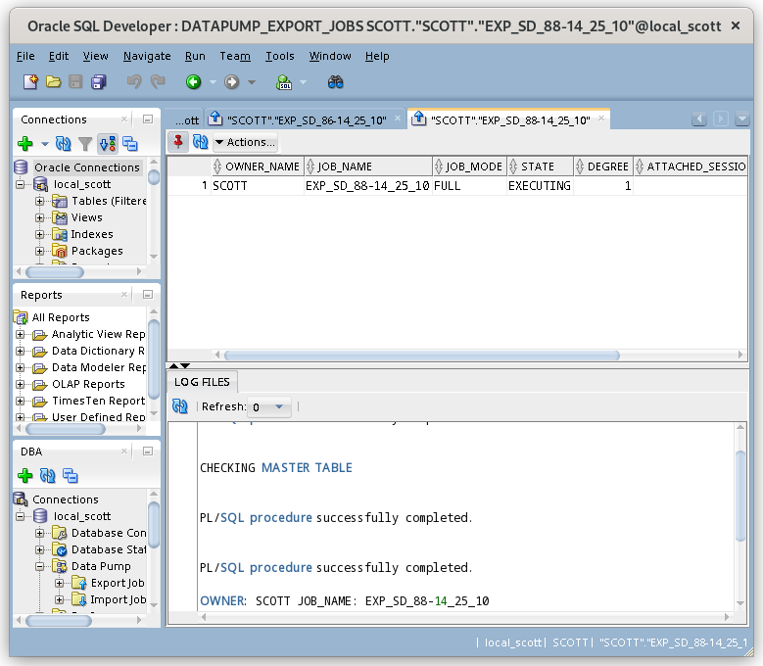
Location of the file as I started sqldeveloper as root to overcome writing prohibited permissions.

[root@pandya FFBBD5BA9F2D5ED9E055C0F118646828]# pwd
/opt/oracle/admin/XE/dpdump/FFBBD5BA9F2D5ED9E055C0F118646828
[root@pandya FFBBD5BA9F2D5ED9E055C0F118646828]# ls -l
total 4212
-rw-r-----. 1 oracle oinstall 4308992 Jul 11 14:30 EXPDAT01-14_28_02.DMP
[root@pandya FFBBD5BA9F2D5ED9E055C0F118646828]#

Step 4.
Now remove existing table.

drop table client_master;
drop table product_master;
drop table subject_master;

commit;

export DATA_PUMP_DIR=/run/media/jigar/6BF2D0CF44B3482D/my-dev/database/sql/oracle/datadump_pump_demo

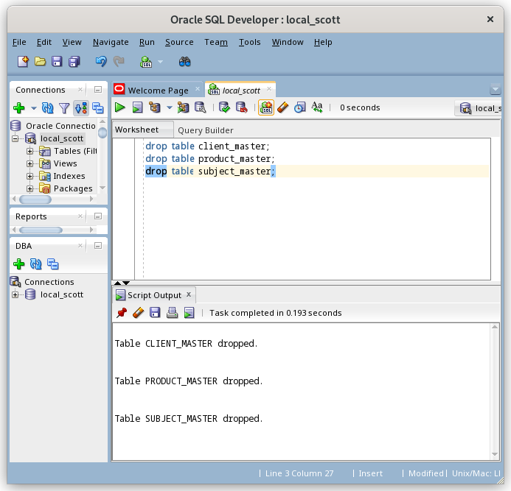

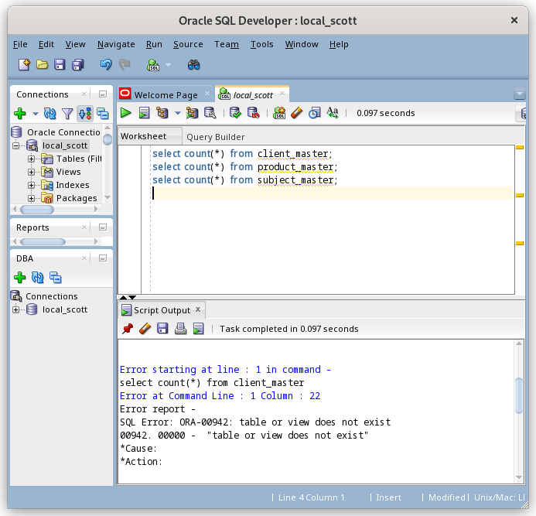

Step 5:
Import using wizard

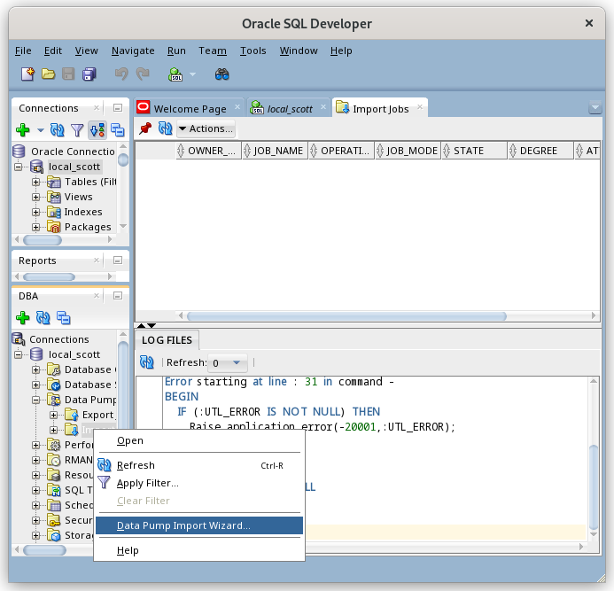

sudo cp EXPDAT01-14_28_02.DMP $ORACLE_HOME

I am running as root for now.

Import wizard has 6 steps
5.1
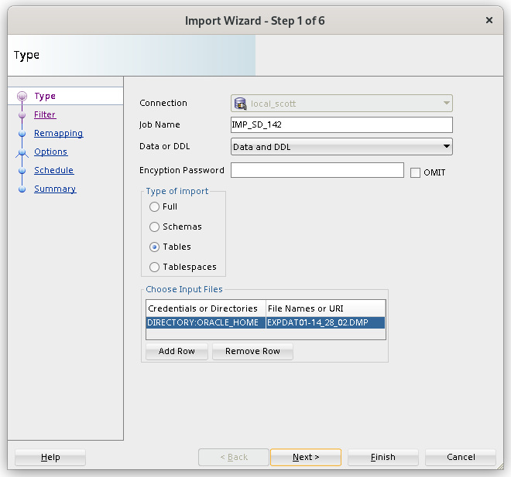

5.2

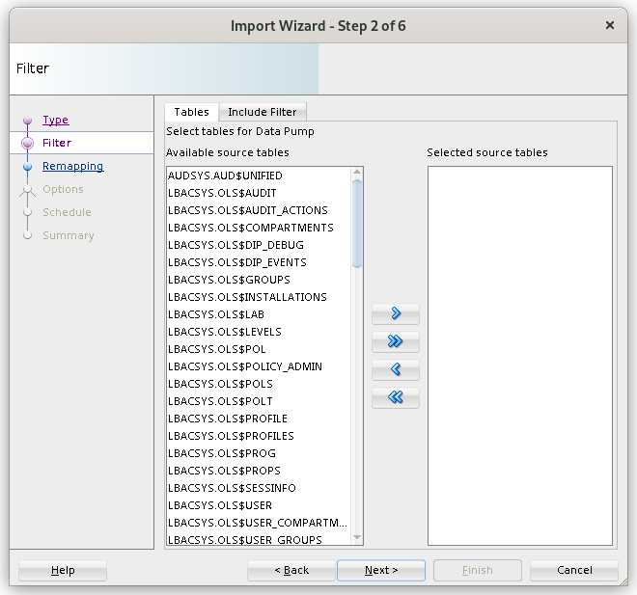
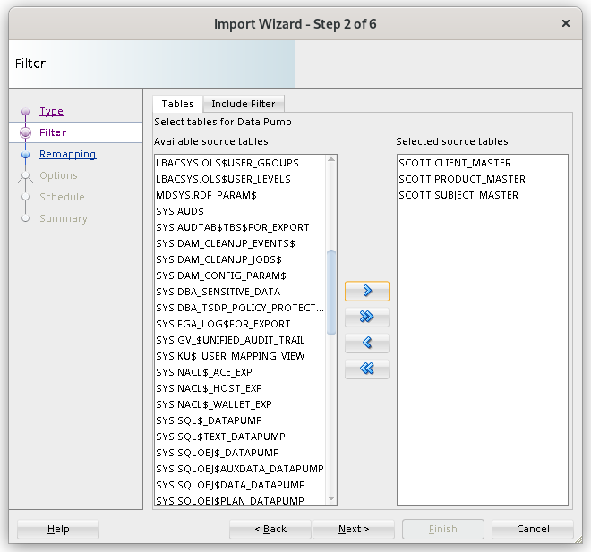

5.3

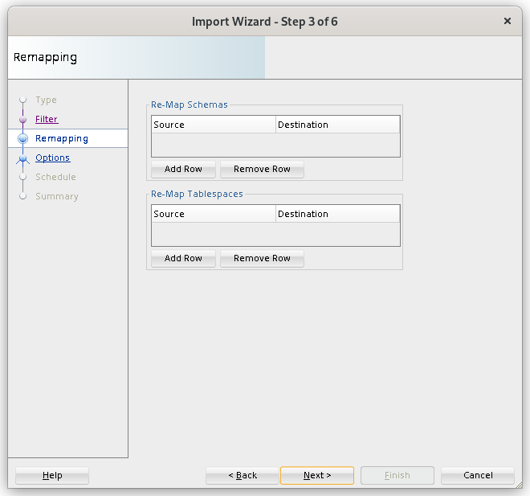

5.4

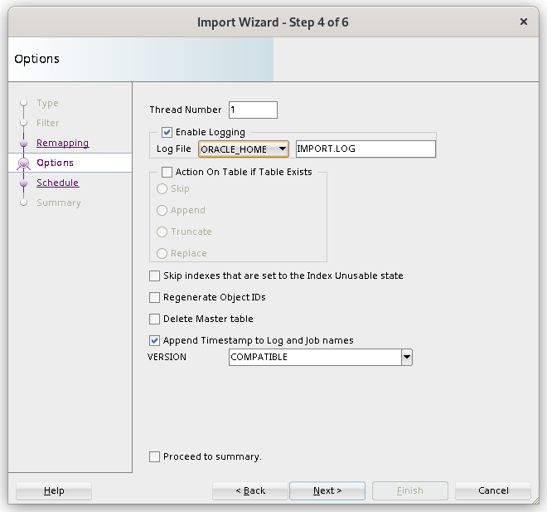

5.5

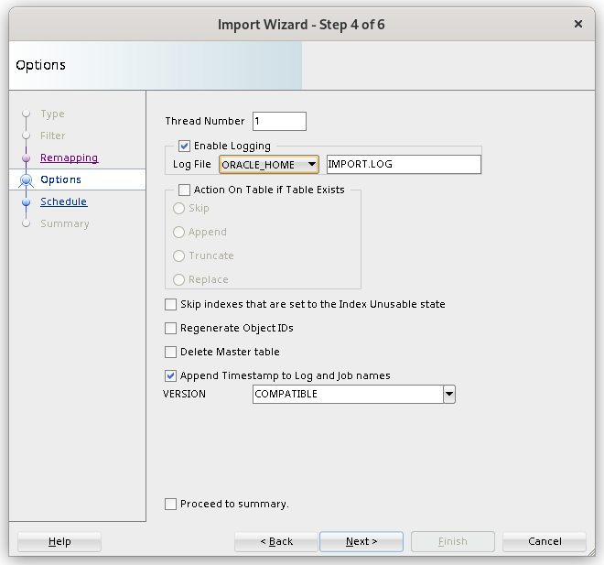
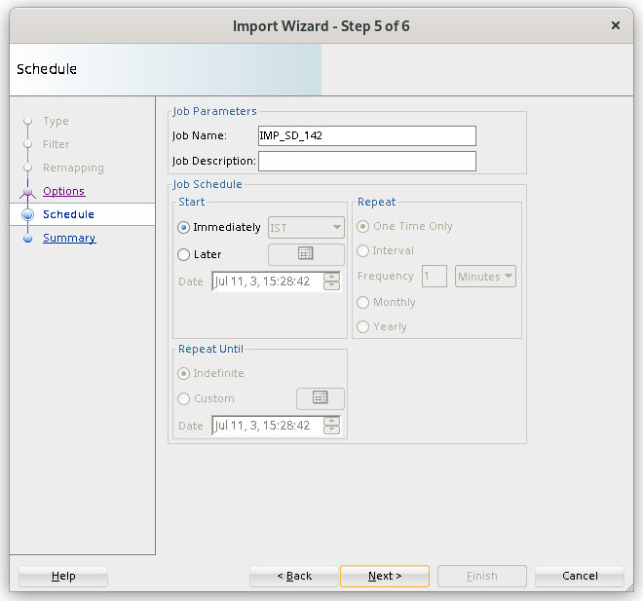

5.6

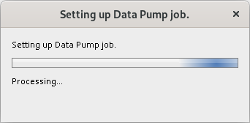

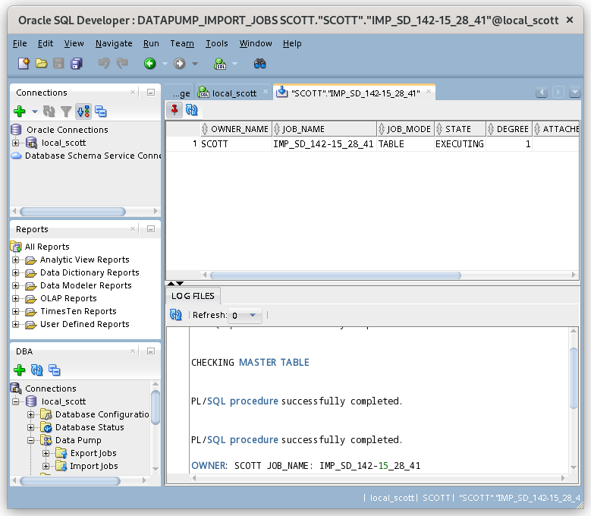
Step 6:
Verify that Import from database dump file works well.

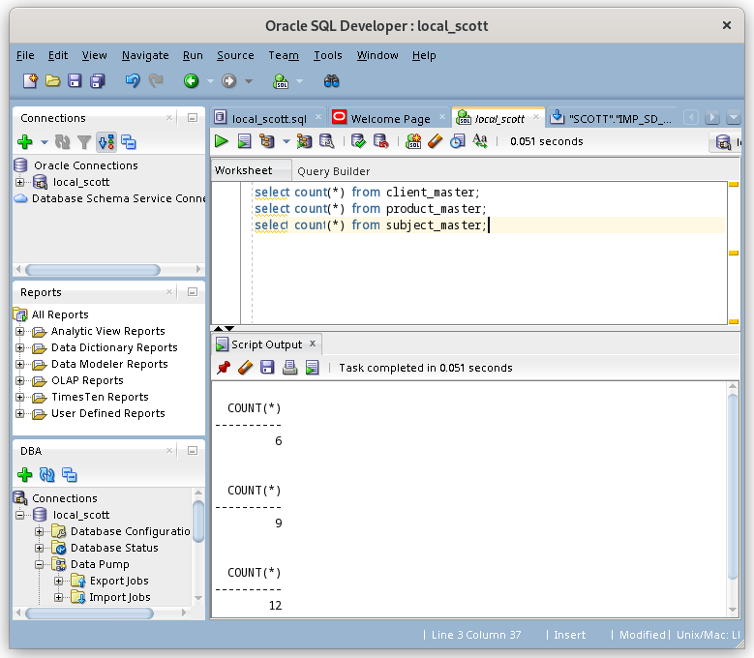

Note, that all three tables’ records are imported successfully.

https://www.oracle.com/webfolder/technetwork/tutorials/obe/db/sqldev/r31/datapump_OBE/datapump.html

https://oracle-base.com/articles/misc/sql-developer-31-data-pump-wizards

Documented By:
Jigar M. Pandya
https://www.linkedin.com/in/jigar-pandya
Document Last updated: 11th July, 2023.

