**When two tables refer to each other, which do you create first? Similarly, which record do you insert first?**

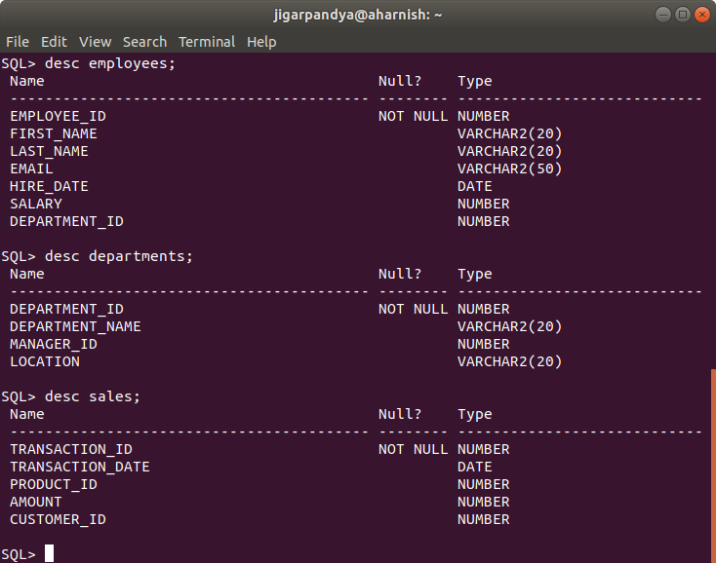

select CONSTRAINT_NAME, CONSTRAINT_TYPE, TABLE_NAME, R_CONSTRAINT_NAME from all_constraints where table_name in ('EMPLOYEES','DEPARTMENTS','SALES');

CONSTRAINT_NAME

--------------------------------------------------------------------------------

C

-

TABLE_NAME

--------------------------------------------------------------------------------

R_CONSTRAINT_NAME

--------------------------------------------------------------------------------

SYS_C0018043

R

DEPARTMENTS

SYS_C0018041

CONSTRAINT_NAME

--------------------------------------------------------------------------------

C

-

TABLE_NAME

--------------------------------------------------------------------------------

R_CONSTRAINT_NAME

--------------------------------------------------------------------------------

SYS_C0018044

R

EMPLOYEES

SYS_C0018042

CONSTRAINT_NAME

--------------------------------------------------------------------------------

C

-

TABLE_NAME

--------------------------------------------------------------------------------

R_CONSTRAINT_NAME

--------------------------------------------------------------------------------

SYS_C0018041

P

EMPLOYEES

CONSTRAINT_NAME

--------------------------------------------------------------------------------

C

-

TABLE_NAME

--------------------------------------------------------------------------------

R_CONSTRAINT_NAME

--------------------------------------------------------------------------------

SYS_C0018042

P

DEPARTMENTS

CONSTRAINT_NAME

--------------------------------------------------------------------------------

C

-

TABLE_NAME

--------------------------------------------------------------------------------

R_CONSTRAINT_NAME

--------------------------------------------------------------------------------

SYS_C0018045

P

SALES

create table employees (employee_id number primary key, first_name varchar2(20), last_name varchar2(20), email varchar2(50), hire_date date, salary number);

create table departments ( department_id number primary key, department_name varchar2(20), manager_id number references employees(employee_id), location varchar2(20));

Alter table employees add (department_id number references departments(department_id));

create table sales ( transaction_id number primary key, transaction_date date, product_id number, amount number, customer_id number);

insert into departments (department_id,department_name,location) values (1,'Sales','New York');

insert into departments (department_id,department_name,location) values (2,'Marketing','Los Angeles');

select * from departments;

Insert into employees (employee_id, first_name, last_name, email, hire_date, salary,department_id) values (1,'John','Doe','[john.doe@example.com](mailto:john.doe@example.com)','15-JAN-2023',50000,1);

Insert into employees (employee_id, first_name, last_name, email, hire_date, salary,department_id) values (2,'Jane','Smith','jane.smith@example.com','20-FEB-2023',60000,2);

update departments set manager_id=1 where department_id=1;

update departments set manager_id=2 where department_id=2;

Insert into sales values (1, '01-JAN-2023',101,1000,1001);

Insert into sales values (2, '02-JAN-2023',102,1500,1002);

There is an analogy in C Programming with this problem and solution. That is when two structures are having data members of each other, how do you define them?

struct B; //Declaration of struct B

struct A

{

struct B b;

};

struct B

{

struct A a;

};