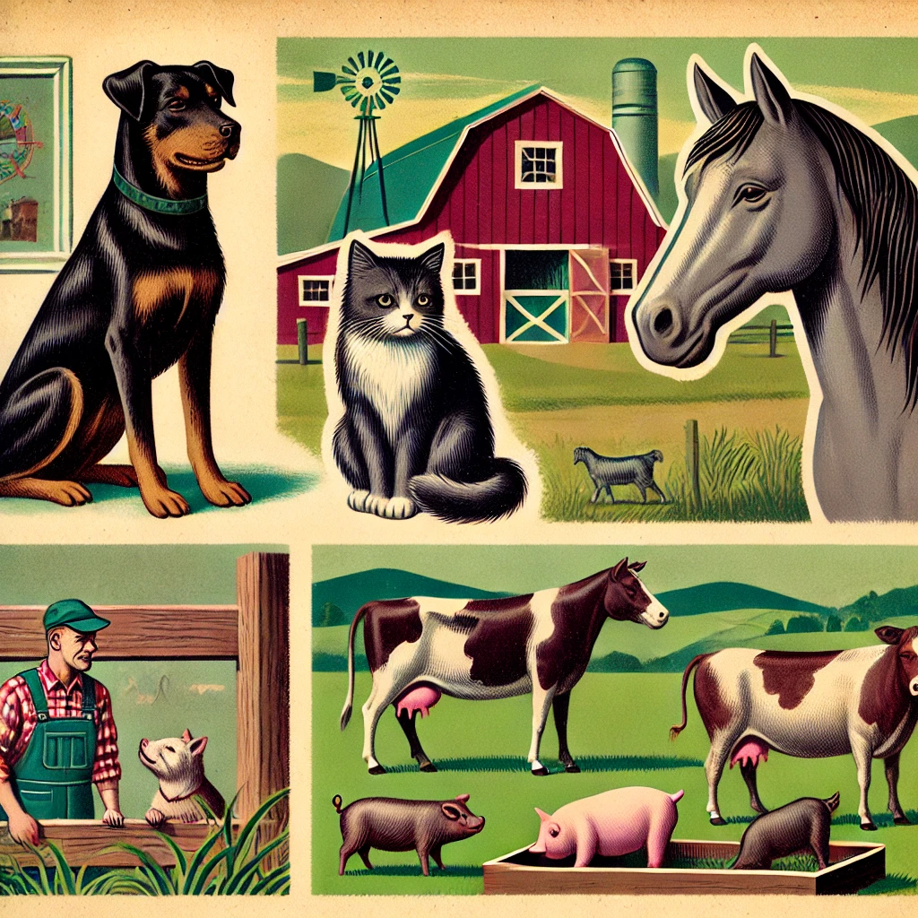
In-Class Lab: Creating and Using an `Animal` Class

Objective:
In this lab, you will create an `Animal` class with attributes for animal type, name, and sound. The class will include:
- A constructor (`__init__`) to initialize attributes
- Getters and setters for each attribute
- A `__str__` method to display the animal's details
- A `speak` method that prints the sound the animal makes

Instructions:
- Work with your partner to implement the Animal class

Step 1: Designing the Class by defining the Constructor
- Create an `Animal` class with animal type, name, and sound as attributes.
- Pick appropriate data types for each attribute. Since `type` is a reserved keyword in Python, what alternative name should we use for the animal's species? (Hint: `animal_type` or `species’ are good options, feel free to use others)
- Write the constructor (`__init__`) method
- The constructor must include each of the class attributes as arguments
- The constructor must set the class attributes
- Add default values for each attribute
- Save your code in a file called Animal.py
Constructor Syntax:
def __init__(self, parameter1=default, parameter2=default, parameter3=default):
self.attribute1 = parameter1
self.attribute2 = parameter2
self.attribute3 = parameter3
Step 2. Add Getters and Setters for each class attribute
- Why should we use getters and setters instead of directly accessing attributes?

Example Getter & Setter:
def get_name(self):
return self.name

def set_name(self, new_name):
self.name = new_name

Step 3: Adding the `__str__` Method

Example str method
def __str__(self):
return f”data is {self.attribute1}, {self.attribute2}, {self.attribute3}”

Step 4: Add a `speak` Method
Add and update the method speak to use the format “Maynard the kitten says meow”
Example speak method
def speak(self):
print( f“animal goes {self.sound} )

Step 5: Creating and Testing Objects

- Place code in if statement if __name__ == “__main__”:
to allow class to be test and used by other files.
- Create two animal instances using the default attribute values
  - maynard = Animal()
- Call the speak method for each
  - maynard.speak()
- Use print to display each of the instances
  - print( maynard )
- Update each animal instance attribute using the “setters”
  - maynard.set_sound( “meow” )
- Use the “getters” to display each of the attributes for both animals
  - print( maynard.get_sound )

- Create an animal instance by setting the attributes
  - maynard = Animal( “cat”, “Maynard”, “meow”)

Bonus Challenges (if time allows):
- Create a list of animals and loop through them, calling `speak()` for each one.
maynard = Animal( “cat”, “Maynard”, “meow”)
finn = Animal( “dog”, “Finn”, “woof”)
Pets = [maynard, finn]
for pet in Pets:
pet.speak()
- Modify the `speak` method to repeat the sound a random number of times 1 to 3.
- Add an `age` attribute to the class and update the constructor, getters, setters, and str methods to utilize the age attribute

