Entrenamiento de Red Neuronal con Keras en “R”
Guillermo Cardenas, Juan Suarez
Link del colab: https://colab.research.google.com/drive/1sj6da-qZM_h3ieu2Bvqw6njyanliQ6Jw?usp=sharing

Introducción
Este reporte muestra el uso de R para entrenar un modelo de red neuronal utilizando los paquetes Keras y TensorFlow.

Configuración Inicial

Instalación de Paquetes
if (!requireNamespace("tensorflow", quietly = TRUE)) install.packages("tensorflow")
if (!requireNamespace("keras", quietly = TRUE)) install.packages("keras")
library(keras)
library(tensorflow)
library(ggplot2)
library(gridExtra)
library(png)

Configuración inicial del dataset
dataset_path <- "C:/Users/aasal/OneDrive/Documentos/Curso Samsung/.venv/IA uni/Alfabeto/dateset400"
epochs <- as.integer(10)
batch_size <- as.integer(32)
target_size <- c(32, 32)
classes <- c("A", "B", "C", "D", "E", "F", "G", "H", "I", "K", "L", "M", "N", "O", "P", "Q", "R", "S", "T", "U", "V", "W", "X", "Y")
#Preprocesamiento de Datos
train_datagen <- image_data_generator(
rescale = 1 / 255,
rotation_range = 20,
width_shift_range = 0.2,
height_shift_range = 0.2,
horizontal_flip = TRUE,
validation_split = 0.2
)
train_generator <- flow_images_from_directory(
directory = dataset_path,
generator = train_datagen,
target_size = target_size,
color_mode = "grayscale",
batch_size = batch_size,
class_mode = "categorical",
classes = classes,
subset = "training",
seed = 123
)
## Found 7680 images belonging to 24 classes.
validation_generator <- flow_images_from_directory(
directory = dataset_path,
generator = train_datagen,
target_size = target_size,
color_mode = "grayscale",
batch_size = batch_size,
class_mode = "categorical",
classes = classes,
subset = "validation",
seed = 123
)
## Found 1920 images belonging to 24 classes.

Definición del Modelo CNN
# Definición de la arquitectura
inputs <- layer_input(shape = c(32, 32, 1))
outputs <- inputs %>%
layer_conv_2d(filters = 64, kernel_size = c(3,3), activation = "relu", padding = "same") %>%
layer_conv_2d(filters = 64, kernel_size = c(3,3), activation = "relu", padding = "same") %>%
layer_batch_normalization() %>%
layer_max_pooling_2d(pool_size = c(2,2)) %>%
layer_dropout(rate = 0.25) %>%
layer_conv_2d(filters = 128, kernel_size = c(3,3), activation = "relu", padding = "same") %>%
layer_conv_2d(filters = 128, kernel_size = c(3,3), activation = "relu", padding = "same") %>%
layer_batch_normalization() %>%
layer_max_pooling_2d(pool_size = c(2,2)) %>%
layer_dropout(rate = 0.25) %>%
layer_flatten() %>%
layer_dense(units = 256, activation = "relu") %>%
layer_dense(units = 64, activation = "relu") %>%
layer_dropout(rate = 0.3) %>%
layer_dense(units = 24, activation = "softmax")
model <- keras_model(inputs = inputs, outputs = outputs)

Compilacion del modelo
# Resumen del modelo
summary(model)
## <Functional name=functional, built=True>

Callbacks necesarios para salvar
# Callbacks
checkpoint_dir <- "C:/Users/aasal/OneDrive/Documentos/Curso Samsung/.venv/IA uni/Alfabeto/save"
if (!dir.exists(checkpoint_dir)) {
dir.create(checkpoint_dir, recursive = TRUE)
}
checkpoint_callback <- callback_model_checkpoint(
filepath = file.path(checkpoint_dir, "weights-{epoch:02d}-{val_accuracy:.2f}.h5"), # Cambiado a .h5
monitor = "val_accuracy",
save_best_only = TRUE,
mode = "max",
verbose = 1
)
early_stop <- callback_early_stopping(
monitor = "val_loss",
patience = 5,
restore_best_weights = TRUE
)
Entrenamiento del modelo
# 3. Compilar el modelo
model$compile(
optimizer = optimizer_adam(),
loss = "categorical_crossentropy", # Cambiado a categorical_crossentropy
metrics = list("accuracy")
)

# Resumen del modelo
summary(model)
# 4. Entrenar el modelo
history <- model$fit(
train_generator,
epochs = epochs, # Usar la variable definida
validation_data = validation_generator,
callbacks = list(checkpoint_callback, early_stop),
verbose = 1
)

# 5. Evaluar el modelo
evaluation <- model$evaluate(validation_generator)
cat(sprintf("Pérdida en validación: %.4f\n", evaluation["loss"]))
cat(sprintf("Precisión en validación: %.4f\n", evaluation["accuracy"]))

Found 7680 images belonging to 24 classes.
Found 1920 images belonging to 24 classes.
<Functional name=functional_3, built=True>
Epoch 1/10
240/240 ━━━━━━━━━━━━━━━━━━━━ 19s 70ms/step - accuracy: 0.0510 - loss: 3.1517

Epoch 1: val_accuracy improved from -inf to 0.12500, saving model to C:/Users/aasal/OneDrive/Documentos/Curso Samsung/.venv/IA uni/Alfabeto/save/weights-01-0.12.h5
WARNING:absl:You are saving your model as an HDF5 file via `model.save()` or `keras.saving.save_model(model)`. This file format is considered legacy. We recommend using instead the native Keras format, e.g. `model.save('my_model.keras')` or `keras.saving.save_model(model, 'my_model.keras')`.
240/240 ━━━━━━━━━━━━━━━━━━━━ 22s 81ms/step - accuracy: 0.0511 - loss: 3.1514 - val_accuracy: 0.1250 - val_loss: 2.9117
Epoch 2/10
240/240 ━━━━━━━━━━━━━━━━━━━━ 16s 64ms/step - accuracy: 0.1838 - loss: 2.6366

Epoch 2: val_accuracy improved from 0.12500 to 0.22031, saving model to C:/Users/aasal/OneDrive/Documentos/Curso Samsung/.venv/IA uni/Alfabeto/save/weights-02-0.22.h5
WARNING:absl:You are saving your model as an HDF5 file via `model.save()` or `keras.saving.save_model(model)`. This file format is considered legacy. We recommend using instead the native Keras format, e.g. `model.save('my_model.keras')` or `keras.saving.save_model(model, 'my_model.keras')`.
240/240 ━━━━━━━━━━━━━━━━━━━━ 18s 74ms/step - accuracy: 0.1839 - loss: 2.6360 - val_accuracy: 0.2203 - val_loss: 2.5516
Epoch 3/10
240/240 ━━━━━━━━━━━━━━━━━━━━ 16s 65ms/step - accuracy: 0.3016 - loss: 2.2003

Epoch 3: val_accuracy improved from 0.22031 to 0.25885, saving model to C:/Users/aasal/OneDrive/Documentos/Curso Samsung/.venv/IA uni/Alfabeto/save/weights-03-0.26.h5
WARNING:absl:You are saving your model as an HDF5 file via `model.save()` or `keras.saving.save_model(model)`. This file format is considered legacy. We recommend using instead the native Keras format, e.g. `model.save('my_model.keras')` or `keras.saving.save_model(model, 'my_model.keras')`.
240/240 ━━━━━━━━━━━━━━━━━━━━ 19s 78ms/step - accuracy: 0.3017 - loss: 2.2001 - val_accuracy: 0.2589 - val_loss: 2.4173
Epoch 4/10
240/240 ━━━━━━━━━━━━━━━━━━━━ 15s 64ms/step - accuracy: 0.3822 - loss: 1.9369

Epoch 4: val_accuracy improved from 0.25885 to 0.29115, saving model to C:/Users/aasal/OneDrive/Documentos/Curso Samsung/.venv/IA uni/Alfabeto/save/weights-04-0.29.h5
WARNING:absl:You are saving your model as an HDF5 file via `model.save()` or `keras.saving.save_model(model)`. This file format is considered legacy. We recommend using instead the native Keras format, e.g. `model.save('my_model.keras')` or `keras.saving.save_model(model, 'my_model.keras')`.
240/240 ━━━━━━━━━━━━━━━━━━━━ 18s 74ms/step - accuracy: 0.3823 - loss: 1.9367 - val_accuracy: 0.2911 - val_loss: 2.2943
Epoch 5/10
240/240 ━━━━━━━━━━━━━━━━━━━━ 16s 65ms/step - accuracy: 0.4493 - loss: 1.7054

Epoch 5: val_accuracy did not improve from 0.29115
240/240 ━━━━━━━━━━━━━━━━━━━━ 18s 74ms/step - accuracy: 0.4493 - loss: 1.7054 - val_accuracy: 0.2833 - val_loss: 2.2434
Epoch 6/10
240/240 ━━━━━━━━━━━━━━━━━━━━ 17s 71ms/step - accuracy: 0.4861 - loss: 1.5901

Epoch 6: val_accuracy did not improve from 0.29115
240/240 ━━━━━━━━━━━━━━━━━━━━ 19s 80ms/step - accuracy: 0.4862 - loss: 1.5901 - val_accuracy: 0.2786 - val_loss: 2.2225
Epoch 7/10
240/240 ━━━━━━━━━━━━━━━━━━━━ 16s 65ms/step - accuracy: 0.5042 - loss: 1.5329

Epoch 7: val_accuracy improved from 0.29115 to 0.34896, saving model to C:/Users/aasal/OneDrive/Documentos/Curso Samsung/.venv/IA uni/Alfabeto/save/weights-07-0.35.h5
WARNING:absl:You are saving your model as an HDF5 file via `model.save()` or `keras.saving.save_model(model)`. This file format is considered legacy. We recommend using instead the native Keras format, e.g. `model.save('my_model.keras')` or `keras.saving.save_model(model, 'my_model.keras')`.
240/240 ━━━━━━━━━━━━━━━━━━━━ 18s 75ms/step - accuracy: 0.5043 - loss: 1.5326 - val_accuracy: 0.3490 - val_loss: 2.0472
Epoch 8/10
240/240 ━━━━━━━━━━━━━━━━━━━━ 16s 66ms/step - accuracy: 0.5423 - loss: 1.3801

Epoch 8: val_accuracy improved from 0.34896 to 0.37656, saving model to C:/Users/aasal/OneDrive/Documentos/Curso Samsung/.venv/IA uni/Alfabeto/save/weights-08-0.38.h5
WARNING:absl:You are saving your model as an HDF5 file via `model.save()` or `keras.saving.save_model(model)`. This file format is considered legacy. We recommend using instead the native Keras format, e.g. `model.save('my_model.keras')` or `keras.saving.save_model(model, 'my_model.keras')`.
240/240 ━━━━━━━━━━━━━━━━━━━━ 19s 79ms/step - accuracy: 0.5424 - loss: 1.3800 - val_accuracy: 0.3766 - val_loss: 1.9332
Epoch 9/10
240/240 ━━━━━━━━━━━━━━━━━━━━ 17s 66ms/step - accuracy: 0.5797 - loss: 1.2877

Epoch 9: val_accuracy improved from 0.37656 to 0.41094, saving model to C:/Users/aasal/OneDrive/Documentos/Curso Samsung/.venv/IA uni/Alfabeto/save/weights-09-0.41.h5
WARNING:absl:You are saving your model as an HDF5 file via `model.save()` or `keras.saving.save_model(model)`. This file format is considered legacy. We recommend using instead the native Keras format, e.g. `model.save('my_model.keras')` or `keras.saving.save_model(model, 'my_model.keras')`.
240/240 ━━━━━━━━━━━━━━━━━━━━ 20s 76ms/step - accuracy: 0.5797 - loss: 1.2876 - val_accuracy: 0.4109 - val_loss: 1.8455
Epoch 10/10
240/240 ━━━━━━━━━━━━━━━━━━━━ 16s 67ms/step - accuracy: 0.5950 - loss: 1.2392

Epoch 10: val_accuracy did not improve from 0.41094
240/240 ━━━━━━━━━━━━━━━━━━━━ 19s 80ms/step - accuracy: 0.5950 - loss: 1.2392 - val_accuracy: 0.3995 - val_loss: 1.8910
60/60 ━━━━━━━━━━━━━━━━━━━━ 2s 39ms/step - accuracy: 0.3895 - loss: 1.8559
60/60 ━━━━━━━━━━━━━━━━━━━━ 2s 39ms/step - accuracy: 0.3896 - loss: 1.8565
Pérdida en validación: NA
Precisión en validación: NA
WARNING:absl:The `save_format` argument is deprecated in Keras 3. We recommend removing this argument as it can be inferred from the file path. Received: save_format=h5
WARNING:absl:You are saving your model as an HDF5 file via `model.save()` or `keras.saving.save_model(model)`. This file format is considered legacy. We recommend using instead the native Keras format, e.g. `model.save('my_model.keras')` or `keras.saving.save_model(model, 'my_model.keras')`.
List of 2
$ : num [1:32, 1:32, 1:32, 1] 0.557 0.204 0.538 0.269 0.082 ...
$ : num [1:32, 1:24] 0 0 0 0 0 0 0 0 0 0 ...
NULL

Evaluar y salvar el modelo
# 6. Guardar el modelo
save_model_hdf5(model, "modelo_cajas.h5")
(str(generator_next(train_generator)))
## List of 2
## $ : num [1:32, 1:32, 1:32, 1] 0.149 0.708 0.788 0.238 0.066 ...
## $ : num [1:32, 1:24] 0 0 1 0 0 0 0 0 0 0 ...
## NULL

Graficas:

Grafica de arreglo de la red:
# Función para visualizar la arquitectura del modelo
plot_model_architecture <- function() {
# Capas representadas en el gráfico
layers <- c(
"Input (32x32x1)",
"Conv2D (64 filtros, ReLU, padding=same)",
"Conv2D (64 filtros, ReLU, padding=same)",
"BatchNorm",
"MaxPooling2D",
"Dropout (rate=0.25)",
"Conv2D (128 filtros, ReLU, padding=same)",
"Conv2D (128 filtros, ReLU, padding=same)",
"BatchNorm",
"MaxPooling2D",
"Dropout (rate=0.25)",
"Flatten",
"Dense (256 unidades, ReLU)",
"Dense (64 unidades, ReLU)",
"Dropout (rate=0.3)",
"Dense (24 unidades, Softmax)"
)
# Crear un data frame para las posiciones de las capas
df <- data.frame(
x = rep(1, length(layers)),
y = seq(length(layers), 1),
label = layers
)
# Generar el gráfico utilizando ggplot2
ggplot(df, aes(x, y, label = label)) +
geom_point(size = 10, color = "steelblue") + # Puntos azules que representan las capas
geom_text(color = "black", size = 3, fontface = "bold", vjust = -0.6) + # Texto en negro
geom_segment(aes(x = x, xend = x, y = y - 0.4, yend = y + 0.4),
arrow = arrow(length = unit(0.2, "cm")),
color = "gray") +
theme_void() +
labs(title = "Arquitectura de la Red Neuronal") +
theme(plot.title = element_text(hjust = 0.5, size = 16, face = "bold"))
}
# Llamar a la función para visualizar el gráfico
plot_model_architecture()

Grafica de imagenes de ejemplo:

# Visualizar algunas imágenes de ejemplo
plot_sample_images <- function(generator, n = 6) {
batch <- generator_next(generator)
images <- batch[[1]]
labels <- batch[[2]]
# Configurar área de gráfico
par(mfrow = c(2, 3), mar = c(1, 1, 2, 1))
for (i in 1:n) {
# Extraer y normalizar la imagen (convertir a rango [0,1])
img <- images[i,,,1]
img_norm <- (img - min(img)) / (max(img) - min(img))
# Crear plot con funciones base de R
plot(NA, xlim = c(0, 1), ylim = c(0, 1), xaxt = 'n', yaxt = 'n', ann = FALSE)
rasterImage(img_norm, 0, 0, 1, 1)
title(main = ifelse(labels[i] == 1, classes[2], classes[1]), line = 0.5)
box()
}
}
# Mostrar todas las visualizaciones
plot_model_architecture()
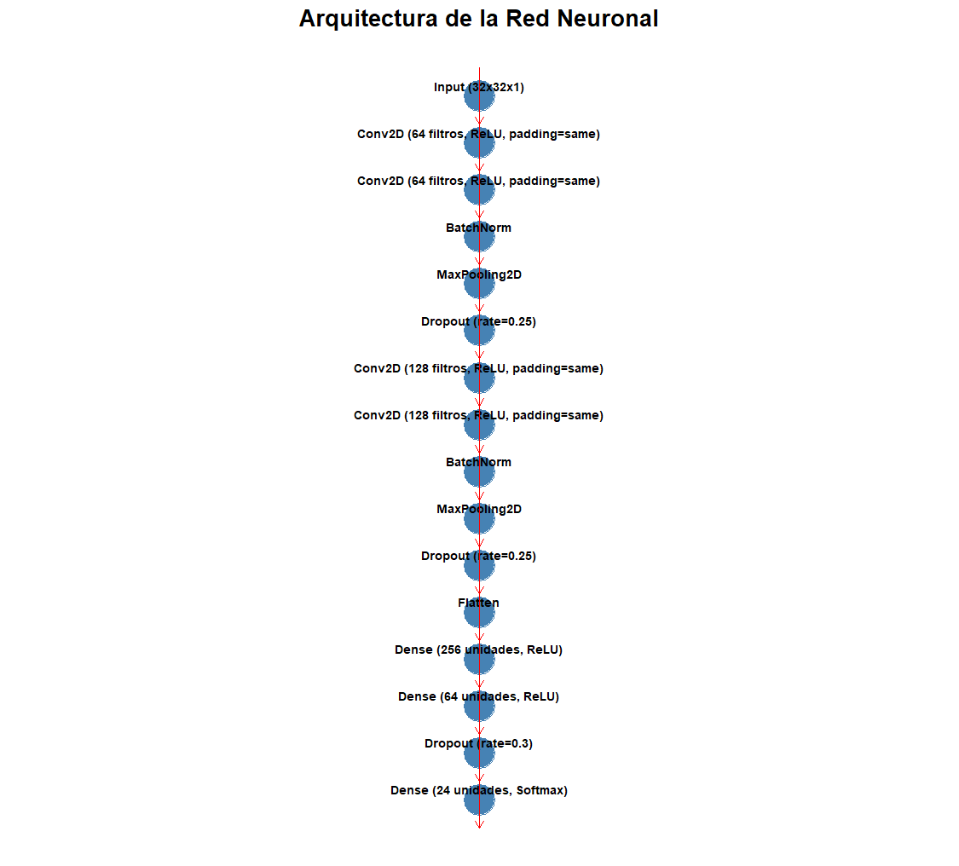
plot_sample_images(train_generator)
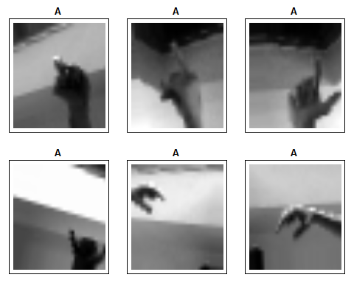

Grafica de entrenamiento:
}

# Gráficos de entrenamiento
plot_training_history <- function(history) {
# Extraer métricas de la nueva estructura
metrics <- history$history

# Crear dataframe para ggplot
df <- data.frame(
epoch = rep(1:length(metrics$loss), 2),
value = c(metrics$loss, metrics$val_loss,
metrics$accuracy, metrics$val_accuracy),
metric = rep(c("Loss", "Accuracy"), each = length(metrics$loss)),
dataset = rep(rep(c("Train", "Validation"), each = length(metrics$loss)), 2)
)

# Gráfico de pérdida
p_loss <- ggplot(subset(df, metric == "Loss"), aes(epoch, value, color = dataset)) +
geom_line() + geom_point() +
labs(title = "Training and Validation Loss", y = "Loss") +
theme_minimal()

# Gráfico de precisión
p_acc <- ggplot(subset(df, metric == "Accuracy"), aes(epoch, value, color = dataset)) +
geom_line() + geom_point() +
labs(title = "Training and Validation Accuracy", y = "Accuracy") +
theme_minimal()

grid.arrange(p_loss, p_acc, ncol = 1)
}

plot_training_history(history)

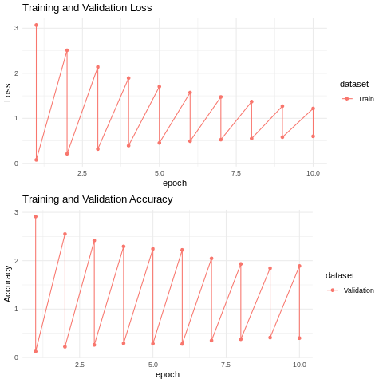

VERSION DEL MODELO EN PHYTON:
Link del colab: https://colab.research.google.com/drive/17E3Ozxa_7kIT_RDpvUAX4pV4VzWo0x6M?usp=sharing
import kagglehub

# Download latest version
path = kagglehub.dataset_download("grassknoted/asl-alphabet")

print("Path to dataset files:", path)
train_path = path + "/asl_alphabet_train/asl_alphabet_train"
test_path = path + "/asl_alphabet_test/asl_alphabet_test"
print("Path to train files:", train_path)
print("Path to test files:", test_path)
Downloading from https://www.kaggle.com/api/v1/datasets/download/grassknoted/asl-alphabet?dataset_version_number=1...
100%|██████████| 1.03G/1.03G [00:20<00:00, 54.4MB/s]
Extracting files...

Path to dataset files: /root/.cache/kagglehub/datasets/grassknoted/asl-alphabet/versions/1
Path to train files: /root/.cache/kagglehub/datasets/grassknoted/asl-alphabet/versions/1/asl_alphabet_train/asl_alphabet_train
Path to test files: /root/.cache/kagglehub/datasets/grassknoted/asl-alphabet/versions/1/asl_alphabet_test/asl_alphabet_test

clases = ["A","B","C","D","E","F","G","H","I","K","L","M","N","O","P","Q","R","S","T","U","V","W","X","Y"]
len(clases)
24

import os
ruta = train_path
carpetas = os.listdir(ruta)
carpetas.sort()
for carpeta in carpetas:
print(carpeta)
A
B
C
D
E
F
G
H
I
J
K
L
M
N
O
P
Q
R
S
T
U
V
W
X
Y
Z
del
nothing
space

import os
def length_of_folders(path, clases):
lista = []
for clase in clases:
ruta = path + '/' + clase
imagenes = os.listdir(ruta)
tupla = (len(imagenes),clase)
lista.append(tupla)
lista.sort()
for tupla in lista:
print(f"{tupla[0]}: {tupla[1]}")
return min(lista)[0]
train_len = length_of_folders(train_path, clases)
print(train_len)

3000: A
3000: B
3000: C
3000: D
3000: E
3000: F
3000: G
3000: H
3000: I
3000: K
3000: L
3000: M
3000: N
3000: O
3000: P
3000: Q
3000: R
3000: S
3000: T
3000: U
3000: V
3000: W
3000: X
3000: Y
3000
import shutil
import os
import cv2
import numpy as np

def crear_data_grayscale(carpeta_fuente, carpeta_destino, num):
imagenes = os.listdir(carpeta_fuente)
for i, nombreimg in enumerate(imagenes):
if i < num:
ruta = carpeta_fuente + '/' + nombreimg
image = cv2.imread(ruta)
if image is None:
print("Error: No se pudo cargar la imagen.")
continue
gray_image = cv2.cvtColor(image, cv2.COLOR_BGR2GRAY)

if not os.path.exists(carpeta_destino):
os.makedirs(carpeta_destino)
cv2.imwrite(carpeta_destino + '/' + nombreimg, gray_image)
imagenes_salidas = os.listdir(carpeta_destino)
print(len(imagenes_salidas))

import shutil
import os

def crear_data(carpeta_fuente, carpeta_destino, num):
imagenes = os.listdir(carpeta_fuente)
if not os.path.exists(carpeta_destino):
os.makedirs(carpeta_destino)
for i, nombreimg in enumerate(imagenes):
if i < num:
#Copia de la carpeta fuente a la destino
shutil.copy(carpeta_fuente + '/' + nombreimg, carpeta_destino + '/' + nombreimg)
imagenes_salidas = os.listdir(carpeta_destino)
print(len(imagenes_salidas))

def usar_funcion_de_carpetas(carpeta_fuente, carpeta_destino, clases, funcion, num):
for clase in clases:
fuente = carpeta_fuente + '/' + clase
destino = carpeta_destino + '/' + clase
funcion(fuente, destino, num)

color = "grayscale"

import os
import pandas as pd
import numpy as np
import matplotlib.pyplot as plt
import seaborn as sns
from sklearn.model_selection import train_test_split
from sklearn.metrics import confusion_matrix
import tensorflow as tf
from tensorflow import keras
from tensorflow.keras.layers import Dense, Conv2D, MaxPooling2D, Flatten, Dropout
from tensorflow.keras.models import Sequential
from tensorflow.keras.optimizers import Adamax
from tensorflow.keras.callbacks import EarlyStopping, ModelCheckpoint
from tensorflow.keras.layers import BatchNormalization
from tqdm import tqdm
from tensorflow.keras.preprocessing.image import ImageDataGenerator
from PIL import Image
import warnings
warnings.filterwarnings('ignore')

# 1. Configurar rutas y parámetros
dataset_path = "/content/train"
target_size = (64, 64) # Redimensionar a 256x256
batch_size = 32
epochs = 20
saved_models = "/content/saved_models"

# 2. Preprocesamiento y aumento de datos
datagen = ImageDataGenerator(
rescale = 1.0/255.0, # Normalización de píxeles
rotation_range = 20, # Rotación aleatoria
shear_range=0.2,
zoom_range=0.2,
horizontal_flip = True,
validation_split=0.3
)

# 3. Cargar las imágenes de las 4 clases
train_gen = datagen.flow_from_directory(
dataset_path,
target_size = target_size,
batch_size = batch_size,
color_mode = color,
class_mode = 'categorical', # Clasificación multiclase
classes = clases,
subset='training' # Conjunto de entrenamiento
)

valid_gen = datagen.flow_from_directory(
dataset_path,
target_size = target_size,
batch_size = batch_size,
color_mode = color,
class_mode = 'categorical', # Clasificación multiclase
classes = clases,
subset='validation'
)

# 4. Construir el modelo
Model = Sequential([
Conv2D(64, kernel_size= (3,3),padding='same', activation='relu', input_shape=(target_size[0], target_size[1],1)),
Conv2D(64, kernel_size= (3,3),padding='same', activation='relu'),
BatchNormalization(),
MaxPooling2D((2,2)),

Conv2D(128, kernel_size= (3,3),padding='same', activation='relu'),
Conv2D(128, kernel_size= (3,3),padding='same', activation='relu'),
BatchNormalization(),
MaxPooling2D((2,2)),

Conv2D(128, kernel_size= (3,3),padding='same', activation='relu'),
Conv2D(128, kernel_size= (3,3),padding='same', activation='relu'),
BatchNormalization(),
MaxPooling2D((2,2)),

Conv2D(256, kernel_size= (3,3),padding='same', activation='relu'),
Conv2D(256, kernel_size= (3,3),padding='same', activation='relu'),
BatchNormalization(),
MaxPooling2D((2,2)),

Conv2D(512, kernel_size= (3,3),padding='same', activation='relu'),
Conv2D(512, kernel_size= (3,3),padding='same', activation='relu'),
BatchNormalization(),
MaxPooling2D((2,2)),

Conv2D(512, kernel_size= (3,3),padding='same', activation='relu'),
Conv2D(512, kernel_size= (3,3),padding='same', activation='relu'),
BatchNormalization(),
MaxPooling2D((2,2)),

Flatten(),
Dense(256, activation='relu'),
Dense(64, activation='relu'),
Dropout(0.3),
Dense(24, activation='softmax')
])

# 5. Compilar el modelo
Model.compile(optimizer = "adam",
loss='categorical_crossentropy',
metrics=['accuracy']
)

# 6. Resumen del modelo
Model.summary()
if not os.path.exists(saved_models):
os.makedirs(saved_models)
filepath= "/content/saved_models/weights-improvement-{epoch:02d}-{val_accuracy:.2f}.keras" #File name includes epoch and validation accuracy.
#Use Mode = max for accuracy and min for loss.
checkpoint = ModelCheckpoint(filepath, monitor ='val_accuracy', verbose = 1, save_best_only = True, mode = 'max')
# 7. Callback para EarlyStopping
early_stop = EarlyStopping(
monitor ='val_loss', # Monitorear la pérdida en el conjunto de validación
patience = 5, # Número de épocas sin mejora antes de detener el entrenamiento
restore_best_weights=True # Restaurar los mejores pesos encontrados
)

callbacks_list = [checkpoint, early_stop]

# 8. Entrenar el modelo con EarlyStopping
history = Model.fit(
train_gen,
epochs = epochs,
validation_data=valid_gen,
callbacks=callbacks_list,
verbose=1
)

# 9. Evaluar el modelo
loss, accuracy = Model.evaluate(valid_gen)
print(f"Pérdida en validación: {loss}")
print(f"Precisión en validación: {accuracy}")

# 10. Guardar el modelo
Model.save("senas_modelo.keras")

Found 50400 images belonging to 24 classes.
Found 21600 images belonging to 24 classes.
Model: "sequential_7"
┏━━━━━━━━━━━━━━━━━━━━━━━━━━━━━━━━━━━━━━┳━━━━━━━━━━━━━━━━━━━━━━━━━━━━━┳━━━━━━━━━━━━━━━━━┓
┃ Layer (type) ┃ Output Shape ┃ Param # ┃
┡━━━━━━━━━━━━━━━━━━━━━━━━━━━━━━━━━━━━━━╇━━━━━━━━━━━━━━━━━━━━━━━━━━━━━╇━━━━━━━━━━━━━━━━━┩
│ conv2d_84 (Conv2D) │ (None, 64, 64, 64) │ 640 │
├──────────────────────────────────────┼─────────────────────────────┼─────────────────┤
│ conv2d_85 (Conv2D) │ (None, 64, 64, 64) │ 36,928 │
├──────────────────────────────────────┼─────────────────────────────┼─────────────────┤
│ batch_normalization_42 │ (None, 64, 64, 64) │ 256 │
│ (BatchNormalization) │ │ │
├──────────────────────────────────────┼─────────────────────────────┼─────────────────┤
│ max_pooling2d_41 (MaxPooling2D) │ (None, 32, 32, 64) │ 0 │
├──────────────────────────────────────┼─────────────────────────────┼─────────────────┤
│ conv2d_86 (Conv2D) │ (None, 32, 32, 128) │ 73,856 │
├──────────────────────────────────────┼─────────────────────────────┼─────────────────┤
│ conv2d_87 (Conv2D) │ (None, 32, 32, 128) │ 147,584 │
├──────────────────────────────────────┼─────────────────────────────┼─────────────────┤
│ batch_normalization_43 │ (None, 32, 32, 128) │ 512 │
│ (BatchNormalization) │ │ │
├──────────────────────────────────────┼─────────────────────────────┼─────────────────┤
│ max_pooling2d_42 (MaxPooling2D) │ (None, 16, 16, 128) │ 0 │
├──────────────────────────────────────┼─────────────────────────────┼─────────────────┤
│ conv2d_88 (Conv2D) │ (None, 16, 16, 128) │ 147,584 │
├──────────────────────────────────────┼─────────────────────────────┼─────────────────┤
│ conv2d_89 (Conv2D) │ (None, 16, 16, 128) │ 147,584 │
├──────────────────────────────────────┼─────────────────────────────┼─────────────────┤
│ batch_normalization_44 │ (None, 16, 16, 128) │ 512 │
│ (BatchNormalization) │ │ │
├──────────────────────────────────────┼─────────────────────────────┼─────────────────┤
│ max_pooling2d_43 (MaxPooling2D) │ (None, 8, 8, 128) │ 0 │
├──────────────────────────────────────┼─────────────────────────────┼─────────────────┤
│ conv2d_90 (Conv2D) │ (None, 8, 8, 256) │ 295,168 │
├──────────────────────────────────────┼─────────────────────────────┼─────────────────┤
│ conv2d_91 (Conv2D) │ (None, 8, 8, 256) │ 590,080 │
├──────────────────────────────────────┼─────────────────────────────┼─────────────────┤
│ batch_normalization_45 │ (None, 8, 8, 256) │ 1,024 │
│ (BatchNormalization) │ │ │
├──────────────────────────────────────┼─────────────────────────────┼─────────────────┤
│ max_pooling2d_44 (MaxPooling2D) │ (None, 4, 4, 256) │ 0 │
├──────────────────────────────────────┼─────────────────────────────┼─────────────────┤
│ conv2d_92 (Conv2D) │ (None, 4, 4, 512) │ 1,180,160 │
├──────────────────────────────────────┼─────────────────────────────┼─────────────────┤
│ conv2d_93 (Conv2D) │ (None, 4, 4, 512) │ 2,359,808 │
├──────────────────────────────────────┼─────────────────────────────┼─────────────────┤
│ batch_normalization_46 │ (None, 4, 4, 512) │ 2,048 │
│ (BatchNormalization) │ │ │
├──────────────────────────────────────┼─────────────────────────────┼─────────────────┤
│ max_pooling2d_45 (MaxPooling2D) │ (None, 2, 2, 512) │ 0 │
├──────────────────────────────────────┼─────────────────────────────┼─────────────────┤
│ conv2d_94 (Conv2D) │ (None, 2, 2, 512) │ 2,359,808 │
├──────────────────────────────────────┼─────────────────────────────┼─────────────────┤
│ conv2d_95 (Conv2D) │ (None, 2, 2, 512) │ 2,359,808 │
├──────────────────────────────────────┼─────────────────────────────┼─────────────────┤
│ batch_normalization_47 │ (None, 2, 2, 512) │ 2,048 │
│ (BatchNormalization) │ │ │
├──────────────────────────────────────┼─────────────────────────────┼─────────────────┤
│ max_pooling2d_46 (MaxPooling2D) │ (None, 1, 1, 512) │ 0 │
├──────────────────────────────────────┼─────────────────────────────┼─────────────────┤
│ flatten_7 (Flatten) │ (None, 512) │ 0 │
├──────────────────────────────────────┼─────────────────────────────┼─────────────────┤
│ dense_21 (Dense) │ (None, 256) │ 131,328 │
├──────────────────────────────────────┼─────────────────────────────┼─────────────────┤
│ dense_22 (Dense) │ (None, 64) │ 16,448 │
├──────────────────────────────────────┼─────────────────────────────┼─────────────────┤
│ dropout_7 (Dropout) │ (None, 64) │ 0 │
├──────────────────────────────────────┼─────────────────────────────┼─────────────────┤
│ dense_23 (Dense) │ (None, 24) │ 1,560 │
└──────────────────────────────────────┴─────────────────────────────┴─────────────────┘
Total params: 9,854,744 (37.59 MB)
Trainable params: 9,851,544 (37.58 MB)
Non-trainable params: 3,200 (12.50 KB)
Epoch 1/20
1575/1575 ━━━━━━━━━━━━━━━━━━━━ 0s 48ms/step - accuracy: 0.0456 - loss: 3.1951
Epoch 1: val_accuracy improved from -inf to 0.04162, saving model to /content/saved_models/weights-improvement-01-0.04.keras
1575/1575 ━━━━━━━━━━━━━━━━━━━━ 120s 67ms/step - accuracy: 0.0456 - loss: 3.1951 - val_accuracy: 0.0416 - val_loss: 3.1785
Epoch 2/20
1574/1575 ━━━━━━━━━━━━━━━━━━━━ 0s 47ms/step - accuracy: 0.0664 - loss: 3.0206
Epoch 2: val_accuracy improved from 0.04162 to 0.11444, saving model to /content/saved_models/weights-improvement-02-0.11.keras
1575/1575 ━━━━━━━━━━━━━━━━━━━━ 100s 64ms/step - accuracy: 0.0664 - loss: 3.0205 - val_accuracy: 0.1144 - val_loss: 3.0117
Epoch 3/20
1575/1575 ━━━━━━━━━━━━━━━━━━━━ 0s 48ms/step - accuracy: 0.1154 - loss: 2.8389
Epoch 3: val_accuracy did not improve from 0.11444
1575/1575 ━━━━━━━━━━━━━━━━━━━━ 143s 64ms/step - accuracy: 0.1154 - loss: 2.8388 - val_accuracy: 0.0824 - val_loss: 4.5897
Epoch 4/20
1574/1575 ━━━━━━━━━━━━━━━━━━━━ 0s 48ms/step - accuracy: 0.2255 - loss: 2.3440
Epoch 4: val_accuracy improved from 0.11444 to 0.18671, saving model to /content/saved_models/weights-improvement-04-0.19.keras
1575/1575 ━━━━━━━━━━━━━━━━━━━━ 101s 64ms/step - accuracy: 0.2255 - loss: 2.3438 - val_accuracy: 0.1867 - val_loss: 3.0747
Epoch 5/20
1575/1575 ━━━━━━━━━━━━━━━━━━━━ 0s 48ms/step - accuracy: 0.3269 - loss: 2.0167
Epoch 5: val_accuracy improved from 0.18671 to 0.24722, saving model to /content/saved_models/weights-improvement-05-0.25.keras
1575/1575 ━━━━━━━━━━━━━━━━━━━━ 142s 64ms/step - accuracy: 0.3269 - loss: 2.0166 - val_accuracy: 0.2472 - val_loss: 3.0193
Epoch 6/20
1574/1575 ━━━━━━━━━━━━━━━━━━━━ 0s 50ms/step - accuracy: 0.4265 - loss: 1.7078
Epoch 6: val_accuracy improved from 0.24722 to 0.32130, saving model to /content/saved_models/weights-improvement-06-0.32.keras
1575/1575 ━━━━━━━━━━━━━━━━━━━━ 145s 66ms/step - accuracy: 0.4265 - loss: 1.7077 - val_accuracy: 0.3213 - val_loss: 2.7410
Epoch 7/20
1575/1575 ━━━━━━━━━━━━━━━━━━━━ 0s 48ms/step - accuracy: 0.5663 - loss: 1.2805
Epoch 7: val_accuracy improved from 0.32130 to 0.37032, saving model to /content/saved_models/weights-improvement-07-0.37.keras
1575/1575 ━━━━━━━━━━━━━━━━━━━━ 155s 75ms/step - accuracy: 0.5663 - loss: 1.2804 - val_accuracy: 0.3703 - val_loss: 3.2461
Epoch 8/20
1575/1575 ━━━━━━━━━━━━━━━━━━━━ 0s 49ms/step - accuracy: 0.6985 - loss: 0.8471
Epoch 8: val_accuracy improved from 0.37032 to 0.43597, saving model to /content/saved_models/weights-improvement-08-0.44.keras
1575/1575 ━━━━━━━━━━━━━━━━━━━━ 127s 65ms/step - accuracy: 0.6985 - loss: 0.8471 - val_accuracy: 0.4360 - val_loss: 2.7704
Epoch 9/20
1574/1575 ━━━━━━━━━━━━━━━━━━━━ 0s 48ms/step - accuracy: 0.7622 - loss: 0.6559
Epoch 9: val_accuracy did not improve from 0.43597
1575/1575 ━━━━━━━━━━━━━━━━━━━━ 103s 65ms/step - accuracy: 0.7622 - loss: 0.6558 - val_accuracy: 0.4358 - val_loss: 2.6851
Epoch 10/20
1575/1575 ━━━━━━━━━━━━━━━━━━━━ 0s 49ms/step - accuracy: 0.8197 - loss: 0.5201
Epoch 10: val_accuracy improved from 0.43597 to 0.46542, saving model to /content/saved_models/weights-improvement-10-0.47.keras
1575/1575 ━━━━━━━━━━━━━━━━━━━━ 104s 66ms/step - accuracy: 0.8197 - loss: 0.5201 - val_accuracy: 0.4654 - val_loss: 2.8412
Epoch 11/20
1574/1575 ━━━━━━━━━━━━━━━━━━━━ 0s 48ms/step - accuracy: 0.8615 - loss: 0.4027
Epoch 11: val_accuracy improved from 0.46542 to 0.49796, saving model to /content/saved_models/weights-improvement-11-0.50.keras
1575/1575 ━━━━━━━━━━━━━━━━━━━━ 140s 64ms/step - accuracy: 0.8615 - loss: 0.4027 - val_accuracy: 0.4980 - val_loss: 2.7154
Epoch 12/20
1575/1575 ━━━━━━━━━━━━━━━━━━━━ 0s 48ms/step - accuracy: 0.8834 - loss: 0.3426
Epoch 12: val_accuracy did not improve from 0.49796
1575/1575 ━━━━━━━━━━━━━━━━━━━━ 101s 64ms/step - accuracy: 0.8834 - loss: 0.3426 - val_accuracy: 0.4852 - val_loss: 2.7566
Epoch 13/20
1574/1575 ━━━━━━━━━━━━━━━━━━━━ 0s 49ms/step - accuracy: 0.9104 - loss: 0.2746
Epoch 13: val_accuracy improved from 0.49796 to 0.51921, saving model to /content/saved_models/weights-improvement-13-0.52.keras
1575/1575 ━━━━━━━━━━━━━━━━━━━━ 103s 66ms/step - accuracy: 0.9104 - loss: 0.2746 - val_accuracy: 0.5192 - val_loss: 2.6261
Epoch 14/20
1575/1575 ━━━━━━━━━━━━━━━━━━━━ 0s 49ms/step - accuracy: 0.9265 - loss: 0.2286
Epoch 14: val_accuracy did not improve from 0.51921
1575/1575 ━━━━━━━━━━━━━━━━━━━━ 104s 66ms/step - accuracy: 0.9265 - loss: 0.2286 - val_accuracy: 0.5053 - val_loss: 2.7529
Epoch 15/20
1575/1575 ━━━━━━━━━━━━━━━━━━━━ 0s 49ms/step - accuracy: 0.9439 - loss: 0.1837
Epoch 15: val_accuracy did not improve from 0.51921
1575/1575 ━━━━━━━━━━━━━━━━━━━━ 102s 65ms/step - accuracy: 0.9439 - loss: 0.1837 - val_accuracy: 0.5162 - val_loss: 3.5029
Epoch 16/20
1575/1575 ━━━━━━━━━━━━━━━━━━━━ 0s 48ms/step - accuracy: 0.9507 - loss: 0.1699
Epoch 16: val_accuracy improved from 0.51921 to 0.52431, saving model to /content/saved_models/weights-improvement-16-0.52.keras
1575/1575 ━━━━━━━━━━━━━━━━━━━━ 102s 65ms/step - accuracy: 0.9507 - loss: 0.1699 - val_accuracy: 0.5243 - val_loss: 2.6860
Epoch 17/20
1575/1575 ━━━━━━━━━━━━━━━━━━━━ 0s 49ms/step - accuracy: 0.9594 - loss: 0.1369
Epoch 17: val_accuracy improved from 0.52431 to 0.58171, saving model to /content/saved_models/weights-improvement-17-0.58.keras
1575/1575 ━━━━━━━━━━━━━━━━━━━━ 144s 66ms/step - accuracy: 0.9594 - loss: 0.1369 - val_accuracy: 0.5817 - val_loss: 3.1237
Epoch 18/20
1575/1575 ━━━━━━━━━━━━━━━━━━━━ 0s 49ms/step - accuracy: 0.9666 - loss: 0.1135
Epoch 18: val_accuracy improved from 0.58171 to 0.59769, saving model to /content/saved_models/weights-improvement-18-0.60.keras
1575/1575 ━━━━━━━━━━━━━━━━━━━━ 140s 65ms/step - accuracy: 0.9666 - loss: 0.1135 - val_accuracy: 0.5977 - val_loss: 2.5831
Epoch 19/20
1575/1575 ━━━━━━━━━━━━━━━━━━━━ 0s 49ms/step - accuracy: 0.9684 - loss: 0.1165
Epoch 19: val_accuracy did not improve from 0.59769
1575/1575 ━━━━━━━━━━━━━━━━━━━━ 141s 65ms/step - accuracy: 0.9684 - loss: 0.1165 - val_accuracy: 0.5807 - val_loss: 2.5385
Epoch 20/20
1575/1575 ━━━━━━━━━━━━━━━━━━━━ 0s 48ms/step - accuracy: 0.9724 - loss: 0.0953
Epoch 20: val_accuracy did not improve from 0.59769
1575/1575 ━━━━━━━━━━━━━━━━━━━━ 101s 64ms/step - accuracy: 0.9724 - loss: 0.0953 - val_accuracy: 0.5206 - val_loss: 3.5846
675/675 ━━━━━━━━━━━━━━━━━━━━ 27s 40ms/step - accuracy: 0.5801 - loss: 2.5146
Pérdida en validación: 2.5170764923095703
Precisión en validación: 0.5775926113128662

from sklearn.metrics import confusion_matrix
import seaborn as sns
import matplotlib.pyplot as plt
import numpy as np
from tensorflow.keras.utils import plot_model

.flow_from_directory(
dataset_path,
target_size = target_size,
batch_size = batch_size,
color_mode = color,
class_mode = 'categorical',
classes = clases,
subset='validation',
shuffle=False # ¡IMPORTANTE PARA LA MATRIZ DE CONFUSIÓN!
)

# ==============================================
# 1. Curvas de Entrenamiento (Accuracy/Loss)
plt.figure(figsize=(12, 5))

plt.subplot(1, 2, 1)
plt.plot(history.history['accuracy'], label='Entrenamiento')
plt.plot(history.history['val_accuracy'], label='Validación')
plt.title('Precisión por Época')
plt.ylabel('Precisión')
plt.xlabel('Época')
plt.legend()

plt.subplot(1, 2, 2)
plt.plot(history.history['loss'], label='Entrenamiento')
plt.plot(history.history['val_loss'], label='Validación')
plt.title('Pérdida por Época')
plt.ylabel('Pérdida')
plt.xlabel('Época')
plt.legend()

plt.tight_layout()
plt.savefig('training_curves.png')
plt.show()

# 2. Matriz de Confusión (¡Requiere que valid_gen tenga shuffle=False!)
valid_gen.reset() # Reiniciar el generador
y_pred = Model.predict(valid_gen, verbose=1)
y_pred_classes = np.argmax(y_pred, axis=1)

# Obtener las etiquetas reales desde el generador
y_true_classes = valid_gen.labels

cm = confusion_matrix(y_true_classes, y_pred_classes)

plt.figure(figsize=(15, 12))
sns.heatmap(cm, annot=True, fmt='d', cmap='Blues',
xticklabels=clases, yticklabels=clases) # Usar tu lista de clases
plt.title('Matriz de Confusión')
plt.xlabel('Predicciones')
plt.ylabel('Reales')
plt.savefig('confusion_matrix.png')
plt.show()

# 4. Arquitectura del Modelo
try:
plot_model(Model, to_file='model_architecture.png', show_shapes=True) # ¡Model con mayúscula!
except ImportError:
print("Instala pydot y graphviz: pip install pydot graphviz")

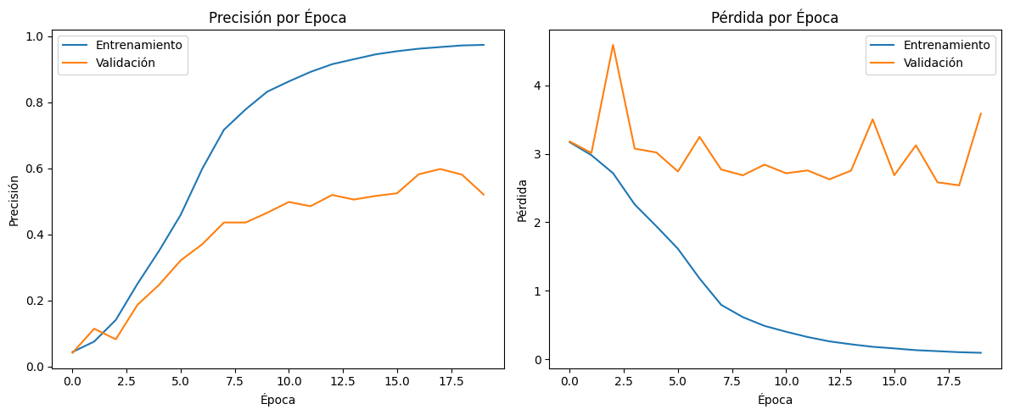

[1m675/675[0m [32m━━━━━━━━━━━━━━━━━━━━[0m[37m[0m [1m27s[0m 40ms/step

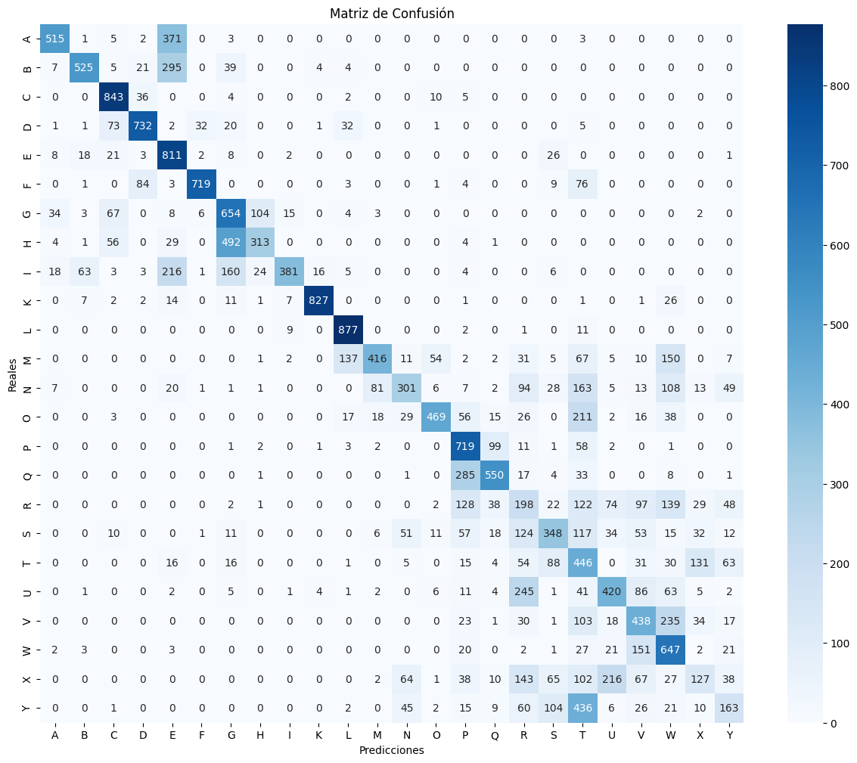
# 3. Ejemplos de Predicciones (MUESTRA VARIAS CLASES)
valid_gen.reset() # Reiniciar el generador

# Obtener TODAS las imágenes y etiquetas del conjunto de validación
num_samples = valid_gen.samples # Número total de muestras en validación
all_images = []
all_true_labels = []

# Iterar sobre todo el generador de validación
for _ in tqdm(range(len(valid_gen)), desc="Cargando datos de validación"):
x_batch, y_batch = next(valid_gen)
all_images.append(x_batch)
all_true_labels.append(y_batch)

# Concatenar todos los batches
all_images = np.concatenate(all_images, axis=0)
all_true_labels = np.concatenate(all_true_labels, axis=0)

# Obtener 5 índices aleatorios de diferentes clases
unique_classes = np.unique(np.argmax(all_true_labels, axis=1))
selected_indices = []
for cls in np.random.choice(unique_classes, size=5, replace=False): # 5 clases únicas
indices = np.where(np.argmax(all_true_labels, axis=1) == cls)[0]
selected_indices.append(np.random.choice(indices))

# Generar predicciones para los índices seleccionados
selected_images = all_images[selected_indices]
selected_true = np.argmax(all_true_labels[selected_indices], axis=1)
selected_pred = np.argmax(Model.predict(selected_images, verbose=0), axis=1)

# Obtener nombres de las clases desde el generador
class_names = list(valid_gen.class_indices.keys()) # Esto debe ser ['A', 'B', ..., 'Z']

# Graficar
plt.figure(figsize=(15, 7))
for i, (idx, true_label, pred_label) in enumerate(zip(selected_indices, selected_true, selected_pred)):
plt.subplot(1, 5, i+1)
plt.imshow(all_images[idx].squeeze(), cmap='gray')
plt.title(f'Real: {class_names[true_label]}\nPred: {class_names[pred_label]}')
plt.axis('off')

plt.tight_layout()
plt.savefig('predictions_examples.png')
plt.show()

Cargando datos de validación: 100%|██████████| 675/675 [00:22<00:00, 30.55it/s]

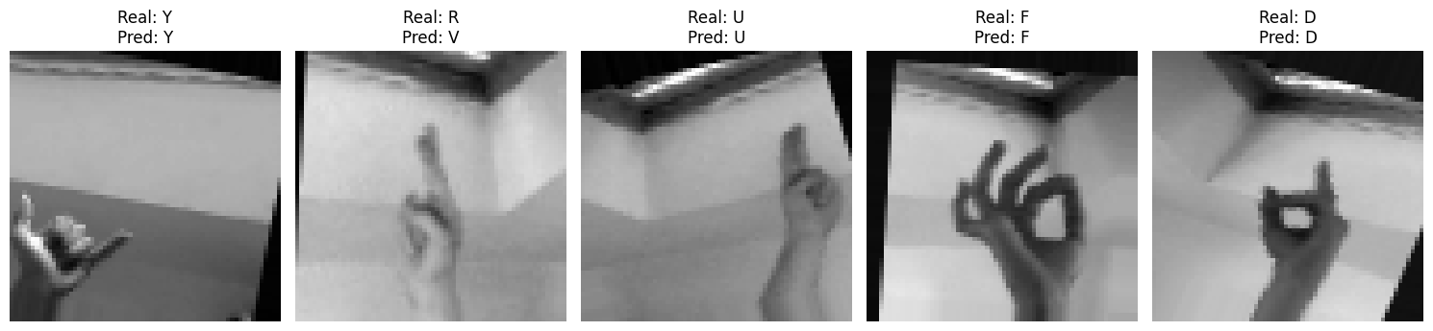

from tensorflow.keras.utils import plot_model
import matplotlib.pyplot as plt

try:
# Generar y guardar el diagrama
plot_model(
Model, # Tu modelo (¡con mayúscula!)
to_file='arquitectura_red_neuronal.png',
show_shapes=True, # Muestra las formas de entrada/salida
show_layer_names=True, # Muestra nombres de capas
dpi=96, # Resolución de la imagen
expand_nested=True # Detalla capas dentro de bloques (ej. Secuenciales)
)

# Mostrar la imagen en el notebook o entorno local
img = plt.imread('arquitectura_red_neuronal.png')
plt.figure(figsize=(20, 15))
plt.imshow(img)
plt.axis('off')
plt.show()

except ImportError:
print("Instala las dependencias: pip install pydot graphviz")

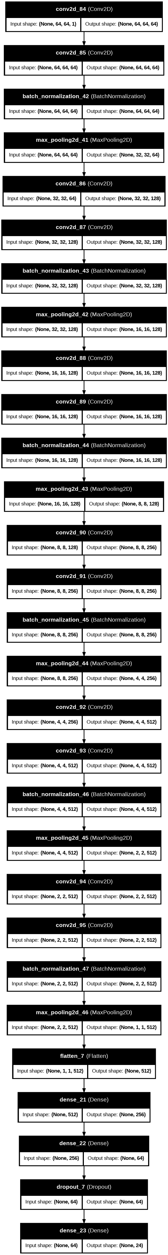

import tensorflow as tf

model = tf.keras.models.load_model("senas_modelo.keras")
# Para modelos secuenciales
visualkeras.layered_view(
model,
legend=True, # mostrar leyenda
to_file='visualkeras.png',
spacing=30 # espacio entre capas
)
