**DSA EXP NO. 08**

Hitansh Gopani

ROLL NO. 15

[SY-IT, S1]

**CODE :**

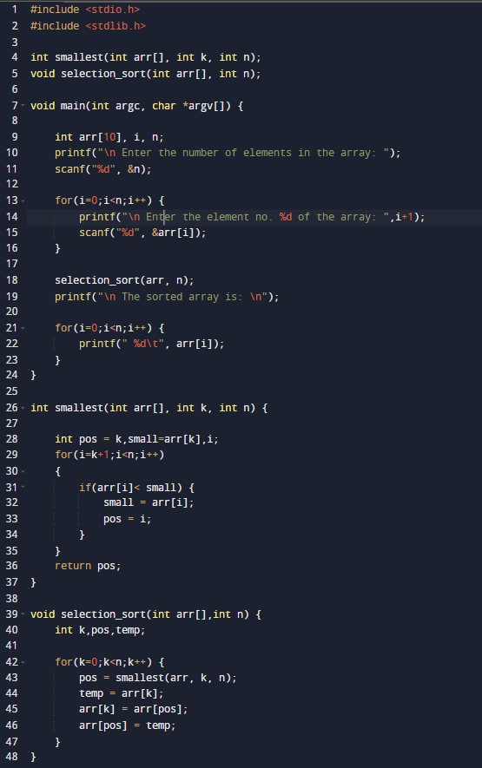

**OUTPUT:**

