Hitansh R Gopani

Sy _ IT
Exp 4

#include <stdio.h>
//#include <conio.h>
#define MAX 10
int deque[MAX];
int left = - 1, right = - 1;
void input_deque(void);
void output_deque(void);
void insert_left(void);
void insert_right(void);
void delete_left(void);
void delete_right(void);
void display(void);
int main()
{
int option;
//clrscr();
printf("\n *****MAIN MENU*****");
printf("\n 1.Input restricted deque");
printf("\n 2.Output restricted deque");
printf("Enter your option : ");
scanf("%d",&option);
switch(option)
{
case 1:
input_deque();
break;
case 2:
output_deque();
break;
}
return 0;
}
void input_deque()
{
int option;
do
{
printf("\n INPUT RESTRICTED DEQUE");
printf("\n 1.Insert at right");
printf("\n 2.Delete from left");
printf("\n 3.Delete from right");
printf("\n 4.Display");
printf("\n 5.Quit");
printf("\n Enter your option : ");
scanf("%d",&option);
switch(option)
{
case 1:
insert_right();
break;
case 2:
delete_left();
break;
case 3:
delete_right();
break;
case 4:
display();
break;
}
}while(option!=5);

}
void output_deque()
{
int option;
do
{
printf("OUTPUT RESTRICTED DEQUE");
printf("\n 1.Insert at right");
printf("\n 2.Insert at left");
printf("\n 3.Delete from left");
printf("\n 4.Display");
printf("\n 5.Quit");
printf("\n Enter your option : ");
scanf("%d",&option);
switch(option)
{
case 1:
insert_right();
break;
case 2:
insert_left();
break;
case 3:
delete_left();
break;
case 4:
display();
break;
}
}while(option!=5);
}
void insert_right()
{
int val;
printf("\n Enter the value to be added:");
scanf("%d", &val);
if((left == 0 && right == MAX- 1) || (left == right+1))
{
printf("\n OVERFLOW");
return;
}
if (left == - 1) /* if queue is initially empty */
{
left = 0;
right = 0;
}
else
{
if(right == MAX- 1) /*right is at last position of queue */
right = 0;
else
right = right+1;
}
deque[right] = val ;
}
void insert_left()
{
int val;
printf("\n Enter the value to be added:");
scanf("%d", &val);
if((left == 0 && right == MAX- 1) || (left == right+1))
{
printf("\n Overflow");
return;
}

if (left == - 1)/*If queue is initially empty*/
{
left = 0;
right = 0;
}
else
{
if(left == 0)
left=MAX- 1;
else
left=left- 1;
}
deque[left] = val;
}
void delete_left()
{
if (left == - 1)
{
printf("\n UNDERFLOW");
return ;
}
printf("\n The deleted element is : %d", deque[left]);
if(left == right) /*Queue has only one element */
{
left = - 1;
right = - 1;
}
else
{
if(left == MAX- 1)
left = 0;
else
left = left+1;
}
}
void delete_right()
{
if (left == - 1)
{
printf("\n UNDERFLOW");
return ;
}
printf("\n The element deleted is : %d", deque[right]);
if(left == right) /*queue has only one element*/
{
left = - 1;
right = - 1;
}
else
{
if(right == 0)
right=MAX- 1;
else
right=right- 1;
}
}
void display()
{
int front = left, rear = right;
if(front == - 1)
{
printf("\n QUEUE IS EMPTY");
return;
}
printf("\n The elements of the queue are : ");

if(front <= rear )
{
while(front <= rear)
{
printf("%d",deque[front]);
front++;
}
}
else
{
while(front <= MAX- 1)
{
printf("%d", deque[front]);
front++;
}
front = 0;
while(front <= rear)
{
printf("%d",deque[front]);
front++;
}
}
printf("\n");
}

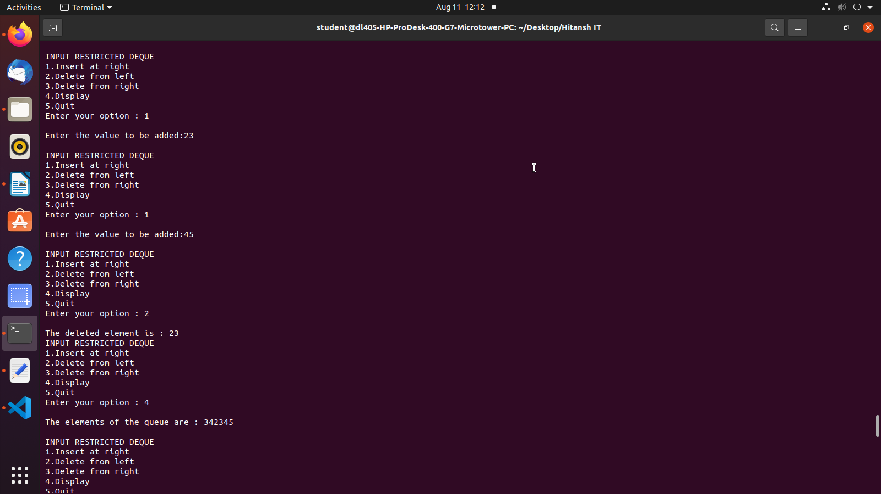
h

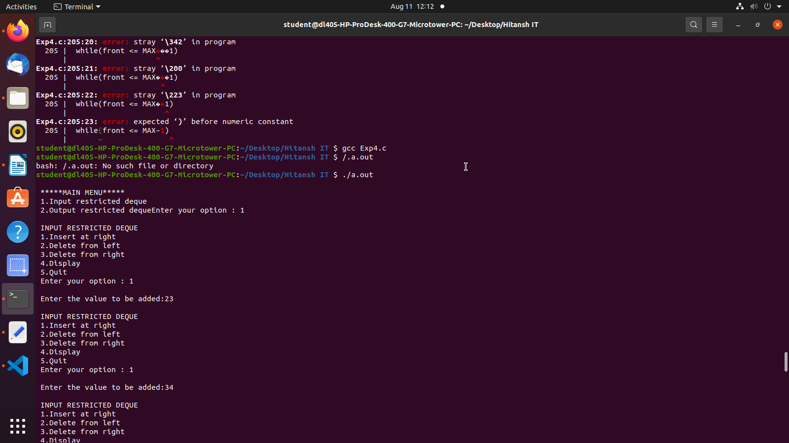
2

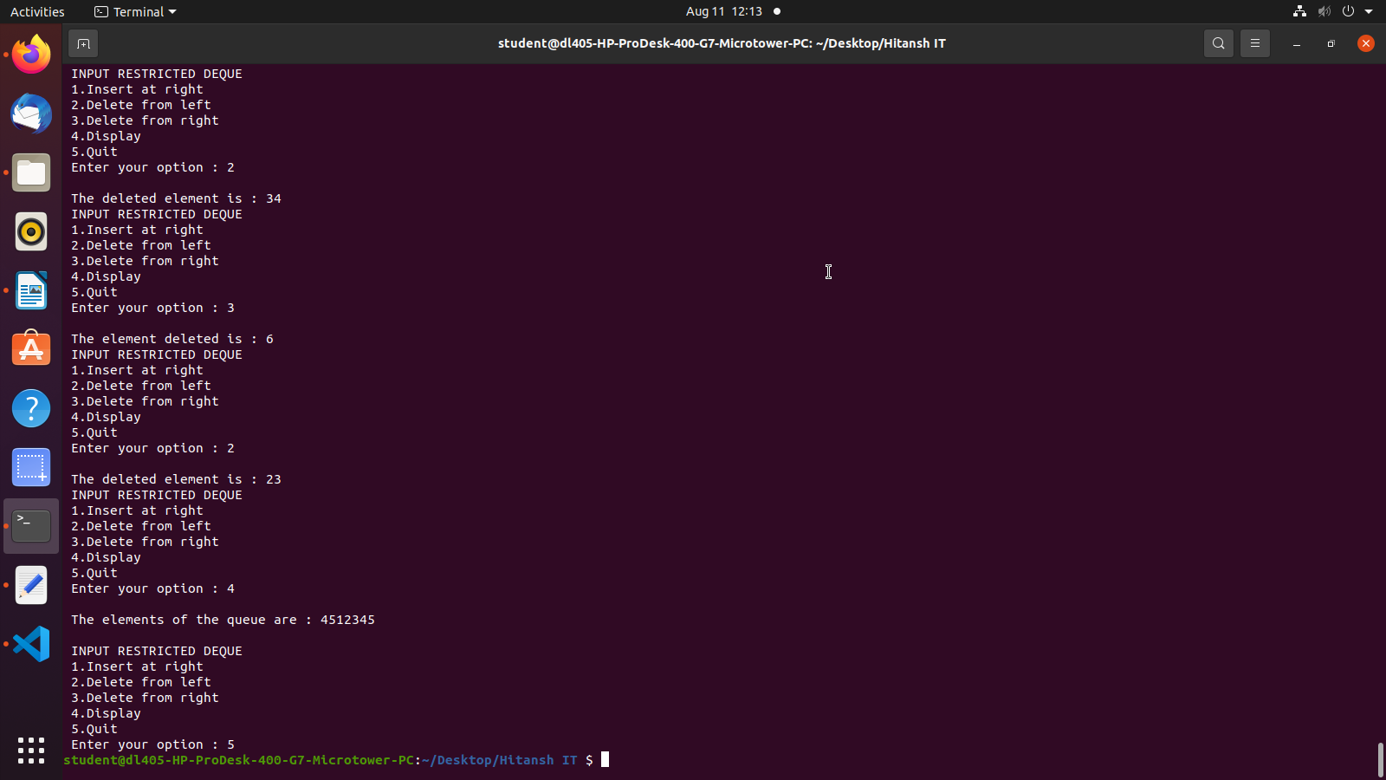
3

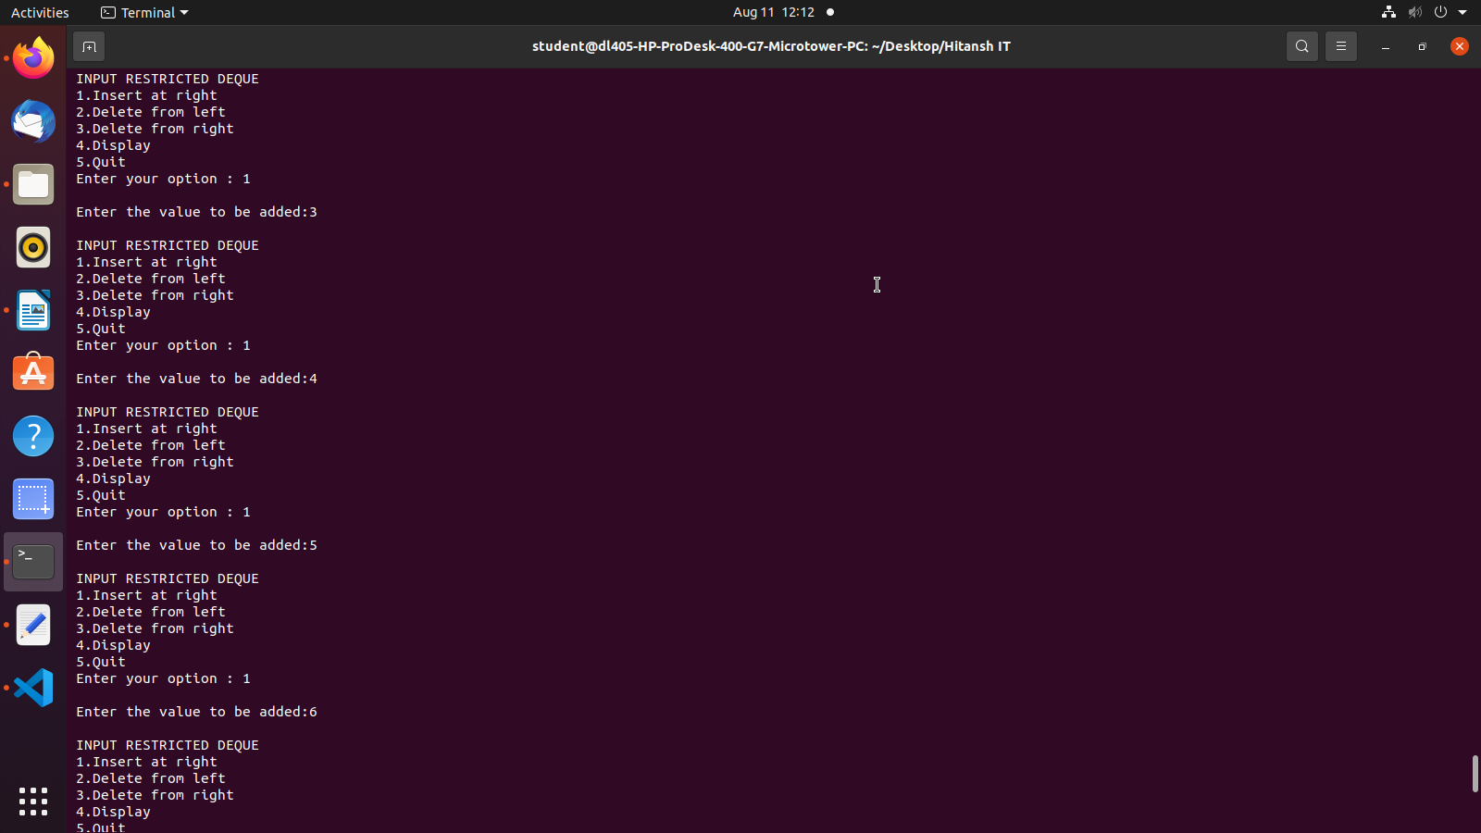
4

