**Splash Screen Activity**

For creating a splash screen, we have to perform following changes-

1) We have to implicitly declare **SplashScreenActivity** as launcher activity. For that in Android Manifest file make following changes-

<activity android:name=".SplashScreenActivity">  
 <intent-filter>  
 <action android:name="android.intent.action.MAIN" />  
  
 <category android:name="android.intent.category.LAUNCHER" />  
 </intent-filter>  
</activity>

2) In corresponding layout file **activity_splash_screen.xml**, make changes as following-

<?xml version="1.0" encoding="utf-8"?>  
<androidx.constraintlayout.widget.ConstraintLayout xmlns:android="http://schemas.android.com/apk/res/android"  
 xmlns:app="http://schemas.android.com/apk/res-auto"  
 xmlns:tools="http://schemas.android.com/tools"  
 android:layout_width="match_parent"  
 android:layout_height="match_parent"  
 tools:context=".SplashScreenActivity">  
  
 <ImageView  
 android:id="@+id/imageView2"  
 android:layout_width="407dp"  
 android:layout_height="737dp"  
 android:layout_marginStart="8dp"  
 android:layout_marginLeft="8dp"  
 android:layout_marginTop="8dp"  
 android:layout_marginEnd="8dp"  
 android:layout_marginRight="8dp"  
 android:layout_marginBottom="8dp"  
 android:background="#000000"  
 app:layout_constraintBottom_toBottomOf="parent"  
 app:layout_constraintEnd_toEndOf="parent"  
 app:layout_constraintStart_toStartOf="parent"  
 app:layout_constraintTop_toTopOf="parent"  
 app:srcCompat="@drawable/logo" />  
</androidx.constraintlayout.widget.ConstraintLayout>

3) We need our SplashScreenActivity to be viewed in full screen. Also, it should last for 5 seconds and then automatically moves to next activity. For that make changes in **SplashScreenActivity.java** as

package com.professionaljk.cgpisgpicalculator;  
  
import android.content.Intent;  
import android.os.Bundle;  
import android.view.WindowManager;  
  
import androidx.appcompat.app.AppCompatActivity;  
  
public class SplashScreenActivity extends AppCompatActivity {  
 private int SLEEP_TIMER = 5;  
 @Override  
 protected void onCreate(Bundle savedInstanceState) {  
 super.onCreate(savedInstanceState);  
 requestWindowFeature(getWindow().*FEATURE_NO_TITLE*);  
 getWindow().setFlags(WindowManager.LayoutParams.*FLAG_FULLSCREEN*, WindowManager.LayoutParams.*FLAG_FULLSCREEN*);  
 setContentView(R.layout.*activity_splash_screen*);  
 getSupportActionBar().hide();  
 LogoLauncher = new LogoLauncher();  
 logoLauncher.start();  
 }  
 private class LogoLauncher extends Thread{  
 public void run(){  
 try{  
 *sleep*(1000 * SLEEP_TIMER);  
 }catch(InterruptedException e){  
 e.printStackTrace();  
 }  
 Intent = new Intent(SplashScreenActivity.this, LoginActivity.class);  
 startActivity(intent);  
 SplashScreenActivity.this.finish();  
 }  
 }  
}

4) After 5 seconds of launching this activity it will navigates to next activity i.e. LoginActivity.

**OUTPUT:**

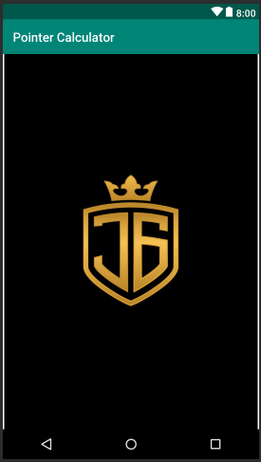

Fig. SplashScreenActivity