**CGPI Activity**

Here, we have implemented two activities as-

1) **CGPIActivity1.java**

In this activity we have asked user to give input as no. of semesters. We will then pass this no of semesters to next activity for further actions.

For this make following changes in **activity_cgpi1.xml-**

<?xml version="1.0" encoding="utf-8"?>  
<androidx.constraintlayout.widget.ConstraintLayout xmlns:android="http://schemas.android.com/apk/res/android"  
 xmlns:app="http://schemas.android.com/apk/res-auto"  
 xmlns:tools="http://schemas.android.com/tools"  
 android:layout_width="match_parent"  
 android:layout_height="match_parent"  
 tools:context=".CGPIActivity1">  
  
 <EditText  
 android:id="@+id/editText"  
 android:layout_width="235dp"  
 android:layout_height="68dp"  
 android:layout_marginStart="8dp"  
 android:layout_marginLeft="8dp"  
 android:layout_marginTop="8dp"  
 android:layout_marginEnd="8dp"  
 android:layout_marginRight="8dp"  
 android:layout_marginBottom="8dp"  
 android:ems="10"  
 android:hint="No. of Semesters"  
 android:inputType="number"  
 app:layout_constraintBottom_toBottomOf="parent"  
 app:layout_constraintEnd_toEndOf="parent"  
 app:layout_constraintStart_toStartOf="parent"  
 app:layout_constraintTop_toTopOf="parent"  
 app:layout_constraintVertical_bias="0.32" />  
  
 <Button  
 android:id="@+id/button"  
 android:layout_width="wrap_content"  
 android:layout_height="wrap_content"  
 android:layout_marginStart="8dp"  
 android:layout_marginLeft="8dp"  
 android:layout_marginTop="8dp"  
 android:layout_marginEnd="8dp"  
 android:layout_marginRight="8dp"  
 android:layout_marginBottom="8dp"  
 android:background="#FFFFFF"  
 android:onClick="noOfSemesters"  
 android:text="Next"  
 android:textColor="#009688"  
 app:layout_constraintBottom_toBottomOf="parent"  
 app:layout_constraintEnd_toEndOf="parent"  
 app:layout_constraintHorizontal_bias="0.498"  
 app:layout_constraintStart_toStartOf="parent"  
 app:layout_constraintTop_toBottomOf="@+id/editText"  
 app:layout_constraintVertical_bias="0.369" />  
</androidx.constraintlayout.widget.ConstraintLayout>

Also, make changes in **CGPIActivity1.java** as follows-

package com.professionaljk.cgpisgpicalculator;  
  
import android.content.Intent;  
import android.os.Bundle;  
import android.view.View;  
import android.widget.EditText;  
import android.widget.Toast;  
  
import androidx.appcompat.app.AppCompatActivity;  
  
public class CGPIActivity1 extends AppCompatActivity {  
 EditText et;  
 @Override  
 protected void onCreate(Bundle savedInstanceState) {  
 super.onCreate(savedInstanceState);  
 setContentView(R.layout.*activity_cgpi1*);  
 et=findViewById(R.id.*editText*);  
 }  
 public void noOfSemesters(View view){  
 if (et.getText().toString().equals("")) {  
 Toast.*makeText*(this, "Enter No. of Semesters", Toast.*LENGTH_SHORT*).show();  
 } else {  
 int no_of_semesters = Integer.*valueOf*(et.getText().toString());  
 if (no_of_semesters >= 1 && no_of_semesters <= 8) {  
 Intent intent = new Intent(this, CGPIActivity2.class);  
 intent.putExtra("semesters_count", String.*valueOf*(no_of_semesters));  
 startActivity(intent);  
 this.finish();  
 } else {  
 Toast.*makeText*(this, "Invalid No. of Semesters", Toast.*LENGTH_SHORT*).show();  
 }  
 }  
 }  
}

2) **CGPIActivity2.java**

In this activity we will receive no of semesters sent from previous activity. On the basis of no of semesters, we will decide, how many fields to be allowed. Through these fields we will take user pointers. We will then calculate the average CGPI. Also, we will display corresponding percentage.

For these make following changes in **activity_cgpi2.xml**-

<?xml version="1.0" encoding="utf-8"?>  
<androidx.constraintlayout.widget.ConstraintLayout xmlns:android="http://schemas.android.com/apk/res/android"  
 xmlns:app="http://schemas.android.com/apk/res-auto"  
 xmlns:tools="http://schemas.android.com/tools"  
 android:layout_width="match_parent"  
 android:layout_height="match_parent"  
 tools:context=".CGPIActivity2">  
  
 <TextView  
 android:id="@+id/textView1"  
 android:layout_width="97dp"  
 android:layout_height="40dp"  
 android:gravity="center|left"  
 android:text="SEM I"  
 android:textSize="18sp"  
 app:fontFamily="serif"  
 app:layout_constraintBottom_toBottomOf="parent"  
 app:layout_constraintEnd_toEndOf="parent"  
 app:layout_constraintHorizontal_bias="0.05"  
 app:layout_constraintStart_toStartOf="parent"  
 app:layout_constraintTop_toTopOf="parent"  
 app:layout_constraintVertical_bias="0.063" />  
 <EditText  
 android:id="@+id/editText1"  
 android:layout_width="239dp"  
 android:layout_height="40dp"  
 android:ems="10"  
 android:enabled="false"  
 android:inputType="numberDecimal"  
 app:layout_constraintBottom_toBottomOf="parent"  
 app:layout_constraintEnd_toEndOf="parent"  
 app:layout_constraintHorizontal_bias="0.347"  
 app:layout_constraintStart_toEndOf="@+id/textView1"  
 app:layout_constraintTop_toTopOf="parent"  
 app:layout_constraintVertical_bias="0.063" />  
 <TextView  
 android:id="@+id/textView2"  
 android:layout_width="97dp"  
 android:layout_height="40dp"  
 android:gravity="center|left"  
 android:text="SEM II"  
 android:textSize="18sp"  
 app:fontFamily="serif"  
 app:layout_constraintBottom_toBottomOf="parent"  
 app:layout_constraintEnd_toEndOf="parent"  
 app:layout_constraintHorizontal_bias="0.05"  
 app:layout_constraintStart_toStartOf="parent"  
 app:layout_constraintTop_toBottomOf="@+id/textView1"  
 app:layout_constraintVertical_bias="0.022" />  
 <EditText  
 android:id="@+id/editText2"  
 android:layout_width="239dp"  
 android:layout_height="40dp"  
 android:ems="10"  
 android:enabled="false"  
 android:inputType="numberDecimal"  
 app:layout_constraintBottom_toBottomOf="parent"  
 app:layout_constraintEnd_toEndOf="parent"  
 app:layout_constraintHorizontal_bias="0.355"  
 app:layout_constraintStart_toEndOf="@+id/textView2"  
 app:layout_constraintTop_toBottomOf="@+id/editText1"  
 app:layout_constraintVertical_bias="0.022" />  
 <TextView  
 android:id="@+id/textView3"  
 android:layout_width="97dp"  
 android:layout_height="40dp"  
 android:gravity="center|left"  
 android:text="SEM III"  
 android:textSize="18sp"  
 app:fontFamily="serif"  
 app:layout_constraintBottom_toBottomOf="parent"  
 app:layout_constraintEnd_toEndOf="parent"  
 app:layout_constraintHorizontal_bias="0.05"  
 app:layout_constraintStart_toStartOf="parent"  
 app:layout_constraintTop_toBottomOf="@+id/textView2"  
 app:layout_constraintVertical_bias="0.02" />  
 <EditText  
 android:id="@+id/editText3"  
 android:layout_width="239dp"  
 android:layout_height="40dp"  
 android:ems="10"  
 android:enabled="false"  
 android:inputType="numberDecimal"  
 app:layout_constraintBottom_toBottomOf="parent"  
 app:layout_constraintEnd_toEndOf="parent"  
 app:layout_constraintHorizontal_bias="0.355"  
 app:layout_constraintStart_toEndOf="@+id/textView3"  
 app:layout_constraintTop_toBottomOf="@+id/editText2"  
 app:layout_constraintVertical_bias="0.02" />  
 <TextView  
 android:id="@+id/textView4"  
 android:layout_width="97dp"  
 android:layout_height="40dp"  
 android:gravity="center|left"  
 android:text="SEM IV"  
 android:textSize="18sp"  
 app:fontFamily="serif"  
 app:layout_constraintBottom_toBottomOf="parent"  
 app:layout_constraintEnd_toEndOf="parent"  
 app:layout_constraintHorizontal_bias="0.05"  
 app:layout_constraintStart_toStartOf="parent"  
 app:layout_constraintTop_toBottomOf="@+id/textView3"  
 app:layout_constraintVertical_bias="0.025" />  
 <EditText  
 android:id="@+id/editText4"  
 android:layout_width="239dp"  
 android:layout_height="40dp"  
 android:ems="10"  
 android:enabled="false"  
 android:inputType="numberDecimal"  
 app:layout_constraintBottom_toBottomOf="parent"  
 app:layout_constraintEnd_toEndOf="parent"  
 app:layout_constraintHorizontal_bias="0.355"  
 app:layout_constraintStart_toEndOf="@+id/textView4"  
 app:layout_constraintTop_toBottomOf="@+id/editText3"  
 app:layout_constraintVertical_bias="0.025" />  
 <TextView  
 android:id="@+id/textView5"  
 android:layout_width="97dp"  
 android:layout_height="40dp"  
 android:gravity="center|left"  
 android:text="SEM V"  
 android:textSize="18sp"  
 app:fontFamily="serif"  
 app:layout_constraintBottom_toBottomOf="parent"  
 app:layout_constraintEnd_toEndOf="parent"  
 app:layout_constraintHorizontal_bias="0.05"  
 app:layout_constraintStart_toStartOf="parent"  
 app:layout_constraintTop_toBottomOf="@+id/textView4"  
 app:layout_constraintVertical_bias="0.038" />  
 <EditText  
 android:id="@+id/editText5"  
 android:layout_width="239dp"  
 android:layout_height="40dp"  
 android:ems="10"  
 android:enabled="false"  
 android:inputType="numberDecimal"  
 app:layout_constraintBottom_toBottomOf="parent"  
 app:layout_constraintEnd_toEndOf="parent"  
 app:layout_constraintHorizontal_bias="0.355"  
 app:layout_constraintStart_toEndOf="@+id/textView5"  
 app:layout_constraintTop_toBottomOf="@+id/editText4"  
 app:layout_constraintVertical_bias="0.038" />  
 <TextView  
 android:id="@+id/textView6"  
 android:layout_width="97dp"  
 android:layout_height="40dp"  
 android:gravity="center|left"  
 android:text="SEM VI"  
 android:textSize="18sp"  
 app:fontFamily="serif"  
 app:layout_constraintBottom_toBottomOf="parent"  
 app:layout_constraintEnd_toEndOf="parent"  
 app:layout_constraintHorizontal_bias="0.05"  
 app:layout_constraintStart_toStartOf="parent"  
 app:layout_constraintTop_toBottomOf="@+id/textView5"  
 app:layout_constraintVertical_bias="0.052" />  
 <EditText  
 android:id="@+id/editText6"  
 android:layout_width="239dp"  
 android:layout_height="40dp"  
 android:ems="10"  
 android:enabled="false"  
 android:inputType="numberDecimal"  
 app:layout_constraintBottom_toBottomOf="parent"  
 app:layout_constraintEnd_toEndOf="parent"  
 app:layout_constraintHorizontal_bias="0.355"  
 app:layout_constraintStart_toEndOf="@+id/textView6"  
 app:layout_constraintTop_toBottomOf="@+id/editText5"  
 app:layout_constraintVertical_bias="0.052" />  
 <TextView  
 android:id="@+id/textView7"  
 android:layout_width="97dp"  
 android:layout_height="37dp"  
 android:gravity="center|left"  
 android:text="SEM VII"  
 android:textSize="18sp"  
 app:fontFamily="serif"  
 app:layout_constraintBottom_toBottomOf="parent"  
 app:layout_constraintEnd_toEndOf="parent"  
 app:layout_constraintHorizontal_bias="0.05"  
 app:layout_constraintStart_toStartOf="parent"  
 app:layout_constraintTop_toBottomOf="@+id/textView6"  
 app:layout_constraintVertical_bias="0.074" />  
 <EditText  
 android:id="@+id/editText7"  
 android:layout_width="239dp"  
 android:layout_height="40dp"  
 android:gravity="center|left"  
 android:ems="10"  
 android:enabled="false"  
 android:inputType="numberDecimal"  
 app:layout_constraintBottom_toBottomOf="parent"  
 app:layout_constraintEnd_toEndOf="parent"  
 app:layout_constraintHorizontal_bias="0.355"  
 app:layout_constraintStart_toEndOf="@+id/textView7"  
 app:layout_constraintTop_toBottomOf="@+id/editText6"  
 app:layout_constraintVertical_bias="0.075" />  
 <TextView  
 android:id="@+id/textView8"  
 android:layout_width="97dp"  
 android:layout_height="37dp"  
 android:gravity="center|left"  
 android:text="SEM VIII"  
 android:textSize="18sp"  
 app:fontFamily="serif"  
 app:layout_constraintBottom_toBottomOf="parent"  
 app:layout_constraintEnd_toEndOf="parent"  
 app:layout_constraintHorizontal_bias="0.05"  
 app:layout_constraintStart_toStartOf="parent"  
 app:layout_constraintTop_toBottomOf="@+id/textView7"  
 app:layout_constraintVertical_bias="0.055" />  
 <EditText  
 android:id="@+id/editText8"  
 android:layout_width="239dp"  
 android:layout_height="40dp"  
 android:ems="10"  
 android:enabled="false"  
 android:inputType="numberDecimal"  
 app:layout_constraintBottom_toBottomOf="parent"  
 app:layout_constraintEnd_toEndOf="parent"  
 app:layout_constraintHorizontal_bias="0.355"  
 app:layout_constraintStart_toEndOf="@+id/textView8"  
 app:layout_constraintTop_toBottomOf="@+id/editText7"  
 app:layout_constraintVertical_bias="0.04" />  
  
 <Button  
 android:id="@+id/calculateButton"  
 android:layout_width="125dp"  
 android:layout_height="wrap_content"  
 android:layout_marginTop="20dp"  
 android:background="#FFFFFF"  
 android:foregroundGravity="center"  
 android:gravity="center"  
 android:onClick="calculateCGPI"  
 android:text="Calculate"  
 android:textColor="#009688"  
 android:textSize="20dp"  
 app:layout_constraintBottom_toBottomOf="parent"  
 app:layout_constraintEnd_toEndOf="parent"  
 app:layout_constraintStart_toStartOf="parent"  
 app:layout_constraintTop_toBottomOf="@+id/editText8"  
 app:layout_constraintVertical_bias="0.0" />  
  
 <TextView  
 android:id="@+id/resultMessage"  
 android:layout_width="307dp"  
 android:layout_height="67dp"  
 android:gravity="center"  
 android:textColor="@android:color/holo_blue_dark"  
 android:textSize="20sp"  
 app:fontFamily="cursive"  
 app:layout_constraintBottom_toBottomOf="parent"  
 app:layout_constraintEnd_toEndOf="parent"  
 app:layout_constraintStart_toStartOf="parent"  
 app:layout_constraintTop_toBottomOf="@+id/calculateButton" />  
  
</androidx.constraintlayout.widget.ConstraintLayout>

Also, make changes in **CGPIActivity2.java** as follows-

package com.professionaljk.cgpisgpicalculator;  
  
import android.content.Intent;  
import android.os.Bundle;  
import android.view.View;  
import android.widget.EditText;  
import android.widget.TextView;  
import android.widget.Toast;  
  
import androidx.appcompat.app.AppCompatActivity;  
  
public class CGPIActivity2 extends AppCompatActivity {  
 EditText e1,e2,e3,e4,e5,e6,e7,e8;  
 TextView result;  
 int n;  
 @Override  
 protected void onCreate(Bundle savedInstanceState) {  
 super.onCreate(savedInstanceState);  
 setContentView(R.layout.*activity_cgpi2*);  
 e1=findViewById(R.id.*editText1*);  
 e2=findViewById(R.id.*editText2*);  
 e3=findViewById(R.id.*editText3*);  
 e4=findViewById(R.id.*editText4*);  
 e5=findViewById(R.id.*editText5*);  
 e6=findViewById(R.id.*editText6*);  
 e7=findViewById(R.id.*editText7*);  
 e8=findViewById(R.id.*editText8*);  
 result=findViewById(R.id.*resultMessage*);  
 Intent intent=getIntent();  
 n=Integer.*valueOf*(intent.getStringExtra("semesters_count"));  
 switch(n) {  
 case 1:  
 e1.setFocusable(true);  
 e1.setEnabled(true);  
 break;  
 case 2:  
 e1.setFocusable(true);  
 e1.setEnabled(true);  
 e2.setEnabled(true);  
 break;  
 case 3:  
 e1.setFocusable(true);  
 e1.setEnabled(true);  
 e2.setEnabled(true);  
 e3.setEnabled(true);  
 break;  
 case 4:  
 e1.setFocusable(true);  
 e1.setEnabled(true);  
 e2.setEnabled(true);  
 e3.setEnabled(true);  
 e4.setEnabled(true);  
 break;  
 case 5:  
 e1.setFocusable(true);  
 e1.setEnabled(true);  
 e2.setEnabled(true);  
 e3.setEnabled(true);  
 e4.setEnabled(true);  
 e4.setEnabled(true);  
 e5.setEnabled(true);  
 break;  
 case 6:  
 e1.setFocusable(true);  
 e1.setEnabled(true);  
 e2.setEnabled(true);  
 e3.setEnabled(true);  
 e4.setEnabled(true);  
 e5.setEnabled(true);  
 e6.setEnabled(true);  
 break;  
 case 7:  
 e1.setFocusable(true);  
 e1.setEnabled(true);  
 e2.setEnabled(true);  
 e3.setEnabled(true);  
 e4.setEnabled(true);  
 e5.setEnabled(true);  
 e6.setEnabled(true);  
 e7.setEnabled(true);  
 break;  
 case 8:  
 e1.setFocusable(true);  
 e1.setEnabled(true);  
 e2.setEnabled(true);  
 e3.setEnabled(true);  
 e4.setEnabled(true);  
 e5.setEnabled(true);  
 e6.setEnabled(true);  
 e7.setEnabled(true);  
 e8.setEnabled(true);  
 break;  
 default:  
 break;  
 }  
 }  
  
 public boolean checkEmptyField() {  
 switch (n) {  
 case 1:  
 if (e1.getText().toString().equals("")) {  
 Toast.*makeText*(this, "Enter correct pointer", Toast.*LENGTH_SHORT*).show();  
 return false;  
 }  
 break;  
 case 2:  
 if (e1.getText().toString().equals("") || e2.getText().toString().equals("")) {  
 Toast.*makeText*(this, "Enter correct pointers", Toast.*LENGTH_SHORT*).show();  
 return false;  
 }  
 break;  
 case 3:  
 if (e1.getText().toString().equals("") || e2.getText().toString().equals("") || e3.getText().toString().equals("")) {  
 Toast.*makeText*(this, "Enter correct pointers", Toast.*LENGTH_SHORT*).show();  
 return false;  
 }  
 break;  
 case 4:  
 if (e1.getText().toString().equals("") || e2.getText().toString().equals("") || e3.getText().toString().equals("") || e4.getText().toString().equals("")) {  
 Toast.*makeText*(this, "Enter correct pointers", Toast.*LENGTH_SHORT*).show();  
 return false;  
 }  
 break;  
 case 5:  
 if (e1.getText().toString().equals("") || e2.getText().toString().equals("") || e3.getText().toString().equals("") || e4.getText().toString().equals("") || e5.getText().toString().equals("")) {  
 Toast.*makeText*(this, "Enter correct pointers", Toast.*LENGTH_SHORT*).show();  
 return false;  
 }  
 break;  
 case 6:  
 if (e1.getText().toString().equals("") || e2.getText().toString().equals("") || e3.getText().toString().equals("") || e4.getText().toString().equals("") || e5.getText().toString().equals("") || e6.getText().toString().equals("")) {  
 Toast.*makeText*(this, "Enter correct pointers", Toast.*LENGTH_SHORT*).show();  
 return false;  
 }  
 break;  
 case 7:  
 if (e1.getText().toString().equals("") || e2.getText().toString().equals("") || e3.getText().toString().equals("") || e4.getText().toString().equals("") || e5.getText().toString().equals("") || e6.getText().toString().equals("") || e7.getText().toString().equals("")) {  
 Toast.*makeText*(this, "Enter correct pointers", Toast.*LENGTH_SHORT*).show();  
 return false;  
 }  
 break;  
 case 8:  
 if (e1.getText().toString().equals("") || e2.getText().toString().equals("") || e3.getText().toString().equals("") || e4.getText().toString().equals("") || e5.getText().toString().equals("") || e6.getText().toString().equals("") || e7.getText().toString().equals("") || e8.getText().toString().equals("")) {  
 Toast.*makeText*(this, "Enter correct pointers", Toast.*LENGTH_SHORT*).show();  
 return false;  
 }  
 break;  
 default:  
 break;  
 }  
 return true;  
 }  
 public void calculateCGPI(View view){  
 double n1, n2, n3, n4, n5, n6, n7, n8, cgpi = 0, percentage = 0;  
 if (checkEmptyField()) {  
 switch (n) {  
 case 1:  
 n1 = Double.*valueOf*(e1.getText().toString());  
 cgpi = n1;  
 break;  
 case 2:  
 n1 = Double.*valueOf*(e1.getText().toString());  
 n2 = Double.*valueOf*(e2.getText().toString());  
 cgpi = (n1 + n2) / 2;  
 break;  
 case 3:  
 n1 = Double.*valueOf*(e1.getText().toString());  
 n2 = Double.*valueOf*(e2.getText().toString());  
 n3 = Double.*valueOf*(e3.getText().toString());  
 cgpi = (n1 + n2 + n3) / 3;  
 break;  
 case 4:  
 n1 = Double.*valueOf*(e1.getText().toString());  
 n2 = Double.*valueOf*(e2.getText().toString());  
 n3 = Double.*valueOf*(e3.getText().toString());  
 n4 = Double.*valueOf*(e4.getText().toString());  
 cgpi = (n1 + n2 + n3 + n4) / 4;  
 break;  
 case 5:  
 n1 = Double.*valueOf*(e1.getText().toString());  
 n2 = Double.*valueOf*(e2.getText().toString());  
 n3 = Double.*valueOf*(e3.getText().toString());  
 n4 = Double.*valueOf*(e4.getText().toString());  
 n5 = Double.*valueOf*(e5.getText().toString());  
 cgpi = (n1 + n2 + n3 + n4 + n5) / 5;  
 break;  
 case 6:  
 n1 = Double.*valueOf*(e1.getText().toString());  
 n2 = Double.*valueOf*(e2.getText().toString());  
 n3 = Double.*valueOf*(e3.getText().toString());  
 n4 = Double.*valueOf*(e4.getText().toString());  
 n5 = Double.*valueOf*(e5.getText().toString());  
 n6 = Double.*valueOf*(e6.getText().toString());  
 cgpi = (n1 + n2 + n3 + n4 + n5 + n6) / 6;  
 break;  
 case 7:  
 n1 = Double.*valueOf*(e1.getText().toString());  
 n2 = Double.*valueOf*(e2.getText().toString());  
 n3 = Double.*valueOf*(e3.getText().toString());  
 n4 = Double.*valueOf*(e4.getText().toString());  
 n5 = Double.*valueOf*(e5.getText().toString());  
 n6 = Double.*valueOf*(e6.getText().toString());  
 n7 = Double.*valueOf*(e7.getText().toString());  
 cgpi = (n1 + n2 + n3 + n4 + n5 + n6 + n7) / 7;  
 break;  
 case 8:  
 n1 = Double.*valueOf*(e1.getText().toString());  
 n2 = Double.*valueOf*(e2.getText().toString());  
 n3 = Double.*valueOf*(e3.getText().toString());  
 n4 = Double.*valueOf*(e4.getText().toString());  
 n5 = Double.*valueOf*(e5.getText().toString());  
 n6 = Double.*valueOf*(e6.getText().toString());  
 n7 = Double.*valueOf*(e7.getText().toString());  
 n8 = Double.*valueOf*(e8.getText().toString());  
 cgpi = (n1 + n2 + n3 + n4 + n5 + n6 + n7 + n8) / 8;  
 break;  
 default:  
 break;  
 }  
 cgpi = Math.*round*(cgpi * 100.0) / 100.0;  
 if (cgpi >= 4.0 && cgpi <= 6.74) {  
 percentage = cgpi * 8 + 5;  
 percentage = Math.*round*(percentage * 100.0) / 100.0;  
 } else if (cgpi >= 6.75 && cgpi <= 7.24) {  
 percentage = cgpi * 8 + 6;  
 percentage = Math.*round*(percentage * 100.0) / 100.0;  
 } else if (cgpi >= 7.25 && cgpi <= 7.74) {  
 percentage = cgpi * 8 + 7;  
 percentage = Math.*round*(percentage * 100.0) / 100.0;  
 } else if (cgpi >= 7.75 && cgpi <= 8.24) {  
 percentage = cgpi * 8 + 8;  
 percentage = Math.*round*(percentage * 100.0) / 100.0;  
 } else if (cgpi >= 8.25) {  
 percentage = cgpi * 8 + 9;  
 percentage = Math.*round*(percentage * 100.0) / 100.0;  
 }  
 result.setText("CGPI: " + cgpi + "\n" + "Percentage: " + percentage);  
 }  
 }  
}

**OUTPUT:**

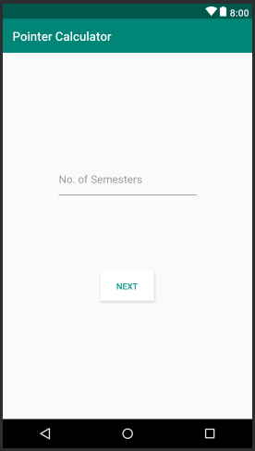 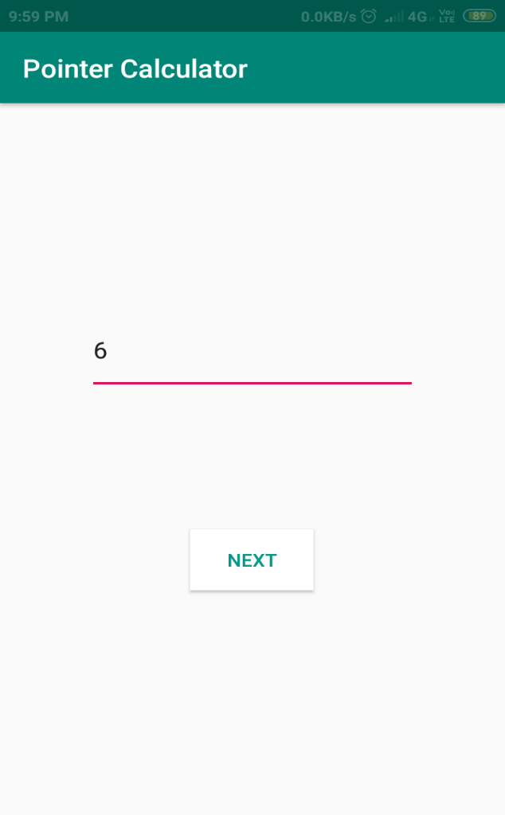

Fig. CGPIActivity1 (Before user input) Fig. CGPIActivity2 (After user input)

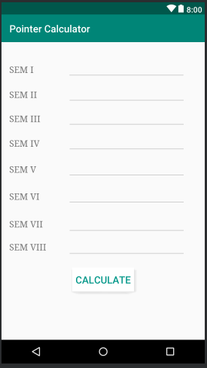 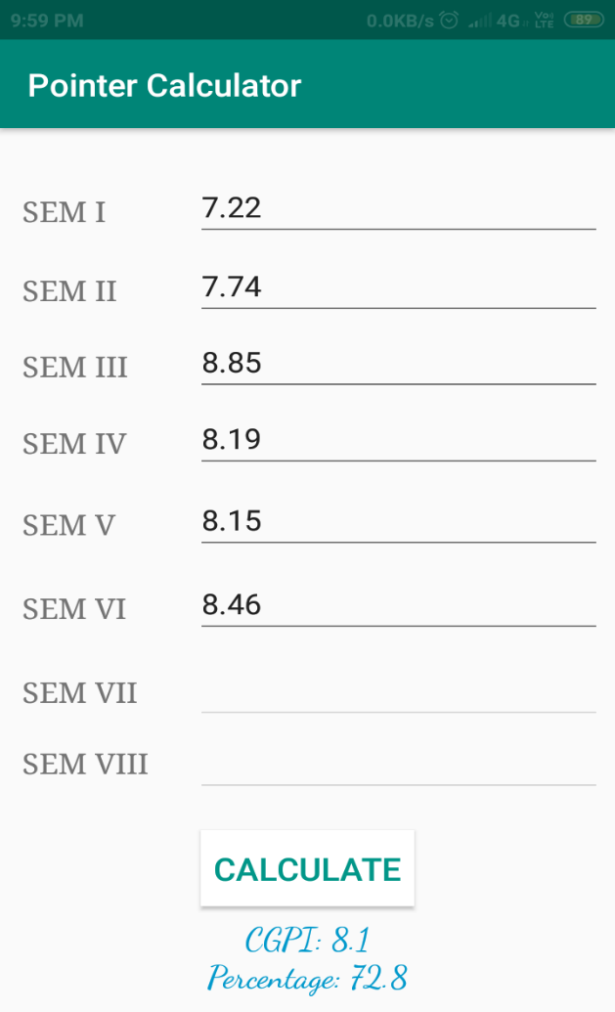

Fig. CGPIActivity2 (Before user input) Fig. CGPIActivity2 (After user input)