1. What is a Data Stream? Explain with example.

ANS. In connection-oriented communication, a data stream is a sequence of digitally encoded coherent signals used to transmit or receive information that is in the process of being transmitted. A data stream is a set of extracted information from a data provider. It contains raw data that was gathered out of users' browser behavior from websites, where a dedicated pixel is placed.

Examples of data streams include computer network traffic, phone conversations, ATM transactions, web searches, and sensor data.

1. What is Data Stream Mining? Give four examples of Data Stream Mining.

ANS. Data Stream Mining is the process of extracting knowledge structures from continuous, rapid data records. A data stream is an ordered sequence of instances that in many applications of data stream mining can be read only once or a small number of times using limited computing and storage capabilities.

Examples –

* Adaptive malicious code detection
* On-line malicious URL detection
* Evolving insider threat detection
* Textual stream classification

1. What is a Collaborative filtering system in view of Recommendation Systems?

ANS. Collaborative filtering systems recommend items based on similarity measures between users and/or items. The items recommended to a user are those preferred by similar users. This sort of recommendation system can use the groundwork laid on similarity search and on clustering. However, these technologies by themselves are not sufficient, and there are some new algorithms that have proven effective for recommendation systems.

1. What is CQL? where it is used?

ANS. Contextual Query Language (CQL), previously known as Common Query Language is a formal language for representing queries to information retrieval systems such as search engines, bibliographic catalogs and museum collection information.

Based on the semantics of Z39.50, its design objective is that queries be human readable and writable, and that the language be intuitive while maintaining the expressiveness of more complex query languages. It is being developed and maintained by the Z39.50 Maintenance Agency, part of the Library of Congress.

1. What are Hash Functions? Give their application and one example.

ANS. A hash function is any function that can be used to map data of arbitrary size to fixed-size values. The values returned by a hash function are called hash values, hash codes, digests, or simply hashes. The values are used to index a fixed-size table called a hash table.

Applications-

* Construct a message authentication code (MAC)
* Digital signature
* Make commitments, but reveal message later
* Timestamping
* Key updating: key is hashed at specific intervals resulting in new key

The example of a hash function is a book call number. Each book in the library has a unique call number. A call number is like an address: it tells us where the book is located in the library.

1. Define (a) Tendrils (b) Tubes (c) SCC (d) Simrank (e) Pagerank

ANS. **a. Tendrils-** Tendrils, which are of two types. Some tendrils consist of pages reachable from the in-component but not able to reach the in-component. The other tendrils can reach the out-component, but are not reachable from the out-component.

**b. Tubes-** Tubes, which are pages reachable from the in-component and able to reach the out-component, but unable to reach the SCC or be reached from the SCC.

**c. SCC-** It stands for Strongly Connected Component. A directed graph is strongly connected if there is a path between all pairs of vertices. A strongly connected component (SCC) of a directed graph is a maximal strongly connected subgraph.

**d. Simrank-** It is an approach to analyze social network graphs. It’s purpose is to measure the similarity between nodes of the same type and it does so by seeing where random walkers on the graph wind up when starting at a particular node.

**e. Pagerank-** PageRank is a function that assigns a real number to each page in the Web (or at least to that portion of the Web that has been crawled and its links discovered). The intent is that the higher the PageRank of a page, the more “important” it is.

1. Where do we see recommendation? List any Four.

ANS. Uses of Recommendation-

* **News Recommendations:** Offering news articles to on-line newspaper readers, based on a prediction of reader interests.
* **Product Recommendations:** Offering customers of an on-line retailer suggestions about what they might like to buy, based on their past history of purchases and/or product searches.
* **Movie Recommendations:** Netflix offers its customers recommendations of movies they might like. These recommendations are based on ratings provided by users.
* **Book Recommendations:** Amazon kindle offers its customers recommendations of books they might like. These recommendations are based on ratings provided by the readers.

1. Draw Block diagram of typical DSMS.

ANS.

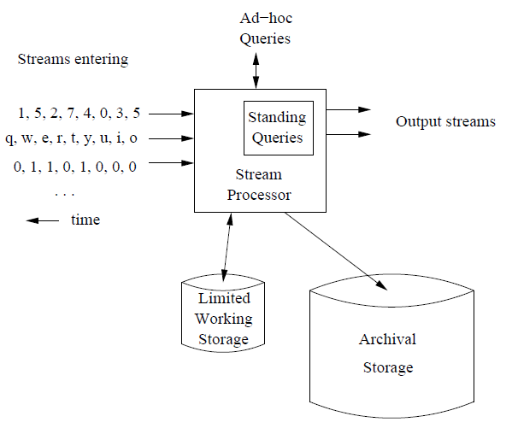

1. What is Random Surfer Concept?

ANS. The random surfer model provides a basis for calculating the Page Rank algorithm. The model represents the behavior of Internet users and provides a probability of a random user visiting a webpage. A surfer moves through the Internet in two ways. They may enter a URL or use a bookmark to go directly to a webpage. Or they may follow a series of successive links until again accessing a new page. In a random surfer model, it is assumed that the link which is clicked next is selected at random. The content does not matter. Moreover, it is assumed that clicking another link is not an infinite chain, but that a random user will lose interest in following those links at a certain point and visit a new website instead.

1. Define (a) Hubs (b) Authority pages

ANS. a. Hubs- Hubs are pages that, while they do not themselves contain the information, link to places where the information can be found.

b. Authority pages- Authorities are those pages that contain valuable information.

1. What is Link Farm?

ANS. On the World Wide Web, a link farm is any group of websites that all hyperlink to other sites in the group for the purpose of increasing SEO rankings. In graph theoretic terms, a link farm is a clique. Although some link farms can be created by hand, most are created through automated programs and services. E.g. Blog Network.

1. What is the use of Recommendation Systems?

ANS. A recommendation system is a subclass of information filtering system that seeks to predict the "rating" or "preference" a user would give to an item. They are primarily used in commercial applications.

Recommendation systems are utilized in a variety of areas and are most commonly recognized as playlist generators for video and music services like Netflix, YouTube and Spotify, product recommenders for services such as Amazon, or content recommenders for social media platforms such as Facebook and Twitter. These systems can operate using a single input, like music, or multiple inputs within and across platforms like news, books, and search queries. There are also popular recommender systems for specific topics like restaurants and online dating. Recommender systems have also been developed to explore research articles and experts, collaborators and financial services.

1. What is HITS algorithm? Explain differences between HITS and PageRank.

ANS. Hyperlink Induced Topic Search (HITS) Algorithm is a Link Analysis Algorithm that rates webpages, developed by Jon Kleinberg. This algorithm is used to the web link-structures to discover and rank the webpages relevant for a particular search. HITS use hubs and authorities to define a recursive relationship between webpages.

|  |  |  |
| --- | --- | --- |
| **Parameters** | **HITS** | **PageRank** |
| Scoring Criteria | Good authorities are pointed to by good hubs and good hubs point to good authorities. | Webpage is important if it is pointed to by other important pages. |
| Number of scores | Dual Rankings a) one with the most authoritative documents related to the query b) other with the most "hubby" documents. | Page rank only presents one score. |
| Query independence | HITS score is calculated after getting the neighborhood graph according to the query | PageRank score is query independent |
| Resilience to spamming | Susceptible to spamming since addition of pages slightly affects the ranking. | Since PageRank is able to isolate spam, it is resilient to spamming. |

1. Explain Bloom’s Filter with example. A bloom filter with m=1000 cells is used to store information about n=100 items, using k=4 hash functions. Calculate the false positive probability of this instance. Will the performance improve by increasing the number of hash functions from 4 to 5? Explain your answer.

ANS. A Bloom filter is a space-efficient probabilistic data structure that is used to test whether an element is a member of a set. An empty bloom filter is a bit array of m bits, all set to zero. We need k number of hash functions to calculate the hashes for a given input. When we want to add an item in the filter, the bits at k indices h1(x), h2(x), … hk(x) are set, where indices are calculated using hash functions.

Example- Suppose we want to enter “jawwad” in the filter, we are using 3 hash functions and a bit array of length 10, all set to 0 initially.

|  |  |  |  |  |  |  |  |  |  |
| --- | --- | --- | --- | --- | --- | --- | --- | --- | --- |
| 0 | 0 | 0 | 0 | 0 | 0 | 0 | 0 | 0 | 0 |

1 2 3 4 5 6 7 8 9 10

First, we’ll calculate the hashes as following-

h1(“jawwad”) % 10 = 1

h2(“jawwad”) % 10 = 4

h3(“jawwad”) % 10 = 7

Now we will set the bits at indices 1, 4 and 7 to 1

jawwad

|  |  |  |  |  |  |  |  |  |  |
| --- | --- | --- | --- | --- | --- | --- | --- | --- | --- |
| 1 | 0 | 0 | 1 | 0 | 0 | 1 | 0 | 0 | 0 |

1 2 3 4 5 6 7 8 9 10

Again, we want to enter “kazi”, similarly we’ll calculate hashes

h1(“kazi”) % 10 = 3

h2(“kazi”) % 10 = 5

h3(“kazi”) % 10 = 4

Set the bits at indices 3, 5 and 4 to 1

kazi

|  |  |  |  |  |  |  |  |  |  |
| --- | --- | --- | --- | --- | --- | --- | --- | --- | --- |
| 1 | 0 | 1 | 1 | 1 | 0 | 1 | 0 | 0 | 0 |

1 2 3 4 5 6 7 8 9 10

Now if we want to check “jawwad” is present in filter or not. We’ll do the same process but this time in reverse order. We calculate respective hashes using h1, h2 and h3 and check if all these indices are set to 1 in the bit array. If all the bits are set then we can say that “jawwad” is probably present. If any of the bit at these indices are 0 then “jawwad” is definitely not present.

Let m=1000, n=100, k=4.

We have, Probability of False Positivity (P) $={(1-{[1-\frac{1}{m}]}^{kn})}^{k}$

$={(1-{[1-\frac{1}{1000}]}^{4*100})}^{4}$

$={(1-{[1-\frac{1}{1000}]}^{400})}^{4}$

$={(1-0.6702)}^{4}$

$=0.0118$

If we consider k=5, then

We have, Probability of False Positivity (P) $={(1-{[1-\frac{1}{m}]}^{kn})}^{k}$

$={(1-{[1-\frac{1}{1000}]}^{5*100})}^{5}$

$={(1-{[1-\frac{1}{1000}]}^{500})}^{5}$

$={(1-0.6064)}^{5}$

$=0.0095$

From above results we can see that, by increasing number of hash functions (k) from 4 to 5, the false positive probability of the instance got reduced to 0.0095 from 0.0118. Hence, we can say that the lesser the no of hash functions the greater is the false positive probability.

1. 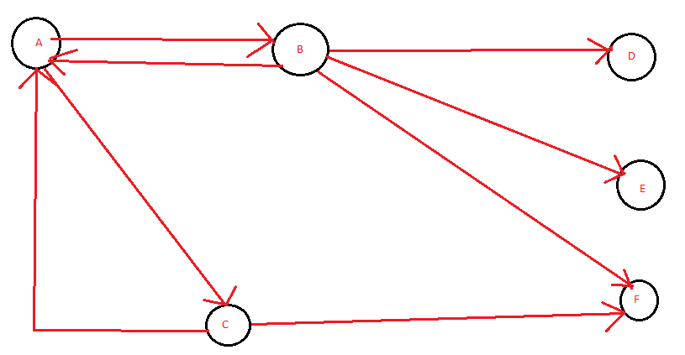Consider a Web Graph as given Below:

Assume that PageRank values for any page ‘m’ at iteration 0 is PR(m)=1 and teleportation factor for iteration is β =0.85. Perform the PageRank algorithm and determine the rank of every page at iteration 2.

ANS.

Transition Matrix

|  |  |  |  |  |  |
| --- | --- | --- | --- | --- | --- |
| 0 | ¼ | ½ | 0 | 0 | 0 |
| ½ | 0 | 0 | 0 | 0 | 0 |
| ½ | 0 | 0 | 0 | 0 | 0 |
| 0 | ¼ | 0 | 0 | 0 | 0 |
| 0 | ¼ | 0 | 0 | 0 | 0 |
| 0 | ¼ | ½ | 0 | 0 | 0 |

M =

From the graph it is clear that D, E and F are dead ends.

Before applying PageRank algorithm, remove the dead ends.

Hence, the new graph will be

So, the new transition matrix will be

M $=\begin{matrix}0 & 1/2 & 1 \\ 1/2 & 0 & 0 \\ 1/2 & 0 & 0\end{matrix}$

$β=0.85$ and initial PageRank vector

V $= \begin{matrix}1 \\ 1 \\ 1\end{matrix}$

Iteration 1: V $= βmv +\left( 1-β \right)e/n$

V $= \frac{17}{20}$ $\begin{matrix}0 & 1/2 & 1 \\ 1/2 & 0 & 0 \\ 1/2 & 0 & 0\end{matrix} \begin{matrix}1 \\ 1 \\ 1\end{matrix} + \frac{3}{20} \begin{matrix}1/3 \\ 1/3 \\ 1/3\end{matrix}$

$= \frac{17}{20} \begin{matrix}2 \\ 1/2 \\ 1/2\end{matrix}$ + $\begin{matrix}1/20 \\ 1/20 \\ 1/20\end{matrix}$

$= \begin{matrix}34/20 \\ 17/40 \\ 17/40\end{matrix} + \begin{matrix}1/20 \\ 1/20 \\ 1/20\end{matrix} = \begin{matrix}35/20 \\ 19/40 \\ 19/40\end{matrix}$

Iteration 2:

V $= βmv +\left( 1-β \right)e/n$

After iteration 2, PageRank of

Page A = 343/400

Page B = 127/160

Page C = 127/160

Page D = $\frac{PR(B)}{2} = \frac{127/160}{2} =\frac{127}{320}$

Page E = $\frac{PR(B)}{2} = \frac{127/160}{2} =\frac{127}{320}$

Page F = $\frac{PR(B)}{2}+\frac{PR(B)}{2} =\frac{127}{320}+ \frac{127}{320} =\frac{254}{320}$