|  |  |  |  |  |  |  |  |  |  |  |  |
| --- | --- | --- | --- | --- | --- | --- | --- | --- | --- | --- | --- |
|  | | **Hope Foundation’s**  **Finolex Academy of Management and Technology, Ratnagiri** | | | | | | | | | |
| **Information Technology Department** | | | | | | | | | |
| Subject name: Cloud Computing and Services | | | | | | | | Subject Code: ITC603 | | | |
| Class | | TE IT | | Semester – VI (CBCGS) | | | | Academic year: 2018-19 | | | |
| Name of Student | | **Kazi Jawwad A Rahim** | | | | | **QUIZ Score :** | | | | |
| Roll No | | **27** | | | Experiment No. | | | | | 01 | |
| **Title: Installation of Ubuntu on VMWare workstation** | | | | | | | | | | | |
|  | | | | | | | | | | | |
| 1. **Course objectives applicable**   **COB1**.Basics of cloud computing.  **COB2**.Key concepts of virtualization. | | | | | | | | | | | |
| **2. Course outcomes applicable:**  **CO1**:-Define cloud computing and memorized the different cloud service and deployment models.  **CO2**:-Describe importance of virtualization along with their technologies. | | | | | | | | | | | |
| **3. Learning Objectives:**   1. To understand the concept of hypervisor. 2. To create a virtual machine. 3. To use guest OS on host platform. 4. To install Ubuntu as a guest operating system and understand virtualization concept. | | | | | | | | | | | |
| 1. **Practical applications of the assignment/experiment:**   **Hypervisors are main components of Cloud Implementation** | | | | | | | | | | | |
| **5. Prerequisites**:   1. Knowledge of VM ware workstation 2. Ubuntu (Guest OS) image file (.iso) | | | | | | | | | | | |
| **6. Hardware Requirements**:   1. PC with 4GB RAM, 500GB HDD   **7. Software Requirements:**   1. Ubuntu / Windows Setup 2. VM Ware workstation | | | | | | | | | | | |
| **8. Experiment/Assignment Evaluation:** | | | | | | | | | | | |
| **Sr. No.** | **Parameters** | | | | | | | | **Marks obtained** | | **Out of** |
| **1** | Technical Understanding (Assessment may be done based on Q & A **or** any other relevant method.) Teacher should mention the other method used - | | | | | | | |  | |  |
| **2** | Neatness/presentation | | | | | | | |  | |  |
| **3** | Punctuality | | | | | | | |  | |  |
| **Date of performance (DOP)** | | |  | | | **Total marks obtained** | | |  | |  |
| **Date of checking (DOC)** | | |  | | | **Signature of teacher** | | | | | |

**10. Installation steps:**

1.Open VMware Workstation and click on “Create a New Virtual Machine”. Select “Installer disc image (ISO)”, click “Browse” to select the Ubuntu ISO file, click “Open” then “Next”.

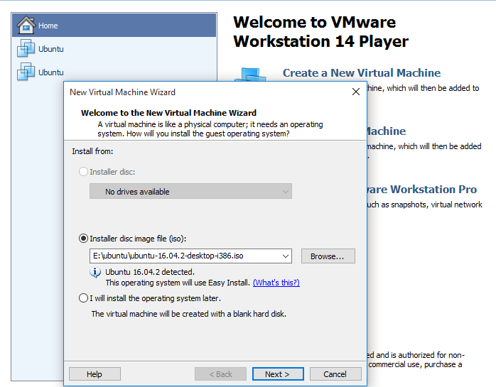

2. Created account with “Full name”, “User name” that must only consist of lowercase and numbers then you must enter a password. After you finished, click “Next”.

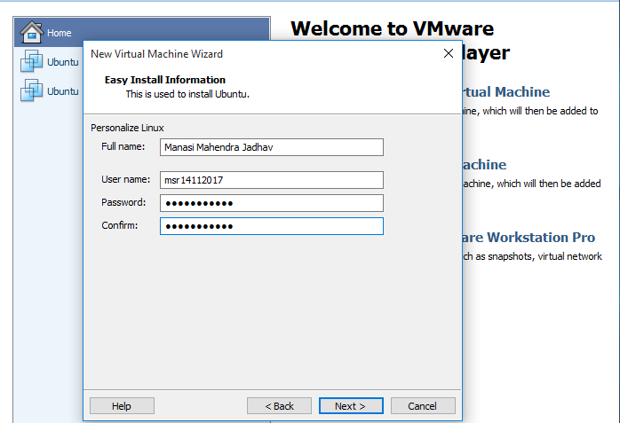

3. Click on “Customize Hardware”. Click “Close” then “Finish” to start the Ubuntu install process.

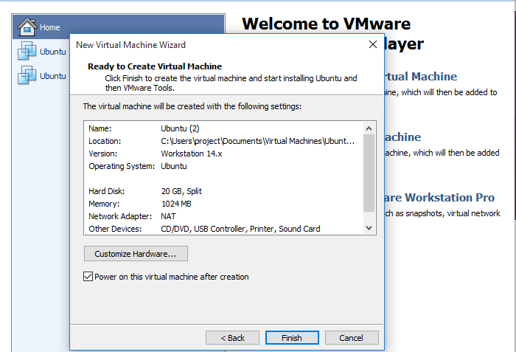

**11. Results:**

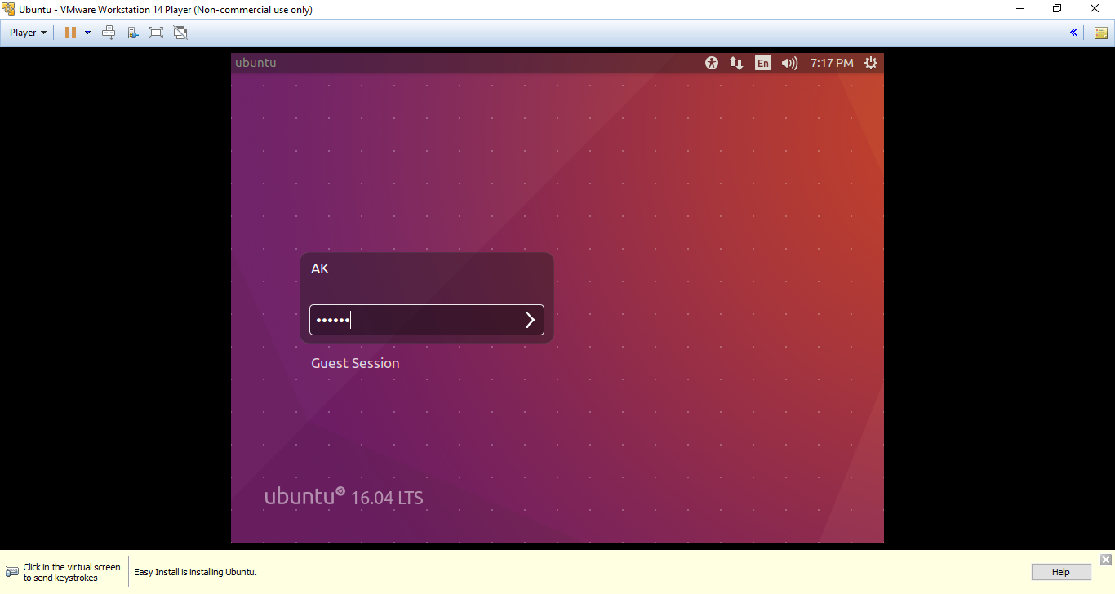

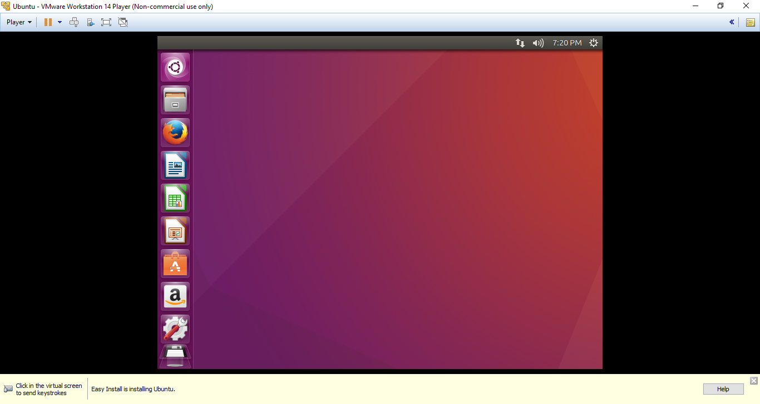

**References** :

[1] https://en.wikipedia.org/wiki/Virtualization

[2] "Virtualization in education" (PDF). IBM. October 2007. Retrieved 6 July 2010. A virtual computer is a logical representation of a computer in software. By decoupling the physical hardware from the operating system, virtualization provides more operational flexibility and increases the utilization rate of the underlying physical hardware.

[3] http://searchservervirtualization.techtarget.com/definition/hosted-hypervisor-Type-2-hypervisor