|  |  |  |  |  |  |  |  |  |  |  |
| --- | --- | --- | --- | --- | --- | --- | --- | --- | --- | --- |
|  | | **Hope Foundation’s**  **Finolex Academy of Management and Technology, Ratnagiri** | | | | | | | | |
| **Information Technology Department** | | | | | | | | |
| Subject name: Cloud Service Design Lab | | | | | | | Subject Code: ITL603 | | | |
| Class | | TE IT | | Semester – VI (CBCGS) | | | Academic year: 2018-19 | | | |
| Name of Student | | **Kazi Jawwad A Rahim** | | | | **QUIZ Score : 08/10** | | | | |
| Roll No | | **27** | | | Assignment/Experiment No. | | | | 10 | |
| **Title: To study installation of VM ware ESXi server.** | | | | | | | | | | |
|  | | | | | | | | | | |
| **1.Course objectives applicable**  **COB1**. To understand use of VM ware ESXi server  **COB2**. To understand features of VM ware ESXi . | | | | | | | | | | |
| **2. Course outcomes applicable:**  **CO1** -To know VM ware ESXi server configuration.  **CO2**-To understand the use of VM ware ESXi server in different applications | | | | | | | | | | |
| **3. Learning Objectives:**   1. To understand installation of VM ware ESXi server installation. 2. To understand the use of VM ware ESXi server. | | | | | | | | | | |
| **4. Practical applications of the assignment/experiment: In cloud environment**  **Used in third party management tool**. | | | | | | | | | | |
| **5. Prerequisites**:   1. Prior knowledge of server. | | | | | | | | | | |
| **6. Hardware Requirements**:   1. Internet Access with Browser   **7. Software Requirements:**  Browser like Chrome, Internet Explorer Edge | | | | | | | | | | |
|  | | | | | | | | | | |
| **8. Quiz Questions (if any): (Online Exam will be taken separately batch wise, attach the certificate/ Marks obtained)**   1. What are features of VM ware ESXi server? 2. What are applications of VM ware ESXi server? | | | | | | | | | | |
|  | | | | | | | | | | |
| **9. Experiment/Assignment Evaluation:** | | | | | | | | | | |
| **Sr. No.** | **Parameters** | | | | | | | **Marks obtained** | | **Out of** |
| **1** | Technical Understanding (Assessment may be done based on Q & A **or** any other relevant method.) Teacher should mention the other method used - | | | | | | |  | | 6 |
| **2** | Neatness/presentation | | | | | | |  | | 2 |
| **3** | Punctuality | | | | | | |  | | 2 |
| **Date of performance (DOP)** | | | **10-04-2019** | | **Total marks obtained** | | |  | | **10** |
| **Date of checking (DOC)** | | | **18-04-2019** | | **Signature of teacher** | | | | | |

**Performance Steps:-**

Step 1 – Power on your Virtual / Physical Machine, and boot from the ESXi 5.5 ISO Image > Press Enter to Start the installation wizard.

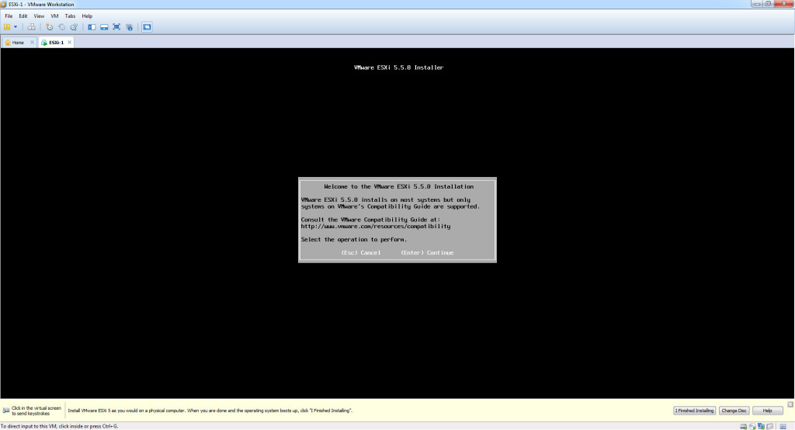

Step 2 – Accept EULA > Press F11

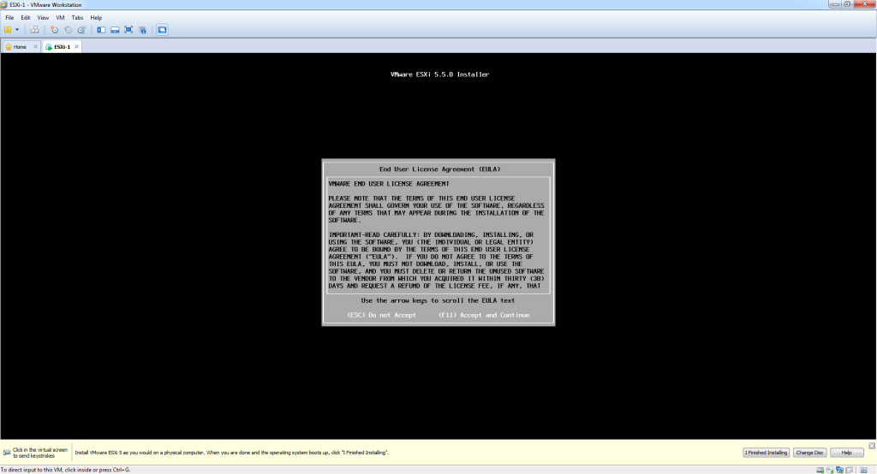

Step 3 – Select the Local Disk for the Installation > Press Enter

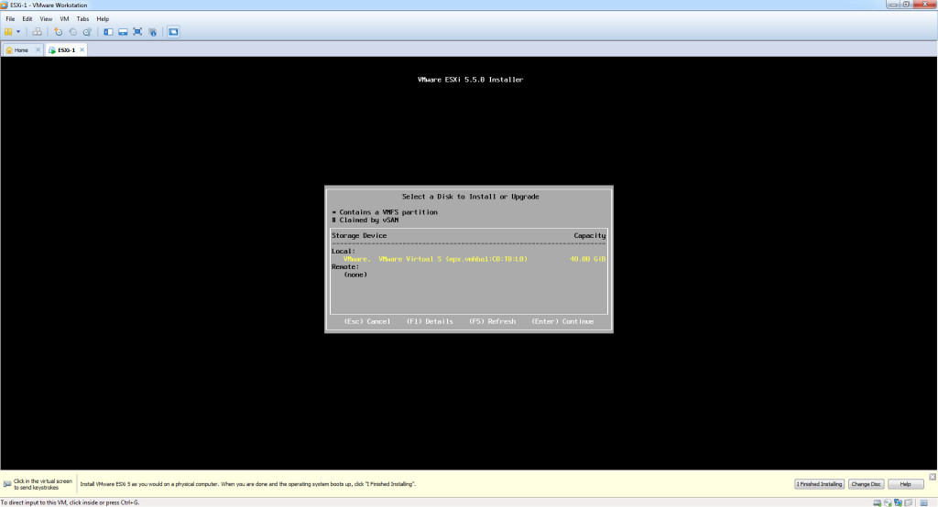

Step 4 – Select your keyboard locale > Press Enter

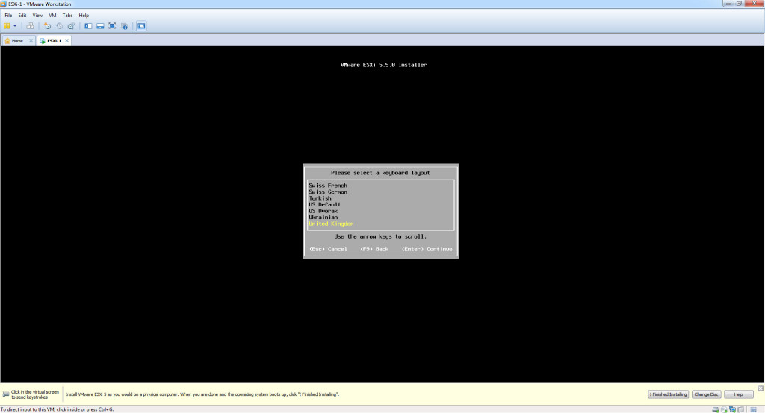

Step 5 – Type a complex password, with a minimum of 7 characters > Press Enter

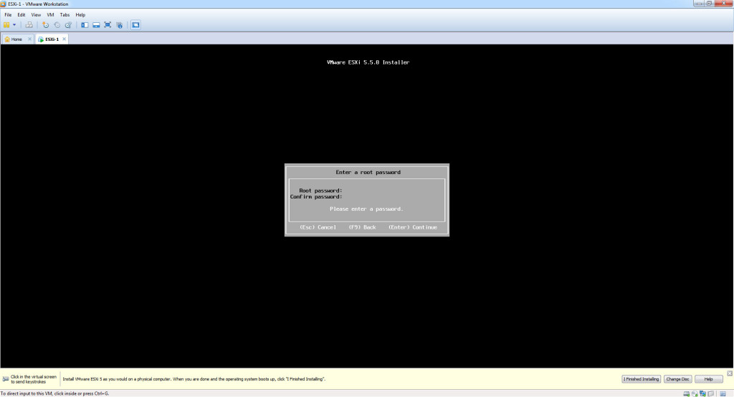

Step 6 – Confirm > Press F11 to start the installation

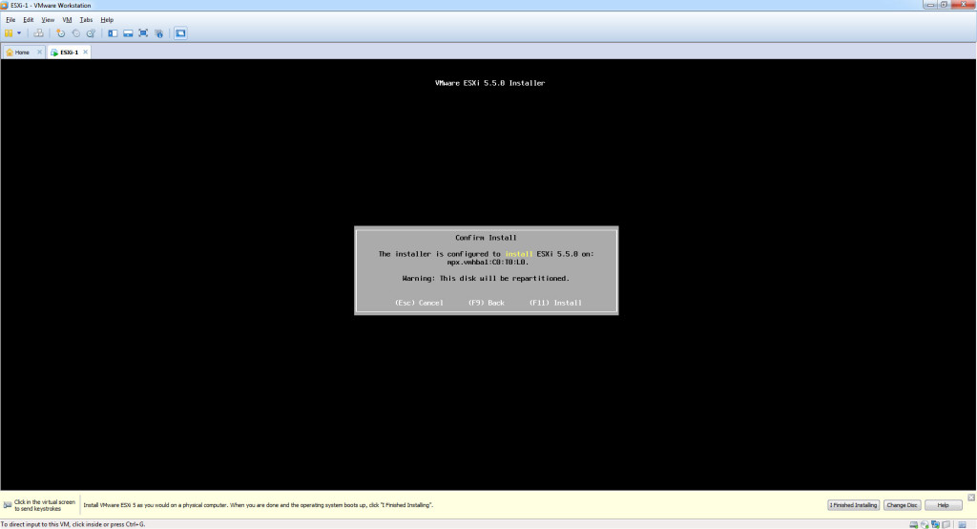

Step 7 – Installation will take about 2-5 minutes to complete.

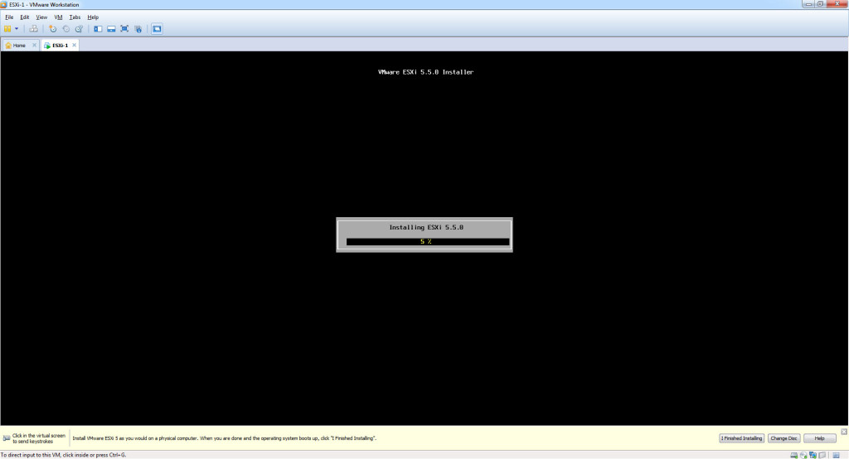

Step 8 – Press Enter to Reboot once the installation has completed successfully.

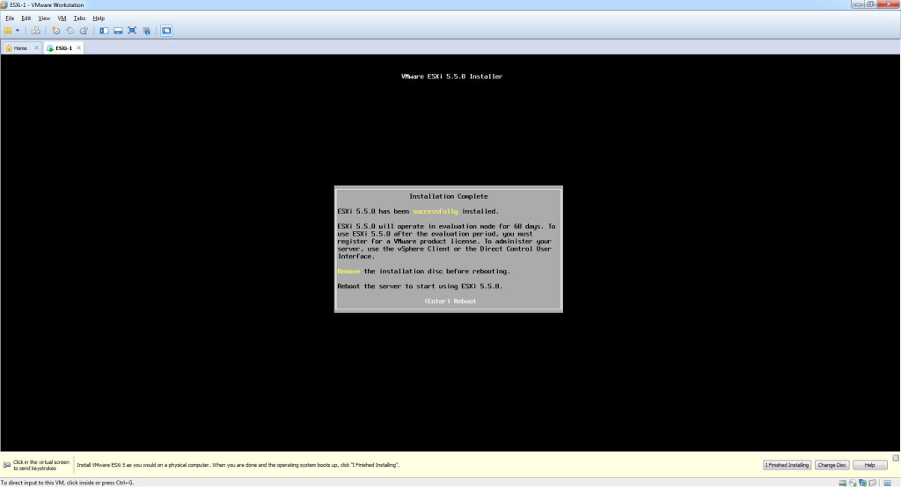

Step 9 – Wait for reboot to complete

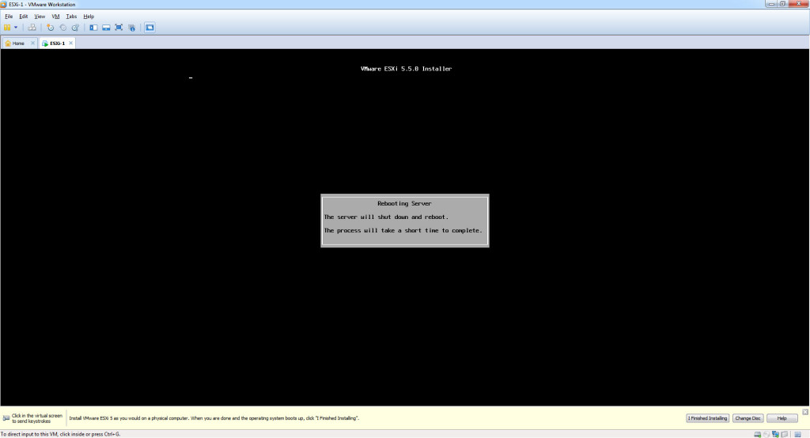

Step 10 – Press F2 to enter the configuration mode

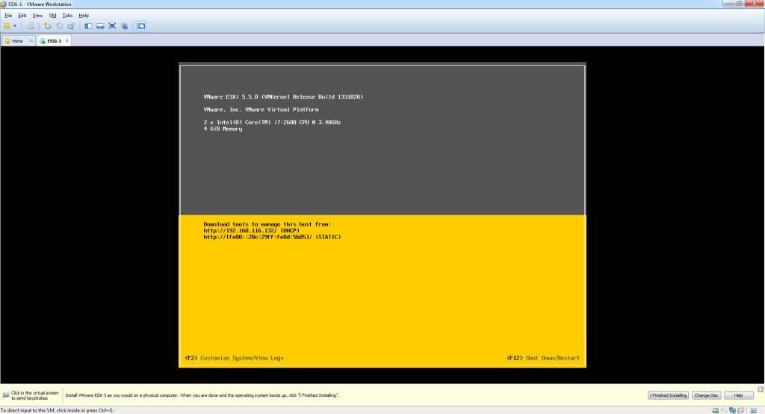

Step 11 – You will be promoted for the password which you created during the installation (note – the default user name is – root).

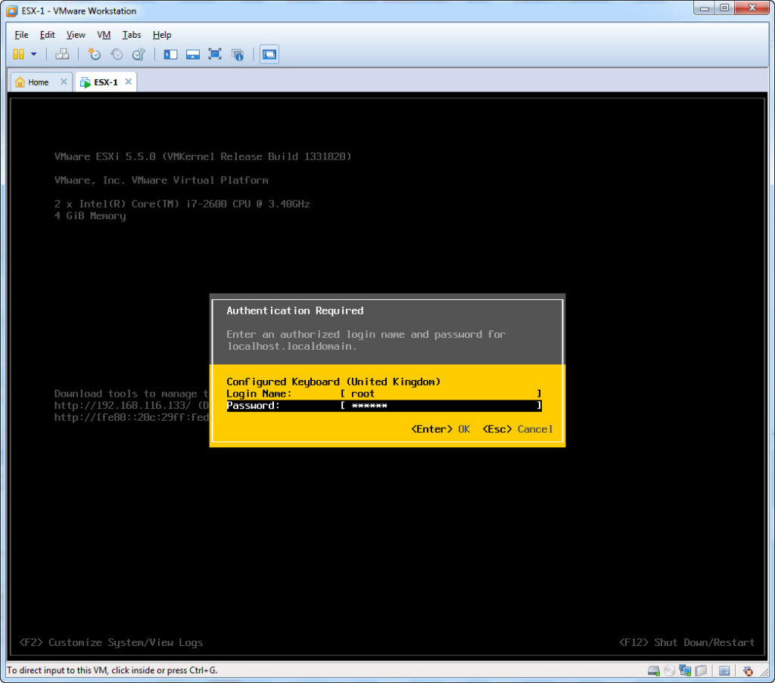

Step 12 – The next step is to configure the management network interface. Select “Configure Management Network” > Press Enter.

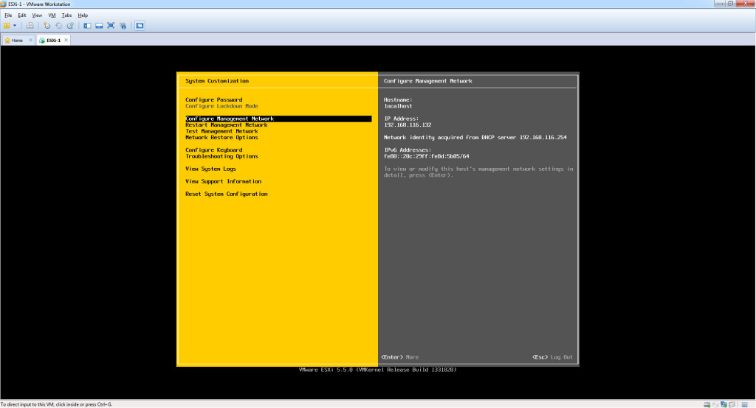

Step 13 – Select IP Configuration > Press Enter

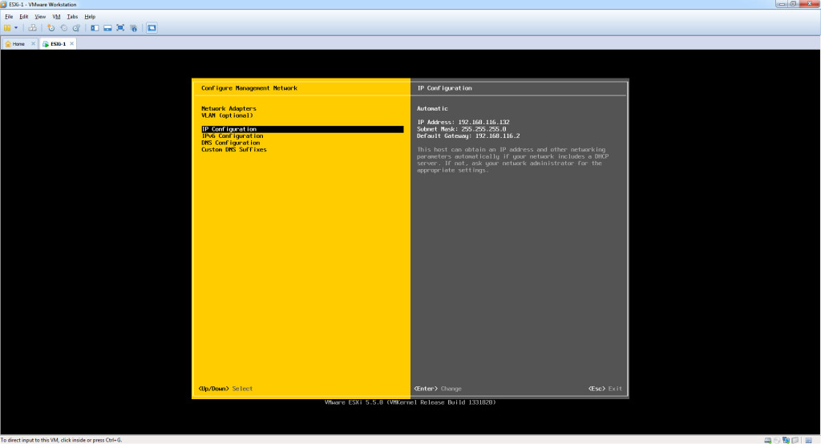

Step 14 – Select “Set Static IP Address and Network Configuration” > Type the static IP Address / Subnet mask and default gateway for ESX1 from the top, or one of your choice > Press Enter once complete.

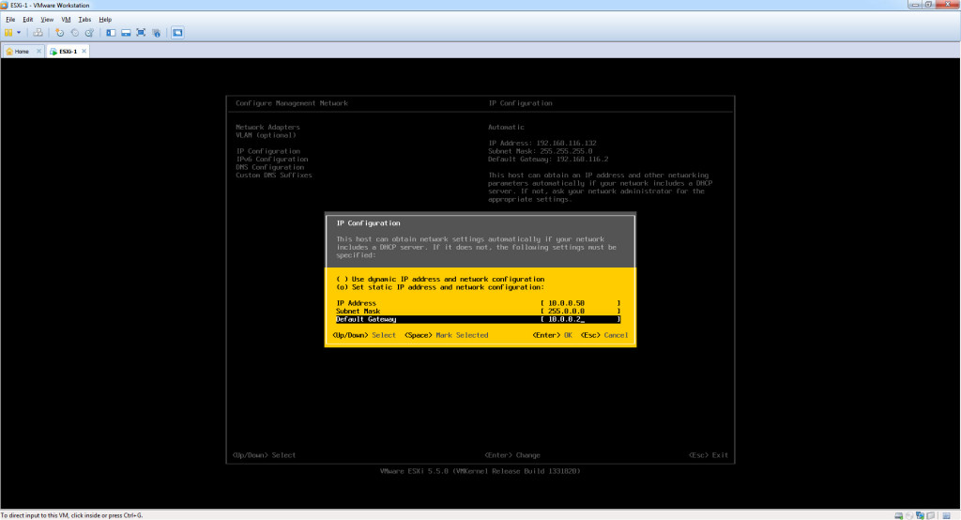

Step 15 – Select “DNS Configuration” > Press Enter

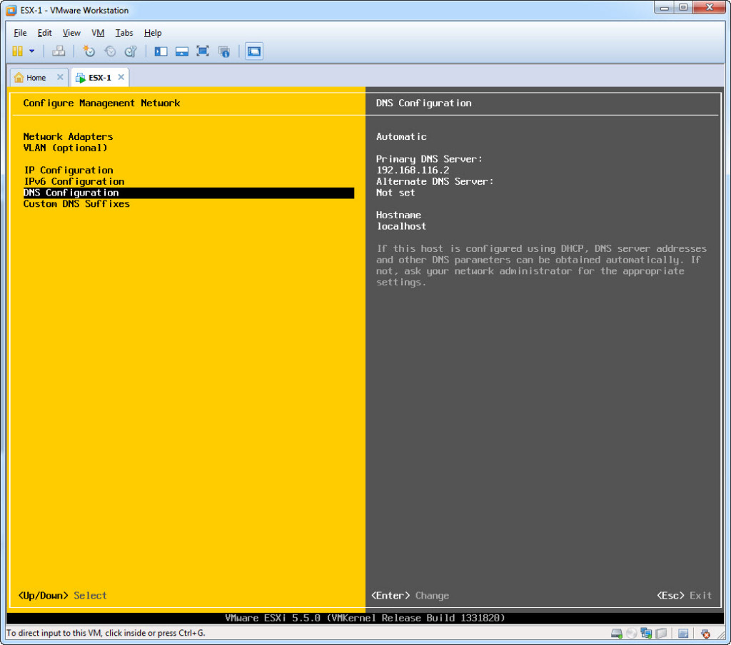

Step 16 – Type the Primary DNS Server / Alternate DNS Server and Hostname for ESX1 from the top, or one of your choice > Press Enter once complete.

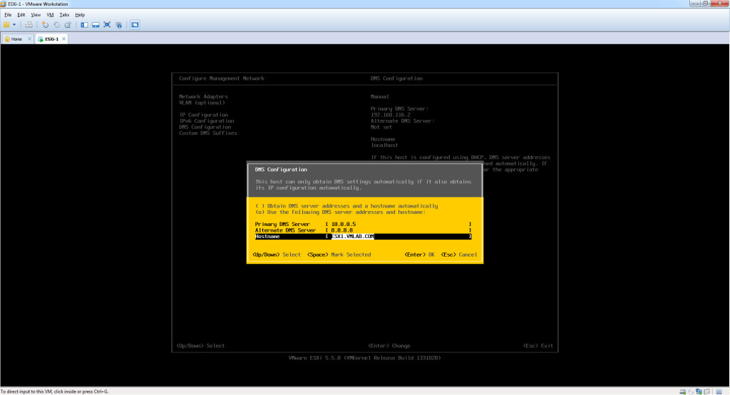

Step 17 – Press ESC > Type [Y] to “Apply changes and restart management network”. This will allow you to successfully exit the ESXi 5.5 configuration menu, back to the home screen.

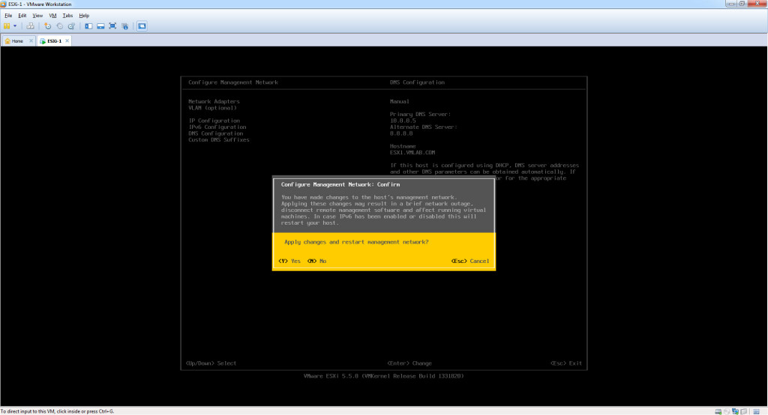

Step 18 – You have successfully completed configuration for ESXi 5.5 with the host name ESX1.

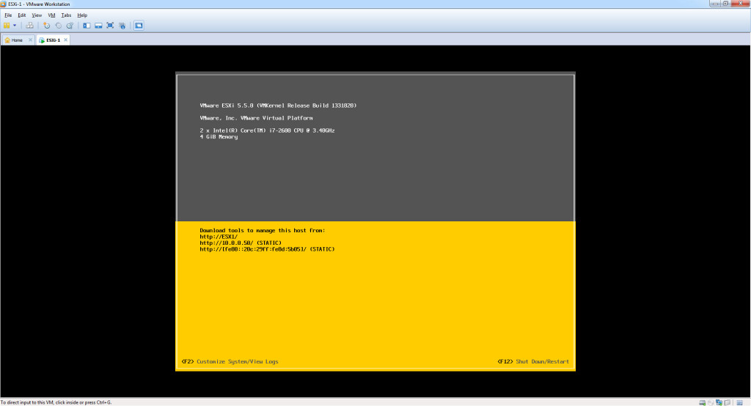

**Result:-**

Step 19 - Login to Virtual Center using Web Client or vSphere Client. Select ESXi Host and do a Right Click. Click on New Virtual Machine. It will open New Virtual Machine Wizard.

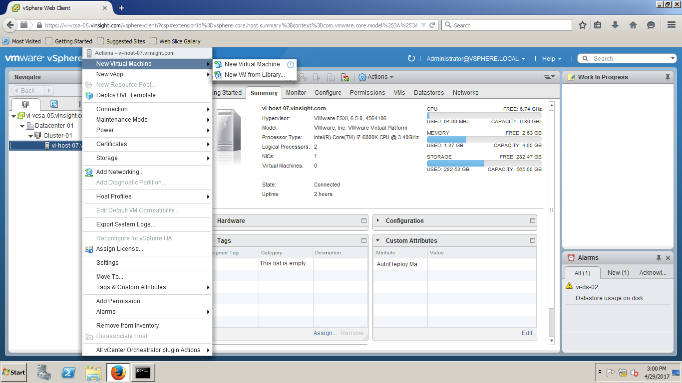

Step 20 - From Select a Create Type, Choose "Create a new virtual machine" and Click on Next.

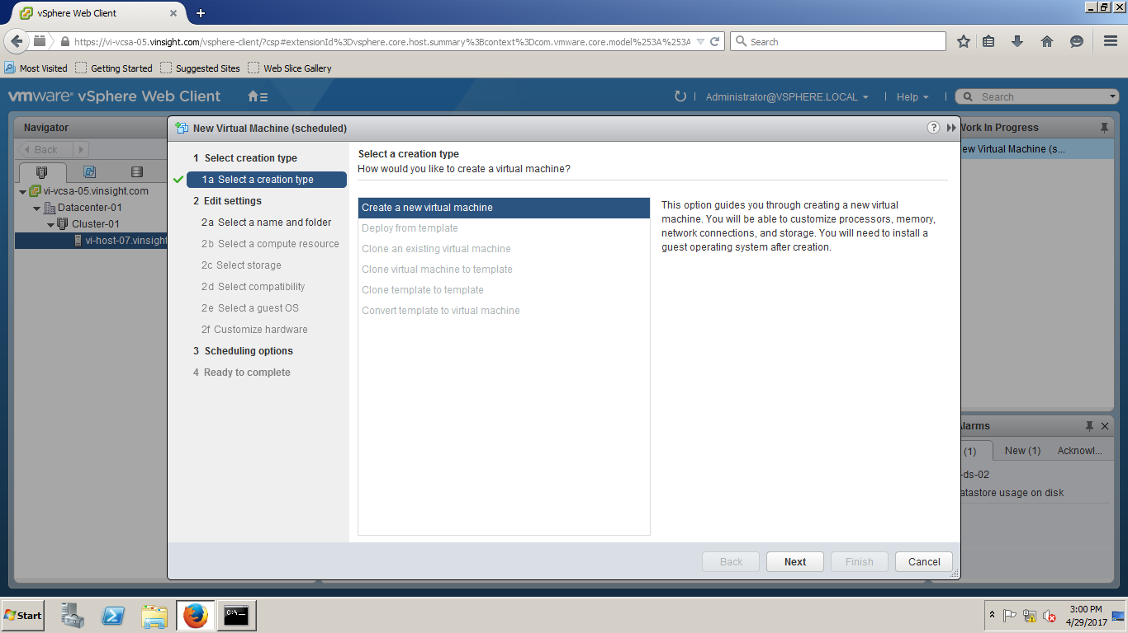

Step 21 - Enter a unique name for the Virtual Machine and Select either Datacenter or Specific Folder you want to deploy this VM. The name can contain up to 80 characters. Click on Next.

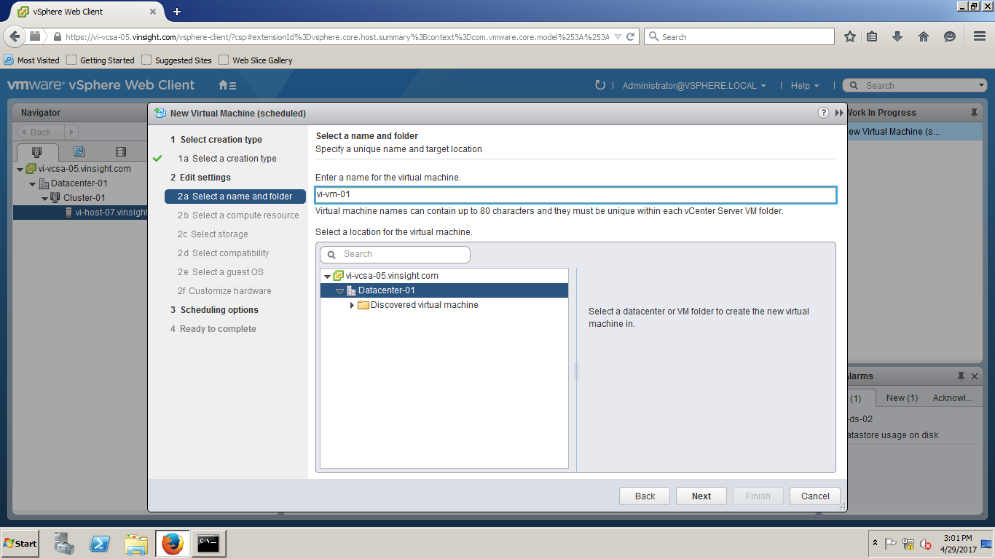

Step 22 - Select Cluster and ESXi host where you will deploy this Virtual Machine. Virtual machine will have access to the resources of the selected object.(i;e Datastore and Network attached to that Cluster/Hosts).

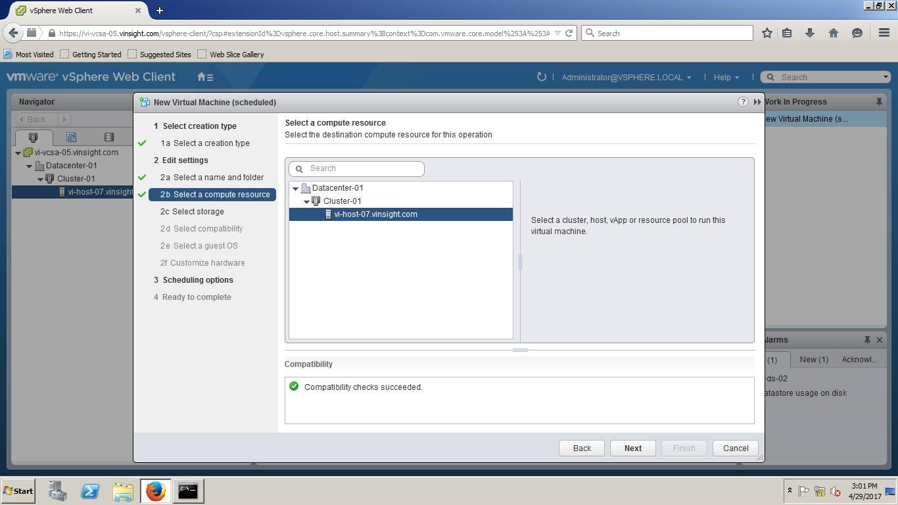

Step 23 - Select Datastore in which you would like to store the Virtual Machine configuration files and all of the virtual disks. Please note that Virtual disks and configuration files can also be in different datastores. Click on Next.

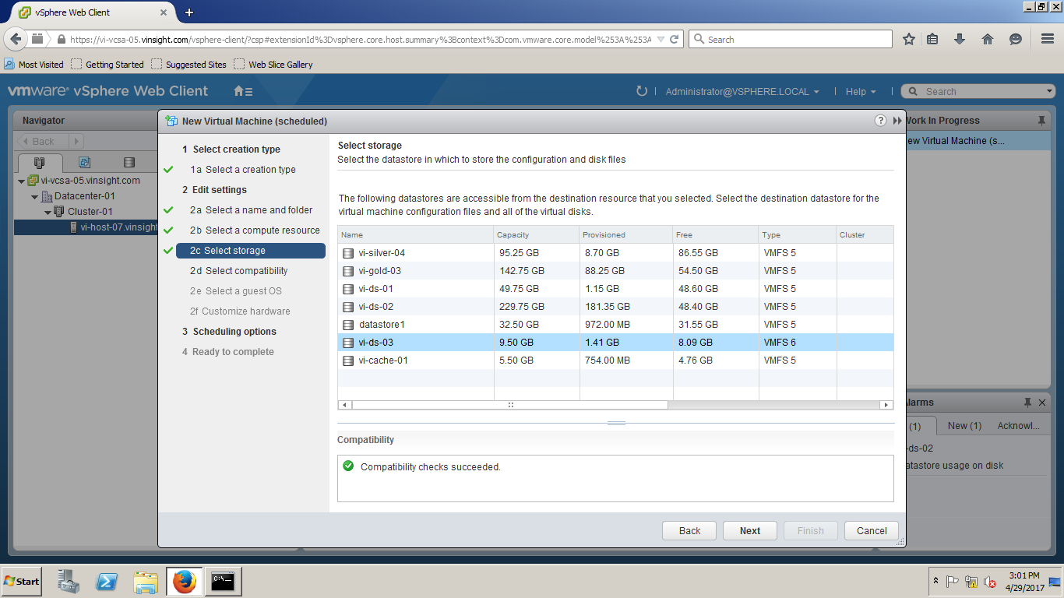

Step 24 - Select Compatibility for this Virtual Machne. Choose default and Click on Next.

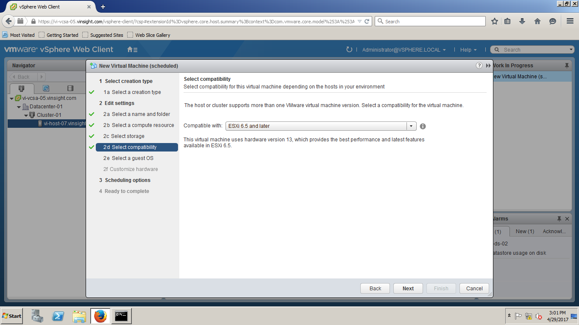

Step 25 - On Select a Guest OS Wizard, Choose the Guest OS type(i;e Windows/Linux/Other, 32/64 Bit) and Guest Name.

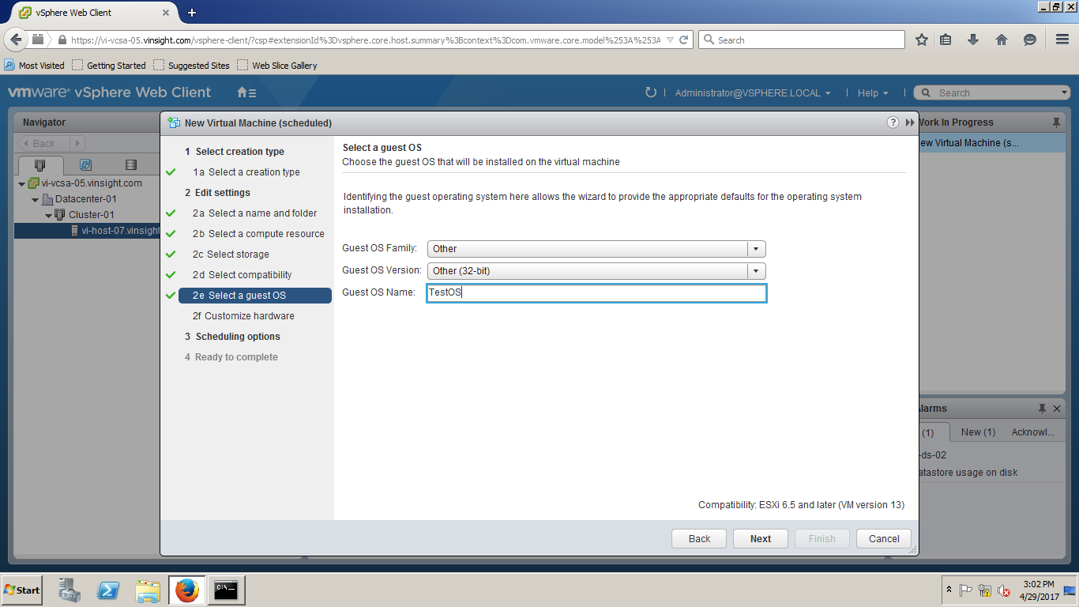

Step 26 - Configure the Virtual Machine Hardware as per requirement and Click on Next.

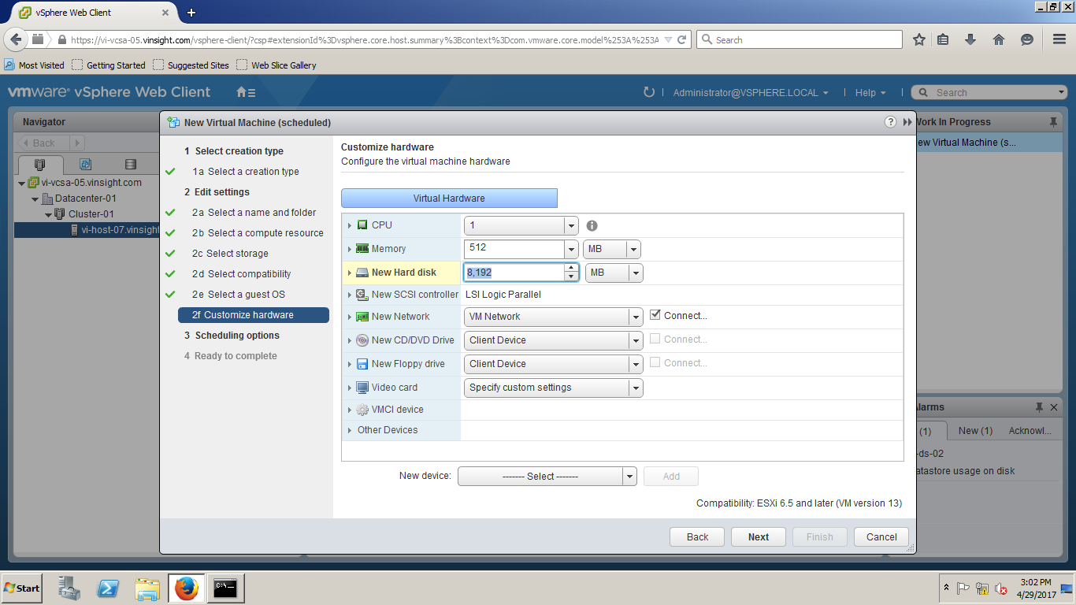

Step 27 - Select Scheduling Option for this Virtual Machine.

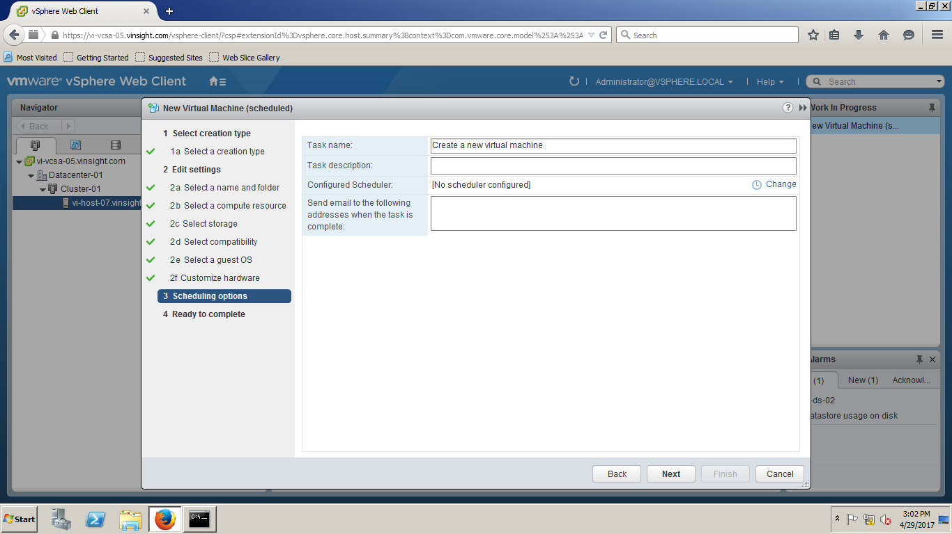

Step 28 - You change Virtual Machine Scheduling to some different time. To do this, Click on Change and setup scheduling.

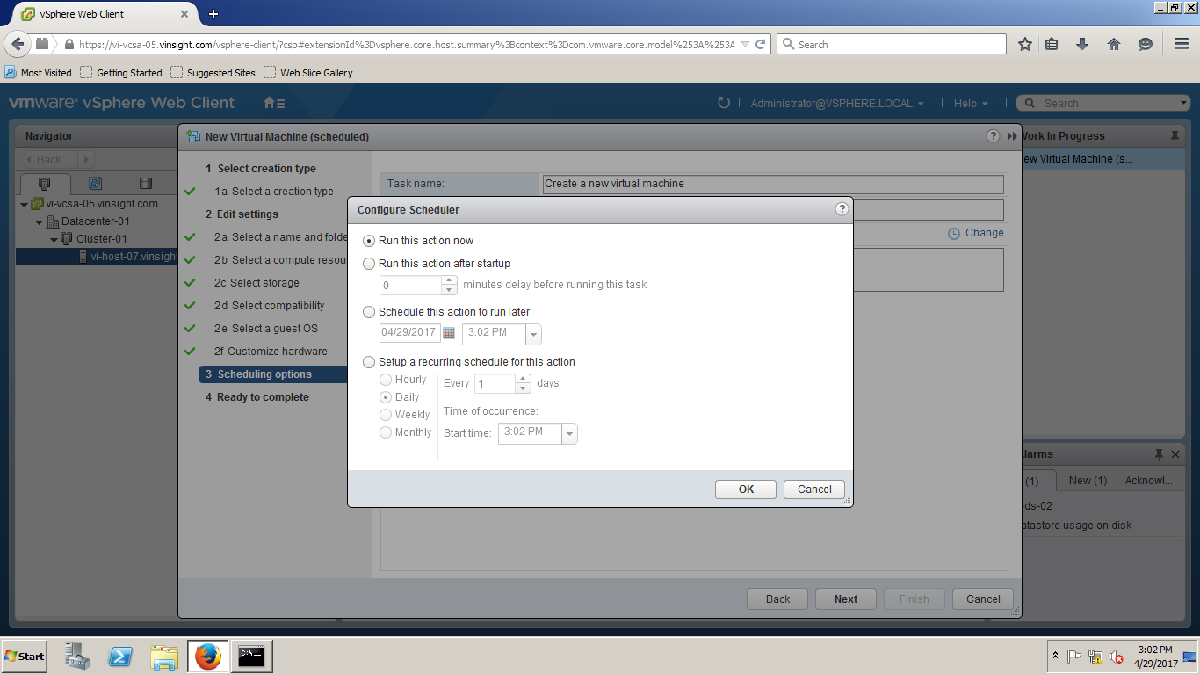

Step 29 - If you want to deploy now, Click on Next.

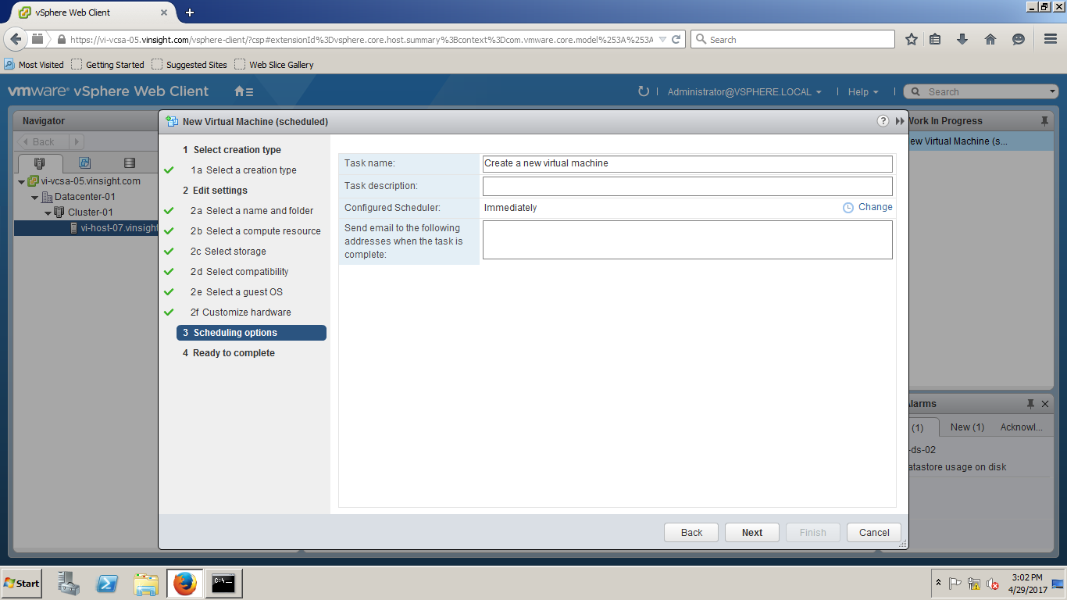

Step 30 - You can review the virtual machine before you deploy the virtual machine. Click on Finish to Complete the New Virtual Machine Wizard.

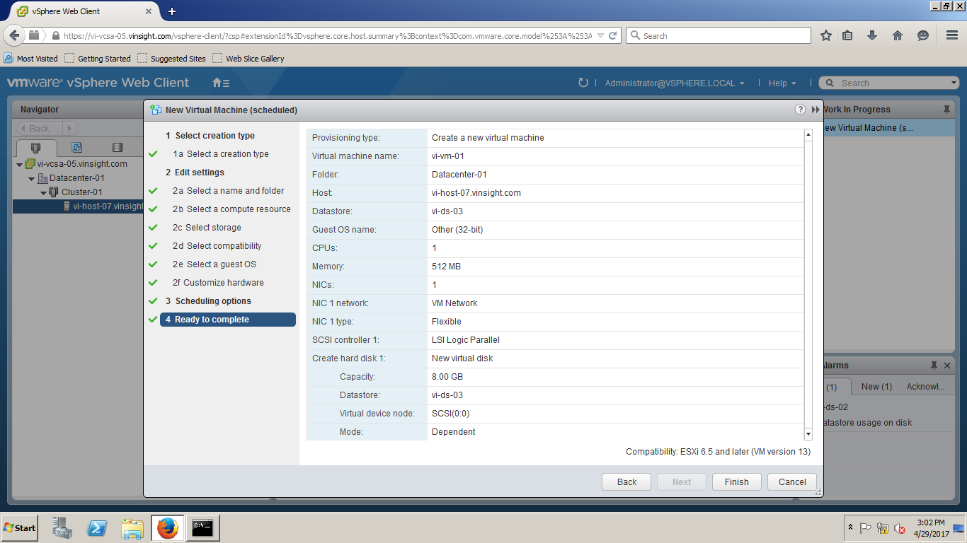

Step 31 - A new Virtual Machine has been deployed in ESXi Host. You can Click on Summary Page and reivew the configuration and status.

