|  |  |  |  |  |  |  |  |  |  |  |  |
| --- | --- | --- | --- | --- | --- | --- | --- | --- | --- | --- | --- |
|  | | **Hope Foundation’s**  **Finolex Academy of Management and Technology, Ratnagiri** | | | | | | | | | |
| **Information Technology Department** | | | | | | | | | |
| Subject name: Cloud Service Design Lab | | | | | | | | Subject Code:ITL603 | | | |
| Class | | TE IT | | Semester – VI (CBCGS) | | | | Academic year: 2018-19 | | | |
| Name of Student | | **Kazi Jawwad A Rahim** | | | | | **QUIZ Score : 08/10** | | | | |
| Roll No | | **27** | | | Assignment/Experiment No. | | | | | 05 | |
| **Title:**  To study IBM blue mix cloud | | | | | | | | | | | |
|  | | | | | | | | | | | |
| **1.Course objectives applicable**  **COB1**.To get familiar with IBM blue mix cloud  **COB3**.To understand various factors for cloud deployment, security aspects at various levels of cloud computing environments. | | | | | | | | | | | |
| **2. Course outcomes applicable:**  **CO3**-Use and Examine different cloud computing services  **CO1** -To define cloud computing and memorize diff. cloud service and deployment models | | | | | | | | | | | |
| **3. Learning Objectives:**   1. To Create an account on IBM Bluemix 2. To study IBM bluemix cloud and its features | | | | | | | | | | | |
| **4. Practical applications of the assignment/experiment:**  Compute and Storage are the major resource groups used by cloud services | | | | | | | | | | | |
| **5. Prerequisites**:   1. Knowledge of Cloud IaaS 2. Internet Access 3. IBM Bluemix Account | | | | | | | | | | | |
| **6. Hardware Requirements**:   1. Internet Access with Browser 2. GitHub account if required   **7. Software Requirements:**  Browser like Chrome, Internet Explorer Edge, VS 2017 Compiler Setup | | | | | | | | | | | |
|  | | | | | | | | | | | |
| **8. Quiz Questions (if any): (Online Exam will be taken separately batchwise, attach the certificate/ Marks obtained)**   1. What is IaaS ? 2. What is the significance of Push command in IBM Bluemix deployment ? | | | | | | | | | | | |
|  | | | | | | | | | | | |
| **9. Experiment/Assignment Evaluation:** | | | | | | | | | | | |
| **Sr. No.** | **Parameters** | | | | | | | | **Marks obtained** | | **Out of** |
| **1** | Technical Understanding (Assessment may be done based on Q & A **or** any other relevant method.) Teacher should mention the other method used - | | | | | | | |  | | 6 |
| **2** | Neatness/presentation | | | | | | | |  | | 2 |
| **3** | Punctuality | | | | | | | |  | | 2 |
| **Date of performance (DOP)** | | |  | | | **Total marks obtained** | | |  | | **10** |
| **Date of checking (DOC)** | | |  | | | **Signature of teacher** | | | | | |

**11. Results:**

Step 1) Log on to <https://ibm.bluemix.com> and register yourself.

Step 2) Verify email

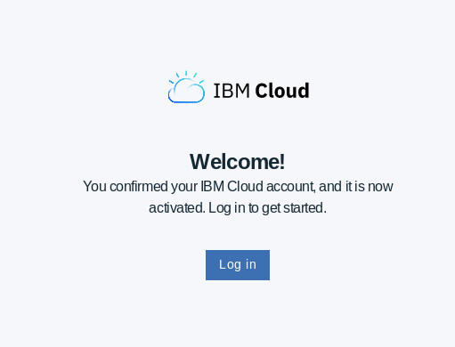

Step 3) And then login to your account

Step 4) After Login, you are in dashbboard

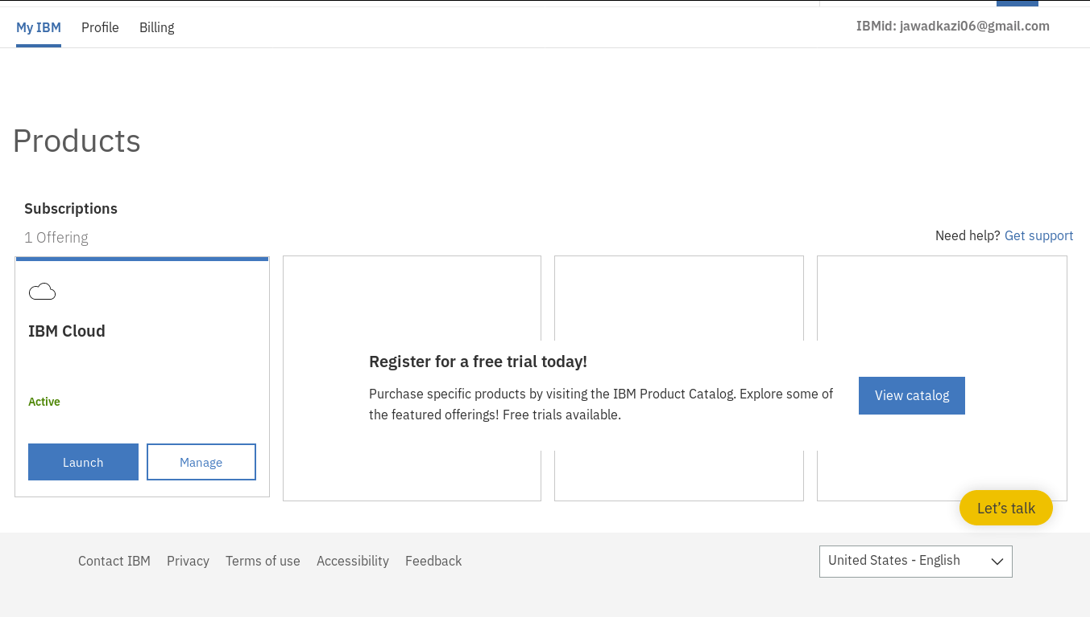

1. IBM Bluemix Dashboard

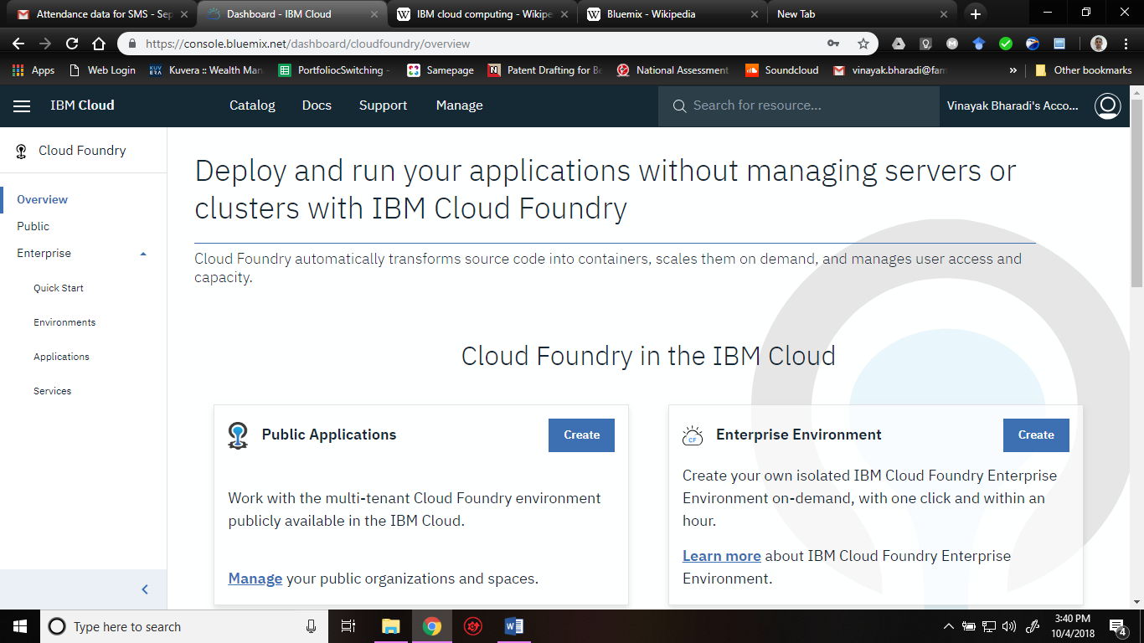

2. Deployment of Web application and its stats

