|  |  |  |  |  |  |  |  |  |  |  |  |
| --- | --- | --- | --- | --- | --- | --- | --- | --- | --- | --- | --- |
|  | | **Hope Foundation’s**  **Finolex Academy of Management and Technology, Ratnagiri** | | | | | | | | | |
| **Information Technology Department** | | | | | | | | | |
| Subject name: Cloud Service Design Lab | | | | | | | | Subject Code: ITL603 | | | |
| Class | | TE IT | | Semester – VI (CBCGS) | | | | Academic year: 2018-19 | | | |
| Name of Student | | **Kazi Jawwad A Rahim** | | | | | **QUIZ Score : 06/10** | | | | |
| Roll No | | **27** | | | Assignment/Experiment No. | | | | | 08 | |
| **Title: To perform analysis of network traffic using wire shark and VM ware workstation** | | | | | | | | | | | |
|  | | | | | | | | | | | |
| **1.Course objectives applicable**  **COB3**. To understand importance of cloud network security.  **COB6**.To understand the concept of network traffic. | | | | | | | | | | | |
| **2. Course outcomes applicable:**  **CO1** -To understand importance of cloud security  **CO6**-To understand the use of network traffic applications | | | | | | | | | | | |
| **3. Learning Objectives:**   1. To analyze network traffic. 2. To understand the use of wire shark for network packet capturing | | | | | | | | | | | |
| **4. Practical applications of the assignment/experiment: In cloud environment** | | | | | | | | | | | |
| **5. Prerequisites**:   1. Prior knowledge of wire shark and VM ware workstation. 2. Internet Access | | | | | | | | | | | |
| **6. Hardware Requirements**:   1. Internet Access with Browser   **7. Software Requirements:**  Browser like Chrome, Internet Explorer Edge | | | | | | | | | | | |
|  | | | | | | | | | | | |
| **8. Quiz Questions (if any): (Online Exam will be taken separately batchwise, attach the certificate/ Marks obtained)**   1. What is network traffic? 2. What is the use of wireshark? | | | | | | | | | | | |
|  | | | | | | | | | | | |
| **9. Experiment/Assignment Evaluation:** | | | | | | | | | | | |
| **Sr. No.** | **Parameters** | | | | | | | | **Marks obtained** | | **Out of** |
| **1** | Technical Understanding (Assessment may be done based on Q & A **or** any other relevant method.) Teacher should mention the other method used - | | | | | | | |  | | 6 |
| **2** | Neatness/presentation | | | | | | | |  | | 2 |
| **3** | Punctuality | | | | | | | |  | | 2 |
| **Date of performance (DOP)** | | |  | | | **Total marks obtained** | | |  | | **10** |
| **Date of checking (DOC)** | | |  | | | **Signature of teacher** | | | | | |

**OUTPUTS:**

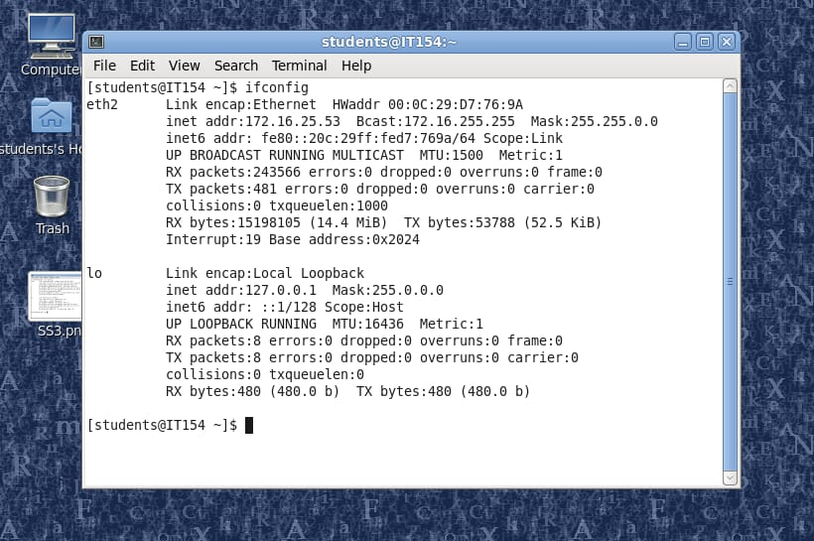

Find the IP address

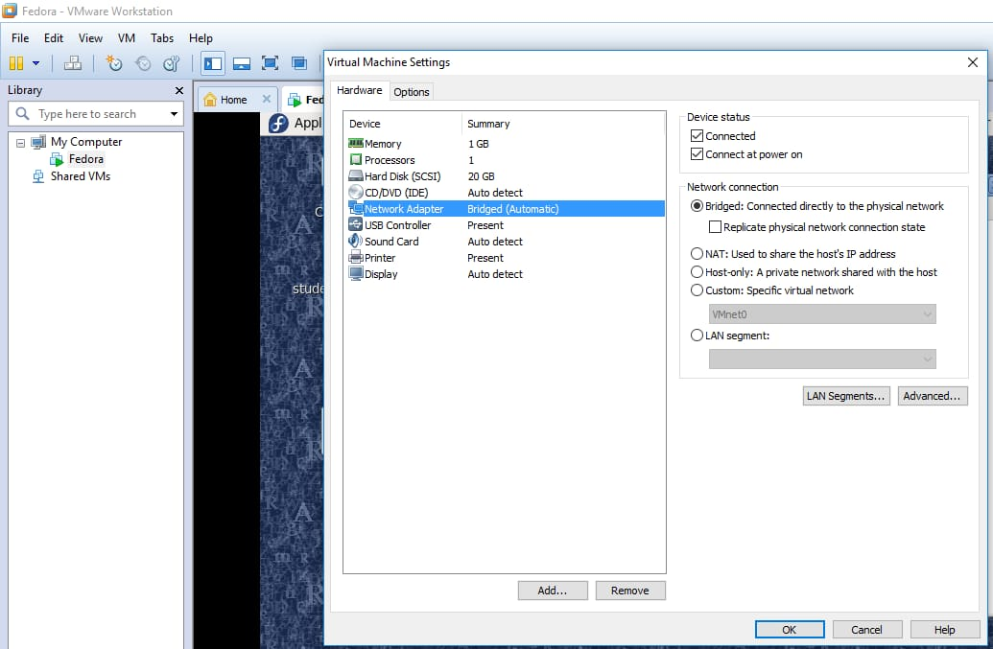

Check the network adapter

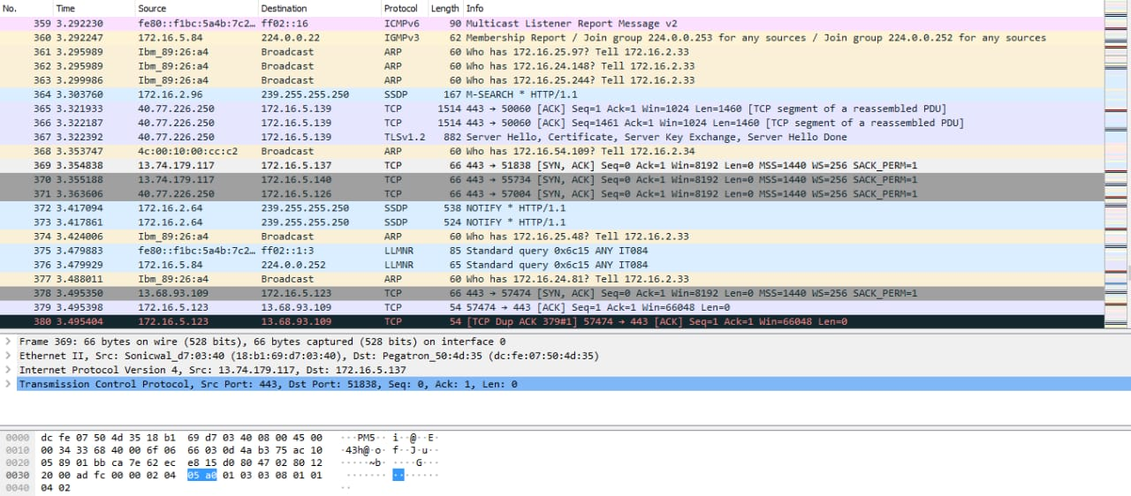

Run the Wireshark to capture packet traffic

**11. Learning Outcomes Achieved**

We have understood the use of wire shark for network packet capturing.

**12. Conclusion:**

1. **Applications of the studied technique in industry**
   1. Use of wire shark in cloud industry for traffic analysis.
2. **Engineering Relevance** 
   1. Importance of cloud security
3. **Skills Developed**
   1. Understanding fundamentals of wire shark software.
   2. Understanding network traffic concept.

**References** :

[1] <https://www.wireshark.org>

[2] <https://en.m.wikipedia.org/wiki/Wireshark>