|  |  |  |  |  |  |  |  |  |  |  |  |
| --- | --- | --- | --- | --- | --- | --- | --- | --- | --- | --- | --- |
|  | | **Hope Foundation’s**  **Finolex Academy of Management and Technology, Ratnagiri** | | | | | | | | | |
| **Information Technology Department** | | | | | | | | | |
| Subject name: Cloud Service Design Lab | | | | | | | | Subject Code: ITL603 | | | |
| Class | | TE IT | | Semester – VI (CBCGS) | | | | Academic year: 2018-19 | | | |
| Name of Student | | **Kazi Jawwad A Rahim** | | | | | **QUIZ Score : 06 / 10** | | | | |
| Roll No | | **27** | | | Assignment/Experiment No. | | | | | 09 | |
| **Title: Case study on Amazon Web Services** | | | | | | | | | | | |
|  | | | | | | | | | | | |
| **1.Course objectives applicable**  **COB1**. To understand use of Amazon Web Services.  **COB2**. To understand features of AWS. | | | | | | | | | | | |
| **2. Course outcomes applicable:**  **CO1** -To understand services provided by AWS.  **CO2**-To understand the use of AWS in different applications | | | | | | | | | | | |
| **3. Learning Objectives:**   1. To understand services provided by AWS. 2. To understand the use of AWS in practical applications. | | | | | | | | | | | |
| **4. Practical applications of the assignment/experiment: In cloud environment**  Content delivery, application hosting, storage. | | | | | | | | | | | |
| **5. Prerequisites**:   1. Prior knowledge of cloud. | | | | | | | | | | | |
| **6. Hardware Requirements**:   1. Internet Access with Browser   **7. Software Requirements:**  Browser like Chrome, Internet Explorer Edge | | | | | | | | | | | |
|  | | | | | | | | | | | |
| **8. Quiz Questions (if any): (Online Exam will be taken separately batch wise, attach the certificate/ Marks obtained)**   1. What is AWS? 2. What are services provided by AWS? | | | | | | | | | | | |
|  | | | | | | | | | | | |
| **9. Experiment/Assignment Evaluation:** | | | | | | | | | | | |
| **Sr. No.** | **Parameters** | | | | | | | | **Marks obtained** | | **Out of** |
| **1** | Technical Understanding (Assessment may be done based on Q & A **or** any other relevant method.) Teacher should mention the other method used - | | | | | | | |  | | 6 |
| **2** | Neatness/presentation | | | | | | | |  | | 2 |
| **3** | Punctuality | | | | | | | |  | | 2 |
| **Date of performance (DOP)** | | |  | | | **Total marks obtained** | | |  | | **10** |
| **Date of checking (DOC)** | | |  | | | **Signature of teacher** | | | | | |

The Kellogg Company Case Study



**About the Kellogg Company**

[The Kellogg Company](http://www.kelloggs.com/en_US/home.html) was founded in 1898 when founder W. K. Kellogg and his brother, Dr. John Harvey Kellogg, accidentally flaked wheat berry—a mistake that would result in the recipe for Kellogg’s Corn Flakes. The company, which is headquartered in Battle Creek, Michigan, now operates in 180 countries, providing ready-to-eat cereals and other food products. Its 2013 reported net sales totaled $14.8 billion. Kellogg’s brands include Froot Loops, Frosted Flakes, Special K, Rice Krispies, Pop Tarts, Eggo Waffles, Nutri-Grain Bars, and of course, Kellogg’s Corn Flakes.

**The Challenge**

Margins are tight in the ready-to-eat cereal industry. For a company like Kellogg, approximately a third of its annual revenue is spent on promotional costs or trade spend: every dollar spent on coupons and special offers, promotions for special pricing, sponsorships, even the location each brand occupies on the grocery-store shelf. “Any improvements we make to trade spend go straight to our bottom line,” says Stover McIlwain, Senior Director of IT Infrastructure Engineering at Kellogg. “If we improve trade spend by just 1 percent, that’s $50 million dollars.” The company keeps a close eye on its trade spend, analyzing large volumes of data and running complex simulations to predict which promotional activities will be the most effective. Kellogg had been using a traditional relational database on premises for data analysis and modeling, but by 2013, that solution was no longer keeping up with the pace of demand. Each day, Kellogg needed to run dozens of complex data simulations on things like TV ad spend, digital marketing, coupon campaigns and other promotions, sales commissions, display and shelving costs—but its system only had the capacity to run just one simulation a day. “Margins are very tight in our industry, and even slight changes in trade spend can swing market share,” McIlwain says. “Revenue growth is flat in some of our categories, so we need to be very agile to stay competitive. We needed to eliminate waste and invest more in the trade spend that drives faster time to market and greater revenue.” It was clear that Kellogg needed to move away from its traditional on-premises infrastructure.

**Why Amazon Web Services**

Kellogg needed a solution that could accommodate terabytes of data, scale according to infrastructure needs, and stay within its budget. The company became interested in an SAP solution called Accelerated Trade Promotion Planning, which is powered by SAP HANA, SAP’s in-memory database technology platform. Amazon Web Services (AWS) offered a fully SAP-certified HANA environment on a public cloud platform. Because SAP works on the AWS Cloud, the company knew it could achieve the speed, performance, and agility it required without making a significant investment in physical hardware. Kellogg decided to start immediately with test and development environments for its US operations. The company is now running the SAP Accelerated Trade Promotion Management (TPM) solution, powered by SAP HANA and leveraging multiple AWS instance types for both the SAP application and HANA database layers. These [Amazon Elastic Compute Cloud](https://aws.amazon.com/ec2/) (Amazon EC2) instances process 16 TB of sales data weekly from promotions in the US, modeling dozens of data simulations a day. The company also uses [Amazon Virtual Private Cloud](https://aws.amazon.com/vpc/) (Amazon VPC), which is connected directly to the Kellogg data centers to allow access to SAP TPM directly for employees who are on the company network. [Amazon Simple Storage Service](https://aws.amazon.com/s3/) (Amazon S3) is used for data backups, including HANA, and [Amazon Elastic Block Store](https://aws.amazon.com/ebs/) (Amazon EBS) provisioned IOPS (P-IOPS) volumes for storage. The company logs events using [AWS Identity and Access Management](https://aws.amazon.com/iam/) (AWS IAM). Kellogg uses [Amazon CloudWatch](https://aws.amazon.com/cloudwatch/) for monitoring, which helps the company allocate costs to each department based on their individual infrastructure use. “CloudWatch helps our people make better decisions around the capacity they need, so that they can avoid waste,” McIlwain says. “We were never able to do that with our on-premises infrastructure. AWS breaks down usage and cost to such a granular level that we can identify which costs come from which department, like a toll model.” Costs and benefits of this IT service can now be aligned so that Kellogg can assess the true return on investment.

For high availability, Kellogg leverages multiple AWS Availability Zones (AZs) without the additional cost of maintaining a separate datacenter.

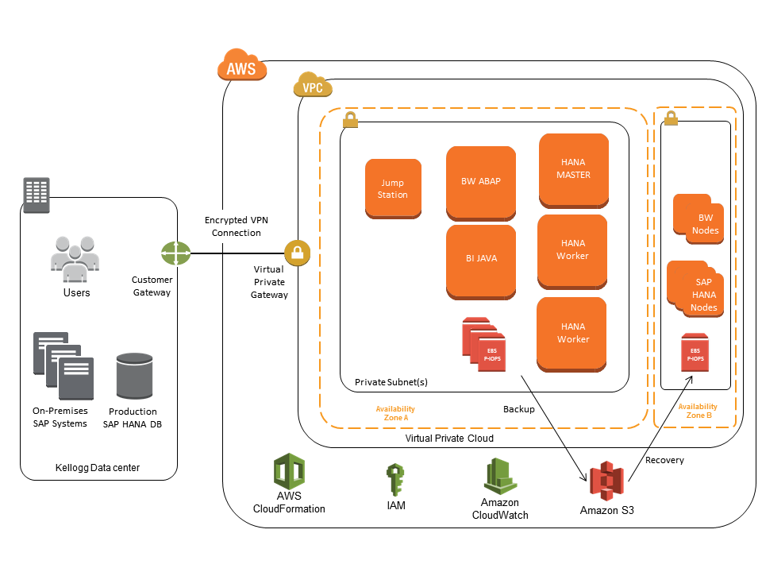

Figure 1. Kellogg SAP HANA Deployment Architecture on AWS

**The Benefits**

Kellogg estimates that it will save close to a million dollars in software, hardware, and maintenance over the next 5 years, just by using AWS in its test and development environments. “Using AWS saves us more than $900,000 and lets us run dozens of data simulations a day so we can reduce trade spend. It’s a win-win, and a pretty compelling business case for moving to the cloud,” McIlwain says. By using AWS, the company is also able to be more agile. Instead of having to wait 30 days to make changes to its trade spend analysis system, the company can spin up instances immediately to perform the necessary data simulations (or calculations). “The speed and agility that using AWS gives us lets us develop and deliver business services much more quickly than before, so that we can keep one step ahead of the market. Our staff can deploy instances 90 percent faster than with our previous on-premises solution,” McIlwain says. “The AWS Cloud drives a lot of business benefits for Kellogg.” Kellogg engineers liked the accessibility and familiarity of the AWS platform, which enabled them to easily apply their existing knowledge and infrastructure skills to the AWS Cloud. In addition, by using AWS, the IT team’s internal customers can now self-fund IT projects—saving the IT team from having to budget for projects from other departments and driving more efficient use of resources. “AWS allows me to do the unprecedented: bill Sales directly for the infrastructure they’re using, instead of the hosting costs being lost in the overall Infrastructure annual budget,” McIlwain says. Kellogg is pleased that AWS supports the option to leverage existing HANA licenses that the company previously purchased from SAP. It allows the team to quickly provision instances and avoid having to repeatedly install and configure the software. The company uses [AWS Support](https://aws.amazon.com/premiumsupport/), Business Level, and training, as well; one engineer already has successfully achieved the [AWS Certified Architect](https://aws.amazon.com/certification/) certification. “The engineering support included training and documentation,” McIlwain says. “It exceeded expectations and became a key differentiator and added benefit in working with AWS.” Kellogg is using AWS for its US operations, and plans to expand worldwide in 2014 — which should increase the amount of data being processed from 16 TB to 50 TB. “By using AWS, we have happier customers and we work faster, cheaper, and better,” McIlwain says.

**Amazon Web Service (AWS)**

Amazon Web Services is a subordinate of Amazon that provides cloud computing platform to evolve an organization. AWS has always been a building block for those organization as they are used to create and develop any type of application over the cloud. Simplified implementation, high security, elasticity, scalability, and flexibility are some of the known advantages of Amazon Web Services. Additionally, Amazon has different services that cater to fulfill the requirements of different domains. Some of the most widely used domains of Amazon Web Services are Compute, Storage, Database, Migration, Network and Content Delivery, Management Tools, and Security and Identity Compliance. Talking about the endless services offered by Amazon Web Services with limitless possibilities, we have mentioned these 5 trending services that can be implemented on applications or database over AWS cloud to perfectly fit into the project.

*Services offered by AWS*

### **1. Amazon Elastic Cloud Compute (EC2)**

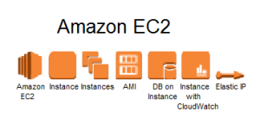

The Amazon EC2 service comes under the compute domain and it provides services that help to compute workloads. Amazon EC2 web interface is used to reduce the expensive physical servers by creating virtual machines. Also, they help in managing different features of the virtual servers such as security, ports, and storage. Amazon EC2 is highly preferable while creating a virtual server within a few minutes with just a few clicks according to the user’s operating system conveniently. It offers resizable compute capacity in the cloud. This helps a lot to focus more on the project rather than the server maintenance.

### **2. Amazon S3 (Simple Storage Service)**

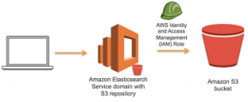

Amazon S3 is categorized under storage domain that provides data storage over the Internet services. Primarily, S3 stores data over the cloud in the form of objects. Amazon S3 stores the data with high security because of its improved infrastructure. The information is distributed over different physical regions and has a high-quality integration. This prevents the data from getting lost and helps to retrieve stored data irrespective of time and space via the Internet. Amazon S3 is highly available so that users can access their data just by one click with minimum or zero retrieving time.

### **3. Amazon Virtual Private Cloud (VPC)**

### https://www.i2k2.com/wp-content/uploads/2018/08/Amazon-Virtual-Private-Cloud-VPC-i2k2-300x243.png

Amazon VPC falls under the Networking domain of AWS which is used to isolate the network infrastructure of user’s computer. Every Amazon account holds a unique virtual network that protects the information from being accessed by others. These networks are logically isolated from other virtual networks in AWS clouds. This makes the user information risk-free in the AWS cloud.

### **4. Amazon CloudFront**

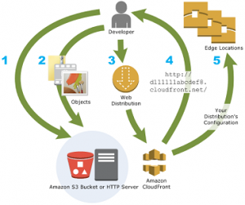

Amazon CloudFront represents the delivery domain that is used to deliver the content with great speed and reduced latency. Amazon CloudFront is used to connect with other AWS services and to help the developers to send the content to the end-users in a seamless manner. AWS CloudFront is managing all the users content in an effective manner via the Global Content Delivery Service.

### **5. Amazon Relational Database Services (RDS)**

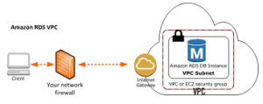

Amazon RDS comes under the Database domain of Amazon Web Services and is used to handle database related workloads. The RDS helps the users to design and manage the relational database in the cloud which stores the complex data of the infrastructure. Earlier RDs used to support MySQL and now it also supports Oracle, Microsoft SQL, and MariaDB. It reduces the operational costs and leverages the database server from maintenance and support.

**11. Learning Outcomes Achieved**

Understood services provided by AWS and its practical applications.

**12. Conclusion:**

1. **Applications of the studied technique in industry**

To deploy or host applications on AWS platform.

1. **Engineering Relevance** 
   1. Used for storage, application hosting, etc.
2. **Skills Developed**
   1. Understanding fundamentals of AWS.

**References**:

[1] <https://www.aws.amazon.com>

[2] <https://www.en.wikipedia.com/wiki/AmazonAWS>