|  |  |  |  |  |  |  |  |  |  |  |  |
| --- | --- | --- | --- | --- | --- | --- | --- | --- | --- | --- | --- |
|  | | **Hope Foundation’s**  **Finolex Academy of Management and Technology, Ratnagiri** | | | | | | | | | |
| **Information Technology Department** | | | | | | | | | |
| Subject name: DevOps Lab | | | | | | | | Subject Code: ITL803 | | | |
| Class | | BE IT | | Semester – VIII (CBCGS) | | | | Academic year: 2019-20 | | | |
| Name of Student | | **Kazi Jawwad A Rahim** | | | | | **QUIZ Score :** | | | | |
| Roll No | | **28** | | | Assignment/Experiment No. | | | | | 01 | |
| **Title: To Understand the concept of DevOps with related technologies** | | | | | | | | | | | |
|  | | | | | | | | | | | |
| **1.Lab objectives applicable**  **LOB1.**To understand the concept of DevOps with associated technologies and methodologies. | | | | | | | | | | | |
| **2. Lab outcomes applicable:**  **LO2** -Students understood the technologies involved in DevOps process. | | | | | | | | | | | |
| **3. Learning Objectives:**   1. To understand concept of devops and its benefits 2. To know the open source tools to achieve the benefits of DevOps culture | | | | | | | | | | | |
| **4. Practical applications of the assignment/experiment: To get the faster release of software and continuous feedback,its important to know the related technologies** | | | | | | | | | | | |
| **5. Prerequisites**:   1. Knowledge of waterfall model in software development 2. Internet Access 3. Knowledge linux operating system | | | | | | | | | | | |
| **6. Hardware Requirements**:   1. Internet Access with Browser 2. Access to root privilegees   **7. Software Requirements:**  Browser like Chrome, Internet Explorer Edge | | | | | | | | | | | |
|  | | | | | | | | | | | |
| **8. Quiz Questions (if any): (Online Exam will be taken separately batchwise, attach the certificate/ Marks obtained)**   1. What is DevOps ? 2. What are the devops development life cycles? 3. How the devops is different than agile technology? | | | | | | | | | | | |
|  | | | | | | | | | | | |
| **9. Experiment/Assignment Evaluation:** | | | | | | | | | | | |
| **Sr. No.** | **Parameters** | | | | | | | | **Marks obtained** | | **Out of** |
| **1** | Technical Understanding (Assessment may be done based on Q & A **or** any other relevant method.) Teacher should mention the other method used - | | | | | | | |  | | 6 |
| **2** | Neatness/presentation | | | | | | | |  | | 2 |
| **3** | Punctuality | | | | | | | |  | | 2 |
| **Date of performance (DOP)** | | |  | | | **Total marks obtained** | | |  | | **10** |
| **Date of checking (DOC)** | | |  | | | **Signature of teacher** | | | | | |

**10.Theory-.**

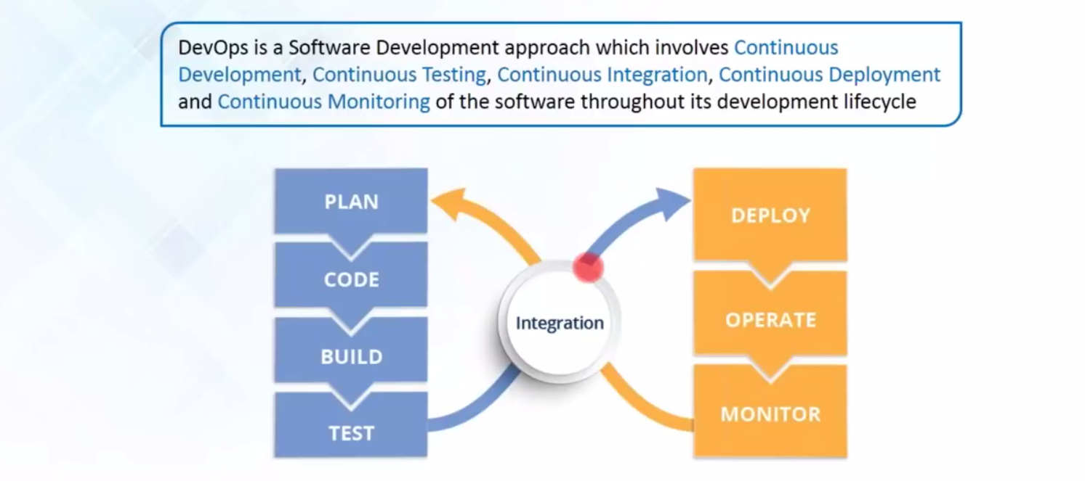

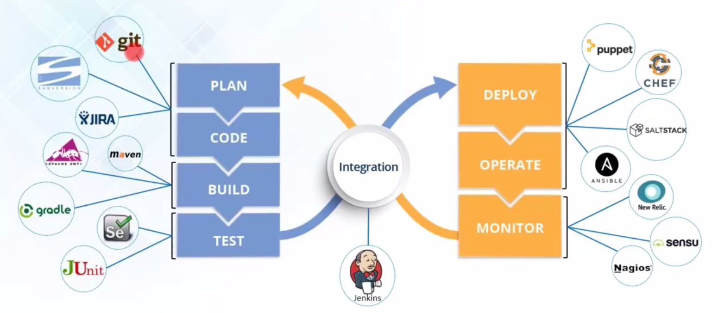

**References** :

[IBM DevOps: Shorten releases, improve reliability, and stay ahead of the competition](https://www.ibm.com/cloud/devops)

* Read the eBook, [DevOps for Dummies](https://www.ibm.com/account/reg/signup?formid=urx-30746)
* [Try IBM UrbanCode Velocity](https://www.ibm.com/account/reg/signup?formid=urx-36281) free for 60 days