|  |  |  |  |  |  |  |  |  |  |  |  |
| --- | --- | --- | --- | --- | --- | --- | --- | --- | --- | --- | --- |
|  | | **Hope Foundation’s**  **Finolex Academy of Management and Technology, Ratnagiri** | | | | | | | | | |
| **Information Technology Department** | | | | | | | | | |
| Subject name: DevOps Lab | | | | | | | | Subject Code: ITL803 | | | |
| Class | | BE IT | | Semester – VIII (CBCGS) | | | | Academic year: 2019-20 | | | |
| Name of Student | | **Kazi Jawwad A Rahim** | | | | | **QUIZ Score :** | | | | |
| Roll No | | **28** | | | Assignment/Experiment No. | | | | | 02 | |
| **Title: Install and configure Jenkins with necessary plugin** | | | | | | | | | | | |
|  | | | | | | | | | | | |
| **1.Course objectives applicable**  LOB1:To be familiarized with Jenkins, which is used to build & test software Applications & Continuous integration in DevOps environment. | | | | | | | | | | | |
| **2. Course outcomes applicable:**  LO2:Students understood the installations of Jenkins and its uses | | | | | | | | | | | |
| **3. Learning Objectives:**   1. To understand the CI/CD tool called Jenkins 2. To know the installations of Jenkins on Fedora 30 os. | | | | | | | | | | | |
| **4. Practical applications of the assignment/experiment: To automate the several tasks such as automatic building the code ,deploying the code and notifying the developer about build status via sms/email etc** | | | | | | | | | | | |
| **5. Prerequisites**:   1. Familar with Linux os 2. Internet Access 3. Knowledge of CI/CD | | | | | | | | | | | |
| **6. Hardware Requirements**:   1. Internet Access with Browser 2. Access to root privileges   **7. Software Requirements:**  Browser like Chrome, Internet Explorer Edge | | | | | | | | | | | |
|  | | | | | | | | | | | |
| **8. Quiz Questions (if any): (Online Exam will be taken separately batchwise, attach the certificate/ Marks obtained)**   1. What is CI/CD? 2. What are the different CI/CD tools ? 3. What is the Jenkins? | | | | | | | | | | | |
|  | | | | | | | | | | | |
| **9. Experiment/Assignment Evaluation:** | | | | | | | | | | | |
| **Sr. No.** | **Parameters** | | | | | | | | **Marks obtained** | | **Out of** |
| **1** | Technical Understanding (Assessment may be done based on Q & A **or** any other relevant method.) Teacher should mention the other method used - | | | | | | | |  | | 6 |
| **2** | Neatness/presentation | | | | | | | |  | | 2 |
| **3** | Punctuality | | | | | | | |  | | 2 |
| **Date of performance (DOP)** | | |  | | | **Total marks obtained** | | |  | | **10** |
| **Date of checking (DOC)** | | |  | | | **Signature of teacher** | | | | | |

**11. Installation Steps / Performance Steps –**

java -jar jenkins.war

1. The initial screen page will ask about the plugin options:

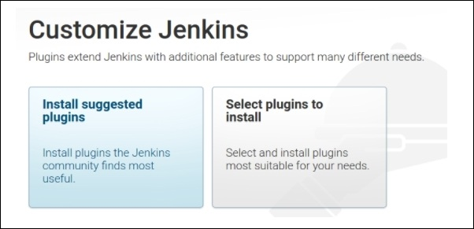

2. Plugins will be installed as per the selected configuration in the preceding

option:

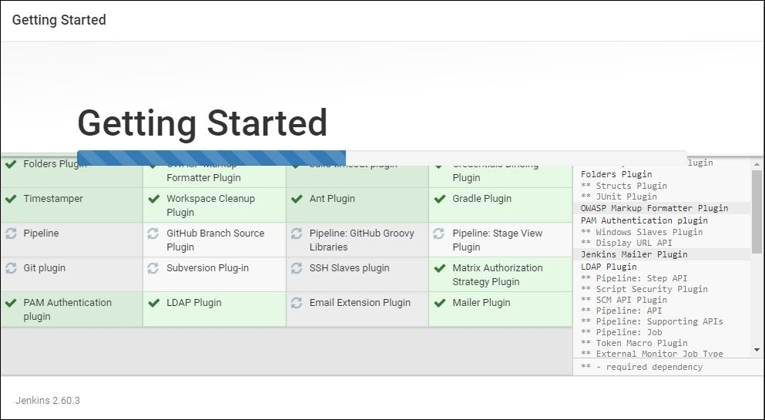

3. After successful installation, the following admin credential creation page

will pop up:

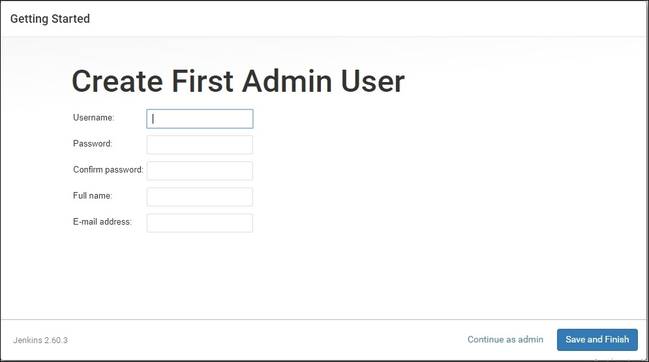

4. Accessing Jenkins: After successful installation, Jenkins can be accessed

through a web browser from your local machine as follows:http://localhost:8080

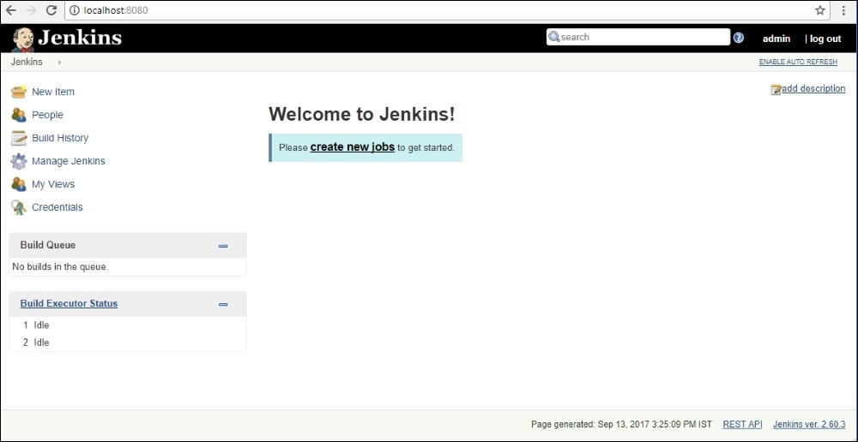

5. The Manage Jenkins option in the dashboard will provide various options

to configure various parameters

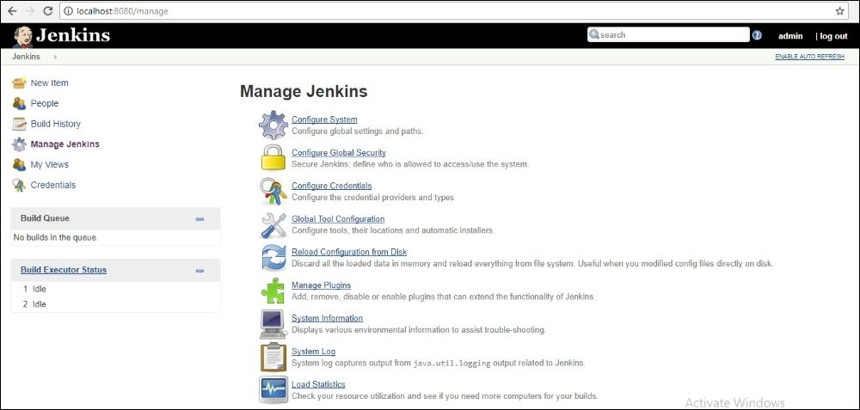

**14.References:**

1.https://linuxconfig.org/how-to-install-jenkins-on-redhat-8

**2.https://www.ibm.com/cloud/learn/devops-a-complete-guide#toc-what-is-de-pMY50L7C**