|  |  |  |  |  |  |  |  |  |  |  |  |
| --- | --- | --- | --- | --- | --- | --- | --- | --- | --- | --- | --- |
|  | | **Hope Foundation’s**  **Finolex Academy of Management and Technology, Ratnagiri** | | | | | | | | | |
| **Information Technology Department** | | | | | | | | | |
| Subject name: DevOps Lab | | | | | | | | Subject Code: ITL803 | | | |
| Class | | BE IT | | Semester – VIII (CBCGS) | | | | Academic year: 2019-20 | | | |
| Name of Student | | **Kazi Jawwad A Rahim** | | | | | **QUIZ Score :** | | | | |
| Roll No | | **28** | | | Assignment/Experiment No. | | | | | 03 | |
| **Title: Integrating Jenkins to the GitHub to automate the jobs with every commit on**  **GitHub** | | | | | | | | | | | |
|  | | | | | | | | | | | |
| **1.Lab objectives applicable**  LOB1:To be familiarized with Jenkins, which is used to build & test software Applications & Continuous integration in DevOps environment. | | | | | | | | | | | |
| **2. Lab outcomes applicable:**  LO2:Students understood the installations of Jenkins and its uses | | | | | | | | | | | |
| **3. Learning Objectives:**   1. To understand the integration of Jenkins with GitHub 2. To understand the working of GitHub | | | | | | | | | | | |
| **4. Practical applications of the assignment/experiment: Adding the developed source code to the central repository for safety reasons and also to perform auto building the code from different developer** | | | | | | | | | | | |
| **5. Prerequisites**:   1. GitHub account 2. Internet Access 3. GitHub commands | | | | | | | | | | | |
| **6. Hardware Requirements**:   1. Internet Access with Browser 2. Access to root privileges   **7. Software Requirements:**  Jenkins and git utility | | | | | | | | | | | |
|  | | | | | | | | | | | |
| **8. Quiz Questions (if any): (Online Exam will be taken separately batchwise, attach the certificate/ Marks obtained)**   1. What GitHub? 2. What are the commands to push code to GitHub ? 3. How to clone any gitHub repository? | | | | | | | | | | | |
|  | | | | | | | | | | | |
| **9. Experiment/Assignment Evaluation:** | | | | | | | | | | | |
| **Sr. No.** | **Parameters** | | | | | | | | **Marks obtained** | | **Out of** |
| **1** | Technical Understanding (Assessment may be done based on Q & A **or** any other relevant method.) Teacher should mention the other method used - | | | | | | | |  | | 6 |
| **2** | Neatness/presentation | | | | | | | |  | | 2 |
| **3** | Punctuality | | | | | | | |  | | 2 |
| **Date of performance (DOP)** | | |  | | | **Total marks obtained** | | |  | | **10** |
| **Date of checking (DOC)** | | |  | | | **Signature of teacher** | | | | | |

**11. Installation Steps / Performance Steps –**

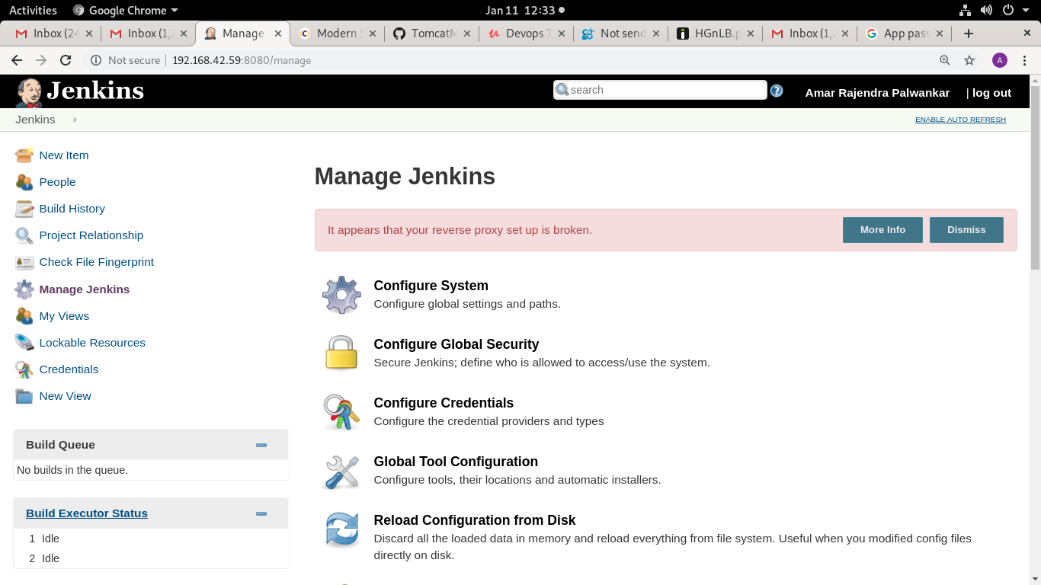

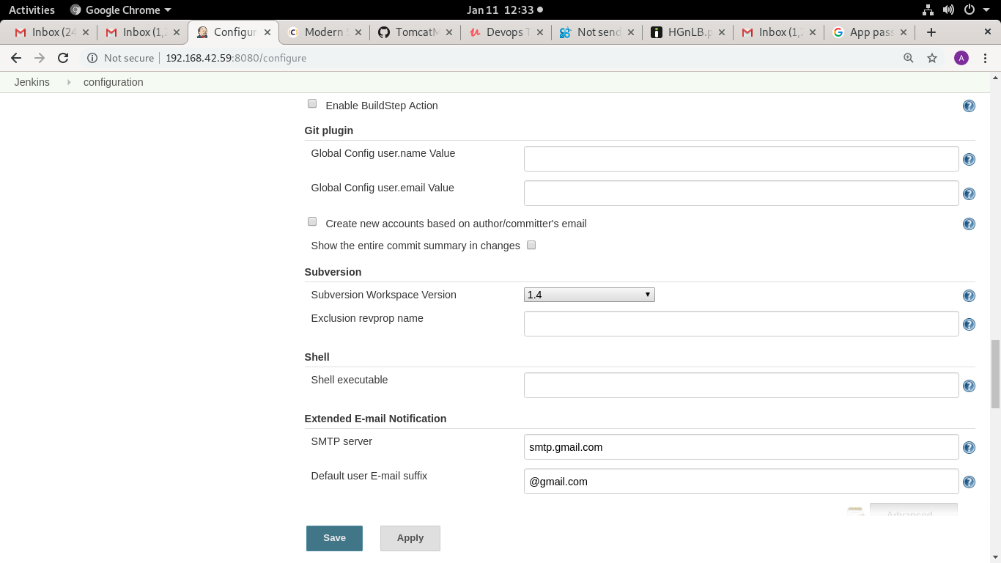

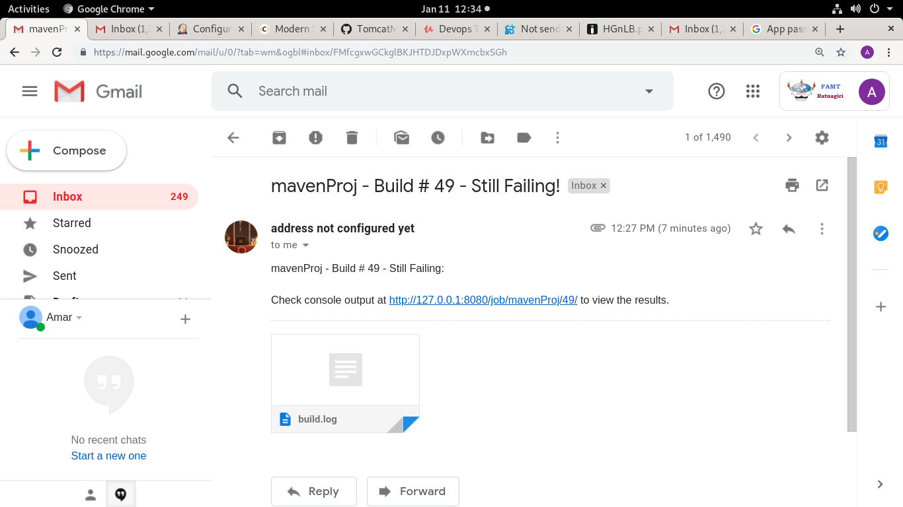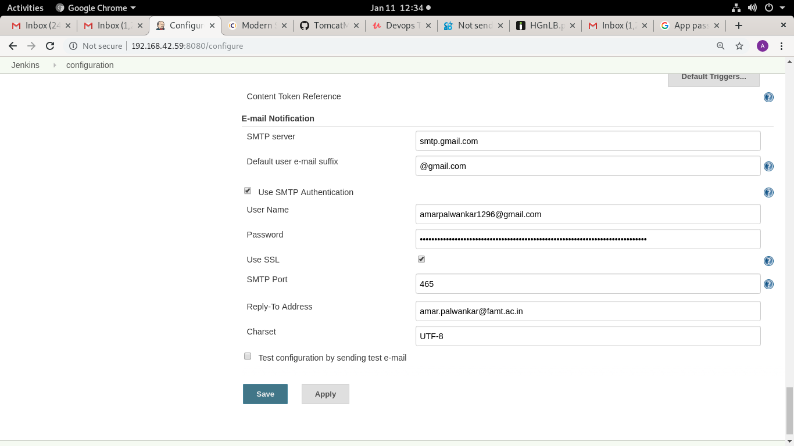

**14.References:**

1.https://kinsta.com/knowledgebase/what-is-github/

2.https://www.blazemeter.com/blog/how-to-integrate-your-github-repository-to-your-jenkins-project/