Decission Tree

1. Vote.arff
2. Without removing attributes

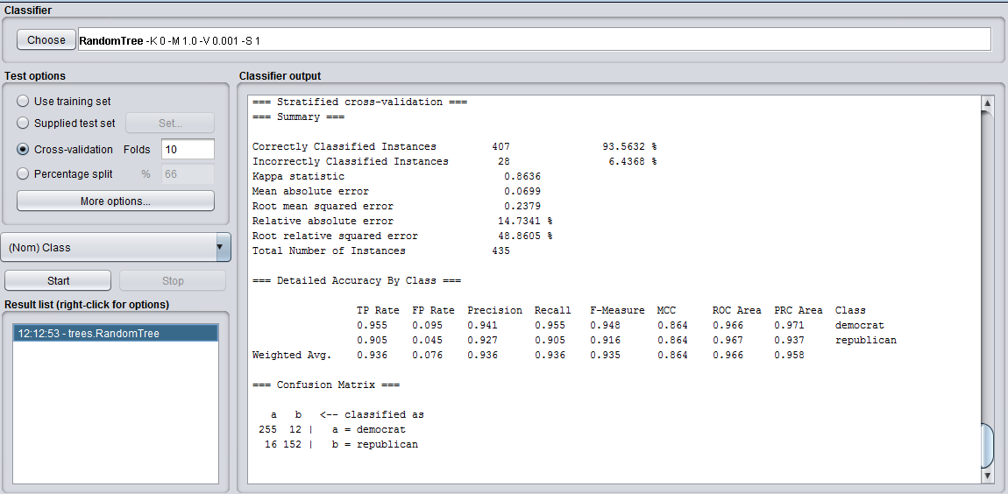

Accuracy = 93.56 %

Precision = 255/(255+16) = 0.94

Recall = 255/(255+12) = 0.96

1. After removing three attributes (mix-missive, immigration, crime)

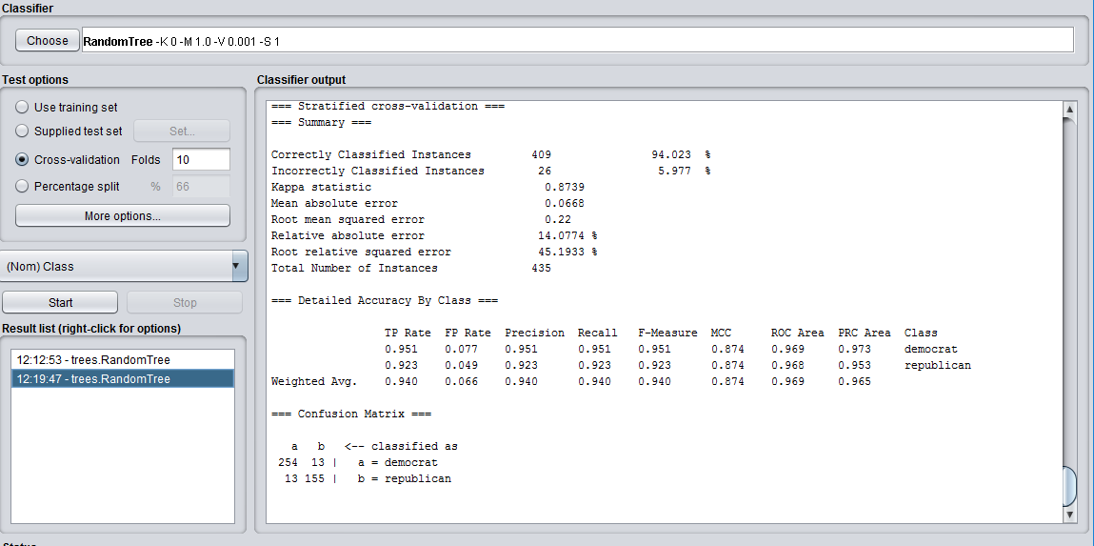

Accuracy = 94.023%

Precision = 254/(254+13) = 0.95

Recall = 254/(254+13) = 0.95

1. Diabetes.arff
2. Without removing attributes

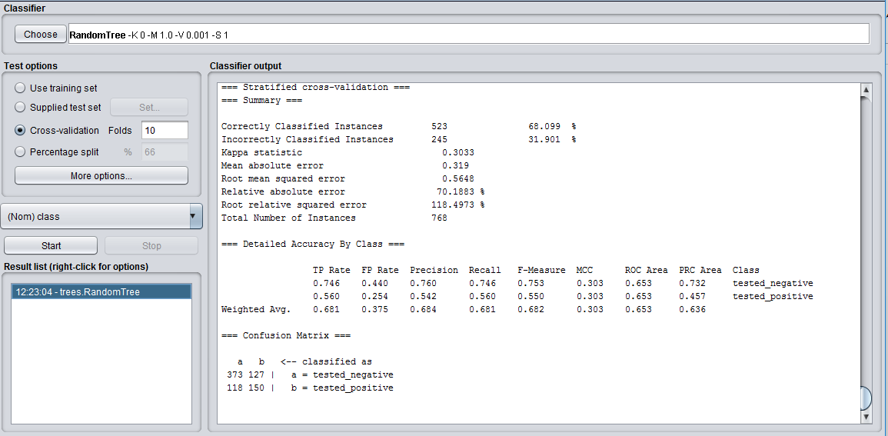

Accuracy = 68.099%

Precision = 373/(373+118) = 0.76

Recall = 373/(373+127) = 0.746

1. After removing three attributes (press, skin, mass)

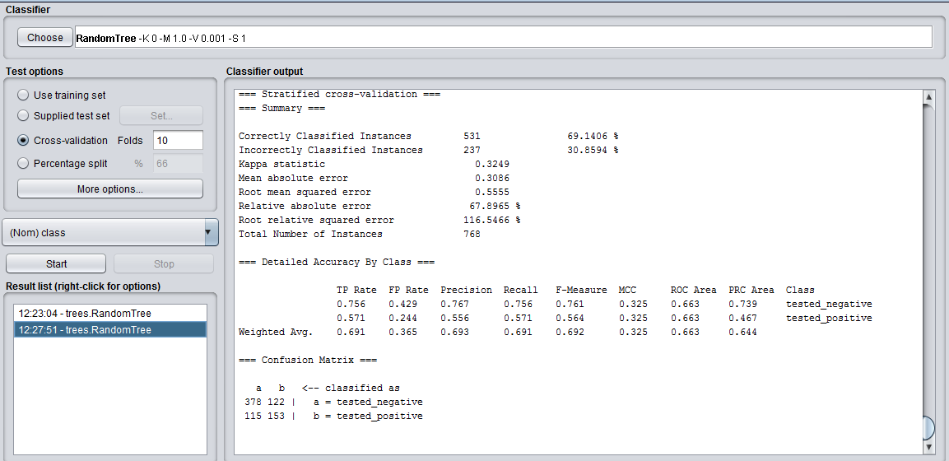

Accuracy = 69.14%

Precision = 378/(378+115) = 0.77

Recall = 378/(378+122) = 0.76

Random Forest

1. Vote.arff
2. Without removing attributes

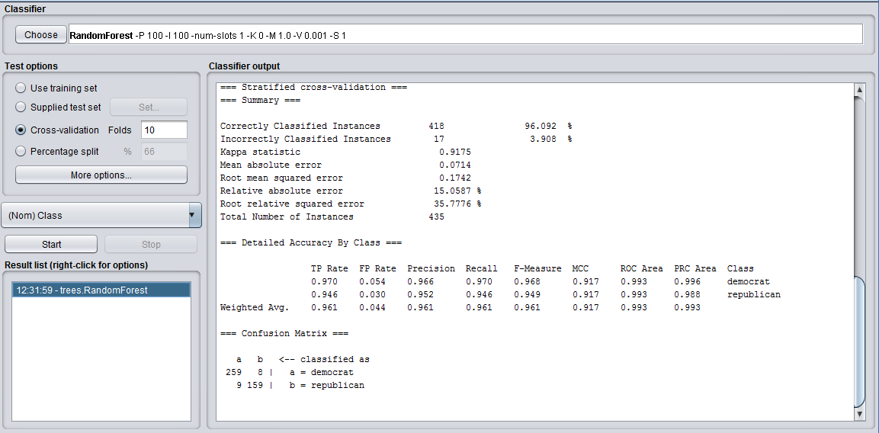

Accuracy = 96.092 %

Precision = 259/(259+9) = 0.97

Recall = 259/(259+8) = 0.97

1. After removing three attributes (education-spending, superfund-right-to-sue, crime)

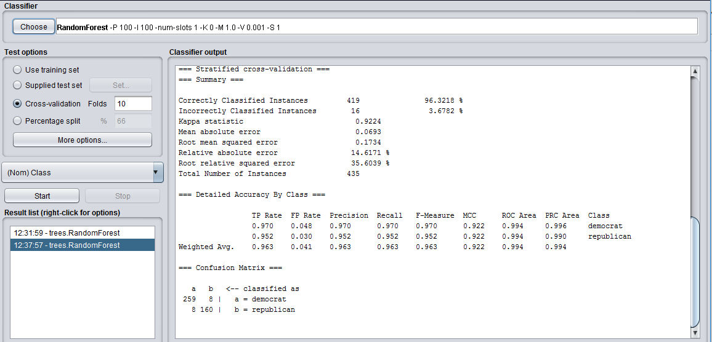

Accuracy = 96.3218%

Precision = 259/(259+8) = 0.97

Recall = 259/(259+8) = 0.97

1. Diabetes.arff
2. Without removing attributes

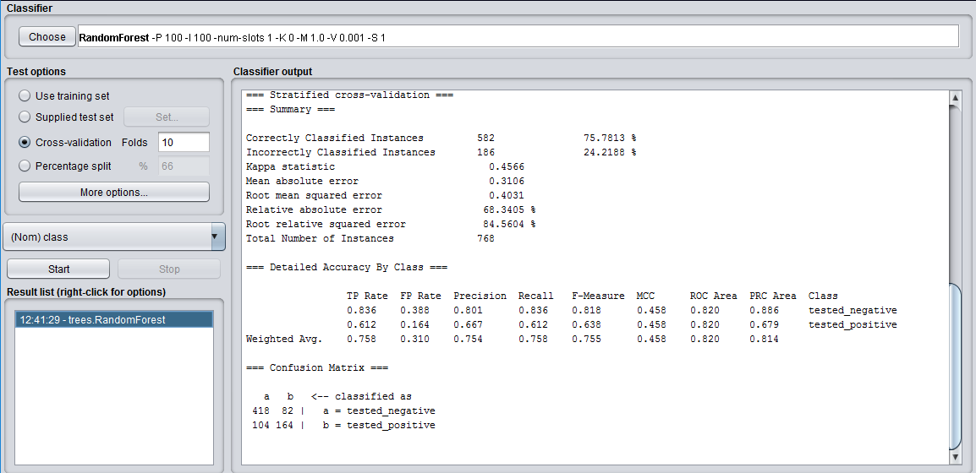

Accuracy = 75.78%

Precision = 418/(418+108) = 0.795

Recall = 418/(418+82) = 0.836

1. After removing two attributes (preg, insu)

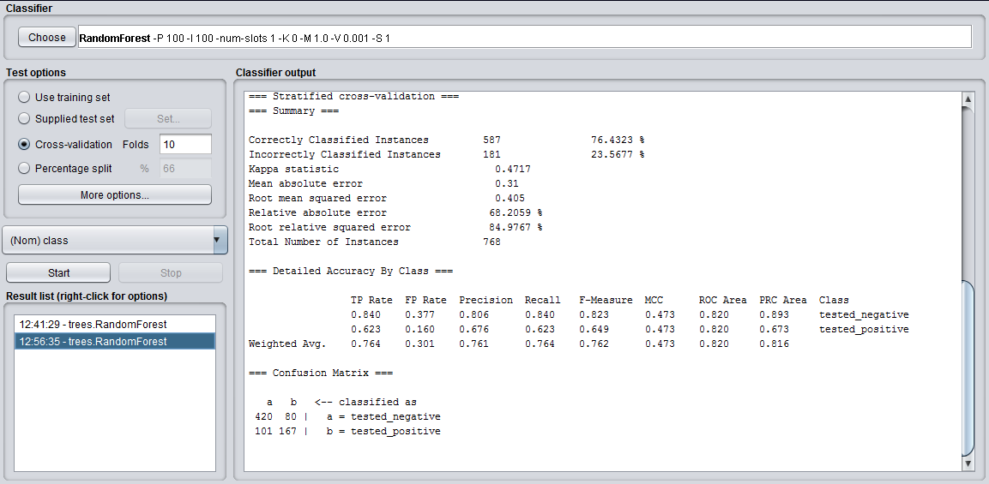

Accuracy = 76.43%

Precision = 420/(420+101) = 0.81

Recall = 420/(420+80) = 0.84

Naïve Bayes

1. Vote.arff
2. Without removing attributes

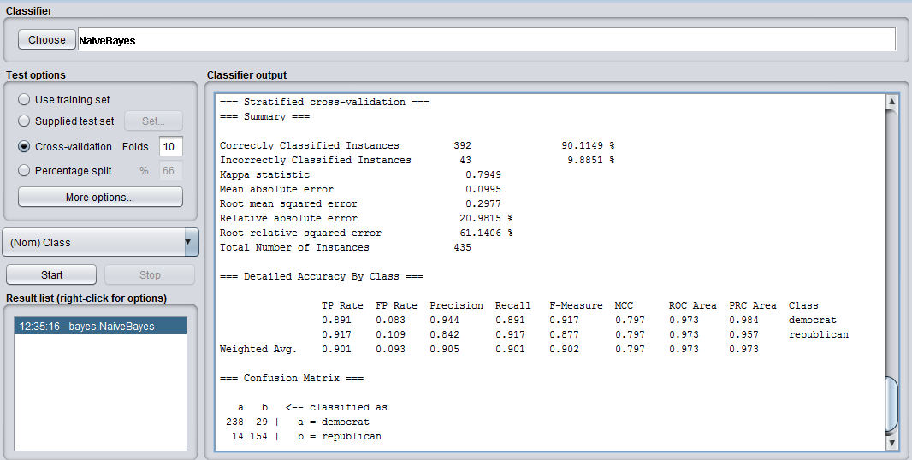

Accuracy = 90.1149 %

Precision = 238/(238+14) = 0.94

Recall = 238/(238+29) = 0.89

1. After removing three attributes (adoption-of-the-budget-resolution, religious-groups-in-school, mx-missile)

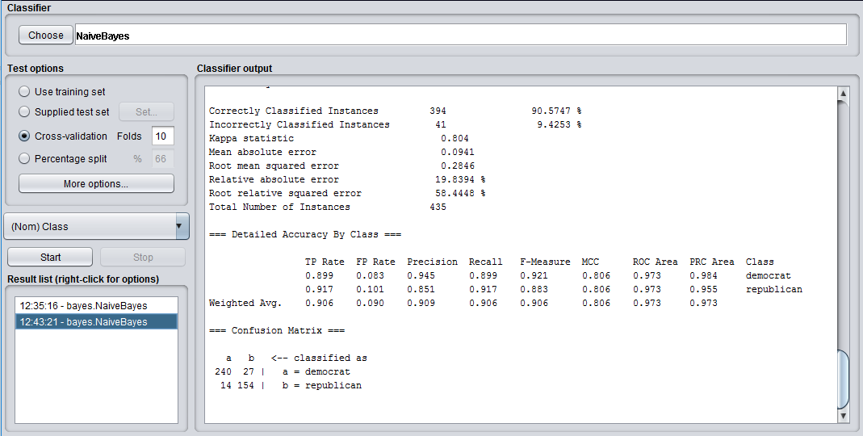

Accuracy = 90.5747%

Precision = 240/(240+14) = 0.95

Recall = 240/(240+27) = 0.90

1. Diabetes.arff
2. Without removing attributes

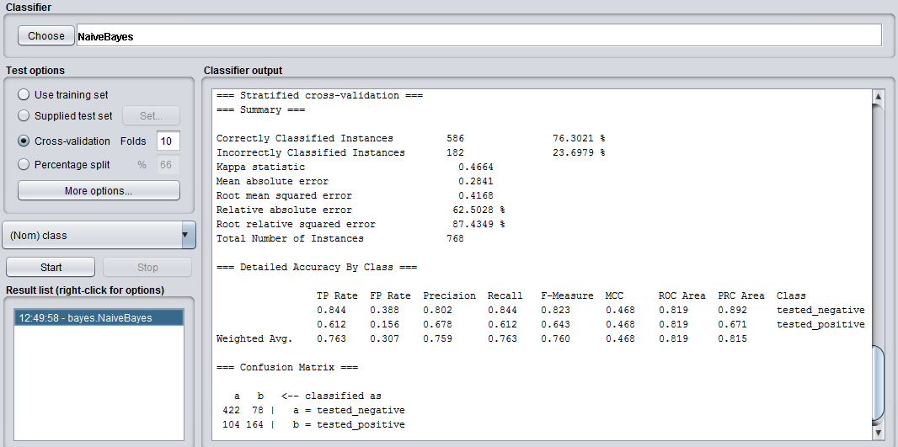

Accuracy = 76.3021%

Precision = 422/(422+104) = 0.802

Recall = 422/(422+78) = 0.844

1. After removing two attributes (preg, insu)

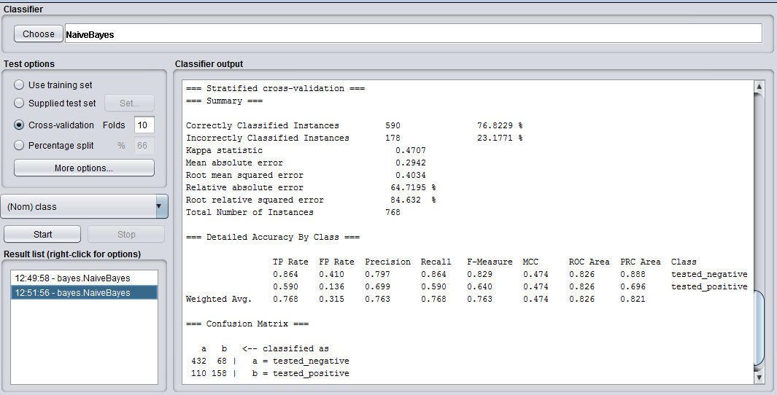

Accuracy = 76.8229%

Precision = 432/(432+110) = 0.797

Recall = 432/(432+68) = 0.864