|  |  |  |  |  |  |  |  |  |  |  |  |
| --- | --- | --- | --- | --- | --- | --- | --- | --- | --- | --- | --- |
|  | | **Finolex Academy of Management and Technology, Ratnagiri** | | | | | | | | | |
| **Department of Information Technology** | | | | | | | | | |
| Subject name: Internet Programming Lab | | | | | | | | Subject Code: TEITL501 | | | |
| Class | | TE IT | | Semester – V (CBCGS) | | | | Academic year: 2018-19 | | | |
| Name of Student | | **Kazi Jawwad A Rahim** | | | | | **QUIZ Score :** | | | | |
| Roll No | | **32** | | | Assignment/Experiment No. | | | | | 02 | |
| Title:  To perform form validations and cookies in a webpage using JavaScript | | | | | | | | | | | |
|  | | | | | | | | | | | |
| 1. **Course objectives applicable:**  **COB1**.Study basic HTML tags and structure of CSS, Study JavaScript as a web programming language | | | | | | | | | | | |
| **2. Course outcomes applicable:**  **CO1**-Design a form on a webpage and demonstrate basic validations using JS. Demonstrate handling of cookies at client-side. | | | | | | | | | | | |
| **3. Learning Objectives:**   1. To understand basic structure and use of JavaScript 2. To implement JS to perform validations 3. To understand cookies and how they are managed 4. To understand the difference between static and dynamic web pages | | | | | | | | | | | |
| **4. Practical applications of the assignment/experiment:** All websites are based on basic HTML tags and using different types of CSS styles. Also dynamic and interactive pages can be created using JS as programming language. | | | | | | | | | | | |
| **5. Prerequisites**: Introduction to Java | | | | | | | | | | | |
| **6. Hardware Requirements**:   1. PC with 4GB RAM, 500GB HDD, Intel core i3/i5/i7 processor   **7. Software Requirements:**  1. Windows or Linux Desktop OS  2. HTML5 compatible web browsers (Chrome, Firefox)  3. Notepad++ | | | | | | | | | | | |
|  | | | | | | | | | | | |
| **8. Quiz Questions (if any): (Online Exam will be taken separately batchwise, attach the certificate/ Marks obtained)**   1. What is JavaScript used for? 2. At what place can you add JavaScript code? 3. What are objects in JS? 4. How do we write output statements in JS? 5. What are cookies? | | | | | | | | | | | |
|  | | | | | | | | | | | |
| **9. Experiment/Assignment Evaluation:** | | | | | | | | | | | |
| **Sr. No.** | **Parameters** | | | | | | | | **Marks obtained** | | **Out of** |
| **1** | Technical Understanding (Assessment may be done based on Q & A **or** any other relevant method.) Teacher should mention the other method used - | | | | | | | |  | | 6 |
| **2** | Neatness/presentation | | | | | | | |  | | 2 |
| **3** | Punctuality | | | | | | | |  | | 2 |
| **Date of performance (DOP)** | | |  | | | **Total marks obtained** | | |  | | **10** |
| **Date of checking (DOC)** | | |  | | | **Signature of teacher** | | | | | |

**Installation Steps / Performance Steps –**

**Example of cookie**

<!DOCTYPE html>

<html>

<head>

<script>

function setCookie(cname,cvalue,exdays) {

var d = new Date();

d.setTime(d.getTime() + (exdays*24*60*60*1000));

var expires = "expires=" + d.toGMTString();

document.cookie = cname + "=" + cvalue + ";" + expires + ";path=/";

}

function getCookie(cname) {

var name = cname + "=";

var decodedCookie = decodeURIComponent(document.cookie);

var ca = decodedCookie.split(';');

for(var i = 0; i < ca.length; i++) {

var c = ca[i];

while (c.charAt(0) == ' ') {

c = c.substring(1);

}

if (c.indexOf(name) == 0) {

return c.substring(name.length, c.length);

}

}

return "";

}

function checkCookie() {

var user=getCookie("username");

if (user != "") {

alert("Welcome again " + user);

} else {

user = prompt("Please enter your name:","");

if (user != "" && user != null) {

setCookie("username", user, 30);

}

}

}

</script>

</head>

<body onload="checkCookie()">

</body>

</html>

**Output:**

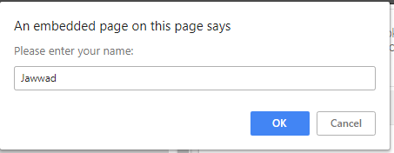

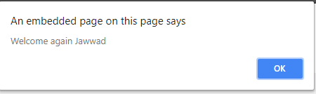

**formvalidation.html**

<!DOCTYPE html>

<html>

<head>

<title>Form Validation Example</title>

<style>

.signup{

border:1px solid #999999;

font:normal 14px helvetica;

}

body{

margin:10%;

background-color:powderblue;

}

h2{

color:green;

text-align:left;

margin:10px;

padding 25px;

}

</style>

<script src="validate_functions.js"></script>

</head>

<body>

<h2><u>Registration Form</u></h2>

<table border="0" cellpadding="2" cellspacing="5" bgcolor="#eeeeee">

<th colspan="2" align="center">Signup Form</th>

<form method="post" action="adduser.html" onsubmit="return validate(this)">

<tr><td>Firstname</td>

<td><input type="text" maxlength="32" name="forename"></td></tr>

<tr><td>Lastname</td>

<td><input type="text" maxlength="32" name="surname"></td></tr>

<tr><td>Username</td>

<td><input type="text" maxlength="16" name="username"></td></tr>

<tr><td>Password</td>

<td><input type="password" maxlength="12" name="password"></td></tr>

<tr><td>Age</td>

<td><input type="text" maxlength="3" name="age"></td></tr>

<tr><td>Email</td>

<td><input type="text" maxlength="64" name="email"></td></tr>

<tr><td colspan="2" align="center"><input type="submit" value="Signup"></td></tr>

</form>

</table>

</body>

</html>

**Validate_functions.js**

function validate(form)

{

fail = validateForename(form.forename.value)

fail += validateSurname(form.surname.value)

fail += validateUsername(form.username.value)

fail += validatePassword(form.password.value)

fail += validateAge(form.age.value)

fail += validateEmail(form.email.value)

if (fail == "") return true

else { alert(fail); return false }

function validateForename(field)

{

return (field == "") ? "No Forename was entered.\n" : ""

}

function validateSurname(field)

{

return (field == "") ? "No Surname was entered.\n" : ""

}

function validateUsername(field)

{

if (field == "") return "No Username was entered.\n"

else if (field.length < 5)

return "Usernames must be at least 5 characters.\n"

else if (/[^a-zA-Z0-9_-]/.test(field))

return "Only a-z, A-Z, 0-9, - and _ allowed in Usernames.\n"

return ""

}

function validatePassword(field)

{

if (field == "") return "No Password was entered.\n"

else if (field.length < 6)

return "Passwords must be at least 6 characters.\n"

else if (!/[a-z]/.test(field) || ! /[A-Z]/.test(field) ||!/[0-9]/.test(field))

return "Passwords require one each of a-z, A-Z and 0-9.\n"

return ""

}

function validateAge(field)

{

if (isNaN(field)) return "No Age was entered.\n"

else if (field < 18 || field > 110)

return "Age must be between 18 and 110.\n"

return ""

}

function validateEmail(field)

{

if (field == "") return "No Email was entered.\n"

else if (!((field.indexOf(".") > 0) &&

(field.indexOf("@") > 0)) ||

/[^a-zA-Z0-9.@_-]/.test(field))

return "The Email address is invalid.\n"

return ""

}

}

**adduser.html**

<!DOCTYPE html>

<html>

<title>

Success

</title>

<body bgcolor="cyan" align="center">

<h1 style="color: blue;">Registration Successful</h1>

</body>

</html>

**Results: Before**

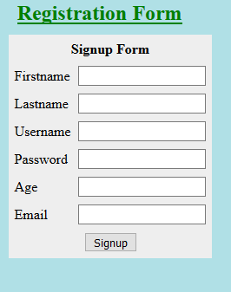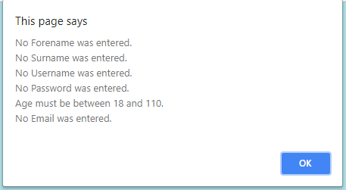

**After**

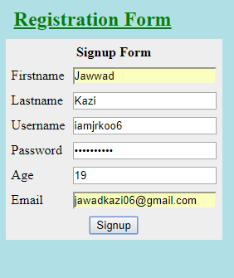

**References** :

[1] https://www.w3schools.com/js/default.asp

[2] https://www.w3schools.com/js/js_cookies.asp

[3]https://www.w3schools.com/js/js_intro.asp

[4] Advanced Internet Technologies (includes practicals), Deven Shah, Dreamtech Publication

[5] HTML Black Book, Steven Holzner, DreamTech Press