|  |  |  |  |  |  |  |  |  |  |  |  |
| --- | --- | --- | --- | --- | --- | --- | --- | --- | --- | --- | --- |
|  | | **Finolex Academy of Management and Technology, Ratnagiri** | | | | | | | | | |
| **Department of Information Technology** | | | | | | | | | |
| Subject name: Internet Programming Lab | | | | | | | | Subject Code: TEITL501 | | | |
| Class | | TE IT | | Semester – V (CBCGS) | | | | Academic year: 2018-19 | | | |
| Name of Student | | **Kazi Jawwad A Rahim** | | | | | **QUIZ Score :** | | | | |
| Roll No | | 32 | | | Assignment/Experiment No. | | | | | 03 | |
| Title:  To design a webpage for tourist place where you want to travel using HTML5 and CSS3 | | | | | | | | | | | |
|  | | | | | | | | | | | |
| **1. Course objectives applicable:**  **COB2**. To acquire knowledge and skills for creation of website considering client side programming | | | | | | | | | | | |
| **2. Course outcomes applicable:**  **CO2**-Design a responsive website using HTML5, CSS3 and RWD | | | | | | | | | | | |
| **3. Learning Objectives:**   1. To understand advanced elements of HTML5 2. To understand advanced CSS with RWD support. 3. To be able to design responsive webpage 4. To understand difference between responsive and non-responsive websites | | | | | | | | | | | |
| **4. Practical applications of the assignment/experiment: Most websites are based on HTML5 elements and use advanced CSS3 properties. Mostly all websites today are responsive.** | | | | | | | | | | | |
| **5. Prerequisites**: Basic HTML and CSS | | | | | | | | | | | |
| **6. Hardware Requirements**:   1. PC with 4GB RAM, 500GB HDD, Intel core i3/i5/i7 processor   **7. Software Requirements:**  1. Windows or Linux Desktop OS  2. HTML5 compatible web browsers (Chrome, Firefox)  3. Notepad++ | | | | | | | | | | | |
|  | | | | | | | | | | | |
| **8. Quiz Questions (if any): (Online Exam will be taken separately batchwise, attach the certificate/ Marks obtained)**   1. What are semantic elements in HTML5? 2. What are advanced CSS3 properties? 3. How can you find location of a web user? 4. How do we embed multimedia in a webpage? 5. What is the difference between <svg> and <canvas>? | | | | | | | | | | | |
|  | | | | | | | | | | | |
| **9. Experiment/Assignment Evaluation:** | | | | | | | | | | | |
| **Sr. No.** | **Parameters** | | | | | | | | **Marks obtained** | | **Out of** |
| **1** | Technical Understanding (Assessment may be done based on Q & A **or** any other relevant method.) Teacher should mention the other method used - | | | | | | | |  | | 6 |
| **2** | Neatness/presentation | | | | | | | |  | | 2 |
| **3** | Punctuality | | | | | | | |  | | 2 |
| **Date of performance (DOP)** | | |  | | | **Total marks obtained** | | |  | | **10** |
| **Date of checking (DOC)** | | |  | | | **Signature of teacher** | | | | | |

**10. Theory:**

The most interesting new HTML5 elements are:

New semantic elements like **<header>**, **<footer>**, **<aside>**, **<article>**, and **<section>**.

New attributes of form elements like number, date, time, calendar, and range.

New graphic elements: **<svg>** and **<canvas>**.

New multimedia elements: **<audio>** and **<video>**.

Advanced CSS3 properties include gradients, shadows, text effects, web fonts, 2D transform, 3D transform, transitions, animation, pagination etc.

Responsive web design makes your web page look good on all devices. It is not a program or JS. Web pages can be viewed using many different devices: desktops, tablets, and phones. Your web page should look good, and be easy to use, regardless of the device. Web pages should not leave out information to fit smaller devices, but rather adapt its content to fit any device.

**   **

**Desktop Tablet Phone**

Number of things like media queries, viewport, grid view, images have to be taken care of to make a page responsive.

**12. Installation Steps / Performance Steps –**

**TRAVEL.HTML**

<!DOCTYPE html>

<html>

<head>

<title>I want to travel to Taj Mahal</title>

<meta name="viewport" content="maximum_scale=3.0, width=device-width, minimum_scale=0.5"/>

<link rel="stylesheet" href="style1.css">

<link rel="stylesheet" href="https://cdnjs.cloudflare.com/ajax/libs/font-awesome/4.7.0/css/font-awesome.min.css">

<script>

function myFunction(){

var x = document.getElementById("myTopnav");

if (x.className === "topnav")

x.className += " responsive";

else

x.className = "topnav";

}

</script>

</head>

<body>

<header class="style0" id="home">

<h2>Taj Mahal</h2>

</header>

<div class="style1">

<img src="taj.jpg" alt="logo of Taj" width="100%" height="100%">

</div>

<div class="topnav" id="myTopnav">

<a href="#home" class="active">Home</a>

<a href="#about">About</a>

<a href="#travel">Travel</a>

<a href="#gallery">Gallery</a>

<a href="https://en.wikipedia.org/wiki/Taj_Mahal">History</a>

<a href="#address">Address</a>

<a href="#credit">Credit</a>

<a href="javascript:void(0);" class="icon" onclick="myFunction()">

<i class="fa fa-bars"></i>

</a>

</div>

<div class="style2" id="about">

<blockquote>

<h2>About</h2>

<p>The Taj Mahal is an enormous mausoleum complex commissioned in 1632 by the Mughal emperor Shah Jahan to house the remains of his beloved wife. Constructed over a 20-year period on the southern bank of the Yamuna River in Agra, India, the famed complex is one of the most outstanding examples of Mughal architecture, which combined Indian, Persian and Islamic influences. At its center is the Taj Mahal itself, built of shimmering white marble that seems to change color depending on the daylight. Designated a UNESCO World Heritage site in 1983, it remains one of the world’s most celebrated structures and a stunning symbol of India's rich history.</p>

</blockquote>

</div>

<hr>

<div class="style3" id="travel">

<h2>Travel Options</h2>

<h4>By Air</h4>

<p>Agra's Kheria airport is also a military base. It is a seasonal commercial airport and is connected only by Air India flights from New Delhi. The flight from Delhi to Agra is less than an hour long. Kheria airport is 13 kilometres away from Agra city. Hire a taxi from the airport to get to the city, which should take you around 10-15 minutes depending on traffic. </p><hr>

<h4>By Bus</h4>

<p>Agra is well connected by bus to cities like Delhi, Jaipur, Gwalior, Lucknow and Kanpur. Daily buses ply between these cities. Agra has two major interstate bus terminals called Idgah Bus Stand (which is located right in the centre of the city and is 8 kilometres from the Taj Mahal) and ISBT (which is located at a distance of 12 kilometres from the Taj Mahal). </p><hr>

<h4>By Train</h4>

<p>Agra is situated on the Delhi-Mumbai and Delhi-Chennai route and is well connected to most cities across India. There are regular trains to Agra from cities like Delhi, Jaipur, Gwalior and Jhansi. Agra is also well connected to cities in other parts of the country such as Kolkata, Mumbai and Chennai. There are five railway stations in Agra - Agra Cantt Station (the main station), Agra Fort Railway Station, Raja ki Mandi, Agra City and Idgah Railway Station. The Taj Mahal and Agra Fort are a short distance away from Agra Cantt railway station and one can hire a pre-paid taxi, auto rickshaw or even a cycle rickshaw to get to these attractions. </p><hr>

<h4>Road/Self Drive</h4>

<p>Agra is connected to Delhi by NH2 and the new Yamuna Expressway. The drive time is about 4-5 hours depending on traffic and time of the day. Jaipur is connected to Agra by NH11 and is a 4-hour drive. Gwalior, connected by NH3 is a 1.5-hour drive while Lucknow and Kanpur, connected by NH2, are about a 2-hour and 5-hour drive respectively. </p>

</div><hr>

<div class="style4" id="gallery">

<h2>Image Gallery</h2>

<img src="1.jpg">

<img src="2.jpg">

<img src="3.jpg">

<img src="4.png">

<img src="5.jpg">

<img src="6.jpg">

<img src="7.jpg">

<img src="8.jpg">

<img src="9.jpg">

<img src="10.jpg">

<img src="11.jpg">

<img src="12.jpg">

</div>

<hr>

<div class="row">

<div class="style5" id="address">

<h2>Address</h2>

<iframe src="https://www.google.com/maps/embed?pb=!1m18!1m12!1m3!1d3549.404678736423!2d78.03996651505052!3d27.175015083015424!2m3!1f0!2f0!3f0!3m2!1i1024!2i768!4f13.1!3m3!1m2!1s0x0%3A0xdd2ae4803f767dde!2sTaj+Mahal!5e0!3m2!1sen!2sin!4v1534947613212" frameboder="0" allowfullscreen></iframe>

<p>Taj Mahal<br>

Dharmapuri,<br>

Forest Colony,<br>

Tajganj,<br>

Agra,<br>

Uttar Pradesh 282001<br>

</p>

</div></div>

<footer class="style6" id="credit">

<p>This page was created for the purpose of demonstartion only.</p>

</footer>

</body>

</html>

**STYLE.CSS**

body{

margin: 0px;

background-color: white;

text-decoration: none;

}

a:link,a:visited{

color: black;

text-decoration: none;

}

a:hover{

color: red;

text-decoration: none;

}

.style0{

font-family:monospace;

color: rgb(22,21,73);

font-size:2em;

text-align:center;

margin: 0;

}

.style1{

width: 100%;

height:500px;

margin-bottom: 0;

}

.topnav{

background-color: green;

overflow: hidden;

position: static;

}

.topnav a {

float: left;

display: block;

color: #f2f2f2;

text-align: center;

padding: 14px 16px;

text-decoration: none;

font-size: 1.5em;

}

.style2{

font-size:2em;

text-align:justify;

}

.style3{

margin:50px;

font-size:2em;

text-align:justify;

}

.style4{

font-size: 2em;

margin-left: 50px;

}

.style4 img{

padding: 10px;

width: 400px;

height: 400px;

margin-top: 12px;

}

.style4 img:hover{

position: absolute;

width: 700px;

height: 700px;

}

.style5{

font-size:2em;

margin-left: 50px;

border: 1px;

}

.style5 iframe{

float:left;

overflow:hidden;

position:relative;

width:600px;

height:400px;

border: 1px solid black;

}

.style5 p{

text-align:right;

margin-right: 50px

}

.style6{

width: 100%;

height: 50px;

background-color: black;

color:white;

font-family: monospace;

font-size: 2em;

text-align:center;

}

.row:after {

content: "";

display: table;

clear: both;

}

@media screen and (max-width: 375px)

{

body{

background-color: skyblue;

font-family: monospace;

font-size:1.3em;

}

iframe{

max-width:100%;

}

.topnav a:not(:first-child) {display: none;}

.topnav a.icon {

float: right;

display: block;

}

.topnav.responsive {position: relative;}

.topnav.responsive a.icon {

position: absolute;

right: 0;

top: 0;

position: fixed;

}

.topnav.responsive a {

float: none;

display: block;

text-align: left;

}

a:link,a:visited{

color: black;

text-decoration: none;

}

a:hover{

color: red;

text-decoration: none;

}

.style0{

font-family:monospace;

color: rgb(22,21,73);

font-size:1em;

text-align:center;

margin: 0;

}

.style1{

width: 100%;

height:300px;

margin-bottom: 0;

}

.style2{

font-size:1em;

text-align: justify;

}

.style3{

margin:20px;

font-size:1em;

text-align:justify;

}

.style4{

font-size: 1em;

margin-left: 20px;

}

.style4 img{

padding: 10px;

width: 300px;

height: 300px;

margin-top: 12px;

}

.style4 img:hover{

position: relative;

width: 375px;

height: 375px;

}

.style5{

font-size:2em;

margin-left:20px;

border: 1px;

}

.style5 iframe{

float:left;

overflow:hidden;

position:relative;

width:300px;

height:300px;

border: 1px solid black;

}

.style5 p{

text-align:left;

}

.style6{

width: 100%;

height: 50px;

background-color: black;

color:white;

font-family: monospace;

font-size: 1em;

text-align:center;

}

.row:after {

content: "";

display: table;

clear: both;

}

}

@media screen and (max-width: 600px)

{

body{

margin: 0px;

max-width: 600px;

background-color: pink;

text-decoration: none;

}

a:link,a:visited{

color: black;

text-decoration: none;

}

a:hover{

color: red;

text-decoration: none;

}

.style0{

font-family:monospace;

color: rgb(22,21,73);

font-size:2em;

text-align:center;

margin: 0;

}

.style1{

width: 100%;

height:300px;

margin-bottom: 0;

}

.style2{

font-size:1.5em;

text-align: justify;

}

.style3{

margin:20px;

font-size:1.5em;

text-align:justify;

}

.style4{

font-size: 1.5em;

margin-left: 20px;

}

.style4 img{

padding: 10px;

width: 400px;

height: 400px;

margin-top: 12px;

}

.style4 img:hover{

position: absolute;

width: 700px;

height: 700px;

}

.style5{

font-size:2em;

margin-left: 50px;

border: 1px;

}

.style5 iframe{

float:left;

overflow:hidden;

position:relative;

width:400px;

height:450px;

border: 1px solid black;

}

.style5 p{

text-align:right;

margin-right: 50px

}

.style6{

width: 100%;

background-color: black;

color:white;

font-family: monospace;

font-size: 1.3em;

text-align:center;

}

.row:after {

content: "";

display: table;

clear: both;

}

.topnav a:not(:first-child) {display: none;}

.topnav a.icon {

float: right;

display: block;

}

.topnav.responsive {position: relative;}

.topnav.responsive a.icon {

position: absolute;

right: 0;

top: 0;

position: fixed;

}

.topnav.responsive a {

float: none;

display: block;

text-align: left;

}

}

**AT MAXIMUM VIEWPORT:**

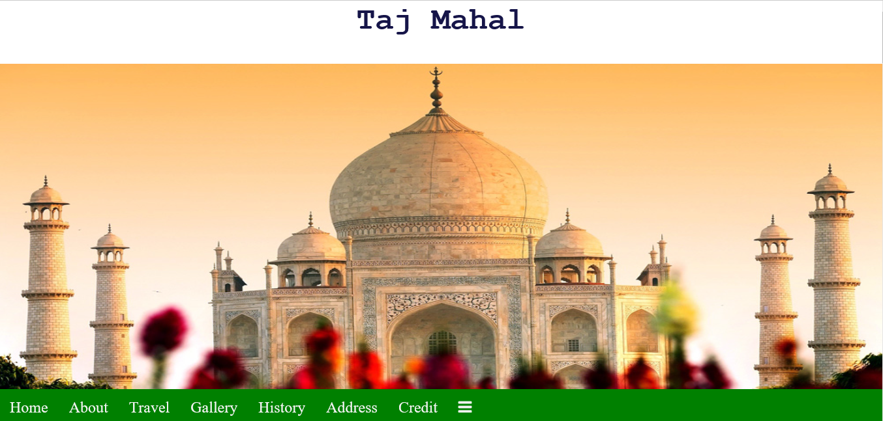

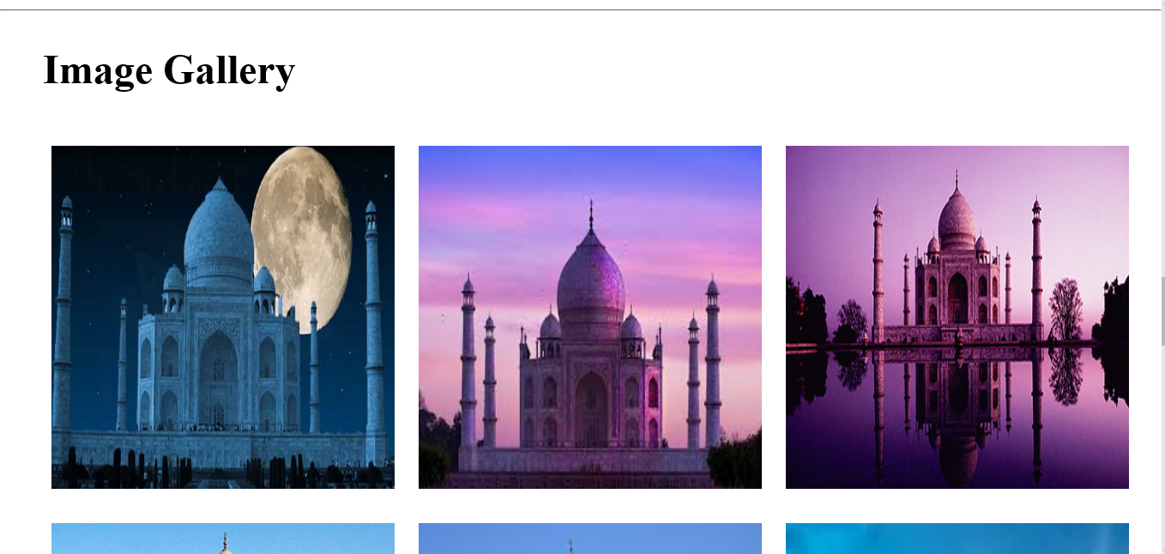

**AT 600PX:**

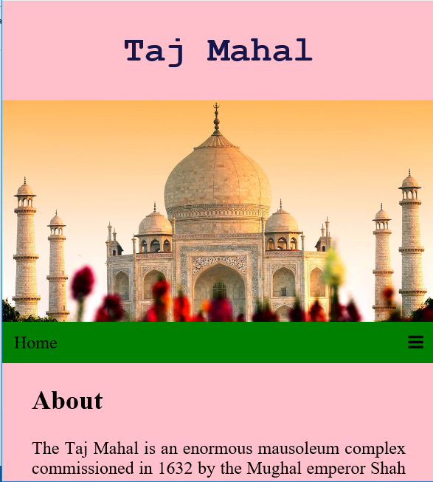

**References** :

[1] https://www.w3schools.com/css/css_rwd_intro.asp

[2] https://www.w3schools.com/css/css_rwd_mediaqueries.asp

[3] Advanced Internet Technologies (includes practicals), Deven Shah, Dreamtech Publication

[4] https://www.w3schools.com/css/css3_transitions.asp

[5] https://www.w3schools.com/html/html5_canvas.asp

[6] Responsive Web Design with HTML5 and CSS3, Ben Frain, PACKT Publication

[7] HTML5 Cookbook, By Christopher Schmitt, Kyle Simpson, O'Reilly Media