|  |  |  |  |  |  |  |  |  |  |  |  |
| --- | --- | --- | --- | --- | --- | --- | --- | --- | --- | --- | --- |
|  | | **Finolex Academy of Management and Technology, Ratnagiri** | | | | | | | | | |
| **Department of Information Technology** | | | | | | | | | |
| Subject name: Intelligent Systems Labs | | | | | | | | Subject Code: BEITC703 | | | |
| Class | | BE IT | | Semester – VII (CBGS) | | | | Academic year: 2019-20 | | | |
| Name of Student | | **Kazi Jawwad A Rahim** | | | | | **QUIZ Score :** | | | | |
| Roll No | | **29** | | | Assignment/Experiment No. | | | | | 07 | |
| Title:  **To implement basic programs using PROLOG.** | | | | | | | | | | | |
|  | | | | | | | | | | | |
| **1. Course objectives applicable:** COB5 Apply of basics of PROLOG programming. | | | | | | | | | | | |
| **2. Course outcomes applicable:**  **CO5** –To study how to do programming in Artificial Intelligence using PROLOG. | | | | | | | | | | | |
| **3. Learning Objectives:**   1. To understand expressions, operators, functions in PROLOG. 2. To use PROLOG for programming in AI. 3. To learn how to represent relations using PROLOG. | | | | | | | | | | | |
| **4. Practical applications of the assignment/experiment:** Used in development of algorithms based on Knowledge Base like Robot. | | | | | | | | | | | |
| **5. Prerequisites**:   1. To learn knowledge base. 2. To understand how knowledge base agent behaves and performs. 3. To use First order and propositional logic. | | | | | | | | | | | |
| **6. Hardware Requirements**:   1. PC with minimum 2GB RAM   **7. Software Requirements:**  1. Windows installed  2. PROLOG installed | | | | | | | | | | | |
|  | | | | | | | | | | | |
| **8. Quiz Questions (if any): (Online Exam will be taken separately batch wise, attach the certificate/ Marks obtained)**   1. What do you mean by First order logic? 2. What is the extension for programs written in PROLOG? 3. Complex problems can be solved by using FOL(True or False)? 4. What do you mean by semantics? | | | | | | | | | | | |
|  | | | | | | | | | | | |
| **9. Experiment/Assignment Evaluation:** | | | | | | | | | | | |
| **Sr. No.** | **Parameters** | | | | | | | | **Marks obtained** | | **Out of** |
| **1** | Technical Understanding (Assessment may be done based on Q & A **or** any other relevant method.) Teacher should mention the other method used - | | | | | | | |  | | 6 |
| **2** | Neatness/presentation | | | | | | | |  | | 2 |
| **3** | Punctuality | | | | | | | |  | | 2 |
| **Date of performance (DOP)** | | |  | | | **Total marks obtained** | | |  | | **10** |
| **Date of checking (DOC)** | | |  | | | **Signature of teacher** | | | | | |

**11. Programs and result**

**1. Factorial of a number using prolog.**

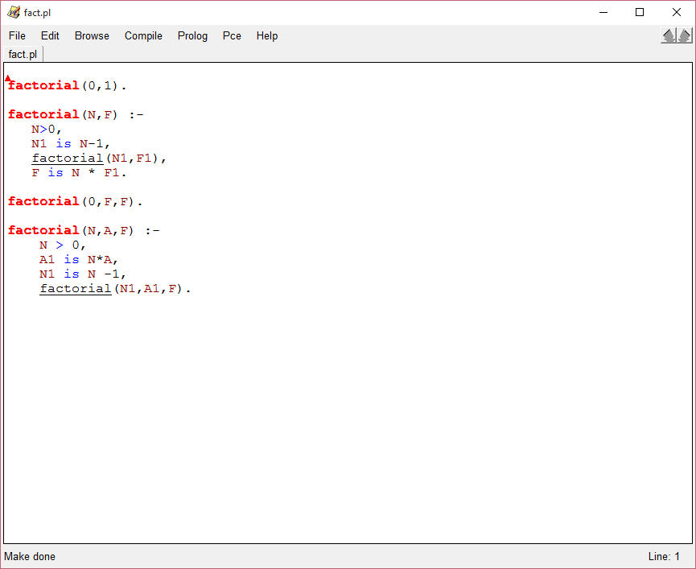

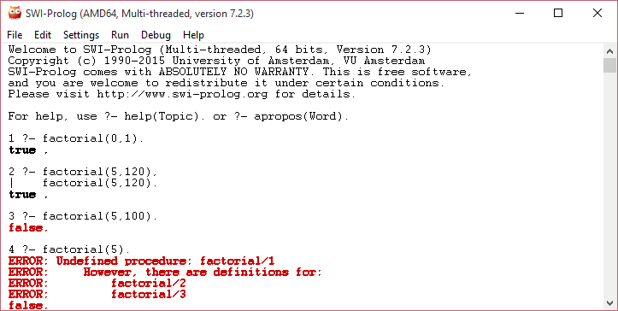

**2.Fibonacci series using prolog.**

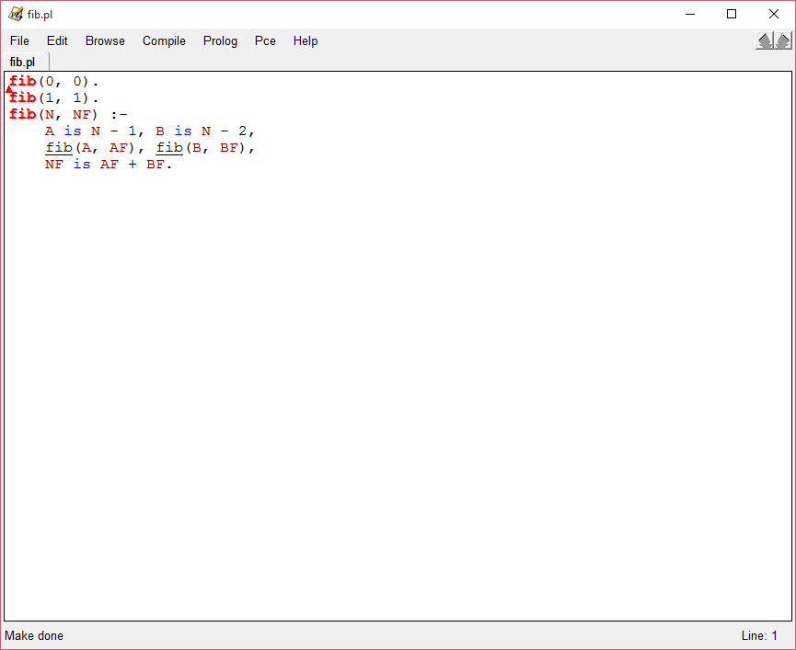

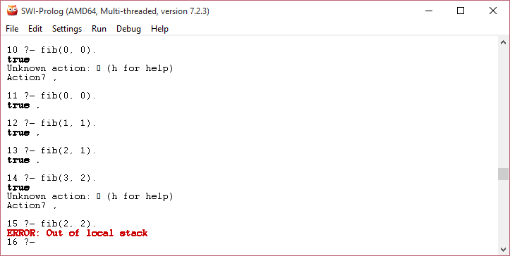

**12. Learning Outcomes Achieved**

1. Understood programming in PROLOG.
2. Implemented basic programs in AI using PROLOG.

**13. Conclusion:**

1. **Applications of the studied technique in industry**
   1. Development of algorithms in machine learning.
   2. expert systems
   3. specification language
   4. machine learning
   5. robot planning
   6. automated reasoning
2. **Engineering Relevance** 
   1. Such algorithms are used to develop algorithms for complex problems.
3. **Skills Developed**
   1. Implementation of programs using PROLOG

**14. References** :

[1] G. Görz, C.-R. Rollinger, J. Schneeberger (Hrsg.) “Handbuch der künstlichen

Intelligenz” Oldenbourg Verlag, 2003, Fourth edition

[2] Turing, A. "Computing Machinery and Intelligence", Mind LIX (236): 433–460,

Ocotober, 1950.

[3] Aristotle “On Interpretation”, 350 B.C.E, see:

<http://classics.mit.edu/Aristotle/interpretation.html>

[4] Artificial Intelligence: A modern approach, Stuart Russel and Peter Norvig, Pearson.

[5] Artificial Intelligence, Elaine Rich and Kevin Knight, Tata McGraw.

[6] Principles of Artificial Intelligence, Nils J. Nilson, Narosa Publications.

[7] Basics of PROLOG available at [http://www.cse.unsw.edu.au/~billw/cs9414/notes/prolog/facts03](http://www.cse.unsw.edu.au/%7Ebillw/cs9414/notes/prolog/facts03)