Q.1 What is Structural Health Monitoring?

ANS. Structural health monitoring is a continuous process of finding safety and soundness status of existing structures. It also helps to find alternative solutions to ensure the safety of structures against early failures. This system uses sensors to collect and analyze the various characteristics of the structure. The collected data used to avoid any damage or failure of structure that may occur in its life span. This system used for mass structures such as bridges, skyscrapers, airports, dams, stadiums, tunnels and many others.

Q.2 Give full form of

1. RPC 2. SNMP 3. CLI 4. SOAP

ANS. 1. RPC - Remote Procedure Call

2. SNMP - Simple Network Management Protocol

3. CLI - Command Line Interface

4. SOAP - Simple Object Access Protocol

Q.3 What is MQTT? State its applications in IoT. Compare MQTT with COAP.

ANS. MQTT stands for Message Queuing Telemetry Transport. It is designed as a lightweight messaging protocol that uses publish/subscribe operations to exchange data between clients and the server.

Applications in IoT-

1. It has minimized data packets.
2. It has low power usage which saves the battery of connected device.
3. It is real time, that’s what makes it perfect for IoT application.

|  |  |  |
| --- | --- | --- |
| **Parameters** | **MQTT** | **CoAP** |
| Full Form | Message Queuing Telemetry Transport | Constrained Application Protocol |
| Model used for communication | Publish-Subscribe | Request-Response, Publish-Subscribe |
| RESTful | No | Yes |
| Transport Layer | Preferably TCP. UDP can also be used. | Preferably UDP. TCP can also be used. |
| Header Size | 2 Bytes. | 4 Bytes. |
| No of message types used | 16 | 4 |
| Messaging | Asynchronous | Synchronous & Asynchronous |
| Application Reliability | 3 Levels | 2 Levels |
| Security | Not defined in the standard | IPSec or DTLS |
| Intermediaries | Yes (MQTT-S) | Yes |
| LLN Suitability | Fair | Excellent |
| Application Success Stories | Extending enterprise messaging into IoT applications. | Utility Field Area Network. |

Q.4 Explain REST API Architecture with detailed diagram.

ANS. REST API Architecture

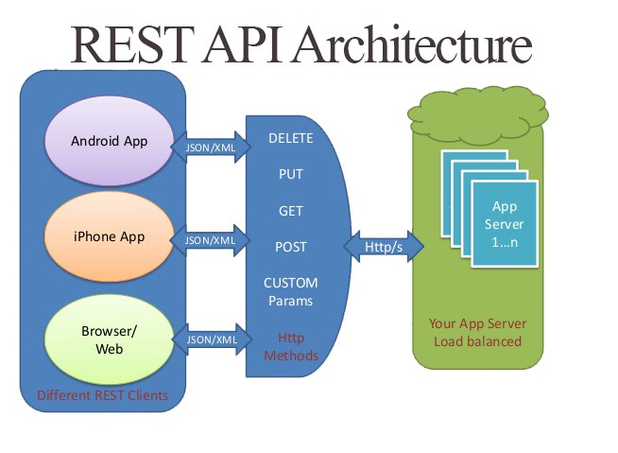

There are six architectural constraints which makes any web service are listed below:

**Uniform Interface:** It is a key constraint that differentiate between a REST API and Non-REST API. It suggests that there should be a uniform way of interacting with a given server irrespective of device or type of application (website, mobile app).

**Stateless:** It means that the necessary state to handle the request is contained within the request itself and server would not store anything related to the session. In REST, the client must include all information for the server to fulfill the request whether as a part of query params, headers or URI.

**Cacheable:** Every response should include whether the response is cacheable or not and for how much duration responses can be cached at the client side. Client will return the data from its cache for any subsequent request and there would be no need to send the request again to the server.

**Client-Server:** REST application should have a client-server architecture. A Client is someone who is requesting resources and are not concerned with data storage, which remains internal to each server, and server is someone who holds the resources and are not concerned with the user interface or user state.

**Layered system:** An application architecture needs to be composed of multiple layers. Each layer doesn’t know anything about any layer other than that of immediate layer and there can be lot of intermediate servers between client and the end server.

**Code on demand:** It is an optional feature. According to this, servers can also provide executable code to the client. The examples of code on demand may include the compiled components such as Java applets and client-side scripts such as JavaScript.

Q.5 Compare IPv4 and IPv6.

ANS.

|  |  |
| --- | --- |
| **IPv4** | **IPv6** |
| Source and destination addresses are 32 bits (4 bytes) in length. | Source and destination addresses are 128 bits (16 bytes) in length. |
| IPSec support is optional. | IPSec is mandatory and end-to-end. |
| Identification of packet flow for QoS handling by routers is absent within the IPv4 header. | Packet flow is identification for QoS handling by routers is included in the IPv6 header using flow label field. |
| Fragmentation is performed by both routers and the sending host. | Fragmentation is not done by routers, only the sending host. |
| Header includes a checksum. | Header doesn’t include a checksum. |
| Header includes options. | All optional data is moved to IPv6 extension headers. |
| Address Resolution Protocol (ARP) uses broadcast ARP request frames to resolve an IPv4 address to a link layer address. | ARP request frames are replaced with multicast neighbor solicitation messages. |
| Internet Group Management Protocol (IGMP) is used to manage local subnet group membership. | IGMP is replaced with Multicast Listener Discovery (MLD) messages. |
| ICMP Router Discovery is used to determine the IPv4 address of the best default gateway and is optional. | ICMP Router Discovery is replaced with ICMPv6 Router solicitation and Router Advertisement messages and is required. |
| Broadcast addresses are used to send traffic to all nodes on a subnet. | There are no IPv6 broadcast addresses. Instead, a link local scope all-nodes multicast address is used. |
| Must be configured either manually or through DHCP. | Does not require manual configuration or DHCP. |
| Uses host address (A) resource records in the Domain Name System (DNS) to map host names to IPv4 addresses. | Uses host address (AAA) resource records in the Domain Name System (DNS) to map host names to IPv6 addresses. |
| Must support a 576-byte packet size. | Must support a 1280-byte packet size. |

Q.6 What is Apache Hadoop? How it is relevant for IoT data analytics?

ANS. Apache Hadoop is an open-source software framework for storage and large-scale processing of data-sets on clusters of commodity hardware. Experts believe that enterprises can reap full benefits from the IoT phenomenon by pairing Hadoop with IoT. The main reasons Hadoop is best suited to work with IoT are given below:

1. Hadoop is capable of storing and processing any volumes of data. It can scale up based on rising data volumes.
2. No risk of performance issues or work stoppage because of unforeseen events as the work is divided across clusters. Even if a node crashes or experiences issues, it does not become a showstopper. From the perspective of business continuity, nothing can be more desirable.
3. Hadoop, being an open source Java-based framework, is compatible with all platforms.
4. No dependency on hardware to provide fault-tolerance and high availability (FTHA). Hadoop has a library in the Common Utilities module that can detect and prevent application layer failures.

Right now, there is no better alternative than the Hadoop-IoT pairing in sight for the efficient storage and processing of big data. However, it needs to be noted that both, IoT and Hadoop, are in their early stages of adoption by the industry. There is some hype around both concepts. As the dust settles down, the enterprises will learn more about Hadoop-IoT pairing and ways to better process the data.