**Internet of Everything (IoE)**

**RFID**

**Barcode vs RFID**

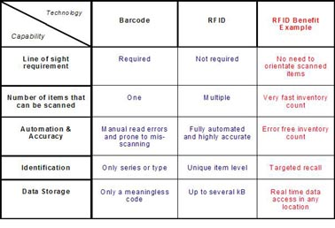

**RFID:**

Radio-frequency identification (RFID) uses electromagnetic fields to automatically identify and track tags attached to objects.

An RFID tag consists of a tiny radio transponder; a radio receiver and transmitter. When triggered by an electromagnetic interrogation pulse from a nearby RFID reader device, the tag transmits digital data, usually an identifying inventory number, back to the reader.

**Types of RFID tag:**

1. **Passive Tag:** A passive tag uses the electromagnetic energy it receives from an interrogator’s transmission to reply to the interrogator. The reply signal from a passive tag, which is also known as the backscattered signal, has only a fraction of the power of the interrogator’s signal. This limited power significantly restricts the operating range of the tag. Since passive tags are low power devices, they can only support data processing of limited complexity. On the other hand, passive tags typically are cheaper, smaller, and lighter than other types of tags, which are compelling advantages for many RFID applications.
2. **Active Tag:** An active tag relies on an internal battery for power. The battery is used to communicate to the interrogator, to power on-board circuitry, and to perform other functions. Active tags can communicate over greater distance than other types of tags, but they have a finite battery life and are generally larger and more expensive. Since these tags have internal power, they can respond to lower power signals than passive tags.
3. **Semi-active Tag:** A semi-active tag is an active tag that remains dormant until it receives a signal from the interrogator to wake up. The tag can then use its battery to communicate with the interrogator. Like active tags, semi- active tags can communicate over a longer distance than passive tags. Their main advantage relative to active tags is that they have a longer battery life. The waking process, however, sometimes causes an unacceptable time delay when tags pass interrogators very quickly or when many tags need to be read within a very short period of time.
4. **Semi-passive Tag:** A semi-passive tag is a passive tag that uses a battery to power on-board circuitry, but not to produce return signals. When the battery is used to power a sensor, they are often called sensor tags. They typically are smaller and cheaper than active tags, but have greater functionality than passive tags because more power is available for other purposes. Some literature uses the terms “semi-passive” and “semi- active” interchangeably.

**How Does RFID Work?**

1. RFID belongs to a group of technologies referred to as Automatic Identification and Data Capture (AIDC).
2. RFID methods utilize radio waves to accomplish this. At a simple level, RFID systems consist of three components:
   1. RFID tag or smart label,
   2. RFID reader, and
   3. Antenna.
3. The reader then converts the radio waves to a more usable form of data. Information collected from the tags is then transferred through a communications interface to a host computer system, where the data can be stored in a database and analyzed at a later time.

**RFID Applications:**

* Inventory management
* Asset tracking
* Personnel tracking
* Controlling access to restricted areas
* ID Badging
* Supply chain management
* Counterfeit prevention (e.g. in the pharmaceutical industry)

**History:**

* The first RFID application was the "Identification Friend or Foe" system (IFF) [Wizard Wars] and it was used by the British in the Second World War. Transponders were placed into fighter planes and tanks, and reading units could query them to decide whether to attack. Successors of this technology are still used in armies around the world.
* The probably first paper related to RFID technology was the landmark paper by Harry Stockman, "Communication by Means of Reflected Power" in October 1948.
* The first patent on RFID was issued in 1973 for a passive radio transponder with memory [US. Patent 3,713,148].

**RFID Principle**

* RFID tags, or simply "tags", are small transponders that respond to queries from a reader by wirelessly transmitting a serial number or similar identifier.

**Current RFID Technology**

* RFID transponders (tags) consist in general of:
  + Micro chip
  + Antenna
  + Case
  + Battery (for active tags only)
* The size of the chip depends mostly on the Antenna. Its size and form are dependent on the frequency the tag is using. The size of a tag also depends on its area of use. It can range from less than a millimeter for implants to the size of a book in container logistic
* In addition to the microchip, some tags also have rewritable memory attached where the tag can store updates between reading cycles or new data like serial numbers.

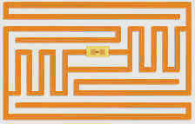

The microchip is visible in the center of the tag, and since this is a passive tag it does not have an internal power source.

**RFID Principle:**

* the reading unit generates an electro-magnetic field which induces a current into the tag's antenna.
* The current is used to power the chip. In passive tags the current also charges a condenser which assures uninterrupted power for the chip.
* In active tags a battery replaces the condenser.
* Once activated the tag receives commands from the reading unit and replies by sending its serial number or the requested information. In general, the tag does not have enough energy to create its own electro-magnetic field, instead it uses back scattering to modulate (reflect/absorb) the field sent by the reading unit.
* During a reading cycle, the reader has to continuously power the tag. The created field is called continuous wave, and because the strength of the field decreases with the square of the distance the readers have to use a rather large power.
* That field overpowers any response a tag could give, so therefore tags reply on side-channels which are located directly below and above the frequency of the continuous wave.

**Layers in RFID Implementation:**

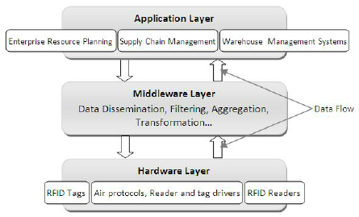

**RFID Middleware:**

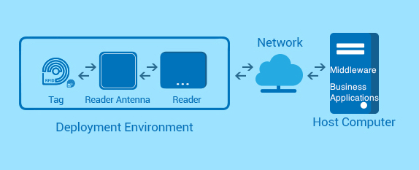

**RFID in SCM:**

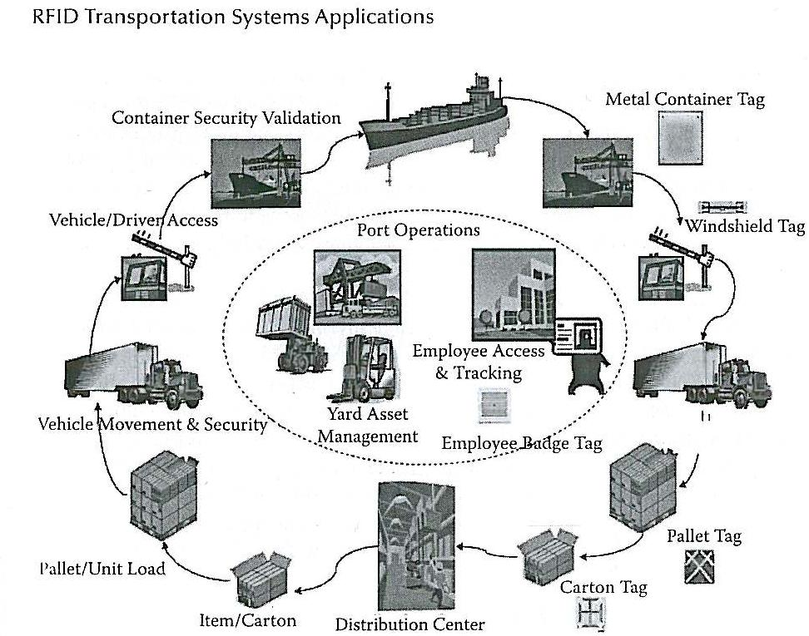

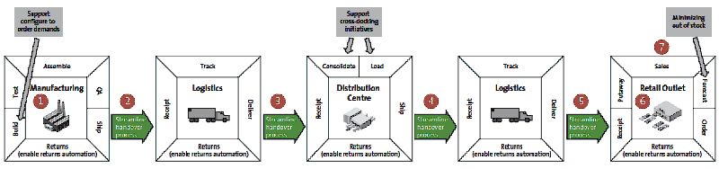

**RFID Issues-**

1. **Technology related:**
   1. **RFID can be more costly:**

Whether it be software or hardware, RFID requires more costly equipment that needs to be maintained through the life of the solution. Additionally, tags, whether they be Active, Passive or Semi-Passive, can set a business back a way. Although prices have fallen with RFID upgrades since the 1970s, businesses are still taking a pass because of the steep prices.

* 1. **RFID Reader Collision:**

Reader collision occurs when the signals from two or more readers overlap. The tag is unable to respond to simultaneous queries. Systems must be carefully set up to avoid this problem; many systems use an anti-collision protocol (also called a singulation protocol. Anti-collision protocols enable the tags to take turns in transmitting to a reader. (Learn more about RFID reader collision).

* 1. **Trouble with metals and liquids:**

RFID has long had a difficult relationship working among liquids and metals, as both make it harder to get proper reads on assets. With metal, the problem stems from the radio waves bouncing all over the place. Liquids play havoc with RFID in that it can absorb signals sent from a tag.

* 1. **RFID Tag Collision:**

It occurs when there are many of the cards found in a small area, in addition to the reading time is short, so it is easy for vendors to develop systems that ensure a response card and only one by employing the appropriate algorithms.

1. **Privacy and ethics related:**

* The contents of an RFID tag can be read after the item leaves the supply chain
* RFID tags are difficult to remove
* RFID tags can be read without your knowledge
* RFID tags with unique serial numbers could be linked to an individual credit card number