|  |  |  |  |  |  |  |  |  |  |  |  |
| --- | --- | --- | --- | --- | --- | --- | --- | --- | --- | --- | --- |
|  | | **Hope Foundation’s,**  **Finolex Academy of Management and Technology, Ratnagiri** | | | | | | | | | |
| **Department of Information Technology** | | | | | | | | | |
| Subject name: OLAP LAB | | | | | | | | Subject Code: ITL503 | | | |
| Class | | TE IT | | Semester – V (CBCGS) | | | | Academic year: 2018-19 | | | |
| Name of Student | | **Kazi Jawwad A Rahim** | | | | | **QUIZ Score :** | | | | |
| Roll No | | **32** | | | Assignment/Experiment No. | | | | | 01 | |
| Title**: Implementation of Two Phase locking protocol.** | | | | | | | | | | | |
|  | | | | | | | | | | | |
| 1. **Course objectives applicable:**   **LOB1**- Understand the stages and properties of transactions and the concepts involved with Serializability. | | | | | | | | | | | |
| 1. **Course outcomes applicable:**   **LO1**- Apply the knowledge of Concurrency control management to simulate Two Phase Locking protocol. | | | | | | | | | | | |
| **3. Learning Objectives:**   * To be able to apply the knowledge of Concurrency control management. * To be able to understand the working of Two Phase Commit protocol. | | | | | | | | | | | |
| 1. **Practical applications of the assignment/experiment:**  * Wherever the distributed database management system is utilized, the 2 PC or 3 PC protocols are implemented to achieve atomicity. E.g. Banking system. | | | | | | | | | | | |
| **5. Prerequisites**: Working of Client Server communication, Transaction properties. | | | | | | | | | | | |
| **6. Hardware Requirements**:   1. PC with 4GB RAM, 500GB HDD,   **7. Software Requirements:**  1. Programming language , Java | | | | | | | | | | | |
|  | | | | | | | | | | | |
| **8. Quiz Questions (if any): (Online Exam will be taken separately batch wise, attach the certificate/ Marks obtained)**   1. What is transaction? 2. List all the properties of transaction. 3. What is atomicity? | | | | | | | | | | | |
|  | | | | | | | | | | | |
| **9. Experiment/Assignment Evaluation:** | | | | | | | | | | | |
| **Sr. No.** | **Parameters** | | | | | | | | **Marks obtained** | | **Out of** |
| **1** | Technical Understanding (Assessment may be done based on Q & A **or** any other relevant method.) Teacher should mention the other method used - | | | | | | | |  | | 6 |
| **2** | Neatness/presentation | | | | | | | |  | | 2 |
| **3** | Punctuality | | | | | | | |  | | 2 |
| **Date of performance (DOP)** | | |  | | | **Total marks obtained** | | |  | | **10** |
| **Date of checking (DOC)** | | |  | | | **Signature of teacher** | | | | | |

**Results:**

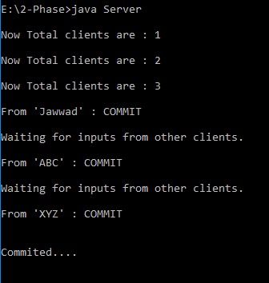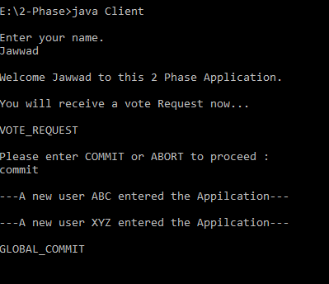

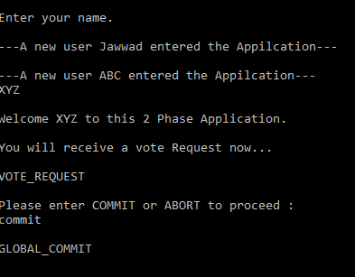

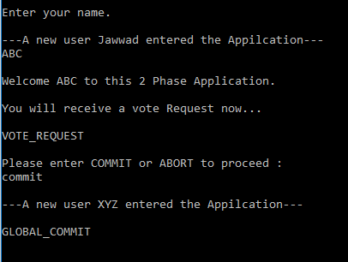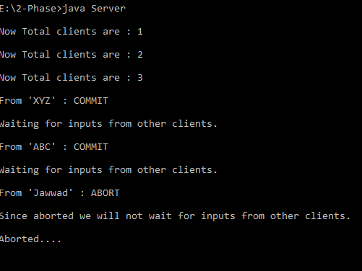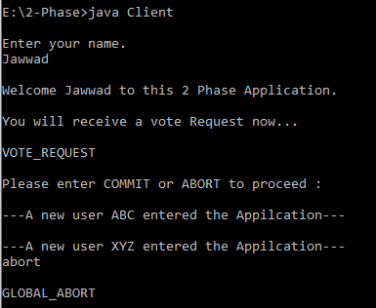

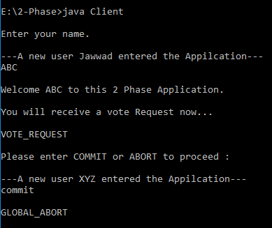

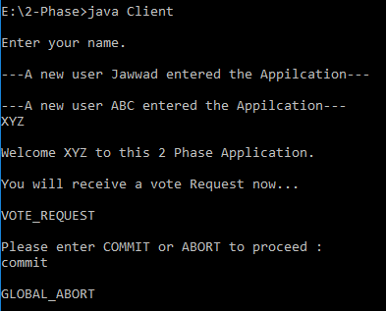

**References** :

1. https://www.javatpoint.com/mysql-tutorial

2. Advance Database Management system by Rini Chakrabarti.