|  |  |  |  |  |
| --- | --- | --- | --- | --- |
|  | Finolex Academy of Management and Technology, Ratnagiri | | | |
| **Department of Information Technology** | | | |
| **Subject:** | **R Programming Lab. (ITL804)** | | | |
| **Class:** | **BE IT / Semester – VIII (Rev-2016) / Academic year: 2019-20** | | | |
| **Name of Student:** | **Kazi Jawwad A Rahim** | | | |
| **Roll No:** | **28** | | **Date of performance (DOP) :** |  |
| **Assignment/Experiment No:** | | **01** | **Date of checking (DOC) :** |  |
| **Title:** Program to demonstrate basic functionality of R such as- data types, characters, strings, factors, helps, accessing packages. | | | | |
| **Marks:** | |  | **Teacher’s Signature:** |  |

**1. Aim**: To understand basics functionality of R software.

**2. Prerequisites**:

1. Basics of programming disciplines.

**3. Hardware Requirements**:

1. PC with minimum 2GB RAM

**4. Software Requirements:**

1. Windows / Linux OS.
2. R version 3.6 or higher

**5. Learning Objectives:**

1. To understand R software as a software development platform.
2. To understand elementary building blocks of R software such as- data types, character, string, factors, helps, packages.

**6. Learning Objectives Applicable: LO 1**

**7. Program Outcomes Applicable: PO 1**

**8. Program Education Objectives Applicable: PEO 1**

**OUTPUT:**

**Data Types:**

1) x=5 4) x=TRUE

mode(x) mode(x)

>> numeric >> logical

2) x=5.5 5) x=6+4i

mode(x) mode(x)

>> numeric >> complex

3) x=”Jawwad” 6) x=’Jawwad’

mode(x) mode(x)

>> character >> character

**Relational Operators:**

A=6 B=8

> A>B

[1] FALSE

> A>=B

[1] FALSE

> A<B

[1] TRUE

> A<=B

[1] TRUE

> A==B

[1] FALSE

> A!=B

[1] TRUE

**Arithmetic Operators:**

A=6 B=8

> A+B

[1] 14

> A-B

[1] -2

> A*B

[1] 48

> A/B

[1] 0.75

> A%%B

[1] 6

> A%/%B

[1] 0

**Logical Operators:**

> A&B

[1] TRUE

> A&&B

[1] TRUE

> A||B

[1] TRUE

> A|B

[1] TRUE

**Factors:**

> d=c(4,1,6)

> f=factor(d,levels=1:7,labels=c("Monday","Tuesday","Wednesday","Thursday","Friday","Saturday","Sunday"))

> f[1]

[1] Thursday

Levels: Monday Tuesday Wednesday Thursday Friday Saturday Sunday

**Help:**

help(sqrt)

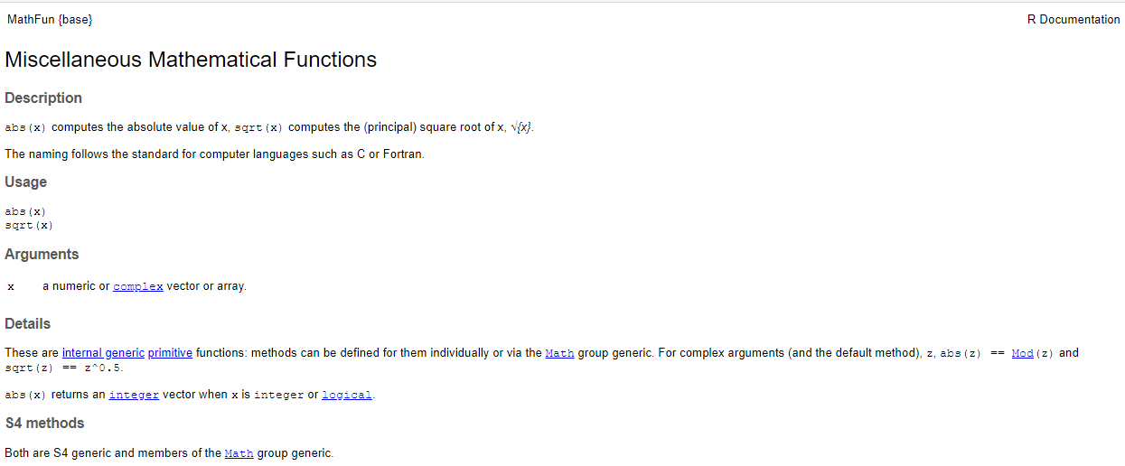

**Packages:**

> install.packages("rmeta")

Select mirror

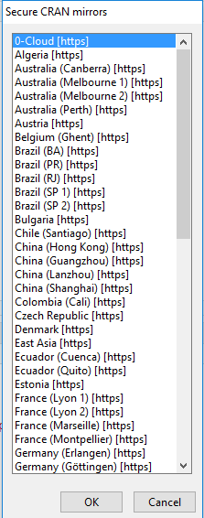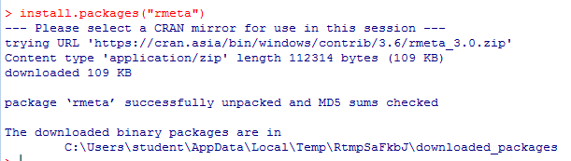

**Learning Outcomes:**

1. We understood R software as a software development platform.
2. We understood elementary building blocks of R software such as- data types, character, string, factors, helps, packages.

**Conclusion:**

We have successfully demonstrated installation of R along with introduction to R and basic building blocks of R.

**13. Experiment/Assignment Evaluation**

|  |  |  |  |  |  |
| --- | --- | --- | --- | --- | --- |
| **Experiment/Assignment Evaluation:** | | | | | |
| **Sr. No.** | **Parameters** | | | **Marks obtained** | **Out of** |
| **1** | Technical Understanding (Assessment may be done based on Q & A **or** any other relevant method.) Teacher should mention the other method used - | | |  | 6 |
| **2** | Neatness/presentation | | |  | 2 |
| **3** | Punctuality | | |  | 2 |
| **Date of performance (DOP)** | |  | **Total marks obtained** |  | **10** |
| **Date of checking (DOC)** | |  | **Signature of teacher** | | |

**References**:

1. URL: https://cran.r-project.org/doc/manuals/r-release/R-intro.pdf ( Online Resources)
2. R Cookbook Paperback – 2011 by Teetor Paul O Reilly Publications
3. Beginning R: The Statistical Programming Language by Dr. Mark Gardener, Wiley Publications
4. R Programming For Dummies by Joris Meys Andrie de Vries, Wiley Publications

**Viva Questions**

1. What is R?
2. How is R different than Python?
3. What are different data-types in R?
4. How to define a string in R?
5. What is factor data class in R?
6. How to take help in R?
7. How to load packages and libraries in R?