|  |  |  |  |  |
| --- | --- | --- | --- | --- |
|  | Finolex Academy of Management and Technology, Ratnagiri | | | |
| **Department of Information Technology** | | | |
| **Subject:** | **R Programming Lab. (ITL804)** | | | |
| **Class:** | **BE IT / Semester – VIII (Rev-2016) / Academic year: 2019-20** | | | |
| **Name of Student:** | **Kazi Jawwad A Rahim** | | | |
| **Roll No:** | **28** | | **Date of performance (DOP) :** |  |
| **Assignment/Experiment No:** | | **04** | **Date of checking (DOC) :** |  |
| **Title:** Exploratory data analysis such as- Range, summary, mean, variance, median, standard deviation, histogram, boxplot, scatterplot | | | | |
| **Marks:** | |  | **Teacher’s Signature:** |  |

**1. Aim**: To understand the exploratory data analysis and the methods required to do it in R.

**2. Prerequisites**:

1. Basics of R programming, various data structures, functions etc.

**3. Hardware Requirements**:

1. PC with minimum 2GB RAM

**4. Software Requirements:**

1. Windows / Linux OS.
2. R version 3.6 or higher

**5. Learning Objectives:**

1. To understand decision and loop control instructions.
2. To understand function definition and calling to it.

**6. Learning Objectives Applicable: LO 3. LO 4**

**7. Program Outcomes Applicable: PO 2, PO 3**

**8. Program Education Objectives Applicable: PEO 2, PEO 3**

**Range:**

a=c(1,5,7,8,9,6,4,9,5,8,9,6)

range(a)

**OUTPUT:**

[1] 1 9

**Summary:**

a=c(1,5,7,8,9,6,4,9,5,8,9,6)

summary(a)

**OUTPUT:**

Min. 1st Qu. Median Mean 3rd Qu. Max.

1.000 5.000 6.500 6.417 8.250 9.000

**Mean:**

a=c(1,5,7,8,9,6,4,9,5,8,9,6)

mean(a)

**OUTPUT:**

[1] 6.416667

**Mode:**

a=c(1,5,7,8,9,6,4,9,5,8,9,6)

table(a)

**OUTPUT:**

a

1 4 5 6 7 8 9

1 1 2 2 1 2 3

=> Mode=9

**Median:**

a=c(1,5,7,8,9,6,4,9,5,8,9,6)

median(a)

**OUTPUT:**

[1] 6.5

**Variance:**

a=c(1,5,7,8,9,6,4,9,5,8,9,6)

var(a)

**OUTPUT:**

[1] 5.901515

**Standard Deviation:**

a=c(1,5,7,8,9,6,4,9,5,8,9,6)

sqrt(var(a))

**OUTPUT:**

[1] 2.429303

**Histogram:**

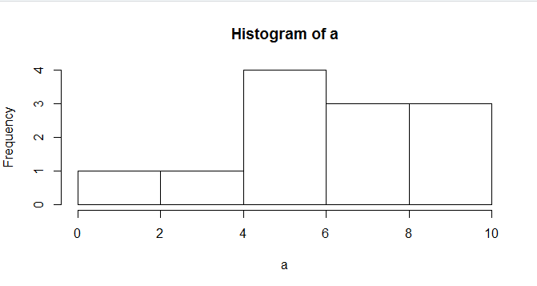

**Boxplot:**

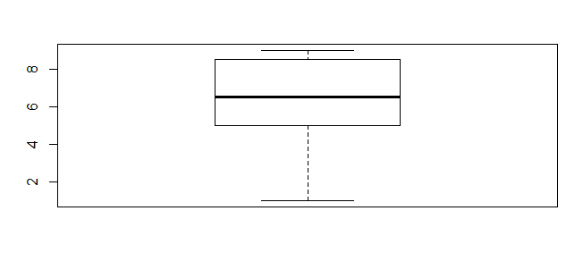

**Scatterplot:**

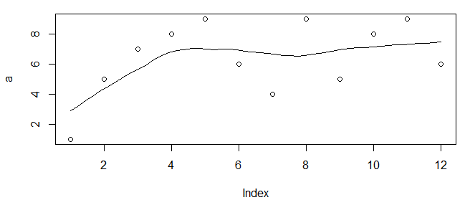

**Learning Outcomes Achieved:**

1. We understood decision and loop control instructions.
2. We understood the function definition and it’s calling.

**Conclusion:** We have successfully demonstrated the data analysis such as- Range, summary, mean, variance, median, standard deviation, histogram, boxplot, scatterplot.

**13. Experiment/Assignment Evaluation**

|  |  |  |  |  |  |
| --- | --- | --- | --- | --- | --- |
| **Experiment/Assignment Evaluation:** | | | | | |
| **Sr. No.** | **Parameters** | | | **Marks obtained** | **Out of** |
| **1** | Technical Understanding (Assessment may be done based on Q & A **or** any other relevant method.) Teacher should mention the other method used - | | |  | 6 |
| **2** | Neatness/presentation | | |  | 2 |
| **3** | Punctuality | | |  | 2 |
| **Date of performance (DOP)** | |  | **Total marks obtained** |  | **10** |
| **Date of checking (DOC)** | |  | **Signature of teacher** | | |

**References**:

1. URL: https://cran.r-project.org/doc/manuals/r-release/R-intro.pdf ( Online Resources)
2. R Cookbook Paperback – 2011 by Teetor Paul O Reilly Publications
3. Beginning R: The Statistical Programming Language by Dr. Mark Gardener, Wiley Publications
4. R Programming For Dummies by Joris Meys Andrie de Vries, Wiley Publications

**Viva Questions**

1. What is exploratory data analysis ?
2. What is summary of the data ?
3. What is importance of median of the data collection ?
4. What is histogram? Why is it important in data?
5. What information does the box plot provides?
6. List various R library functions used in exploratory data analysis.